Lab 01: Inferential Statistics and Data Exploration
Due date: Wednesday, Feb 5, 2025 submitted as Word document to Canvas Lab01 link
This lab counts 9 % toward your total grade.
Objectives: In this lab, you will practice your skills in
- Inferential statistics
- Confidence interval
- Statistical graph
- Data exploration
Format of answer: Submit your answers as a Word document with graphs and verbal descriptions, properly labeled in the task sequence, with answers in red text and only relevant content included

Task 1: Confidence Interval (3 pts)
A survey was conducted on a sample of 1,000 university students to determine the proportion of students who regularly use public transportation. Out of the 1,000 students surveyed, 72.4% reported that they regularly use public transportation. Show your R code for this calculation and explain the result.
- Calculate the 95% confidence interval for the proportion of students who use public transportation. (1 pts)
- Calculate the 99% confidence interval for the same proportion. (1 pts)
- Interpret the results from Task 1.a Task1.b and compare their interval range.(1 pts)
Task 2. Statistical Graph (3 pts)
The following graph is reproduction from the R Graphics Cookbook. R has extensive documentation to introduce its functions. You should be able to learn how to understand the documentation and apply the function to your study. Study the code in the link and reproduce the graph with a different data (Boston).
Boston data in MASS package (??MASS::Boston) contain variables about the housing value in suburbs of Boston.
In this task, you will work with ggplot2 to create a scatter plot with additional layers to enhance the visualization. The output can show relationship between two variables, using different colors to distinguish the third variable. Show your R code and graphs for this calculation.
- Reproduce the graph below using Boston data in MASS package. In ggplot function, set up parameters as: aes(x = rm, y = medv, colour = indus) . (1pts)
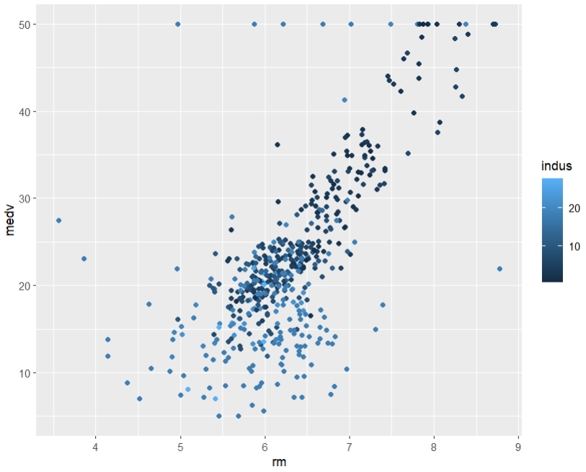
- Explain the data distribution pattern based on Boston data. (0.5pts)

- Based on the scatterplot, a smoothing line is added to the plot using the geom_smooth() function. Your task is to reproduce the below graph using Boston data in MASS package. Before you produce the graph, convert the chas variable in Boston data to factor:
Boston$chas = as.factor(Boston$chas).
Set up the parameters in ggplot() function as follows:
aes(x = rm, y = medv, colour = chas). (1.5 pts)
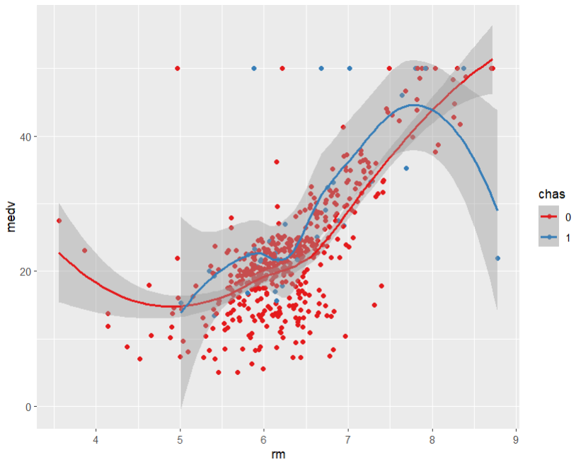
- Explain the data distribution pattern from Taks2. c. (0.5 pts)

Task 3: Data Exploration (3pts)
The MplsDemo Demographic Data 2015 in carData package include the demographic data from the 2015 American Community Survey. Show your R code for this calculation.
- Import the MplsDemo data use the function data(). (1 pts)
- Examine the histogram and pairwise relationships between variables using car::scatterplotMatrix(). Identify any skewed pattern visually and provide a description. Please use following variables: ~population + white + black + hhIncome. (1 pts)
- Evaluate the skewness of the variable identified as having a skewed pattern using e1071::skewness( )and explain the skewness value. (1 pts)

