Lab 02: Bivariate regression and Transformation
Due date: Wednesday, Feb 12, 2025 submitted as Word document to Canvas Lab02 link
This lab counts 9 % toward your total grade.
Objectives: In this lab, you will practice your skills in
- Explore bivariate regression
- Confidence interval
- Accuracy of the model
- Variable Transformation
Format of answer: Submit your answers as a Word document with graphs and verbal descriptions, properly labeled in the task sequence, with answers in red text and only relevant content included

Task 1: Bivariate regression (2.5 pts)
The MASS library contains the Boston data set, which records the attribute information about house in suburbs of Boston. We will use rm (average number rooms per house) to predict medv (median value of owner-occupied homes in $1000s).
- Using the lm() function to fit a bivariate linear regression model, with medv as the dependent variable and rm as the independent variable. (0.5 pts)
data('Boston')
boston_model = lm(medv~rm, data = Boston)
- Get detailed information about the linear model you constructed in 1.a using summary(). Interpret the intercept, slope and $R^{2}$. (1 pts)
summary(boston_model)
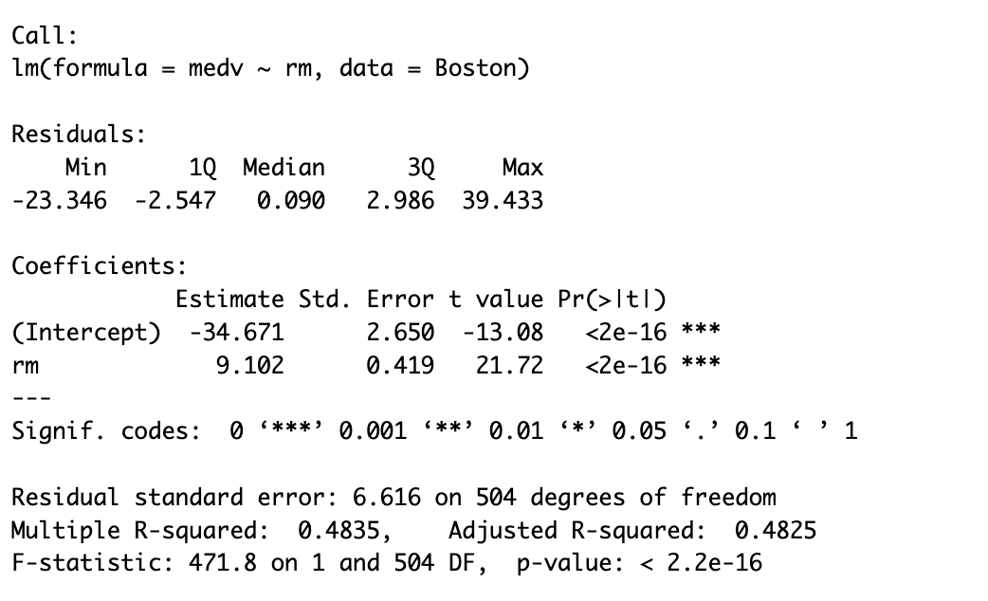
- Compute the 95% confidence interval for the estimated regression parameters. Does the conclusion align with the results obtained from the t-test in part 1.b? yes or no, please interpret. (1pts)
confint(boston_model)
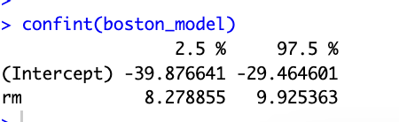
Yes, the conclusion align with the results obtained from the t-test in part 1.b. As summary shows that the t-test checking whether rm has a significant impact on medv. Low p- value and confidence interval without 0 reveals that rm is statistically significant.

Task 2: Bivariate Regression Model and Variable Transformation (6.5 pts)
The UN dataset from the carData package contains various global development indicators. We will analyze the relationship between infant mortality rate (infantMortality) (dependent variable) and GDP per capita (ppgdp) as (independent variable).
- Remove NA value in UN dataset using na.omit(UN). (0.5 pts)
data('UN')
par(mfrow = c(1,1))
new_un = na.omit(UN)
- Create a scatterplot of infant mortality rate (infantMortality) versus GDP per capita (ppgdp) using car::scatterplot(). By visually inspecting the box plots and the LOESS curve, determine whether data transformation is advisable for dependent variable and independent variable. (1pts)
car::scatterplot(infantMortality~ppgdp, data = new_un,xlab = 'Gross Domestic Product per Capita',
ylab = 'Infant Mortality Rate (per 1000 births)',
regLine = list(col = 'darkgreen'),
smooth = list(col.smooth = "red"))
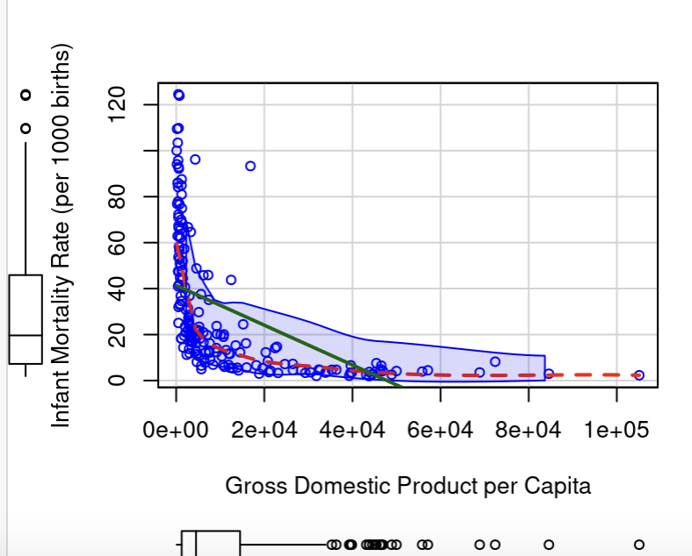
Yes, it is data transformation is advisable for dependent variable and independent variables because:
Dependent and independent variable have skewness based on boxplot. There is a non-linear relationship between GDP per capita (independent variable) and infant mortality rate (dependent variable). Log transformation might help linearize the relationship for better model fitting.

- If a transformation is needed for the independent variable, find the $λ_{optimal}$ using:
Box-Cox transformation (summary (car::powerTransform(lm(varName~1)))) Please justify whether log-transformation ($λ=0$) should be used or if $λ_{optimal}$ is more appropriate. (1pts)
p1 = powerTransform(ppgdp~1, data = new_un, family = 'bcPower')
summary(p1)
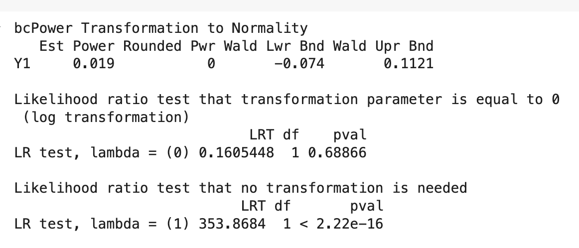
Test for if transformation is needed has p-value < 2.22e-16, so we need to to use transformaton. Test for if transformation parameter equal to 0 (log transformation)., p-value of $λ=0 is$0.68866. It is statistically non-significant. So we failed to reject the null-hypothesis (transformation parameter is equal to 0), so λoptimal We should use log transformation (transformation parameter equal to 0)

- Transformed the independent variable using $λ=1$ , $λ= λ_{optimal }$, $λ= -1$. (1pts)
  - Construct the histogram for the transformed distribution with different $λ$ value.
par(mfrow = c(1,3))
lambda_1 = car::bcPower(new_un$ppgdp, lambda= 1)
lambda_optimal = car::bcPower(new_un$ppgdp, lambda=0.019)
lambda_negative = car::bcPower(new_un$ppgdp, lambda=-1)

hist(lambda_1,breaks = 12,main = 'lambda = 0',xlab = 'x')
hist(lambda_optimal,breaks = 12,main = 'lambda = 0.019',xlab = 'x')
hist(lambda_negative,breaks = 12,main = 'lambda = -1',xlab = 'x')

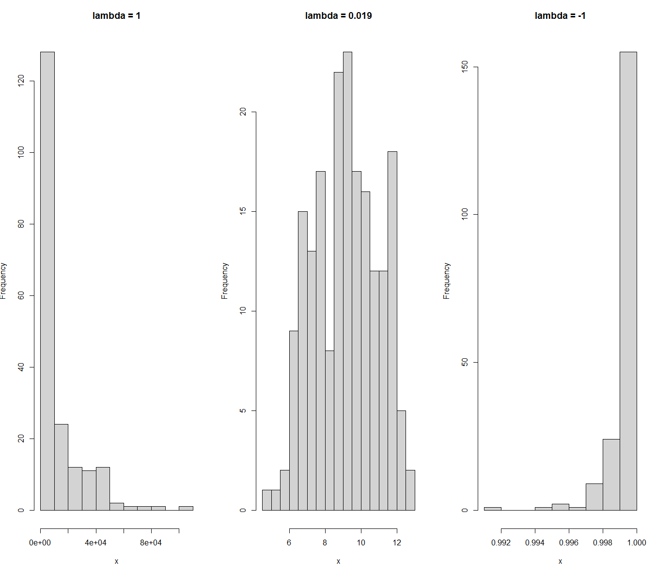
As we can see from the difffernt values of lambda (-1, 0.019, 1), there is an adjustment in the skewness. When λ=1, no transformation is applied, preserving the original distribution. When λ=0.019. the transformation effectively adjusted the skewness, bringing the distribution closer to normaity. However, when λ= -1. The transformation over-adjusted the distribution.
  - Evaluate the skewness and test whether the variables are approximately normal distribution.

shapiro.test(lambda_1)
shapiro.test(lambda_optimal)
shapiro.test(lambda_negative)

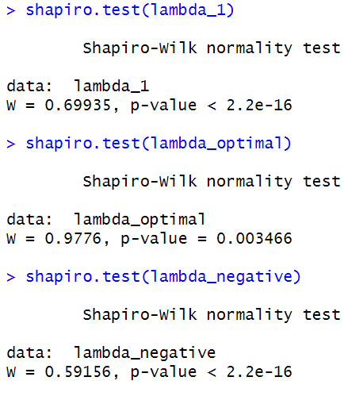

None of the three distributions follow a normal distribution. However, the transformation with the optimal lambda value brings the distribution closer to normality compared to the other two, as indicated by the larger p-value.
- If a transformation appears necessary for dependent variable, find the $λ_{optimal}$. (1pts)
p2 = powerTransform(infantMortality~log(ppgdp), data = new_un, family = 'bcPower')
summary(p2)
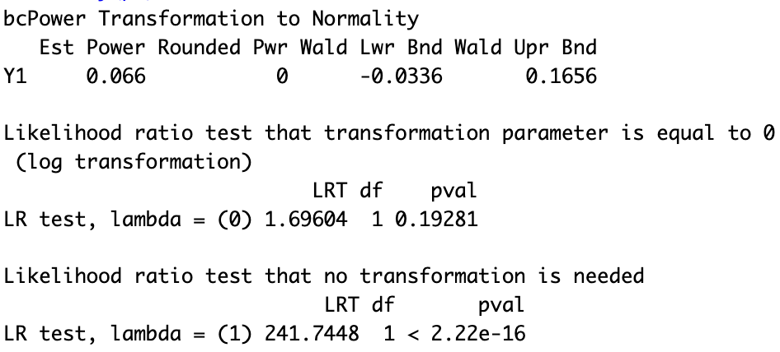
- Create a scatterplot with transformed variables using car::scatterplot(). Visually inspecting the box plots and the LOESS curve and describe how the transformation affects the relationship compared to the scatterplot in Task 2.b. (1pts)
car::scatterplot(log(infantMortality)~log(ppgdp), data = new_un,xlab = 'Gross Domestic Product per Capita',
ylab = 'Infant Mortality Rate (per 1000 births)',
regLine = list(col = 'darkgreen'),
smooth = list(col.smooth = "red"))
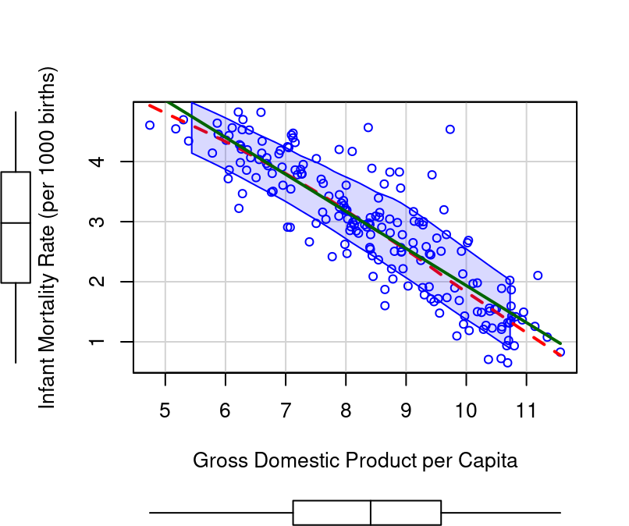
Box plots and the LOESS curve was non- linear and skewed. Transformation has improved the linear relationship and stabilizes the variance.
GDP per capita was decreasing with the increase in low infant mortality rate (per 1000 births) and flattens for higher GDP. After transformation, the spread of points is approximately aligned with straight-line trend.

- Estimate the bivariate regression model using the transformed variables and interpret the estimated coefficients. (1pts)
log_lm_model = lm(log(infantMortality)~log(ppgdp), data = new_un)
summary(log_lm_model)
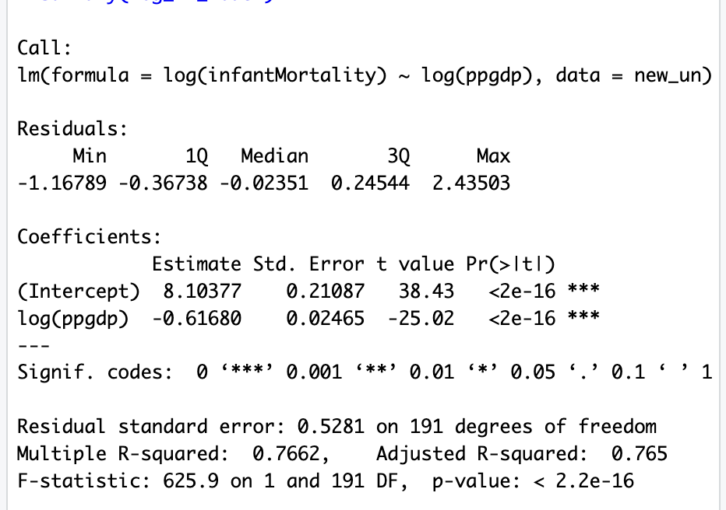
Estimated regression model is:
log(infantMortality)=8.10377−0.61680×log(ppgdp)
According to the model, predicted log of infant mortality will be 8.10377, when Gross domestic product per capita is 0.
The negative value of slope= -0.61680, indicates that there is a negative relationship between GDP per capita and infant mortality. With 1% increase in GDP, there is 0.61680% decrease in infant mortality rate.

