Lab 04: Regression Criticism
Due date: Thursday, March 14, 2025 submitted as Word document to Canvas Lab04 link
This lab counts 9 % toward your total grade.
Objectives: In this lab, you will practice your skills in
- Explore multiple regression
- Residual plot
- Multicollinearity
- Outlier detection
Format of answer: Submit your answers as a Word document with graphs and verbal descriptions, properly labeled in the task sequence, with answers in red text and only relevant content included

Task 1: Multiple regression (9 pts)
We will use the Boston dataset from the MASS package, which contains 506 observations and 15 variables related to housing prices in the Boston suburbs. Data information please check this link (Provide R code for each task and explain the result).

Total_area is a simulated variable that is calculated based on rm.

- Construct a multiple regression model using medv (median home value) as the dependent variable, with all other variables except lstat as independent variable (a total of 14 variables). (1 pt)
Boston = read.csv('Boston.csv')
var_initial_model <- Boston[ , !names(Boston) %in% "lstat"]
initial_model = lm(medv~., data = var_initial_model)
summary(initial_model)
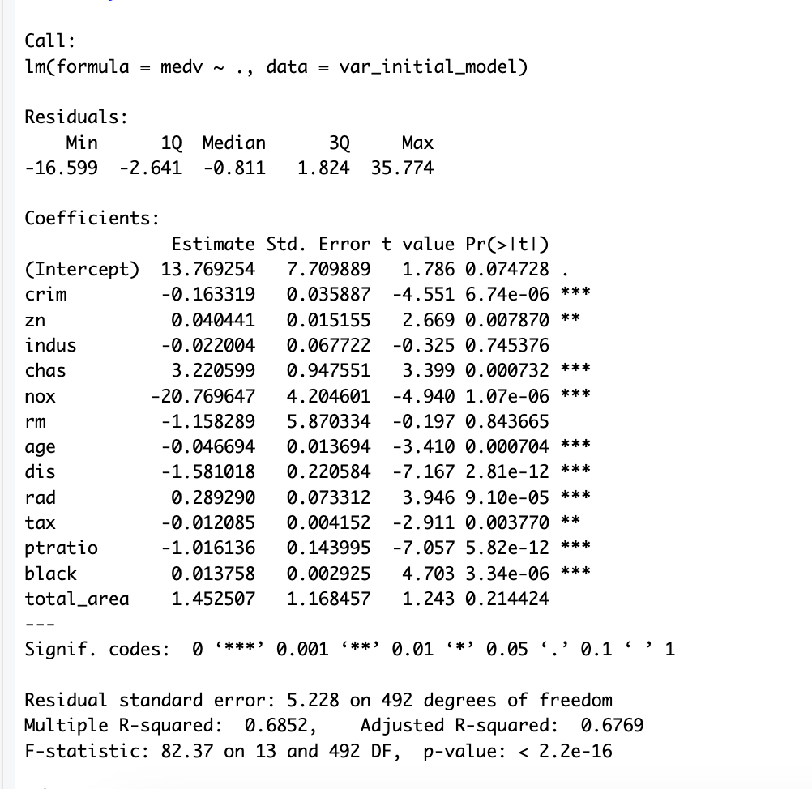

- Use Variance Inflation Factor (VIF) to detect multicollinearity among the predictors. (1 pt)
vif(initial_model)
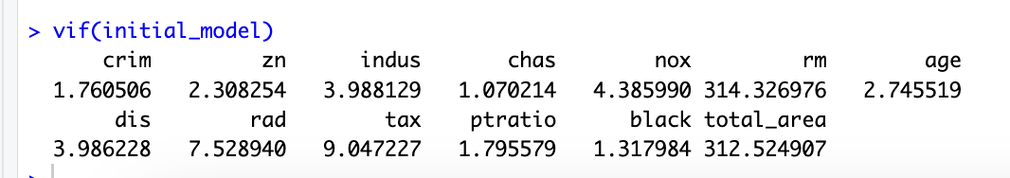

- If multicollinearity is detected, remove one highly collinear variable based on domain knowledge and reasoning. Fit a new regression model (Model 2) without the problematic variable. (2 pts)
As values of rm (314.326976) and total_area (312.524907) are above 10, they are considered as excessively high VIF values, suggesting severe multicollinearity. These variables are likely strongly correlated and could be problematic in the regression model.
var_second_model <- var_initial_model[ , !names(var_initial_model) %in% "total_area"]
second_model = lm(medv~., data = var_second_model)
summary(second_model)

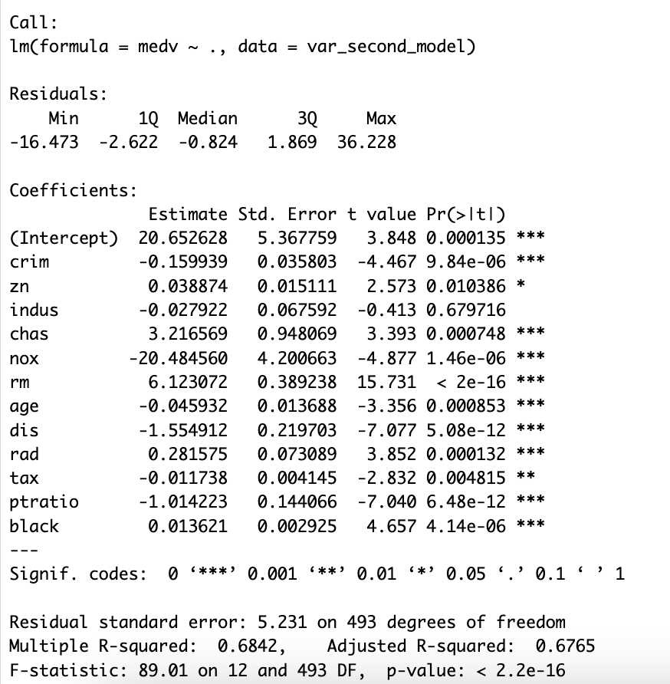

- Compare Model 1 (from Task1. a) and Model 2 (from Task1. c) using: Standard errors and t-statistics. Please illustrate how multicollinearity impacts model estimates by analyzing changes in coefficient significance. (2 pts)
summary(initial_model)
summary(second_model)
vif_initial_model <- vif(initial_model)
print(vif_initial_model)
vif_second_model <- vif(second_model)
print(vif_second_model)
Some variables have decreased standard errors in Model 2, that makes the estimates more precise.The t-statistics have generally increased, indicating that some variables became more statistically significant after removingtotal_aea. The significance of zn decreased, as seen in its t-value dropping from 2.669 to 2.573, meaning it is now less statistically significant. Some variables became slightly more significant, such as chas, nox, rm, and ptratio, as their t-values increased.
Multicollinearity is assessed using the Variance Inflation Factor (VIF). VIF for rm and total_area are highin Model
1 , indicating moderate multicollinearity. After removing total_area, the VIF values
decreased for rm in Model 2, meaning multicollinearity was reduced
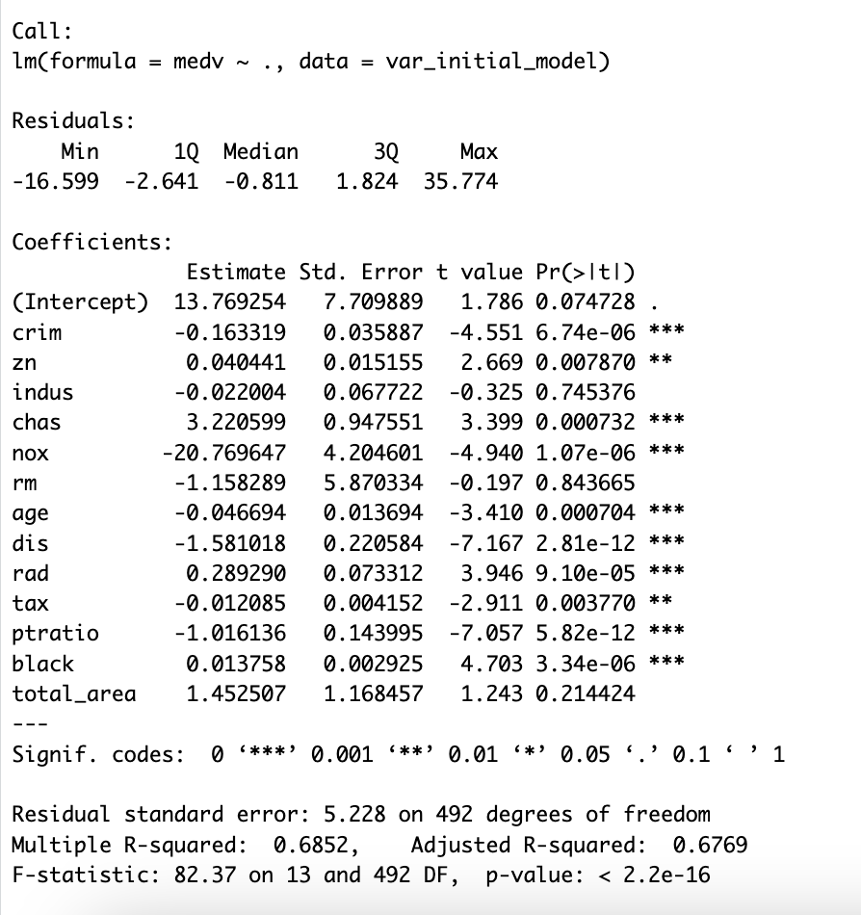
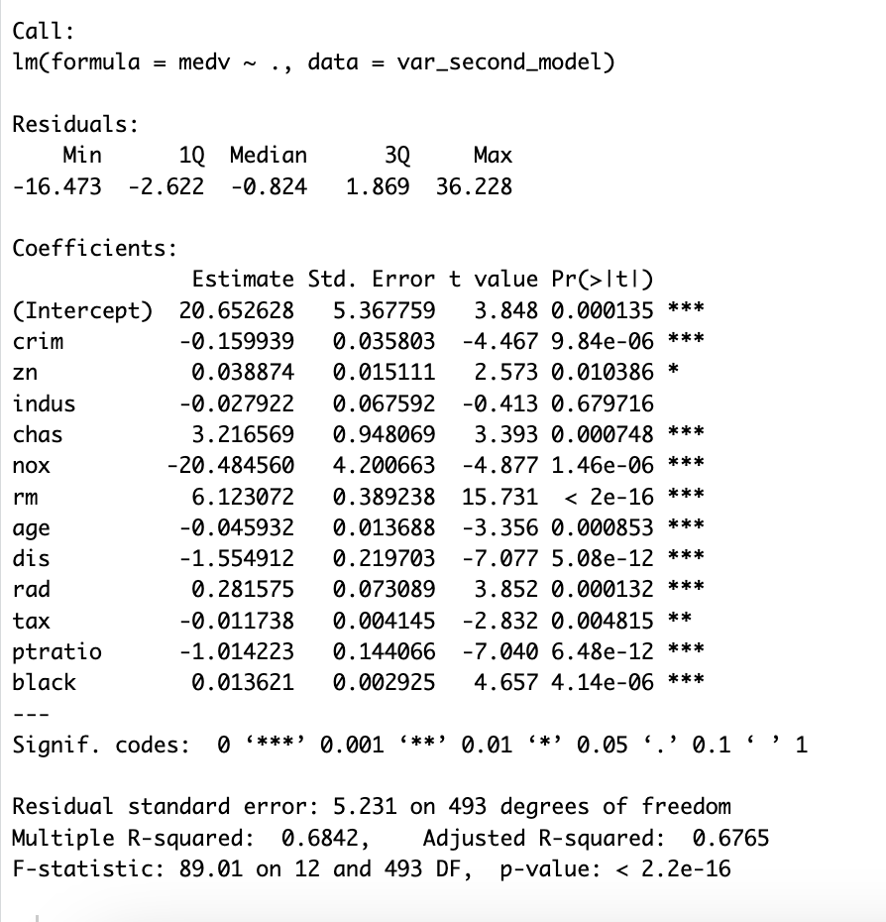
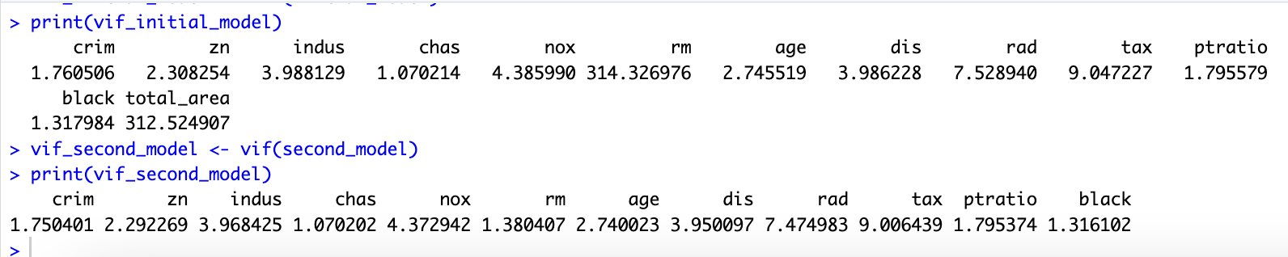

- Check whether residuals exhibit constant variance (homoscedasticity) in Model 2. If heteroscedasticity is detected, suggest one potential remedies. (1 pt)
par(mfrow = c(1,1))
plot(initial_model$fitted.values, initial_model$residuals)
#add a horizontal line at 0
abline(0,0)

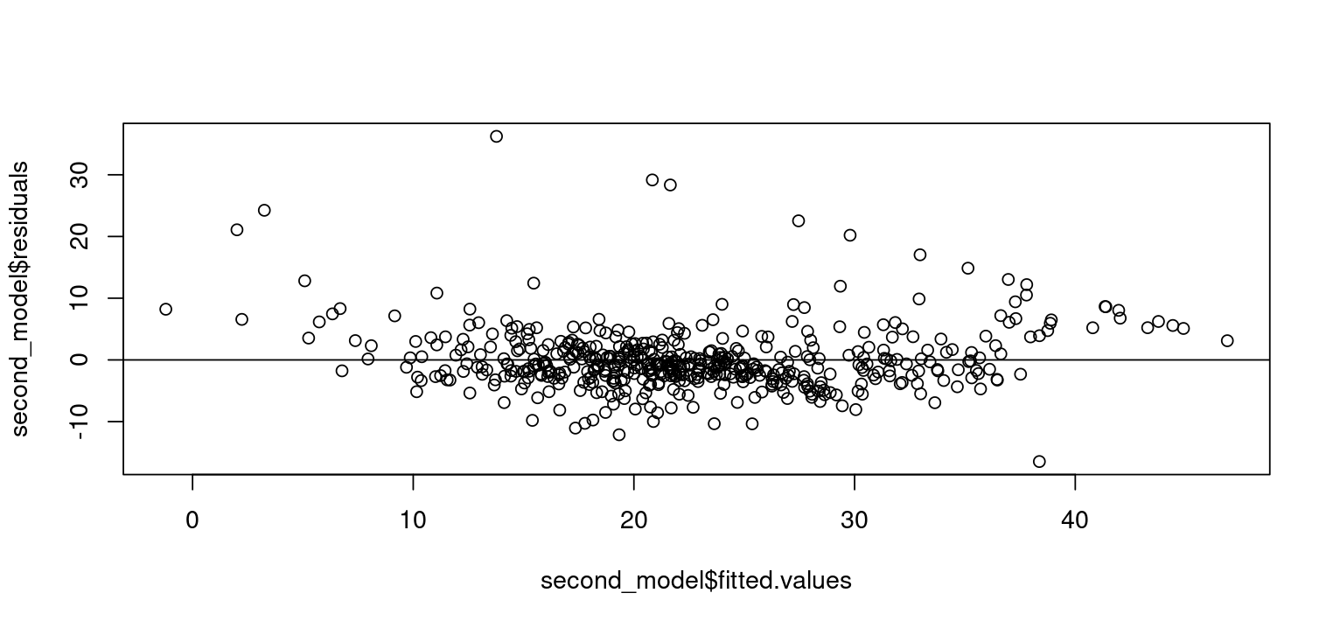
The Residuals vs. Fitted plot shows that residuals are not randomly scattered.There is a funnel shape (i.e., residuals spread out more for higher fitted values).This suggests heteroscedasticity (non-constant variance).
Possible Remedies
- Log transformation is a powerful remedy for heteroscedasticity because it Stabilizes variance,
- Reduces the effect of extreme values, Improves the linearity of relationships and normalizes skewed data. By applying log transformation to a dataset, F-statistic is 89.01 (higher than
before), indicating model 2 can explain more variable in the dependent variable.

- Create Model 3 by adding lstat to Model 2. Use ANOVA to compare Model 2 (without lstat) and Model 3 (with lstat) to determine if lstat significantly improves model performance. (1 pt)
var_third_model = Boston[ , !names(Boston) %in% "total_area"]
third_model = lm(medv~., data = var_third_model)
anova(second_model, third_model)

lstat significantly improves the model_third_model because it reducesresidual sum of square (RSS) from 13490
to 11079, has a high F-statistic (107.06), and has an extremely low p-value (2.2e-16). This
confirms that model_third_model (with lstat) is statistically better than Model 2 (without lstat) and lstat
has a strong effect on medv.

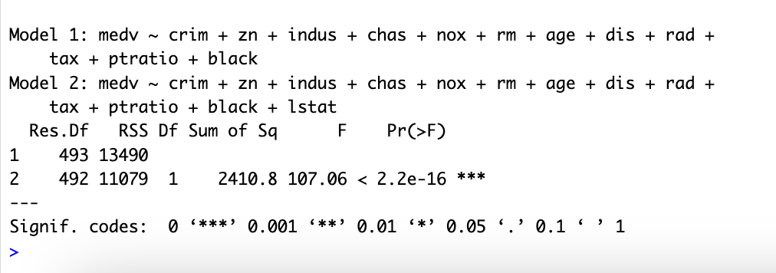

- Based on Model 3, using car::influenceIndexPlot() to investigate the presence of outliers or influential cases in the dataset. Explain the results and analyze the possibility that these observations might be influential. (1 pt)
car::influenceIndexPlot(third_model)

var_third_model[c(369,372,381,419), ]

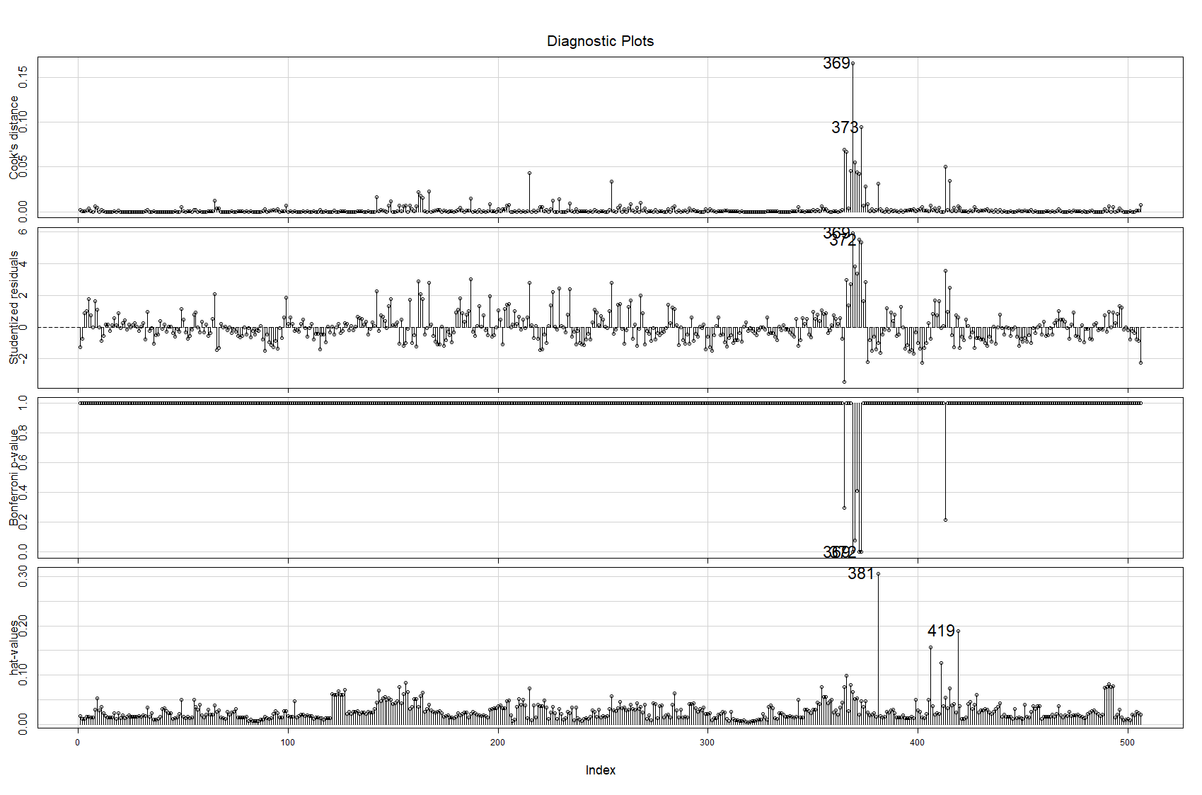
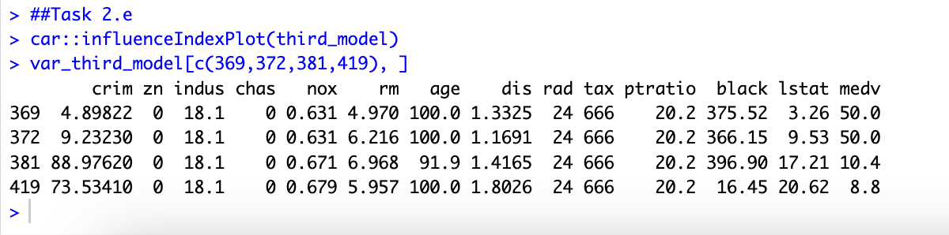
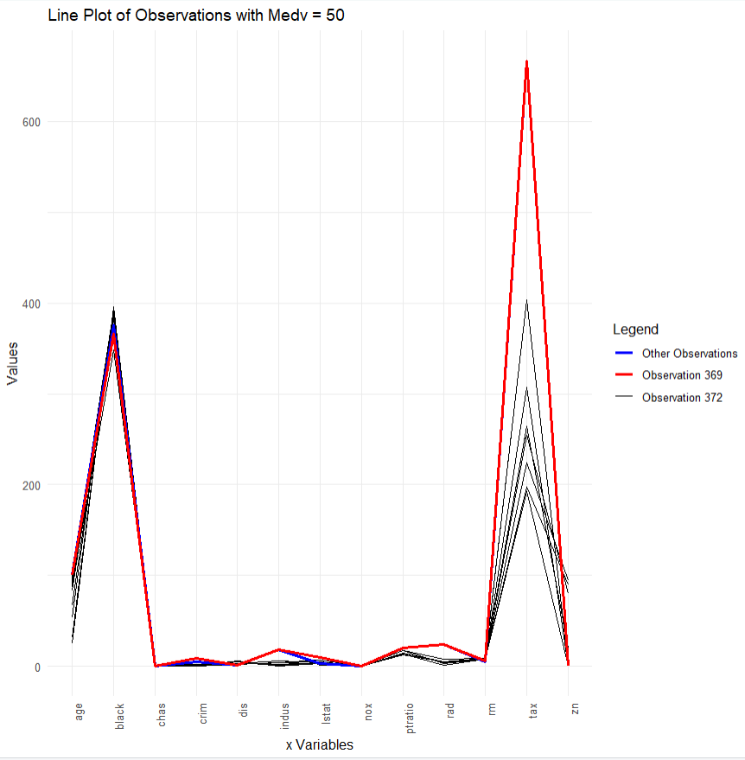

Based on studentized residual (>3) and Bonferroin p-value (<0.05), Observations 369 and 372 are identified as outliers. When plotting the X variables for all observations where medv = 50, we found that observations 369 and 372 exhibit higher house age, a higher proportion of non-retail business acres per town, and higher tax rates compared to other observations with the same medv value. Notably, all three of these variables have a negative relationship with medv, indicating that higher values generally correspond to lower housing prices.
Therefore, among the observations where medv = 50, observations 369 and 372 have less favorable housing attributes, which is why they are identified as outliers.

Based on hat-value Observations 381 and 419 have unusual x variables compared to others. Because they have extremely high crime rates (88.97, 73.53) and very low house prices (10.4, 8.8).

