Lab 05: Logistic Regression
Due date: Thursday, March 21, 2025 submitted as Word document to Canvas Lab05 link
This lab counts 9 % toward your total grade.
Objectives: In this lab, you will practice your skills in
- Explore logistic regression
- All effects plot
- Conditional effects plot

Format of answer: Submit your answers as a Word document with graphs and verbal descriptions, properly labeled in the task sequence, with answers in red text and only relevant content included

Accident_data.shp show the spatial distribution of traffic accidents in the city of Dallas. The accident is represented as 1 (Yes, a traffic accident occurred at the location) and 0 (No, no traffic accident occurred at location).
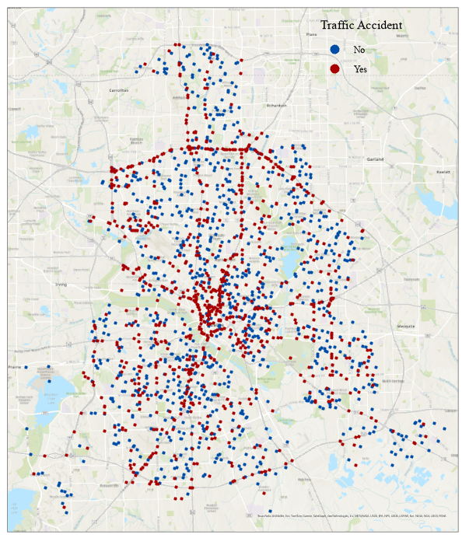

Task 1: Load data (2 pts)
We will use the Accident_data.shp to practice the skills in logistic regression

- Load the Accident_data.shp data using sf::st_read() (1 pt)
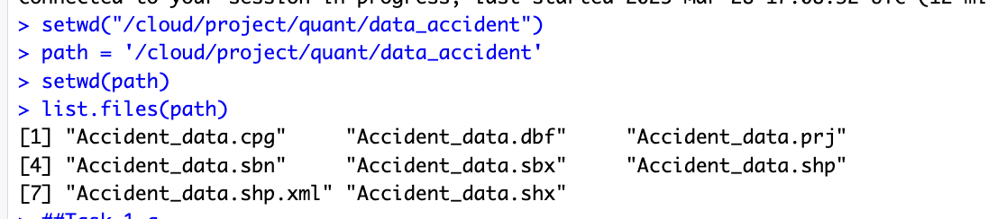
- Check the geometry column and explain what information are stored in geometry column using data$geometry. (0.5 pt)
- Each feature is a point with location coordinates
- Coordinate reference system (CRS) is Lambert Conformal Conic. It’s a metric coordinate system.
- Dimension is xy. Which means no Z (elevation) or M(measure) value.
- Bounding box provides spatial extent of shapefile.

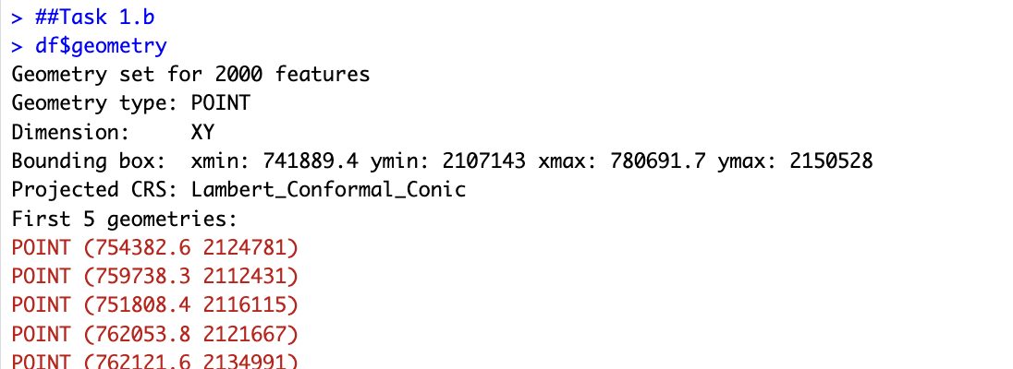
- Convert column ‘accident’ to factor. (0.5 pt)
df$accident = as.factor(df$accident)
Why as.factor is used?
• Converts a numeric or character column into a factor (categorical variable).
• Enables grouping in visualizations, e.g., different colors/shapes for each accident type in ggplot2.
• Tells models (like glm, lm, etc.) to treat accident as a categorical predictor, not a continuous one.

The dependent variable in the data set is whether there is a traffic accident at the location.

Dependent variable | Description
accident | a factor with levels: ‘0’; ‘1’

The independent variable describes the geographical environments around the location.

Independent variable | Description
Hour | Hour of the day, from 0 - 23
F_SYSTEM | Road type at different levels: 0 -7
intersect | Whether the accident occurred at a major intersection
NUM_LANES | The number of lanes
lane_width | Lane width
BelowFreez | Whether the temperature is below freezing, a factor with levels: ‘FALSE’; ‘TRUE’
Fog | Whether foggy conditions are present: ‘FALSE’; ‘TRUE’
Thunder | Whether thunderstorms are present: ‘FALSE’; ‘TRUE’
FrozenPrec | Whether there is frozen precipitation: ‘FALSE’; ‘TRUE’

Task 2: Build logistic regression model (3 pts)
- Build a logistic regression for the probability of accident with independent variable list above and provide the 95% confidence intervals around the logistic regression parameters.
logistic_acc =glm(accident~hour+F_SYSTEM+intersect+NUM_LANES+lane_width+BelowFreez+Fog+Thunder+FrozenPrec,
family = binomial(logit),data = df)
summary(logistic_acc)
confint(logistic_acc, level = 0.95)
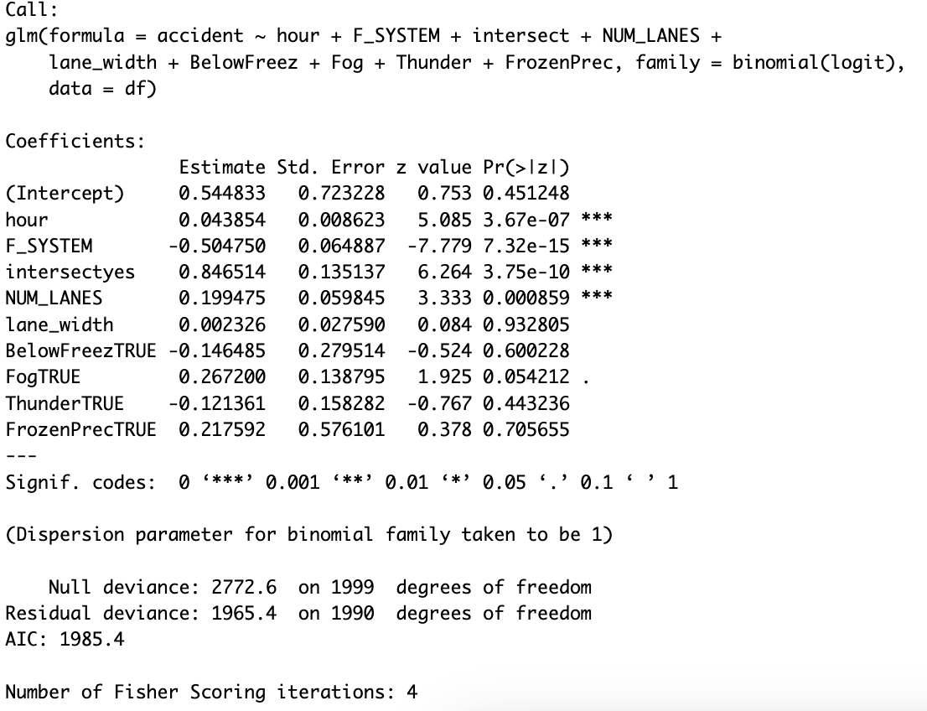
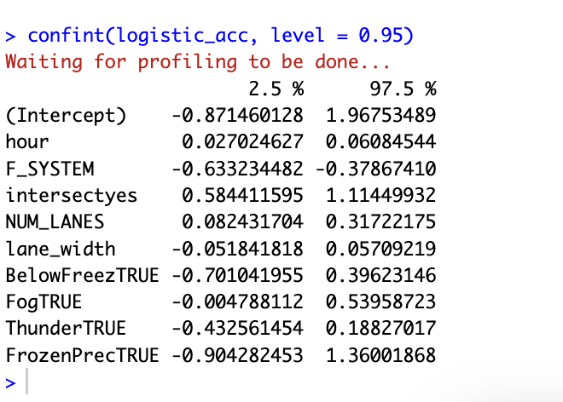

- Discuss the model output from logistic regression (significant of the variable) and analyze whether the results from confidence intervals align with the model results.
Yes, the results of confidence interval are aligned with the output of the logistic regression. For all variables where the p-value < 0.05, the 95% CI does not contain 0 (e.g., hour, F_SYSTEM, intersect, NUM_LANES). This suggested that hour of day, road system type, intersection presence, and number of lanes are significant.

- Using all effects plot to interpret the calibrated logistic regression model in terms of probabilities.

library(effects)
plot(allEffects(logistic_acc), type="response", ylim=c(0,1), ask=FALSE)

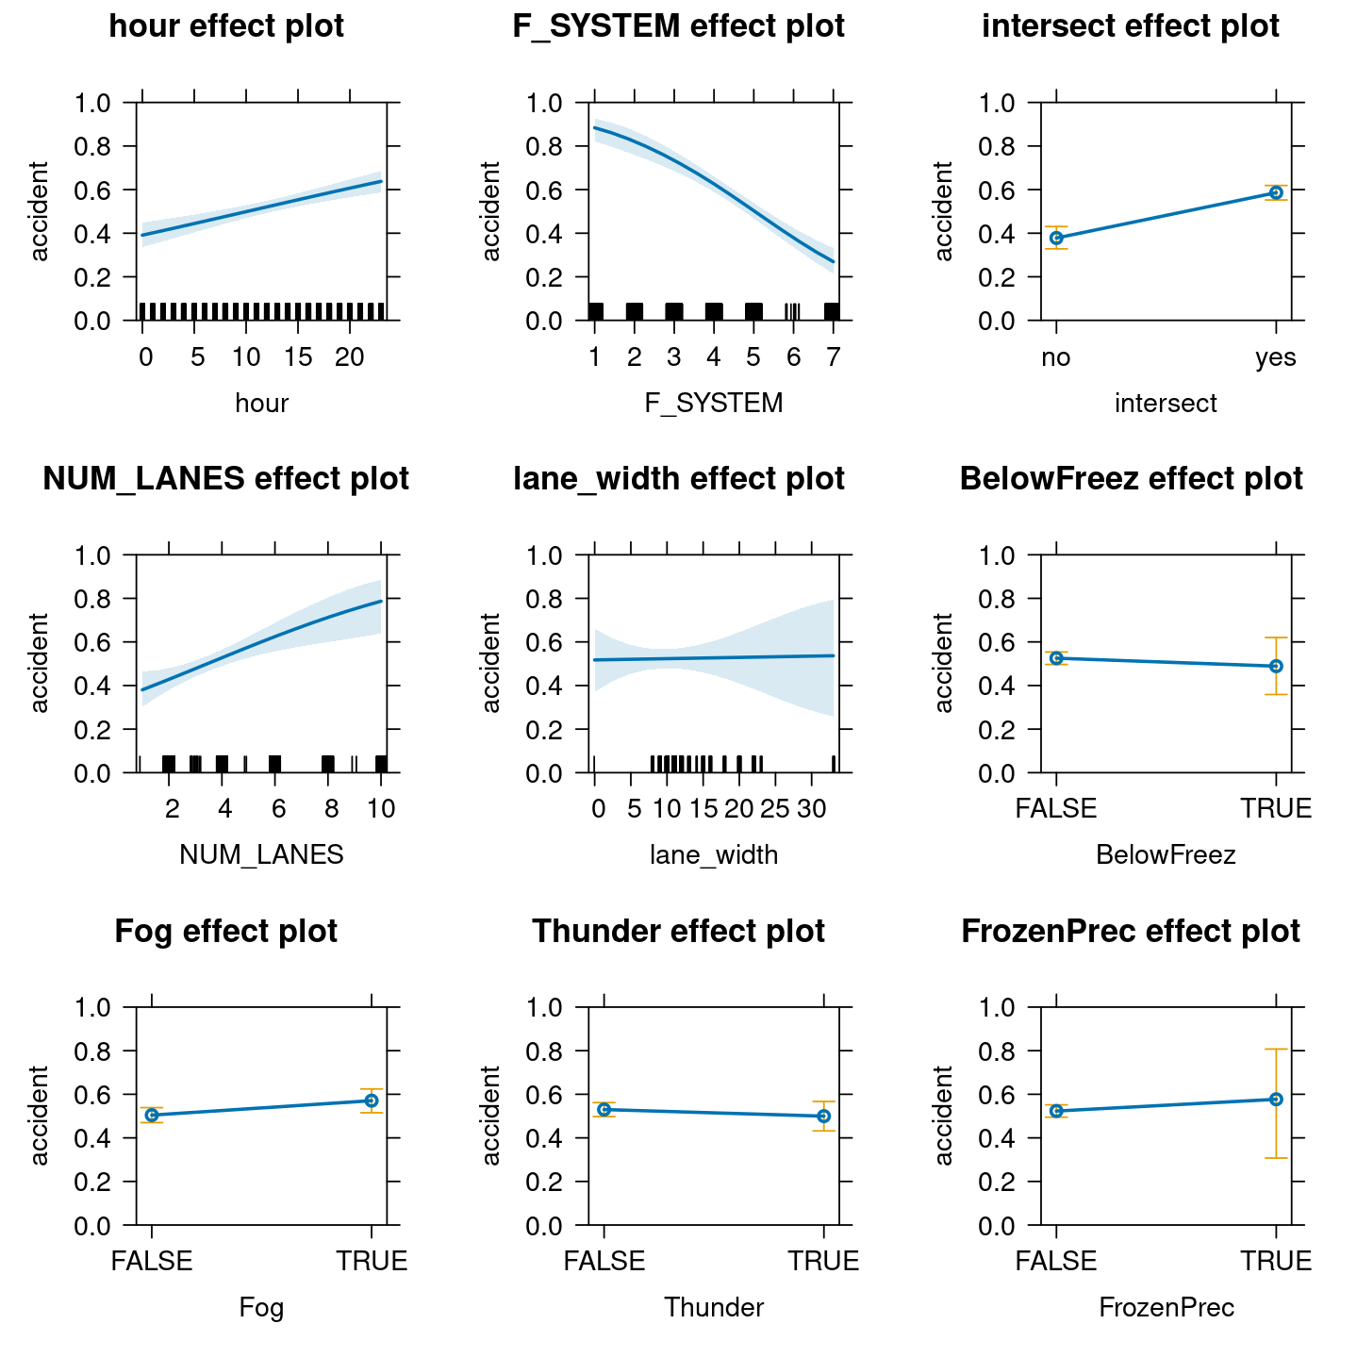

Each panel shows the marginal effect of a single predictor on the predicted probability of an accident keeping rest of the predictors constant. We can see that how the predicted probability of an accident changes when just one variable changes, keeping all others constant.

Task 3: Perform one likelihood ratio test (2 pts)
- Refine the model from Task 2 by dropping all variables that are not significant important for dependent variable. Test whether the removed variables had a significant influence on the dependent variable using ANOVA-based LRT or Manual LRT (logLik()). (2 pts)
logistic_acc02 = glm(accident~hour+F_SYSTEM+intersect+NUM_LANES+Fog,
family = binomial(logit),data = df)
summary(logistic_acc02)
anova(logistic_acc02,logistic_acc)

## Likelihood ratio test
lkh = logLik(logistic_acc02)
lh = logLik(logistic_acc)

LR = -2 * (lkh - lh)

pchisq(LR[1], df = 4, lower.tail = F)

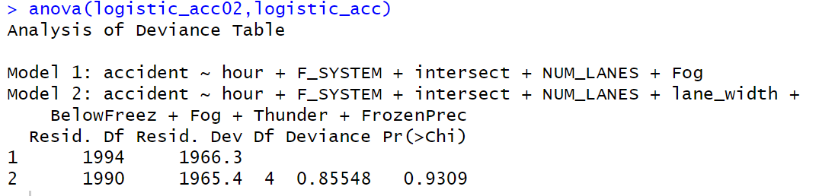
The 4 added variables do not significantly improve the model.

Bonus (+1 point): Try both approaches and compare results. Explain if they have the same result or not.

The p-value of the Chi-squared test from ANOVA-based LRT and Manual LRT (logLik()) are both equal to 0.9309.

Task 4: Conditional effects plots (2 pts)
- Generate conditional effects for the NUM_LANES variable based on the refined model in Task 2.a to estimate the probability of traffic accident. (1.5 pts)

Assume two scenarios with the following values for the additional independent variable in the logistic regression model:

Variable | Low probability | High probability
hour | 3 | 19
F_SYSTEM | 6 | 2
Intersect | ‘no’ | ‘yes’

par(mfrow = c(1, 1))
library(effects)
# Compute effect for low probability scenario
low_prb <- effect("NUM_LANES", logistic_acc02, given.values = c(hour = 3, F_SYSTEM = 6, intersectyes = 0))

# Compute effect for high probability scenario
high_prb <- effect("NUM_LANES", logistic_acc02, given.values = c(hour = 19, F_SYSTEM = 2, intersectyes = 1))

- Discuss the conditional effects plots for the two scenarios. (0.5 pt)
# Extract data
low_data <- as.data.frame(low_prb)
high_data <- as.data.frame(high_prb)

# Plot the low probability case first
plot(low_data$NUM_LANES, low_data$fit, type = "l", col = "blue", lwd = 2, ylim = c(0, 1),
ylab = expression(Pr(Y[i] == "Accident probability")), xlab = "Number of Lanes",
main = "Accident Probability vs. Number of Lanes")

# Add shaded confidence intervals for low probability
polygon(c(low_data$NUM_LANES, rev(low_data$NUM_LANES)),
c(low_data$lower, rev(low_data$upper)), col = rgb(0, 0, 1, 0.2), border = NA)

# Add high probability scenario
lines(high_data$NUM_LANES, high_data$fit, col = "red", lwd = 2)

# Add shaded confidence intervals for high probability
polygon(c(high_data$NUM_LANES, rev(high_data$NUM_LANES)),
c(high_data$lower, rev(high_data$upper)), col = rgb(1, 0, 0, 0.2), border = NA)

# Add legend
legend("bottomright", legend = c("Low Probability", "High Probability"), col = c("blue", "red"), lwd = 2)

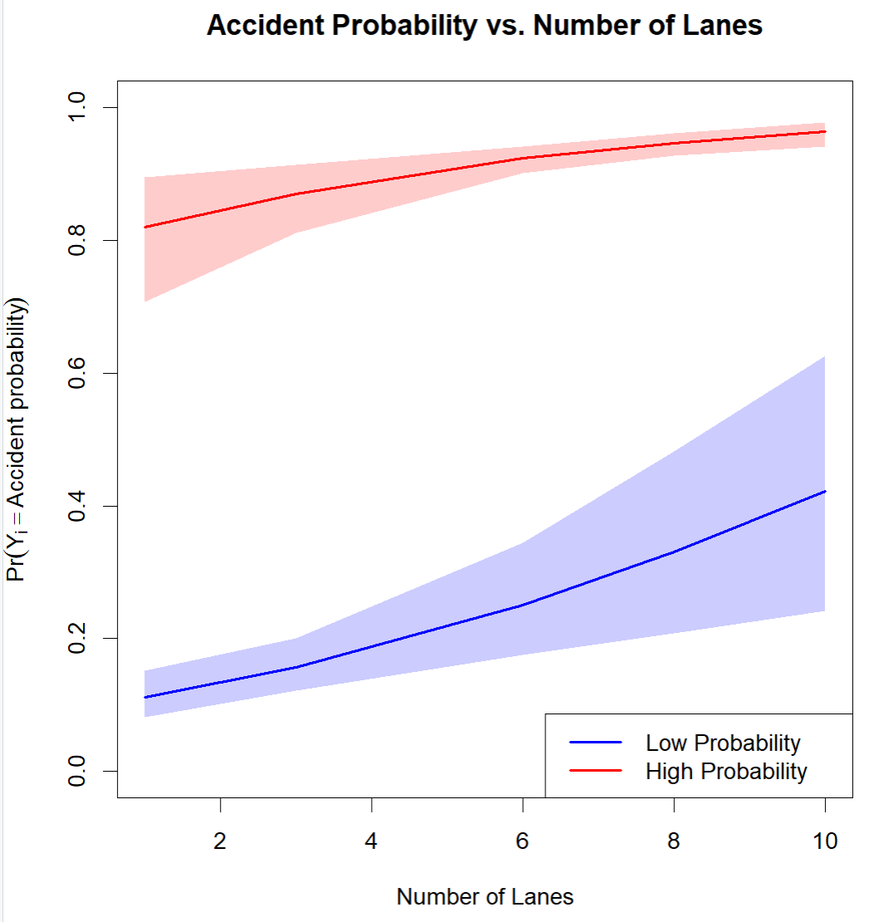

Aspect | Description | Interpretation
Both curves rise | Accident probability increases with number of lanes | Suggests more lanes - higher complexity, traffic volume, decision-making demands
Blue vs. Red curve | Red curve is always above blue | Accident probability depends on context - number of lanes is important, but its impact is conditioned by other variables
Shaded area | Confidence intervals | Wider at extremes (e.g., 10 lanes) in low probability scenario but narrow in high probability scenario- more uncertainty in low probability scenario due to more variability

