Lab 06: Logistic Regression
Due date: Thursday, April 3, 2025 submitted as Word document to Canvas Lab06 link
This lab counts 9 % toward your total grade.
Objectives: In this lab, you will practice your skills in
- Building a decision tree classifier
- Examine the structure and size of the tree
- Training data and testing data
- Prune the Tree

Format of answer: Submit your answers as a Word document with graphs and verbal descriptions, properly labeled in the task sequence, with answers in red text and only relevant content included. For each task, please provide R code, screenshot of the result and.

Accident_data.shp show the spatial distribution of traffic accidents in the city of Dallas. The accident is represented as 1 (Yes, a traffic accident occurred at the location) and 0 (No, no traffic accident occurred at location).
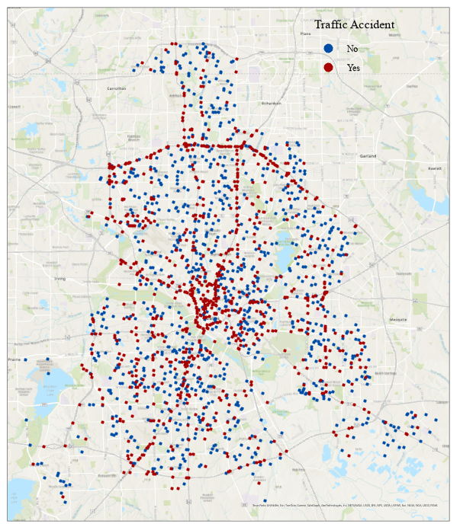

Task 1: Load data (2 pts)
We will use the Accident_data.shp to practice the skills in decision tree.
- Load the Accident_data.shp data using sf::st_read() (1 pt)
accident_data = sf::st_read('Accident_data.shp')
- Decision tree in R handle categorical independent variable more effectively when they are stored as factors. Convert the following columns ("accident", "intersect", "BelowFreez", "Fog", "Thunder","FrozenPrec") into factors. (1 pt)

Task 2: Train-Test Split and Initial Tree modeling (2 pts)
- Using random sampling to split the data into 70% training and 30% testing. Use table(training$accident) to examine how balanced the accident classes are in training data and testing data. Provide interpretation.
sample_idx <- sample(nrow(accident_data), size = 0.7 * nrow(accident_data))
train <- accident_data[sample_idx, ]
test <- accident_data[-sample_idx, ]
- Build a decision tree model using training data to model the relationship between accident occurrence and independent variables.
- Visualizing the tree helps you interpret the decision rules. Plot the tree and label its nodes. Follow the structure from root to leaf – what does it tell you about accident likelihood under certain conditions.

Task 3: Cross-Validation for Optimal Tree Size (2 pts)
- Large trees may overfit the training data. Cross-validation identifies a simpler model with better generalization. Perform 5-fold cross-validation to determine the optimal tree size for the full tree in Task 2.b. (2 pt)

Task 4: Prune Tree (1 pt)
- Prune the initial full tree to the optimal size identified in Task 3.a. (1 pt)

Task 5: Prediction (2 pts)
- Using the pruned tree from Task4.a to predict accident occurrence on the test data. Measure the model accuracy based on the confusion matrix. (2 pts)

