Practice 01: Introduction to R for Statistics
Objectives: In this practice, you will practice your skills in
- Import data into R
- Understand the basics of working with data frames.
- Learn basic R commands for data manipulation and exploration.
- Perform summary statistics
- Create basic statistical graphs.

Task 1: Setting Up Your Environment
- Open RStudio.
- Create a new R script (File > New File > R Script).
- Use function setwd() to setup working directory. Show your R code for this calculation. (0.5 pts)
- Click  to save your R document

Task 2: Importing Data
Import economic_indicators.csv and free_wifi_locations.xls file using function in R. show your R code for this calculation.
- Use function read.csv() to import economic_indicators.csv file and assign it to an object named economics.
- Use function read_excel() from library readxl to import free_wifi_locations.xls file and assign it to an object named wifi.
- Make a screenshot of GLOBAL ENVIRONMENT to display all 2 data-frames.
economics = read.csv('economic_indicators.csv')
wifi = readxl::read_excel('free_wifi_locations.xls')
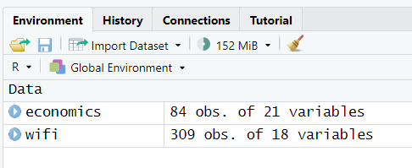

Task 3: Data-Frame Basics
Economic indicators data include values related to topics such employment, housing and real estate development, covering the period from Jan 2013 and Dec 2019. Show your R code for this calculation.
- Access unemp_rate and labor_force_part_rate columns.
economics$unemp_rate
economics$labor_force_part_rate
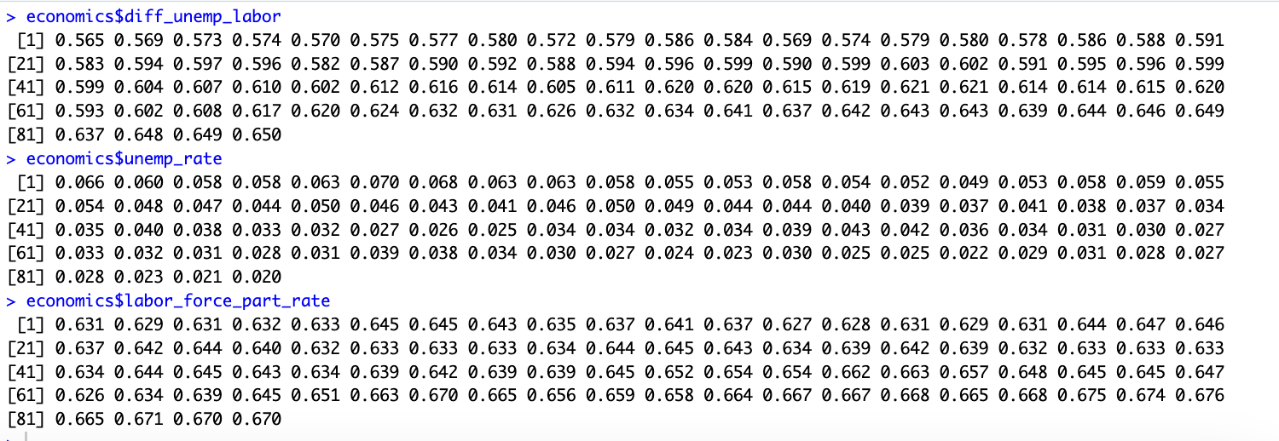
- Use labor_force_part_rate to minus unemp_rate to calculate the difference between these two values and add the new variable diff_unemp_labor to the economics data-frame. (0.5 pts)
economics$diff_unemp_labor = economics$labor_force_part_rate - economics$unemp_rate

- Apply the statement
economics[order(economics$diff_unemp_labor, decreasing = TRUE),c('Year','Month')]
What is this statement doing?
It sorts the rows of the economics data frame based on the values in the diff_unemp_labor column in descending order (largest to smallest).
After sorting, it returns a subset of the data frame that includes only the Year and Month columns, arranged according to the sorted order of diff_unemp_labor. Based on the result, December 2019 has the highest diff_unemp_labor value within the time period.
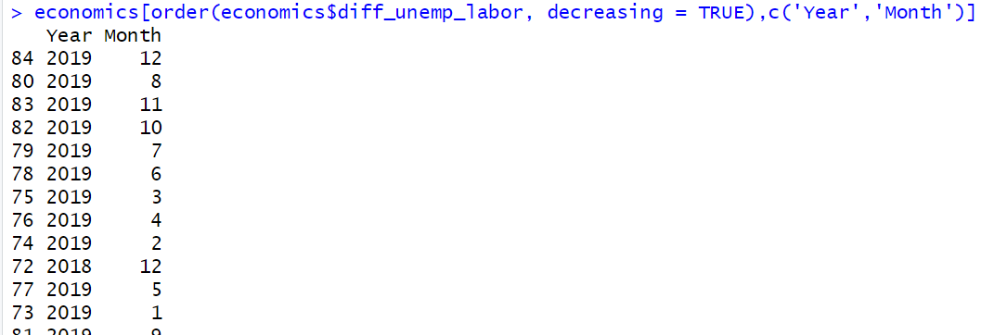
- Use summary() to see the summary information of the wifi data-frame.
summary(wifi)
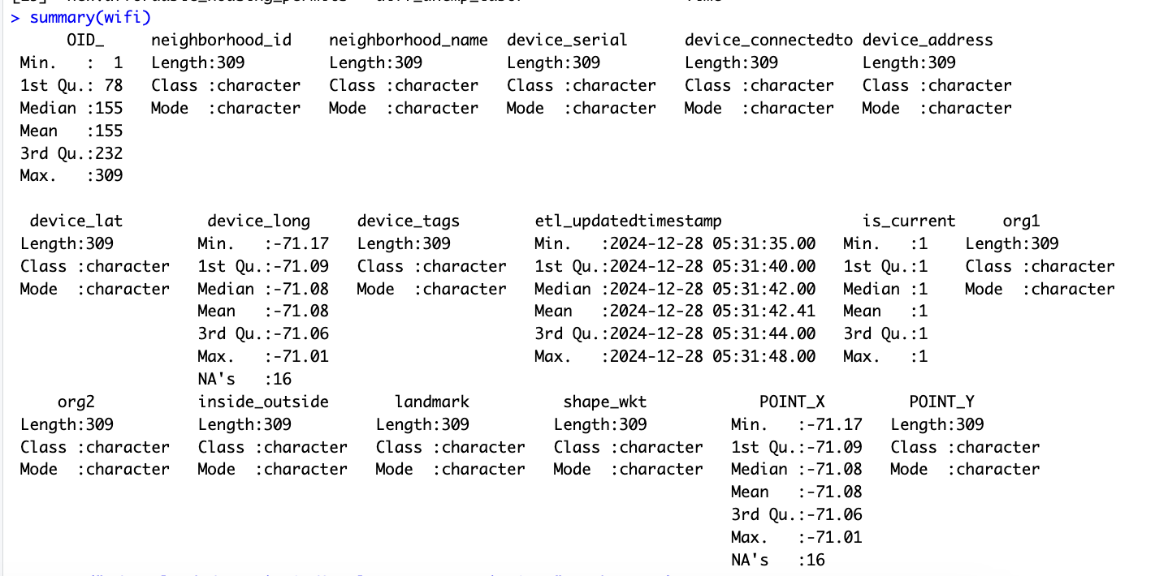
- Describe the summary information for OID_ and neightborhood_id, and explain why they are different?
summary(wifi$OID_)
summary(wifi$neighborhood_id)
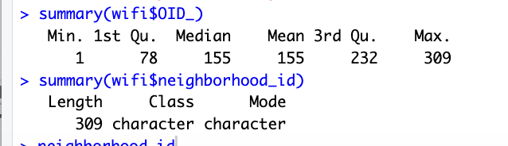
The OID_ variable is numerical, so its summary provides detailed statistics such as the minimum value, first quartile, median, mean, third quartile, and maximum value.

On the other hand, the neighborhood_id variable is categorical (character type). As a result, its summary only displays the length, class, and mode. The length indicates that there are 309 values for this variable, which corresponds to the number of rows in the data frame.

Task 4: Plot basics
Boxplot analysis
- Make a boxplot based on column logan_intl_flights in economics data-frame. (hint: using boxplot() and input variable is logan_intl_flights from economics data-frame)
- Apply below statement:
boxplot(logan_intl_flights ~ Month, data = economics)
what insights can we gather about seasonal trends in international flights from grouped boxplot?
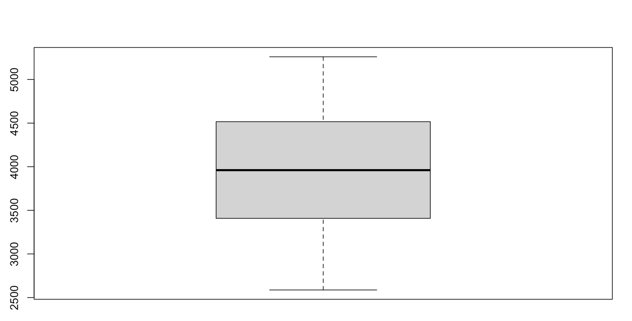
Regarding seasonal trend, we can Identify variability and outliers in data.
The thick horizontal line inside the box represents the median (3960) number of international flights. (The median is the central value of the data and divides it into two halves.)
The edges of the box represent the 1st Quartile (Q1, 25th percentile= 3408) and the 3rd Quartile (Q3, 75th percentile= 4516).Additionally, range contains the middle 50% of the data, indicating the most typical range for the number of flights.
Regression line analysis
- Apply below statements:
plot(logan_intl_flights~Time, data = economics, type = 'l')
abline(lm(logan_intl_flights~Time, data=economics))
how does the trend of logan_intl_flights change over Time based on the first plotted line?
cyclical pattern of international flights with seasonal fluctuations showing positive long term trend
What does the regression line added to the plot tell us about the relationship between logan_intl_flights and Time?
strong linear relationship, positive slope, international flights increasing with time

