Troubleshooting for Installing TexMix in R environment
- Error message related to Rtools
If you encounter an error message indicating the absence of Rtools, it means that Rtools needs to be installed on your system. To resolve this, download the Rtools installer from the following link: https://cran.r-project.org/bin/windows/Rtools/
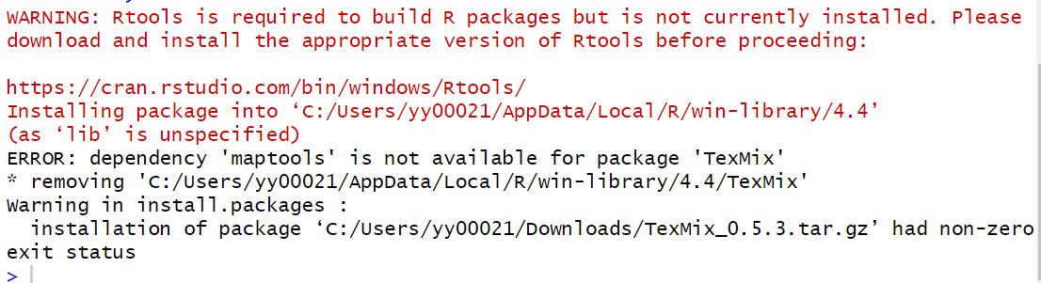
- Install Rtools
Download and Install Rtools on your computer.
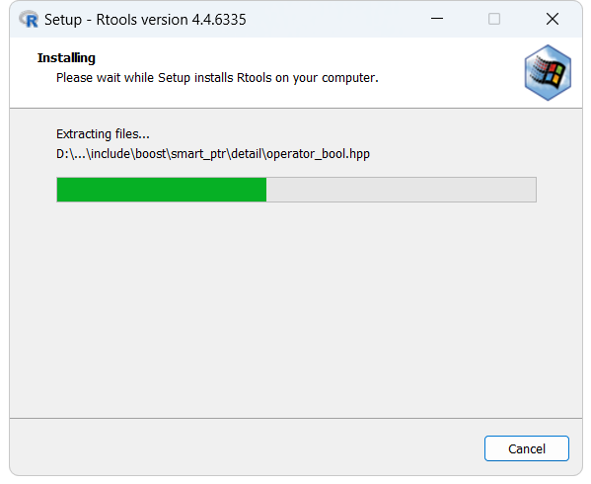
- Check if make is in your Path.
To check if make is in your system’s Path variable, open the Command Prompt (cmd) and run the following command:
make –version
If you receive a message indicating that 'make' is not recognized as an internal or external command, it means make is not included in your system’s Path variable. You will need to add Rtools to your system’s Path.
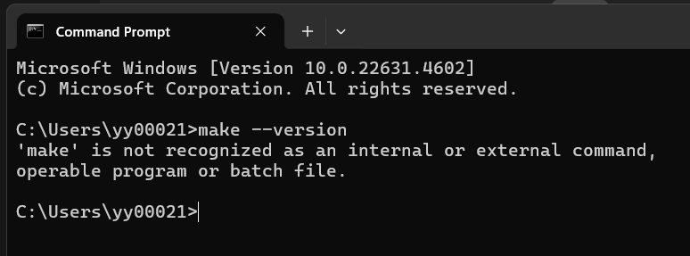
- Open Edit the system environment variables – Environment Variables, edit Path in your user variables. Click New to add ‘D\rtools\usr\bin’ to your Path variable.
Note: The path D:\Rtools\usr\bin depends on the location where you installed Rtools (e.g., it may be in your C: drive)
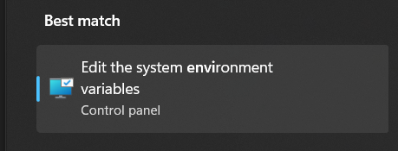
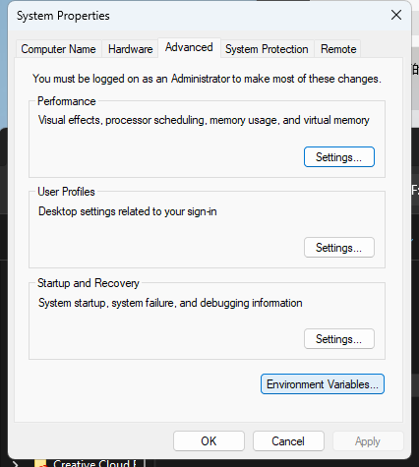
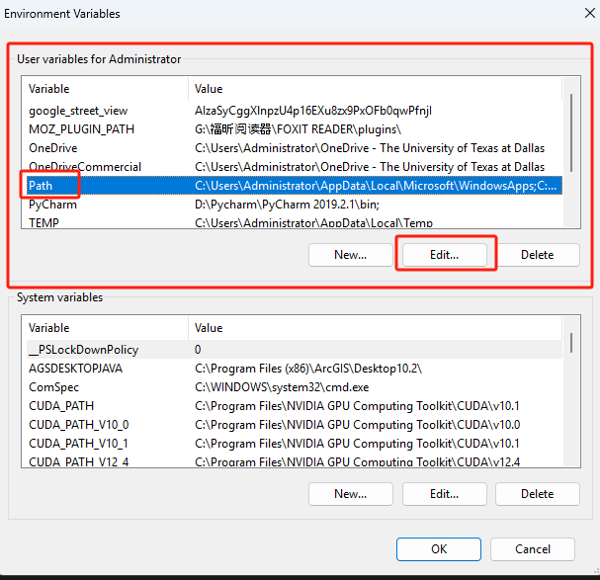
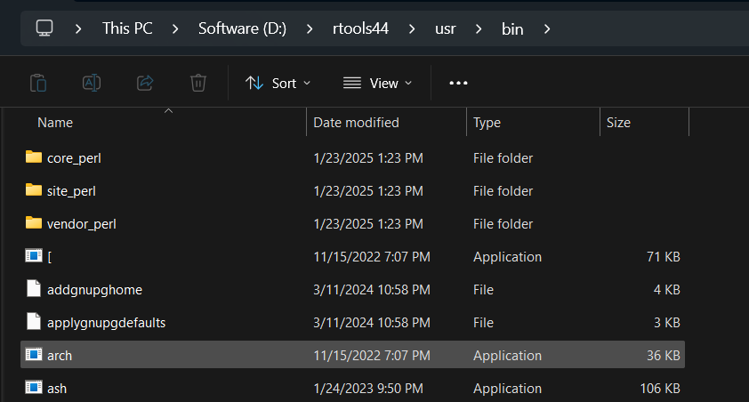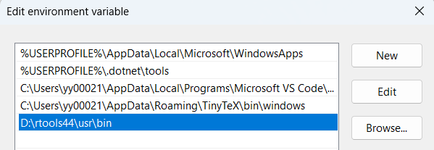
- After adding Rtools to your Path, run the following commands in the Command Prompt to confirm that make is now recognized by the system:
make --version
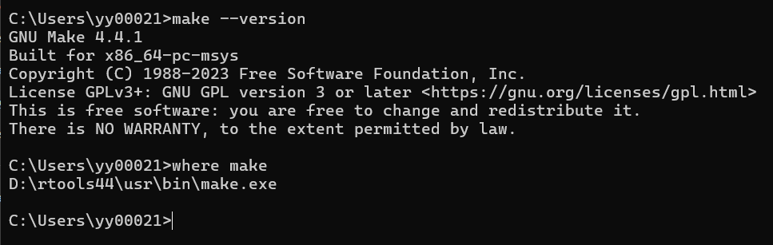
- Get maptools_1.1-8.tar.gz from this link: https://cran.r-project.org/src/contrib/Archive/maptools/ and install it in R.
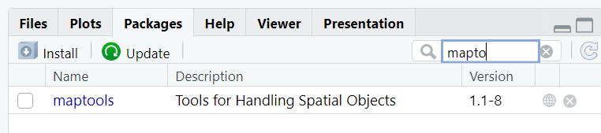
- Get TexMix_0.5.3.tar.gz from this link: https://cran.r-project.org/src/contrib/Archive/TexMix/ and install in R.
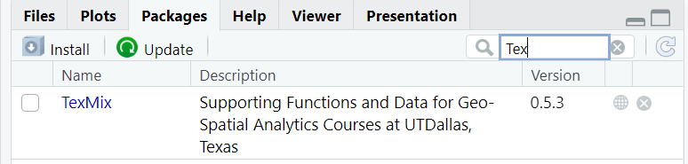
Thank you to my student, Annan Shrestha, for his contribution to this troubleshooting

