Lab 06: Shiny in R
In this lab, you will use the same data (cbsa_points.shp) from lecture. Please add a button to build upon on the web page we created in class.
This lab is worth a total of 65 points and contributes 6.5% toward the final grade
Submit this word document by midnight (11:29 PM) on October 20.

Requirements:
Your interactive map should have below functionality:

Limit choice: Create a radioButtons() to display the available options.
For a Code demonstration, refer to Section 2.2.5 ‘Limited choices’ in below link
https://mastering-shiny.org/basic-ui.html
- Complete server function
- When the user selects "All," the map will display all the points, regardless of which states the user has selected.
- When the user selects "Filter," the map will display the results based on the selected states.
Hint: add if else Statement in:
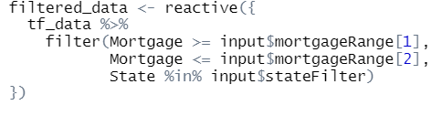

Submission:
  - Please submit the link to your interactive map.
Example:
https://gisynw.github.io/shinylive/

