Lab 01: Introduction to PostgreSQL, PostGIS, pgAdmin
Due date: Wednesday, January 30, 2025 submitted as Word document to Canvas Lab01 link
This lab counts 8 % toward your total grade.
Objectives: In this lab, you will practice your skills in
- Create a database in pdAdmin
- Query tool in pgAdmin
- Basic SQL
- SQL sheel (psql)
Format of answer: Submit your answers as a Word document or pdf with graphs under Output section, properly labeled in the task sequence.
Notice: All SQL commands are in blue color

Task 1: Create a database in pdAdmin (2 pts)
Before you create a database, you should have a server under Servers section in the left panel. Launch pdAdmin.
- Right-click Databases under your connected server.
- Select Create > Database.
- In the General section, enter the name of your database (name: test).
- Owner: Choose your PostgreSQL username (default owner: postgres).
- Expand Databases under your connected server. You should see your new database listed.
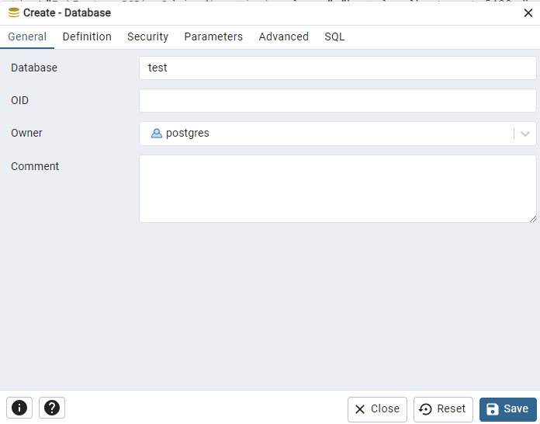

Task 1 Output: Take a screenshot of the test database under the Database section in pgAdmin.

Task 2: Add extension to database (2 pts)
Pre-requisite: Make sure PostGIS is installed.
- Right-click on the target database (e.g., test).
- Select Query Tool from the context menu.
- In the Query Tool, run the following SQL command:
CREATE EXTENSION postgis;
Explanation: This command enables the PostGIS extension in your database. PostGIS provides spatial types (e.g., geometry, geography) and functions for spatial operations.
- To check if the PostGIS extension is successfully installed, run this query:
SELECT * FROM pg_extension;
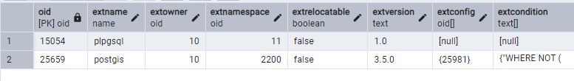
- Alternatively, you can verify it from pgAdmin:
- In the Object Browser, expand Databases > [Your Database] > Extensions.
- You should see postgis listed.

Task 2 Output: Take a screenshot of the postgis extension under the Extensions section in pgAdmin.

Task 3: SQL Shell (psql) (2 pts)
- Launch SQL Shell (psql) from your system.
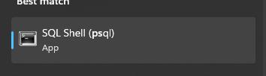
- You will be prompted to provide the following details:
  - Server: Press Enter to use the default (localhost).
  - Database: Press Enter to connect to the default (postgres).
  - Port: Press Enter to use the default (5432).
  - Username: Enter your PostgreSQL username (e.g., postgres).
  - Password: Enter your PostgreSQL password.
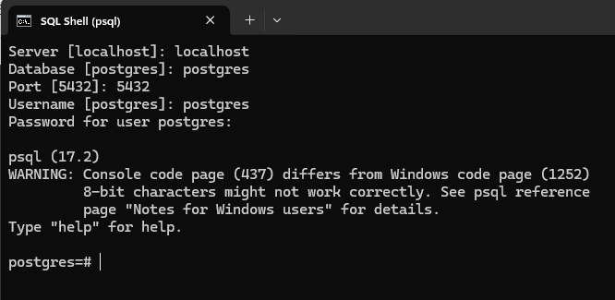
- run the following SQL command to create a new database:
CREATE DATABASE test_psql;
- To switch to your newly created database, use the \c command:
\c test_psql
You’ll see a message like this: You are now connected to database " test_psql " as user "postgres".
- To list all databases, use:
\l
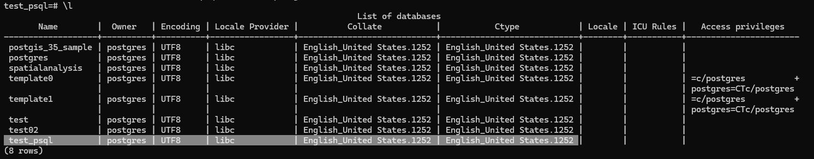
- Refresh the Database under your server then you will see the ‘test_psql’ under your Databases.
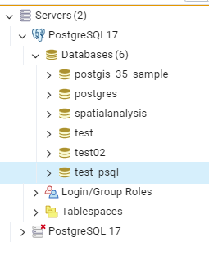

Task 3 Output: Take a screenshot of the test_psql database under the Databases section in pgAdmin.

Task 4: Delete a database (test_psql) in psql. (2 pts)
❗ Important:
When you delete (DROP) a database in PostgreSQL, all data, tables, and relationships inside the database are permanently removed. This action cannot be undone 😟.
- Disconnect from the database (test_psql) you want to delete. You cannot delete a database you are currently connected to. Make sure you are connected to a different database (like postgres) in psql and pgAdmin.
- To disconnect test_psql in psal, you need switch to another database (e.g., postgres), run:
\c postgres
- Disconnect test_psql in pgAdmin.
In pgAdmin, right click test_psql and select Disconnect from Database.
- Use the DROP DATABASE command to delete the database (test_psql) in psql
DROP DATABASE test_psql;

Task 4 Output: Take a screenshot of all databases under the Databases section in pgAdmin. The test_psql database should have a red cross on it, indicating that this database has been deleted.

