Lab 03. Spatial Data
Due date: Thursday, Feb 13 submitted as Word document to Canvas Lab03 link. This lab counts 9 % toward your total grade.
Objectives:
1. Understand and apply logical operators to filter datasets.
2. Utilize Data Query Language (DQL) to retrieve and summarize data.
3. Perform Data Manipulation Language (DML) operations to update and modify records.
4. Use Data Definition Language (DDL) to alter table structures.
5. Implement subqueries to perform complex queries.

Format of answer: Submit your answers as a Word document or pdf with graphs (screenshot of your result table) and answer in SQL.
Notice: All SQL commands are in blue color

In-Class Exercise (3pts)
Recap:
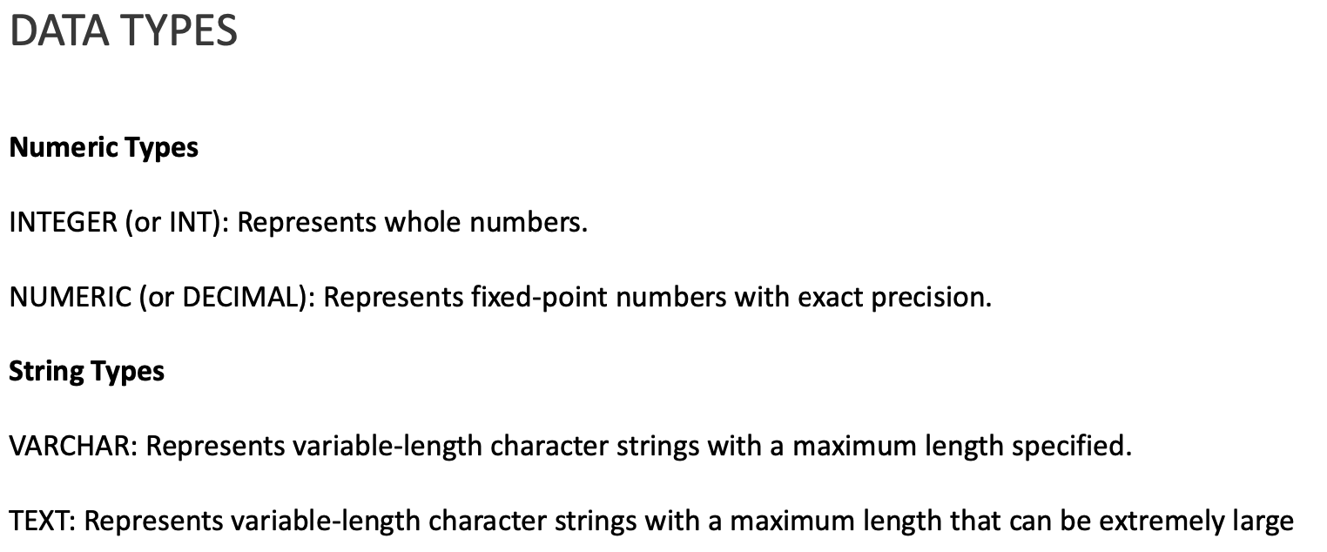
SELECT
stusab,statea,
100.0 * (Sum(associate) + Sum(master)) /Sum(total_pop) AS asso_mastr_pct
FROM ch04.us_attribute
GROUP BY statea,stusab
ORDER BY asso_mastr_pct DESC;
Or
SELECT
stusab,statea,
100 * (Sum(associate) + Sum(master))::NUMERIC /Sum(total_pop) AS asso_mastr_pct
FROM ch04.us_attribute
GROUP BY statea,stusab
ORDER BY asso_mastr_pct DESC;

Import nyc_census_blocks from psql
Psql is the command-line interface (CLI) for PostgreSQL, allowing users to interact with a PostgreSQL database directly from the terminal.
Cmd is the CLI for windows.

1. search cmd and run as administrator, change and paste the following command to check the coordinate system of the data
ogrinfo -al -so "C:\path\to\your\shapefile.shp"

Tips:
- Ogrinfo is a command-line tool providing detailed metadata and structure information about geospatial datasets, such as Shapefiles, GeoJSON, KML, PostGIS, etc.
Task 1. What is the Projected CRS for this data?

Projected CRS: 26918(NAD83/UTM Zone 18N)
2. In cmd, change and run the following command lines to import .shp file (the password is needed after hitting enter)
First, navigate to PostgreSQL’s bin directory:
cd C:\Program Files\PostgreSQL\17\bin

Second, run the shp2pgsql command from there:
shp2pgsql -I -s <SRID> "C:\path\to\your\shapefile.shp" my_schema.my_table | psql -U your_user -d your_database

Tips:
- -I → Creates a spatial index for faster spatial queries.
- -s <SRID> → Sets the SRID (e.g., Spatial Reference System - EPSG:4326 for WGS 84).
- "C:\path\to\your\shapefile.shp" → Full path to your shapefile.
- My_schema.my_table → The PostgreSQL schema and table name.
- | psql -U your_user -d your_database → Pipes the SQL output directly into PostgreSQL.
- shp2pgsql is a command-line tool that converts ESRI Shapefiles (.shp) into SQL statements.

Task 2. please paste your command line and make a screenshot to display the nyc_census_blocks table in pgAdmin.
shp2pgsql -I -s 26918 "C:\Users\wlicc\Downloads\2000\nyc_census_blocks.shp" ch04.nyc_census_blocks | psql -U postgres -d test

You can now type the following line to connect to PostgreSQL
psql -U postgres -d your_database

Tips:
- \l → List databases
- \c db_name → Connect to a database
- \dt → List tables
- \d table_name → Describe a table
- \du → List users
- SELECT * FROM table_name; → Retrieve data
Using the nyc_census_blocks table, answer the following questions.
Here is some helpful information to get started.
blkid | A 15-digit code that uniquely identifies every census block. (“360050001009000”)
popn_total | Total number of people in the census block
popn_white | Number of people self-identifying as “white” in the block
popn_black | Number of people self-identifying as “black” in the block
popn_nativ | Number of people self-identifying as “native american” in the block
popn_asian | Number of people self-identifying as “asias” in the block
popn_other | Number of people self-identifying with other categories in the block
hous_total | Number of housing units in the block
hous_own | Number of owner-occupied housing units in the block
hous_rent | Number of renter-occupied housing units in the block
boroname | Name of the New York borough. Manhattan, The Bronx, Brooklyn, Staten Island, Queens
geom | Polygon boundary of the block

Task 3. Logical Operators
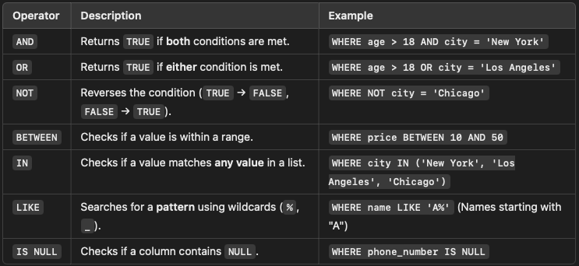
Question: Retrieve all census blocks where the total population exceeds 1000 and the number of owner-occupied housing units is greater than renter-occupied ones.
Psql:
SET search_path TO ch04;

SELECT blkid, popn_total, hous_own, hous_rent
FROM ch04.nyc_census_blocks_2000
WHERE popn_total > 1000 AND hous_own > hous_rent;

Query tool:
SELECT blkid, popn_total, hous_own, hous_rent
FROM ch04.nyc_census_blocks_2000
WHERE popn_total > 1000 AND hous_own > hous_rent;

Task 4. Data Query Language (DQL)
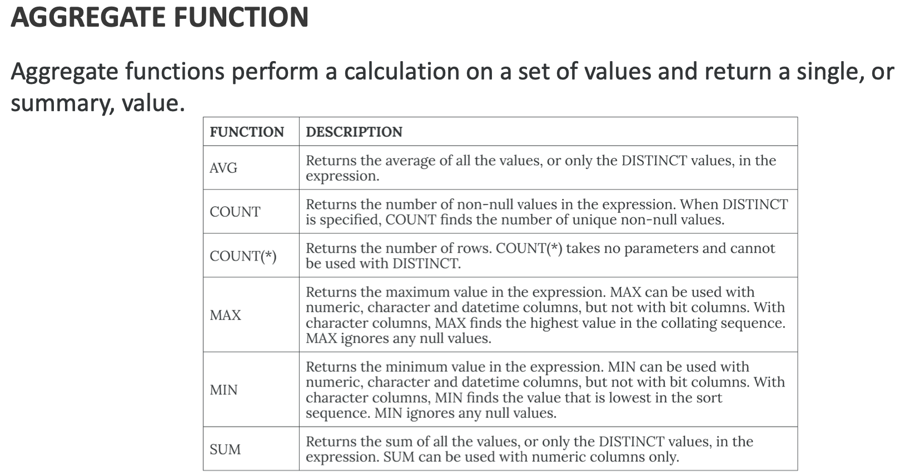
Question: List the total population and total housing units for each borough. Aggregate popn_total and house_total to each borough
SELECT boroname, SUM(popn_total) AS total_population, SUM(hous_total) AS total_housing_units
FROM ch04.nyc_census_blocks
GROUP BY boroname;

Task 5. Data Manipulation Language (DML)
Question: Increase the number of renter-occupied housing units by 10% in all blocks where the borough is 'Manhattan'.
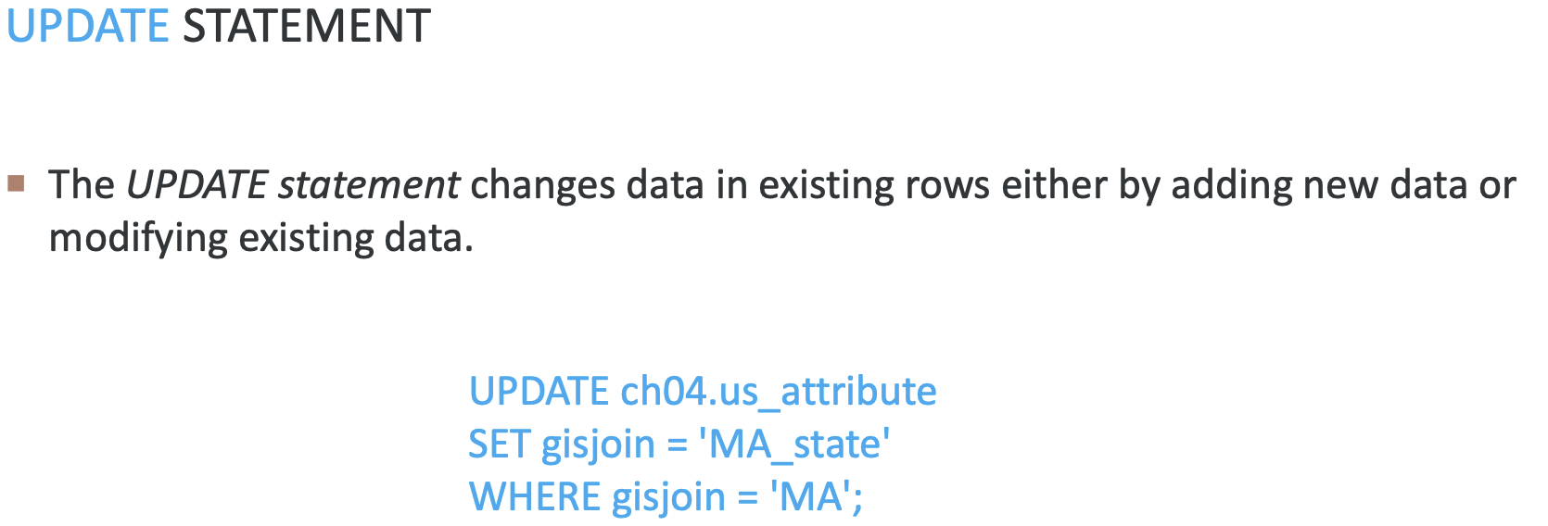
UPDATE ch04.nyc_census_blocks
SET hous_rent = hous_rent * 1.10
WHERE boroname = 'Manhattan';

Task 6. Data Definition Language (DDL)
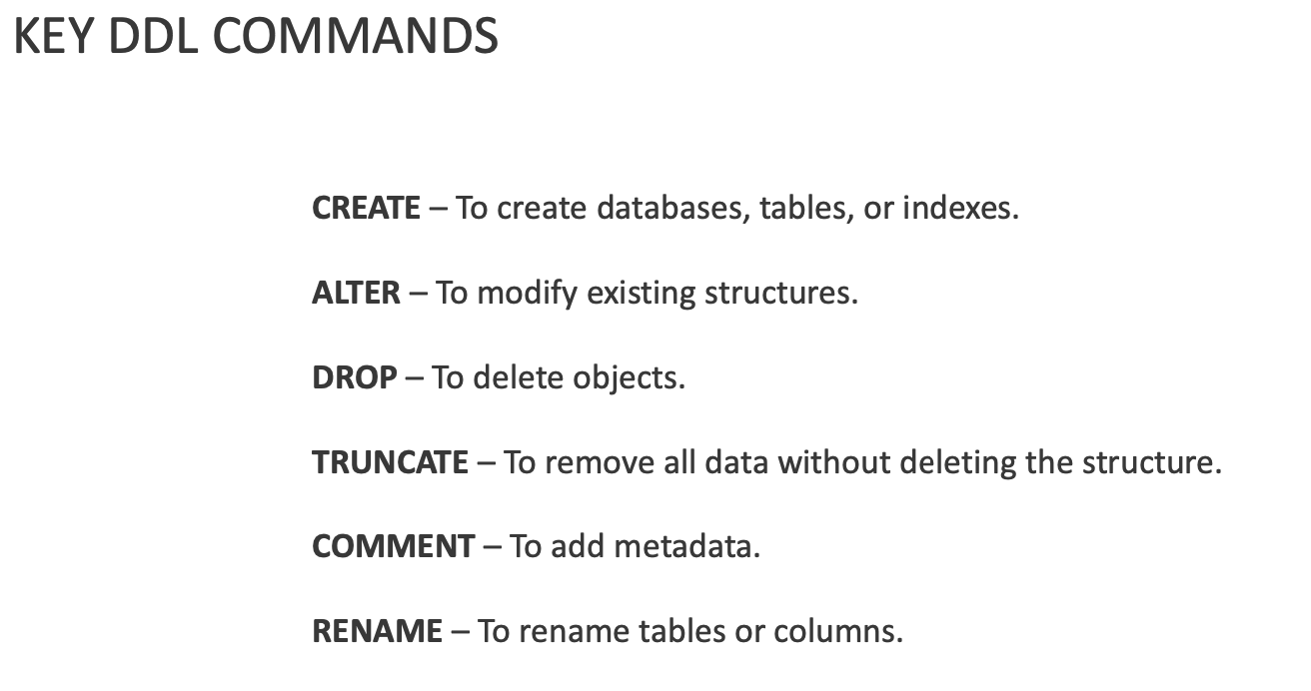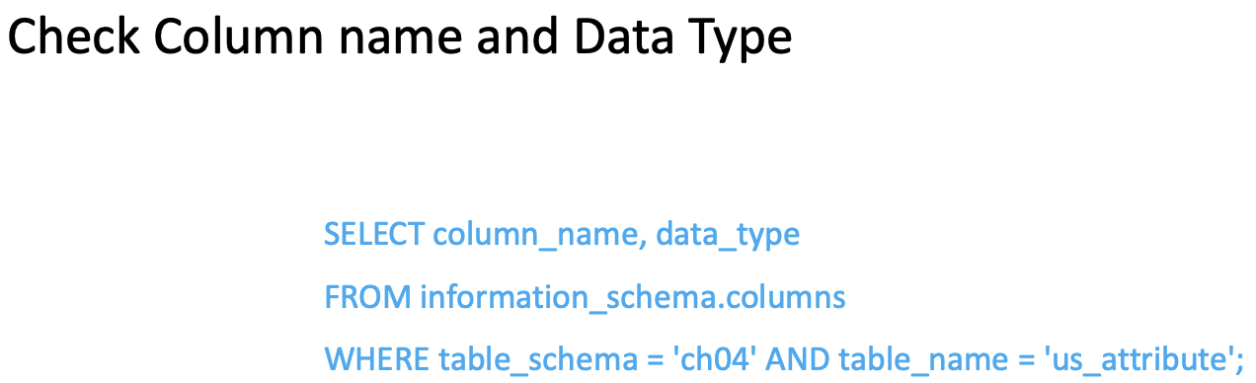
Question: Add a new column to the table to store the percentage of white population in each block. The output should display the attribute table with new columns.
ALTER TABLE ch04.nyc_census_blocks
ADD COLUMN perc_white NUMERIC;
SELECT column_name, data_type
FROM information_schema.columns
WHERE table_schema = 'ch04' AND table_name = 'nyc_census_blocks';

Own Your Own (6pts)
Task 1. Data Manipulation Language (DML)
Question: Populate the new column 'perc_white' with the percentage of the white population relative to the total population.
UPDATE lab03.nyc_census_blocks_2000
SET perc_white = (popn_white::FLOAT / popn_total) * 100
WHERE popn_total > 0;

SELECT perc_white from lab03.nyc_census_blocks_2000;
Task 2. Advanced Logical Operators
Question: Retrieve blocks where the total population is less than 500 or the percentage of the white population exceeds 70%.
SELECT blkid, popn_total, perc_white
FROM lab03.nyc_census_blocks_2000
WHERE popn_total < 500 OR perc_white > 70;

Task 3. Combining DQL and Spatial Queries
Question: Find all census blocks in 'Brooklyn' with a total population density greater than 10,000 people per square kilometer.
Hint: Using ST_Area(geom) to calculate the Area of each census tract
SELECT blkid, popn_total, ST_Area(geom) AS area_sqm,
(popn_total / (ST_Area(geom) / 1000000)) AS pop_density_per_sqm
FROM lab03.nyc_census_blocks_2000
WHERE boroname = 'Brooklyn'
AND (popn_total / (ST_Area(geom) / 1000000)) > 10000;

Task 4. Creating a New Table (DDL)
Question: Create a new table ‘borough_summary’ to store summarized population data by borough.
Column name | Data Type
boroname | VARCHAR(50)
population | INTEGER
housing | INTEGER

CREATE TABLE lab03.borough_summary (
boroname VARCHAR(50),
total_population INTEGER,
total_housing_units INTEGER
);
Task 5. Inserting Data (DML)
Question: Insert data into the new ' borough_summary ' table.
INSERT INTO lab03.borough_summary (boroname, total_population, total_housing_units)
SELECT boroname, SUM(popn_total), SUM(hous_total)
FROM lab03.nyc_census_blocks_2000
GROUP BY boroname;

Task 6. Deleting Records (DML)
Question: Delete records from the 'borough_population_summary' table where the total population is less than 500,000.
DELETE FROM lab03.borough_summary
WHERE total_population < 500000;

Bonus (0.5pts): Using Subqueries
Question: Retrieve blocks where the total population is above the average population of all blocks.
Hint: To solve this, think about how to calculate the average population first using an aggregate function. Then, use a subquery to embed this average into the main query's WHERE clause to compare each block's population against it.
Hint: subquery syntax:
SELECT column_name
FROM table_name
WHERE column_name expression operator
(SELECT column_name FROM table_name WHERE ...);

SELECT blkid, popn_total
FROM lab03.nyc_census_blocks_2000
WHERE popn_total > (
SELECT AVG(popn_total)
FROM lab03.nyc_census_blocks_2000
);

