Processing GPS Data with Temporal Aggregation and Movement Path Construction
By completing this lab, you will:
- Understand date/time manipulation in SQL.
- Learn to group GPS points into fixed time intervals.
- Use PostGIS functions to generate movement paths.
- Analyze the distance traveled and movement duration.
Total points: 9pts
Please submit the lab in word or pdf format, with commands and screenshots.

Data Introduction
aussie_track_points
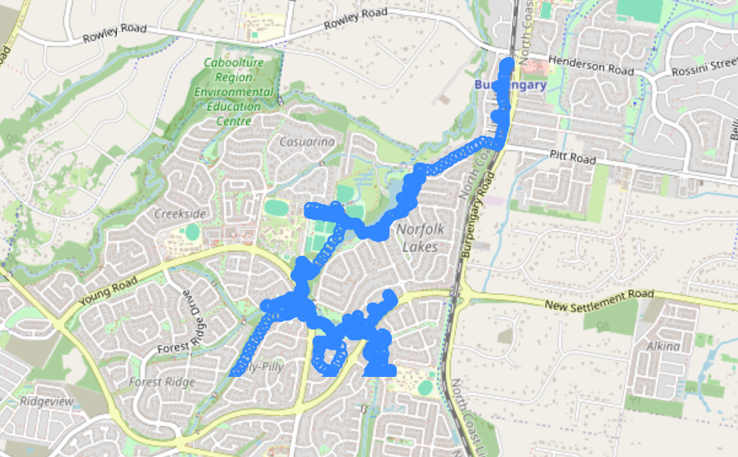
Figure 1 Track Points visualized using PostGIS
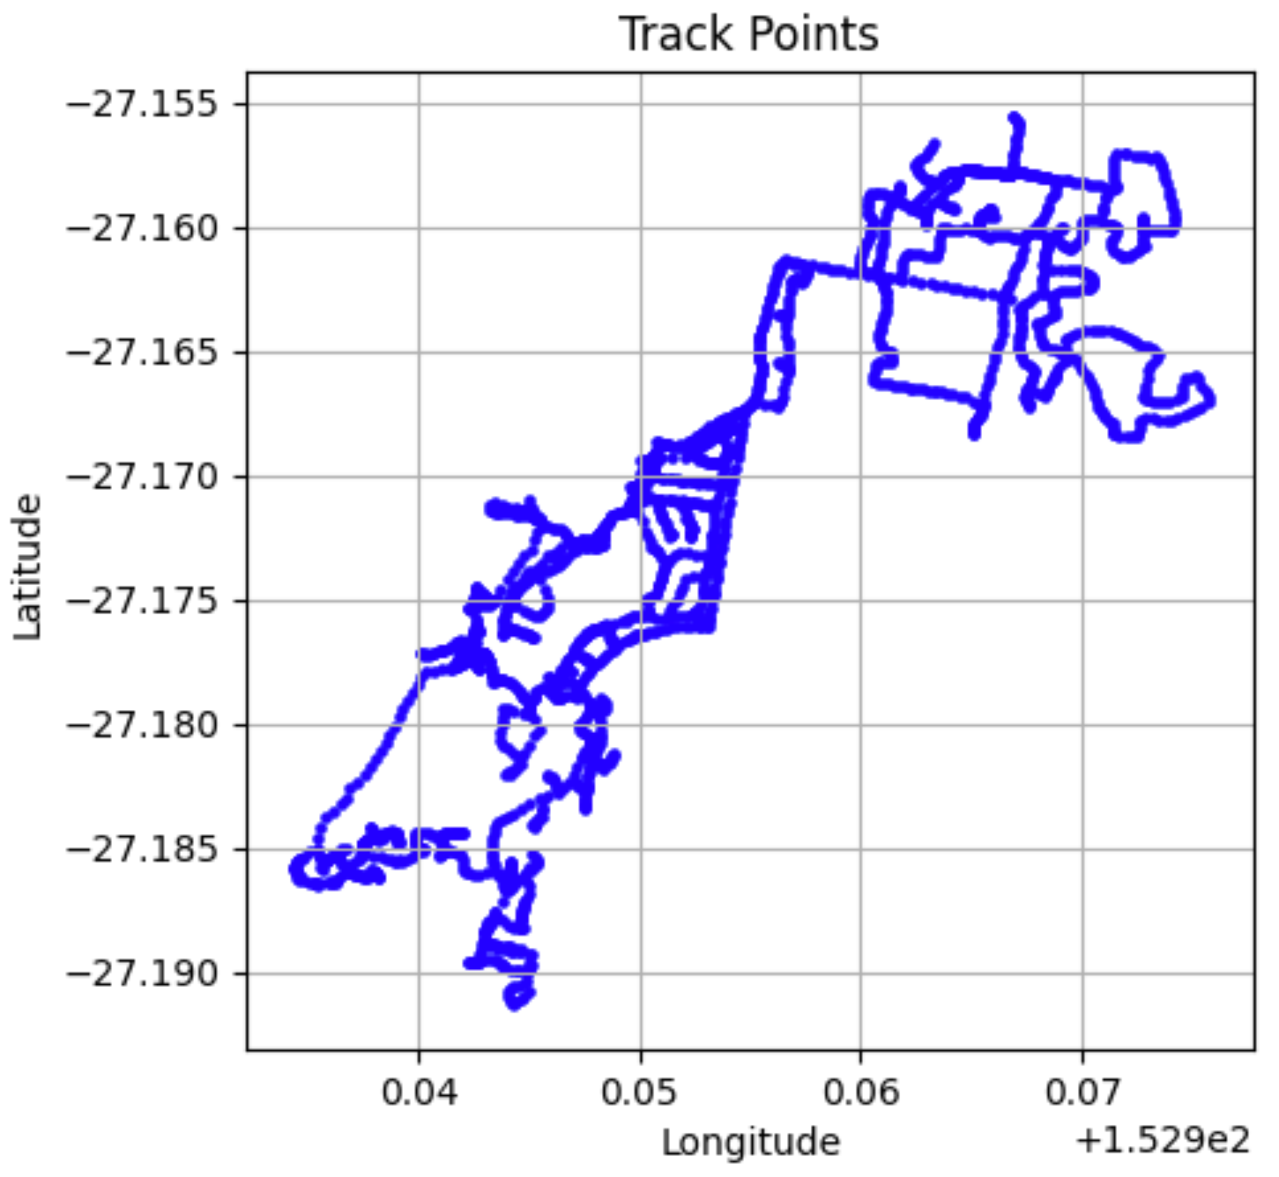
Figure 2 Track Points visualized in python
Assue_track
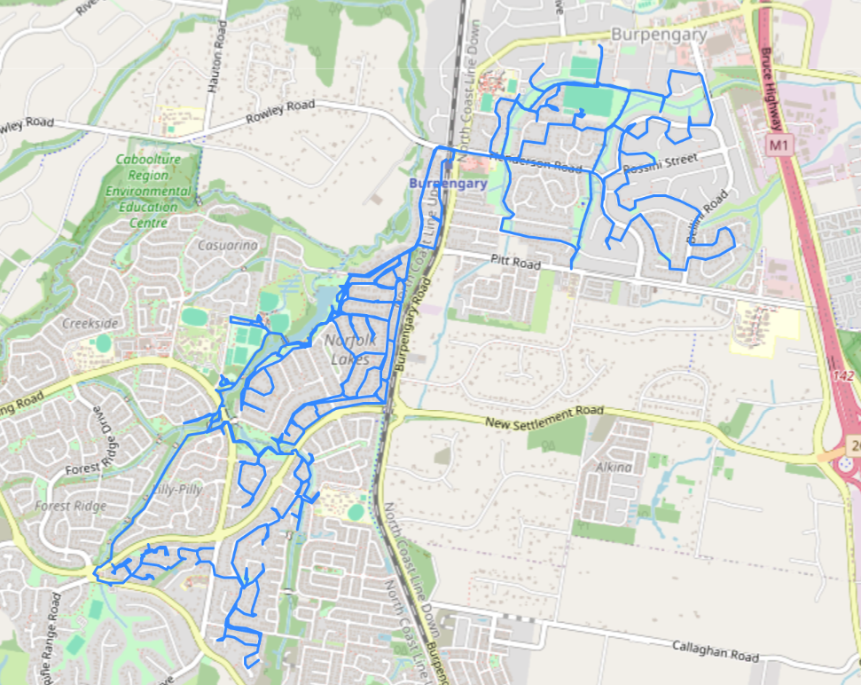
Figure 3 Aussie Track

Linear path from point observations
- Examples of applications: GPS tracking (e.g., vehicle movement, animal migration).
- Route reconstruction from timestamped observations.
- Mapping historical travel routes.

Workflow
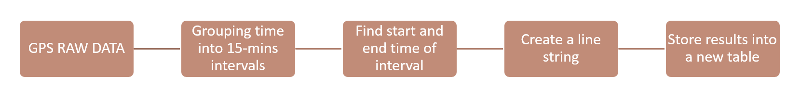

Step 1: Understanding Time Manipulation in SQL
  - Using DATE_TRUNC to Round Timestamps (DATE_TRUNC() function is used to round timestamps to a specific unit);
- The ‘-4’ at the end of the timestamp represents the time zone offset from Coordinated Universal Time (UTC), which mean UTC -4 hours
SELECT DATE_TRUNC('minute', TIMESTAMP '2009-07-18 04:30:20-04');
Practice 1: what is the result of '2019-07-13 15:30:56-04' when round it to second?
SELECT DATE_TRUNC(second, TIMESTAMP ''2019-07-13 15:30:56-04');

1.2 Extracting Date Parts (DATE_PART)
The DATE_PART function extracts a specific part of a timestamp, such as the minute or hour.
SELECT DATE_PART('minute', TIMESTAMP '2009-07-18 04:31:20-04');
Practice 2: change ‘minute’ to ‘hour’ or ‘year’, and what is the result?

Step 2: Normalizing Time Intervals
2.1 Convert Minutes to an Integer
To group GPS points into 15-minute intervals, we adjust timestamps.
- CAST(expression AS target_data_type), this function converts data from one type to another.
SELECT CAST(DATE_PART('minute', TIMESTAMP '2009-07-18 04:31:20-04') AS integer);
Practice 3: How about converting Minutes in column ‘time’ from ch11.aussie_track_points to integers and print it?
2.2 Find the Offset Using MOD
We determine how far each timestamp is from the nearest 15-minute mark.
- MOD(dividend, divisor); dividend is the number to be divided, divisor is the number by which the dividend is divided, and it returns the remainder after division. For example, 10 / 3 = 3 … 1
SELECT mod(CAST(DATE_PART('minute', TIMESTAMP '2009-07-18 04:30:20-04') AS integer), 15);
Practice 4: How about replacing TIMESTAMP '2009-07-18 04:30:20-04' with column ‘time’ from ch11.aussie_track_points?
2.3 Adjusting Time to Fit 15-Minute Bins
- To normalize timestamps to the nearest 15-min interval, use the following query to ensure timestamps align to 0, 15, 30, and 45 minutes.
- When working with INTERVAL, you can specify the unit you need.
SELECT
DATE_TRUNC('minute', time) -
CAST(
mod(
CAST(DATE_PART('minute', time) AS integer), 15
) || ' minutes' AS interval
) AS track_period
FROM ch11.aussie_track_points;

Step 3: Finding Start and End Times in Each Interval
3.1 Compute Minimum (t_start) and Maximum (t_end) Timestamps for each 15-min window
- MIN(time): returns earliest recorded timestamp in the interval.
- MAX(time): returns latest recorded timestamp in the interval.
SELECT
DATE_TRUNC('minute', time) -
CAST(
mod(CAST(DATE_PART('minute', time) AS integer), 15) || ' minutes' AS interval
) AS track_period,
MIN(time) AS t_start,
MAX(time) AS t_end
FROM ch11.aussie_track_points
GROUP BY track_period;

Step 4: Constructing Movement Paths

4.1 Creating a Line from Ordered GPS Points
We use ST_MakeLine() to generate a movement path (ensure geom is ordered by time).
SELECT
DATE_TRUNC('minute', time) -
CAST(
mod(CAST(DATE_PART('minute', time) AS integer), 15) || ' minutes' AS interval
) AS track_period,
MIN(time) AS t_start,
MAX(time) AS t_end,
ST_MakeLine(geom ORDER BY time) AS geom
FROM ch11.aussie_track_points
GROUP BY track_period;

Step 5: Storing Results in a New Table
SELECT
DATE_TRUNC('minute', time) -
CAST(
mod(CAST(DATE_PART('minute', time) AS integer), 15) || ' minutes' AS interval
) AS track_period,
MIN(time) AS t_start,
MAX(time) AS t_end,
ST_MakeLine(geom ORDER BY time) AS geom
INTO ch11.aussie_run
FROM ch11.aussie_track_points
GROUP BY track_period;

Exercise 01 (2pts):
You are working with GPS movement data stored in the ch11.aussie_run table. Your task is to write an SQL query that retrieves key movement statistics for each time period.
The query should:
- Create a table-like result with the following columns:
  - track_period (Timestamp) – The normalized time period for grouping movements.
  - t_start (Timestamp) – The earliest recorded timestamp in the interval.
  - t_end (Timestamp) – The latest recorded timestamp in the interval.
  - np (Integer) – The number of GPS points recorded in the interval.
  - dist_m (Integer) – The total distance traveled in meters.
  - dur (Interval) – The duration of movement in the interval.
SELECT
CAST(track_period AS timestamp),
CAST(t_start AS timestamp) AS t_start,
CAST(t_end AS timestamp) AS t_end,
ST_NPoints(geom) AS np,
CAST(ST_Length(geom::geography) AS integer) AS dist_m,
(t_end - t_start) AS dur
FROM ch11.aussie_run;
