Lab 07: Raster processing
By completing this lab, you will:
- Understand fundamental raster processing in PostGIS SQL.
- Learn to clip raster by using existing boundaries or ST_MakeEnvelope()
- Using ST_AddBand to form multiband rasters from single-band rasters
- Conduct raster statistics functions
Total points: 9pts
Please submit the lab in word or PDF format, with pasted (don’t screenshot) commands and screenshotted results.
Data Instruction
Massachusetts (roughly (41.67° N, 73.15° W) to (42.80° N, 70.70° W))
SHP: Massachusetts_shapefile (SRID: 4326)

Exercise 1 (1pt):
Clip raster (prec) by using Massachusetts_shapefile and store the result as a table (prec_mass)
-- WHERE ST_Intersects(rast,geom);
DROP TABLE IF EXISTS ch10.prec_mass;
-- save result to raster table
-- Step 1: Create a new raster table
CREATE TABLE ch10.prec_mass (
id SERIAL PRIMARY KEY,
rast raster,
filename TEXT,
month INTEGER
);
-- Step 2: Insert the raster result into the new table
INSERT INTO ch10.prec_mass (rast, filename, month)
SELECT
ST_Union(ST_Clip(rast, geom)) AS rast,
filename,
month
FROM ch10.prec
CROSS JOIN ch10.mass_shp AS geom
WHERE ST_Intersects(rast, geom)
GROUP BY filename, month;
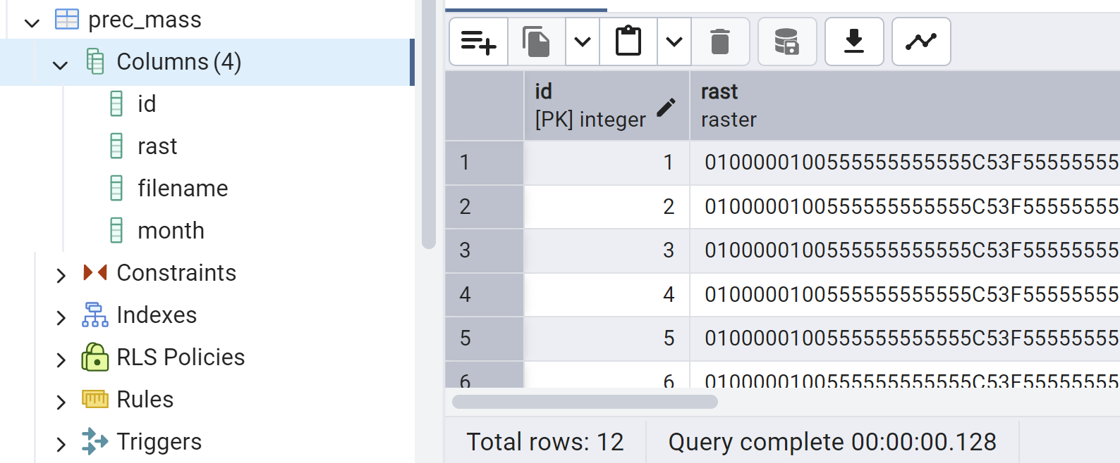
Exercise 2: calculate mean precipitation by each month for prec_class (1pt)
SELECT
month,
(stats).mean AS mean_precipitation
FROM (
SELECT
month,
ST_SummaryStatsAgg(rast, 1, TRUE) AS stats -- Extracting summary statistics for Band 1
FROM ch10.prec_mass
GROUP BY month
) AS subquery
ORDER BY month;
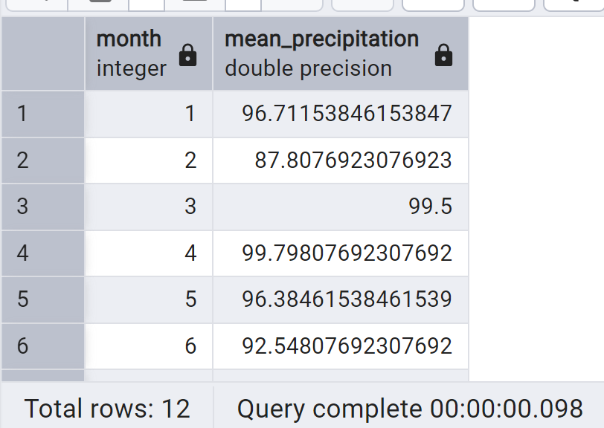
Exercise 3: list out all statistical summary for prec_class by month (1pt)
SELECT
month,
(stats).*
FROM (
SELECT
month,
ST_SummaryStatsAgg(rast, 1, TRUE) AS stats -- Compute summary statistics for Band 1
FROM ch10.prec_mass
GROUP BY month
) AS subquery
ORDER BY month;
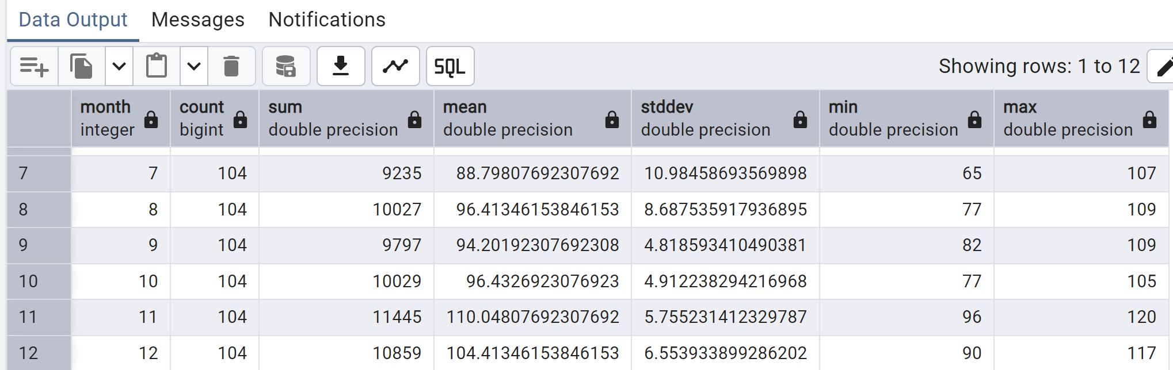
On Your Own:
Task 1: clip elev (elevation) and tmean (temperature) by using Massachusetts_shapefile and store the result as tables (elev_mass, temp_mass); plot the result in QGIS and paste the screenshots here (1pt).
-- WHERE ST_Intersects(rast,geom);
DROP TABLE IF EXISTS ch10.elev_mass;
-- save result to raster table
-- Step 1: Create a new raster table
CREATE TABLE ch10.elev_mass (
id SERIAL PRIMARY KEY,
rast raster,
filename TEXT
);

-- Step 2: Insert the raster result into the new table
INSERT INTO ch10.elev_mass (rast, filename)
SELECT
ST_Union(ST_Clip(rast, geom)) AS rast,
filename
FROM ch10.elev
CROSS JOIN ch10.mass_shp AS geom
WHERE ST_Intersects(rast, geom)
GROUP BY filename;
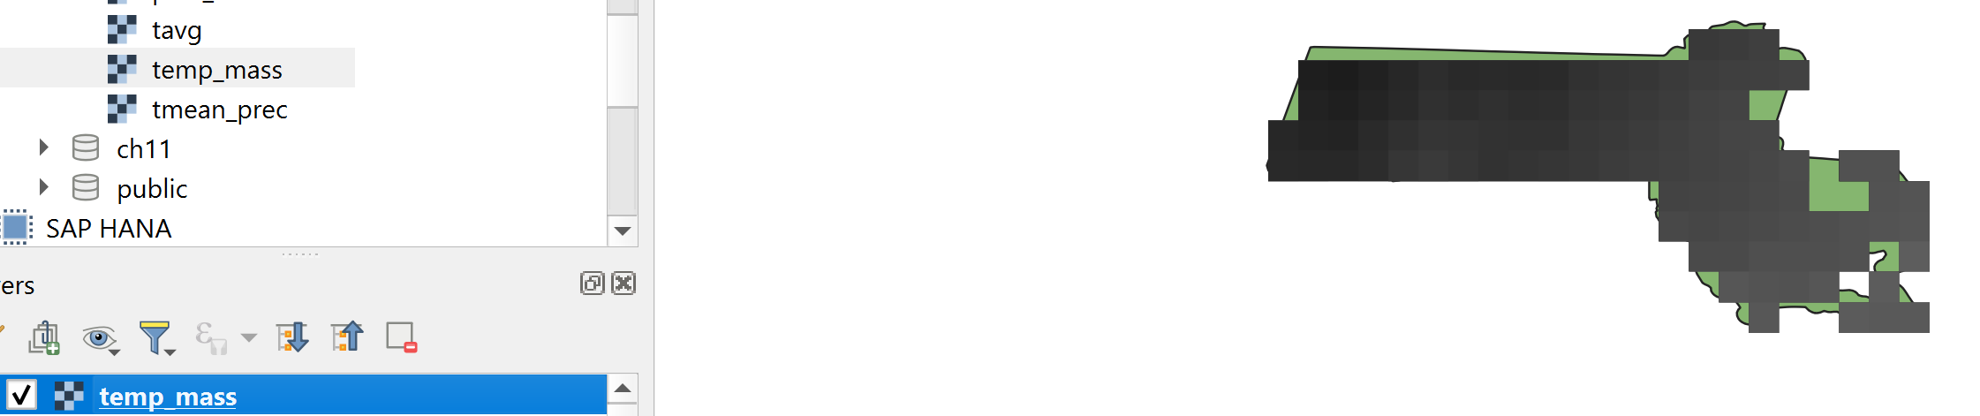
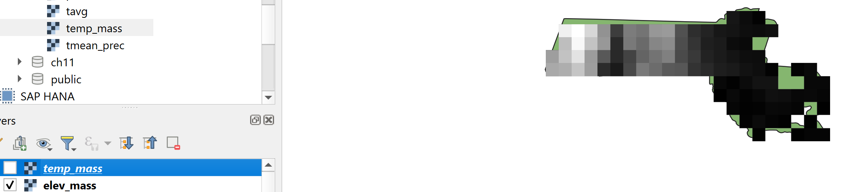
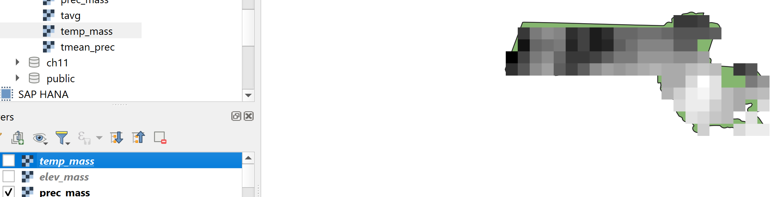
Task 2: combine temp_mass, elev_mass, and prec_mass into a multiband raster (name it: t_p_e_mass) and create the index idx_t_p_e_mass_rast_gist (1pt)
-- working with band
CREATE TABLE ch10.t_p_e_mass (
rid serial primary key,
rast raster,
filename_tmean text,
filename_prec text,
filename_elev text,
month smallint
);

INSERT INTO ch10.t_p_e_mass(rast, filename_tmean, filename_prec, filename_elev, month)

SELECT
ST_AddBand(ST_AddBand(t.rast, p.rast), e.rast) As rast,
t.filename As filename_tmean,
p.filename As filename_prec,
e.filename AS filename_elev,
t.month
FROM ch10.temp_mass As t
INNER JOIN ch10.prec_mass As p
ON t.rast ~= p.rast AND t.month = p.month
INNER JOIN ch10.elev_mass AS e
ON t.rast ~= e.rast;

CREATE INDEX idx_t_p_e_mass_rast_gist
ON ch10.t_p_e_mass
USING gist (ST_ConvexHull(rast));
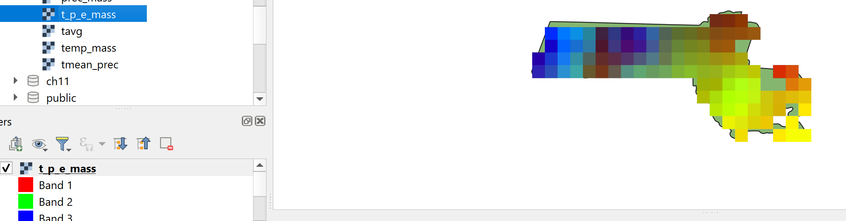
Task 3: list out the mean, max, min, and standard deviation of temperature by month for table t_p_e_mass using ST_SummaryStatsAgg() function (1pt).
SELECT
t.month,
(stats_t).mean AS t_mean,
(stats_t).max AS t_max,
(stats_t).min AS t_min,
(stats_p).mean AS p_mean,
(stats_p).max AS p_max,
(stats_p).min AS p_min
FROM (
SELECT
month,
ST_SummaryStatsAgg(rast, 1, TRUE) AS stats_t
FROM ch10.t_p_e_mass
GROUP BY month
) AS t
JOIN (
SELECT
month,
ST_SummaryStatsAgg(rast, 2, TRUE) AS stats_p
FROM ch10.t_p_e_mass
GROUP BY month
) AS p
ON t.month = p.month
ORDER BY t.month;
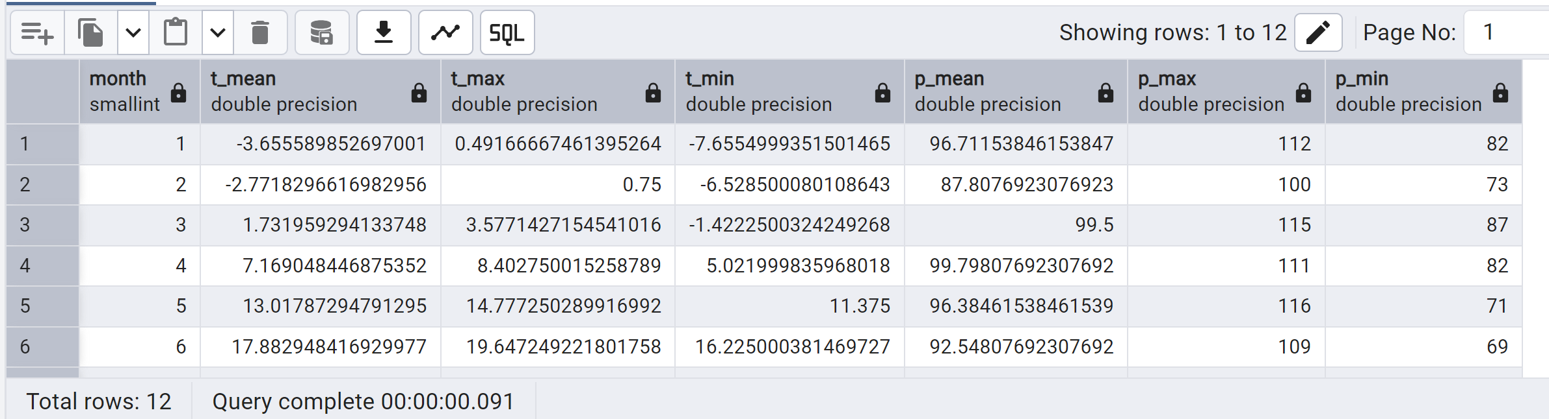
Task 4: query temperature and precipitation at point (71.8W, 42.2N) (Worcester) between January and September on table t_p_e_mass using ST_Value() function (1pt)
-- raster statistics
SELECT month, ST_Value(rast, 1, pt) AS t, ST_Value(rast, 2, pt) AS p
FROM ch10.tmean_prec INNER JOIN
ST_SetSRID(ST_Point(-71.8, 42.2), 4326) AS pt
ON (MONTH BETWEEN 1 AND 9 AND ST_Intersects(rast, pt));
Task 5: extract elevation and clip them based on the point (71.8W, 42.2N) with 0.01 degree buffer, save the result as a vector table and plot it in QGIS (2pt)
DROP TABLE IF EXISTS ch10.raster_result;
CREATE TABLE ch10.raster_result AS
SELECT
CAST((gval).val AS FLOAT) AS val,
ST_Union((gval).geom) AS geom
FROM (
SELECT ST_Intersection(ST_Clip(t.rast, ST_Envelope(buf.geom)), 3, buf.geom) AS gval
FROM ch10.t_p_e_mass AS t
INNER JOIN LATERAL (
SELECT ST_Buffer(ST_Transform(ST_GeomFromText('POINT(-71.8 42.2)', 4326), ST_SRID(t.rast)), 0.3) AS geom
) AS buf ON ST_Intersects(t.rast, buf.geom)
) AS foo
GROUP BY (gval).val
ORDER BY (gval).val;

