Remote Database Connections

Step 1: Find the IP Address of Your First Laptop (Server)
You need to know the IP address of your first laptop, which will act as the PostgreSQL server.
- On Windows:
Open Command Prompt (cmd), type:
ipconfig
Look for the IPv4 Address under your active network connection. It will look something like 192.168.1.100.
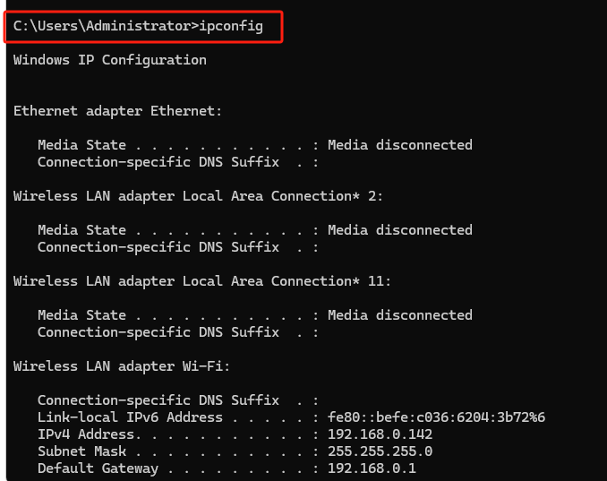
- On Mac/Linux:
Open Terminal, type:
ifconfig
Look for the inet address under your active network interface (like en0 or wlan0).

Step 2: Edit PostgreSQL Configuration Files on the First Laptop

2.1 Modify postgresql.conf

postgresql.conf in path: C:\Program Files\PostgreSQL\15\data\postgresql.conf (windows)

Find the line:

#listen_addresses = 'localhost'

Change it to:

listen_addresses = '*'

2.2 Modify pg_hba.conf
Open the pg_hba.conf file:
Located at: C:\Program Files\PostgreSQL\15\data\pg_hba.conf
Add this line to the end of the file:

host all all 0.0.0.0/0 md5

Step 3: change firewall on first laptop

Follow the steps under 3. Configure the Windows Firewall to allow incoming connections to PostgreSQL in this link to allow income connections to PostgreSQL

Step 4: Ensure the postgresql service is running on your first laptop

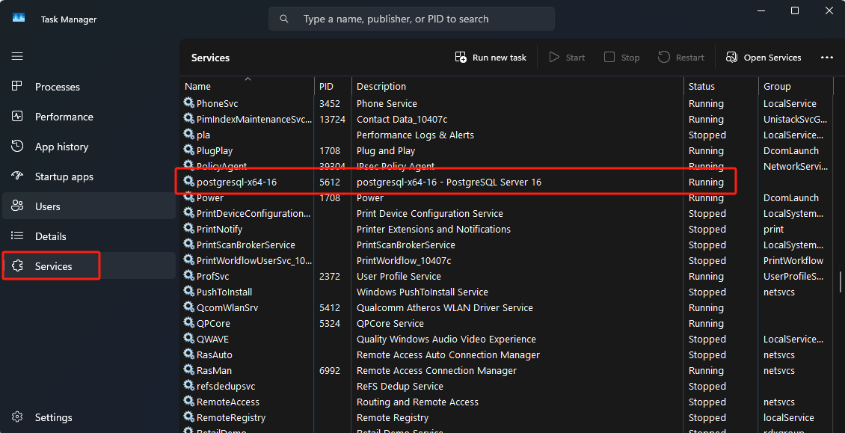

Step 5: Remote connect to server on your second laptop
- Open pgAdmin on your second laptop.
- Go to Servers > Create > Server.
- In the General tab, give your server a name.
- In the Connection tab:
  - Host name/address: Enter the IP address of your first laptop.
  - Port: 5432 (default PostgreSQL port).
  - Username and Password: Enter your PostgreSQL credentials.
- Click Save.

