Lab 07: Raster processing

By completing this lab, you will:

* Understand fundamental raster processing in PostGIS SQL.
* Learn to clip raster by using existing boundaries or ST_MakeEnvelope()
* Using ST_AddBand to form multiband rasters from single-band rasters
* Conduct raster statistics functions

Total points: 9pts

Please submit the lab in word or PDF format, with pasted (don’t screenshot) commands and screenshotted results.

Data Instruction

Massachusetts (roughly (41.67° N, 73.15° W) to (42.80° N, 70.70° W))

SHP: Massachusetts_shapefile (SRID: 4326)

Exercise 1 (1pt):

Clip raster (prec) by using Massachusetts_shapefile and store the result as a table (prec_mass)

-- WHERE ST_Intersects(rast,geom);

DROP TABLE IF EXISTS ch10.prec_mass;

-- save result to raster table

-- Step 1: Create a new raster table

CREATE TABLE ch10.prec_mass (

id SERIAL PRIMARY KEY,

rast raster,

filename TEXT,

month INTEGER

);

-- Step 2: Insert the raster result into the new table

INSERT INTO ch10.prec_mass (rast, filename, month)

SELECT

ST_Union(ST_Clip(rast, geom)) AS rast,

filename,

month

FROM ch10.prec

CROSS JOIN ch10.mass_shp AS geom

WHERE ST_Intersects(rast, geom)

GROUP BY filename, month;

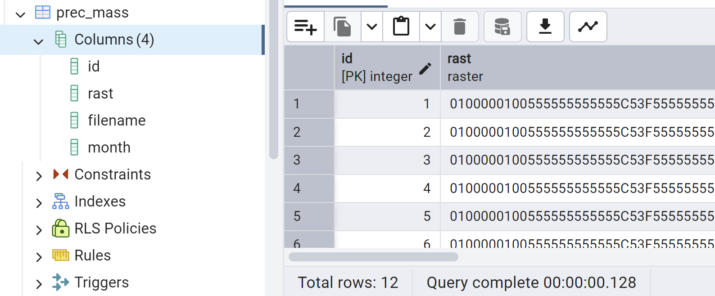

Exercise 2: calculate mean precipitation by each month for prec_class (1pt)

SELECT

month,

(stats).mean AS mean_precipitation

FROM (

SELECT

month,

ST_SummaryStatsAgg(rast, 1, TRUE) AS stats -- Extracting summary statistics for Band 1

FROM ch10.prec_mass

GROUP BY month

) AS subquery

ORDER BY month;

Exercise 3: list out all statistical summary for prec_class by month (1pt)

SELECT

month,

(stats).*

FROM (

SELECT

month,

ST_SummaryStatsAgg(rast, 1, TRUE) AS stats -- Compute summary statistics for Band 1

FROM ch10.prec_mass

GROUP BY month

) AS subquery

ORDER BY month;

On Your Own:

Task 1: clip elev (elevation) and tmean (temperature) by using Massachusetts_shapefile and store the result as tables (elev_mass, temp_mass); plot the result in QGIS and paste the screenshots here (1pt).

-- WHERE ST_Intersects(rast,geom);

DROP TABLE IF EXISTS ch10.elev_mass;

-- save result to raster table

-- Step 1: Create a new raster table

CREATE TABLE ch10.elev_mass (

id SERIAL PRIMARY KEY,

rast raster,

filename TEXT

);

-- Step 2: Insert the raster result into the new table

INSERT INTO ch10.elev_mass (rast, filename)

SELECT

ST_Union(ST_Clip(rast, geom)) AS rast,

filename

FROM ch10.elev

CROSS JOIN ch10.mass_shp AS geom

WHERE ST_Intersects(rast, geom)

GROUP BY filename;

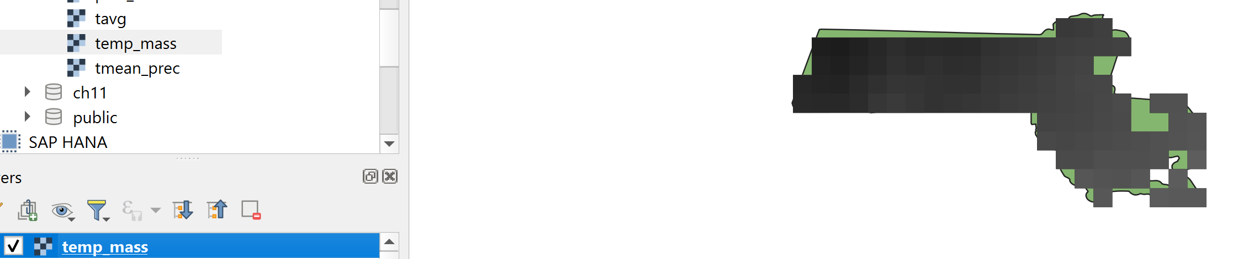

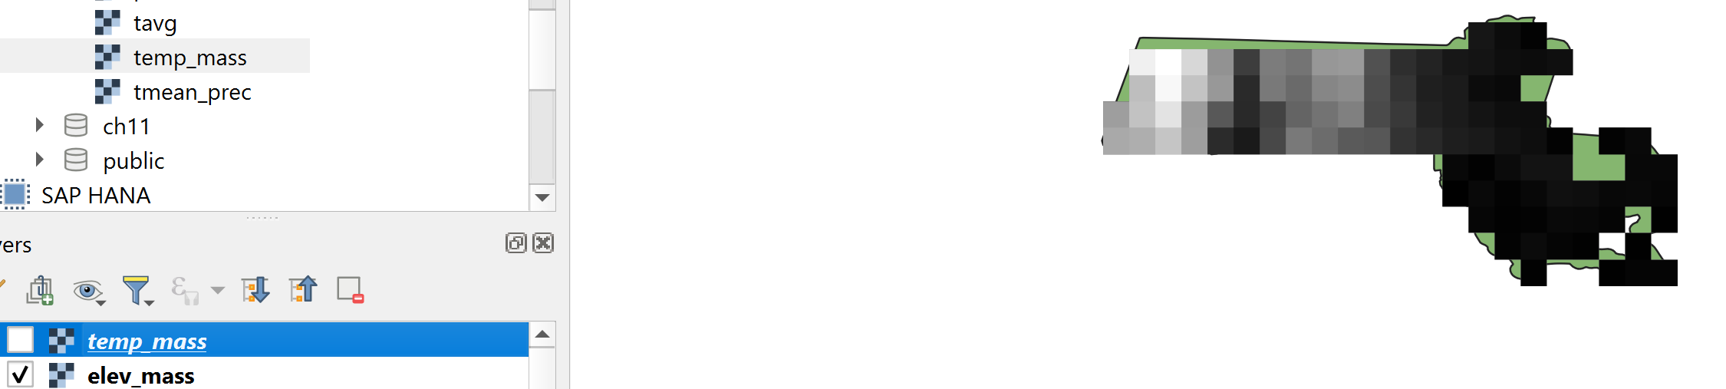

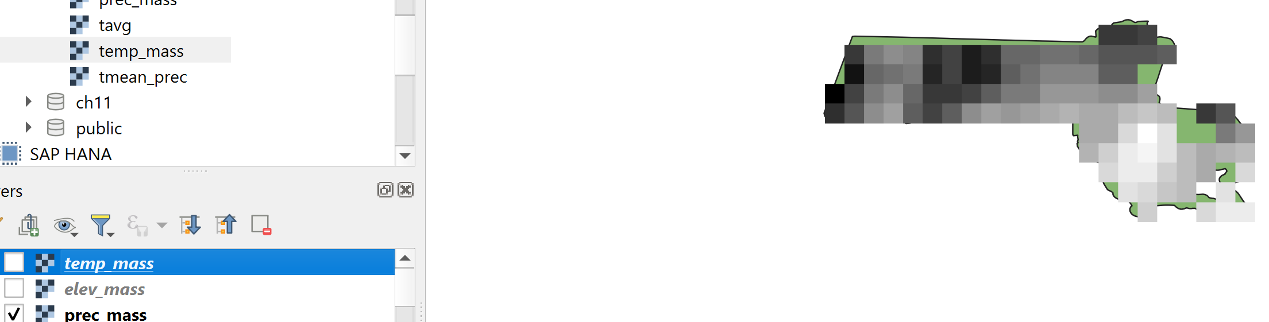

Task 2: combine temp_mass, elev_mass, and prec_mass into a multiband raster (name it: t_p_e_mass) and create the index idx_t_p_e_mass_rast_gist (1pt)

-- working with band

CREATE TABLE ch10.t_p_e_mass (

rid serial primary key,

rast raster,

filename_tmean text,

filename_prec text,

filename_elev text,

month smallint

);

INSERT INTO ch10.t_p_e_mass(rast, filename_tmean, filename_prec, filename_elev, month)

SELECT

ST_AddBand(ST_AddBand(t.rast, p.rast), e.rast) As rast,

t.filename As filename_tmean,

p.filename As filename_prec,

e.filename AS filename_elev,

t.month

FROM ch10.temp_mass As t

INNER JOIN ch10.prec_mass As p

ON t.rast ~= p.rast AND t.month = p.month

INNER JOIN ch10.elev_mass AS e

ON t.rast ~= e.rast;

CREATE INDEX idx_t_p_e_mass_rast_gist

ON ch10.t_p_e_mass

USING gist (ST_ConvexHull(rast));

Task 3: list out the mean, max, min, and standard deviation of temperature by month for table t_p_e_mass using ST_SummaryStatsAgg() function (1pt).

SELECT

t.month,

(stats_t).mean AS t_mean,

(stats_t).max AS t_max,

(stats_t).min AS t_min,

(stats_p).mean AS p_mean,

(stats_p).max AS p_max,

(stats_p).min AS p_min

FROM (

SELECT

month,

ST_SummaryStatsAgg(rast, 1, TRUE) AS stats_t

FROM ch10.t_p_e_mass

GROUP BY month

) AS t

JOIN (

SELECT

month,

ST_SummaryStatsAgg(rast, 2, TRUE) AS stats_p

FROM ch10.t_p_e_mass

GROUP BY month

) AS p

ON t.month = p.month

ORDER BY t.month;

Task 4: query temperature and precipitation at point (71.8W, 42.2N) (Worcester) between January and September on table t_p_e_mass using ST_Value() function (1pt)

-- raster statistics

SELECT month, ST_Value(rast, 1, pt) AS t, ST_Value(rast, 2, pt) AS p

FROM ch10.tmean_prec INNER JOIN

ST_SetSRID(ST_Point(-71.8, 42.2), 4326) AS pt

ON (MONTH BETWEEN 1 AND 9 AND ST_Intersects(rast, pt));

Task 5: extract elevation and clip them based on the point (71.8W, 42.2N) with 0.01 degree buffer, save the result as a vector table and plot it in QGIS (2pt)

DROP TABLE IF EXISTS ch10.raster_result;

CREATE TABLE ch10.raster_result AS

SELECT

CAST((gval).val AS FLOAT) AS val,

ST_Union((gval).geom) AS geom

FROM (

SELECT ST_Intersection(ST_Clip(t.rast, ST_Envelope(buf.geom)), 3, buf.geom) AS gval

FROM ch10.t_p_e_mass AS t

INNER JOIN LATERAL (

SELECT ST_Buffer(ST_Transform(ST_GeomFromText('POINT(-71.8 42.2)', 4326), ST_SRID(t.rast)), 0.3) AS geom

) AS buf ON ST_Intersects(t.rast, buf.geom)

) AS foo

GROUP BY (gval).val

ORDER BY (gval).val;

