**Introduction**

This report will analyze classification of 2 insect species, bees and butterflies, by building convolutional neural network model. The result of this report should provide foundation for refining more accurate image recognition capabilities on the given species well as potential to further expand the model on larger classes of animals.

**Preprocessing**

The image data was obtained from Kaggle animal image dataset, which consist of 90 different species (<https://www.kaggle.com/datasets/iamsouravbanerjee/animal-image-dataset-90-different-animals/>).

For the purpose of this analysis, only bees and butterflies images were used. Each set of species consist of 60 uncropped RGB images. The images were standardized to 150x150px using 1/255 rescaling factor 0.2 validation split. The samples were then split 8:2 for training and test.

**Model**

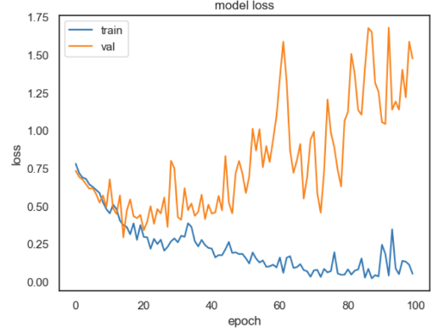The first models were built using 4 convolution layers followed by 1 dense layer with 512 neurons using relu as activation function for hidden layers and sigmoid for the output layer with adam optimizer. The model was then processed for 100 epochs with batch size of 20.

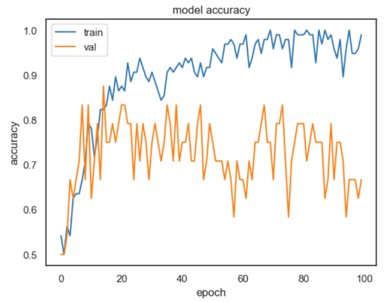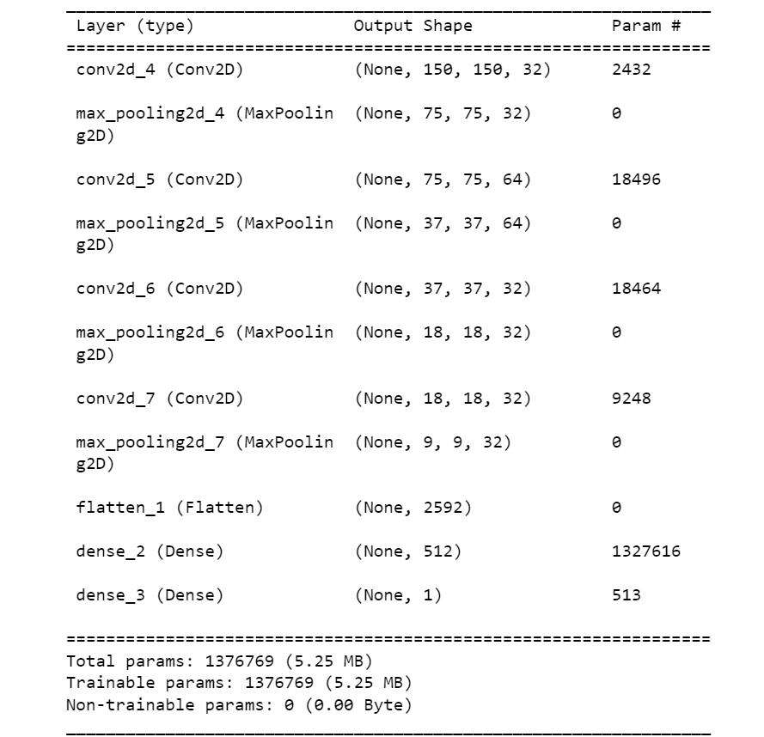

This model resulted in the accuracy score of 0.79167

The second model was built using the same convolution layers with 2 dense layers having 512 neurons each. LeakyReLU was used instead to account for dying ReLU problem. The model was trained for 100 epochs with the batch size of 1.

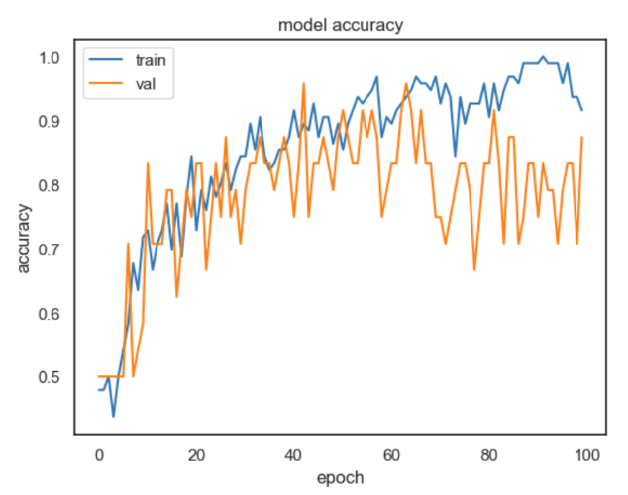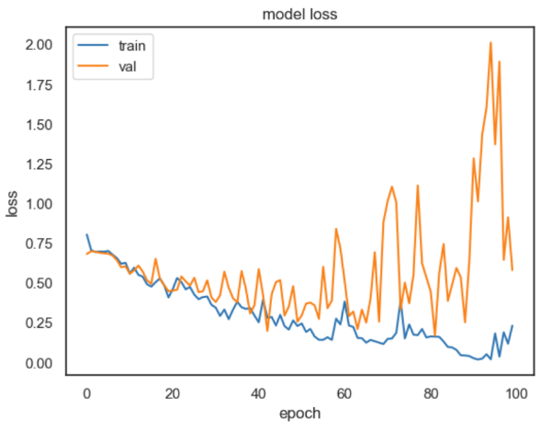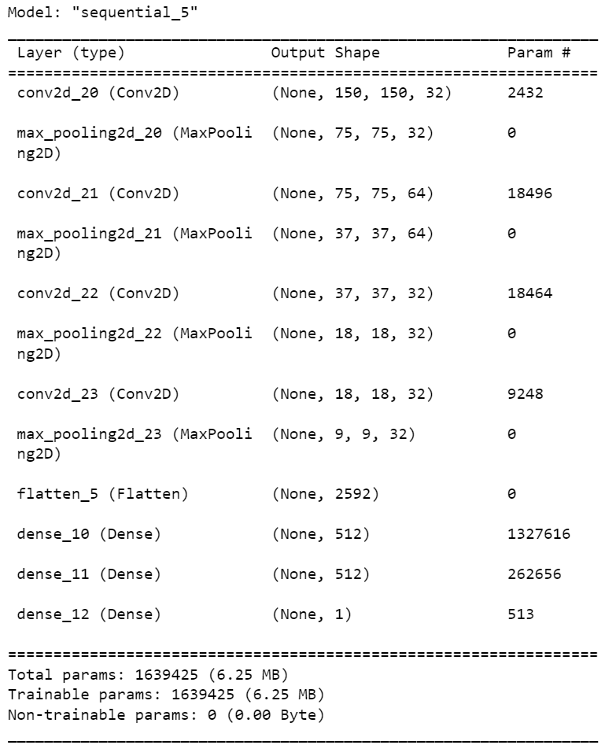

This model resulted in the accuracy score of 0.9583

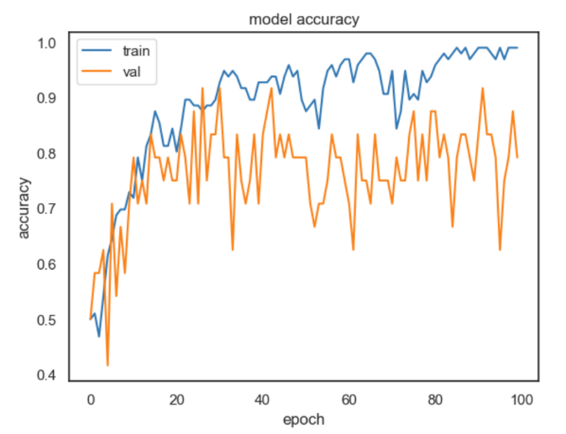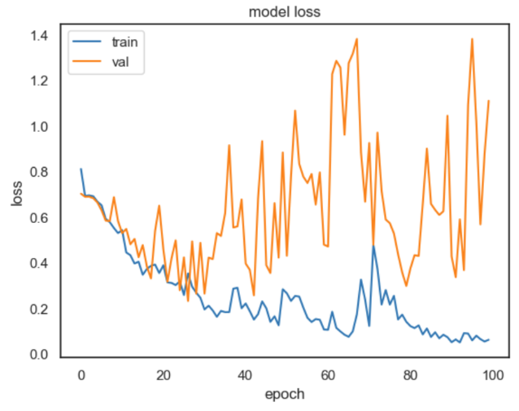The third model was built off of model 2 with regularization by dropout (=0.1). This model was trained for 100 epochs with batch size of 1

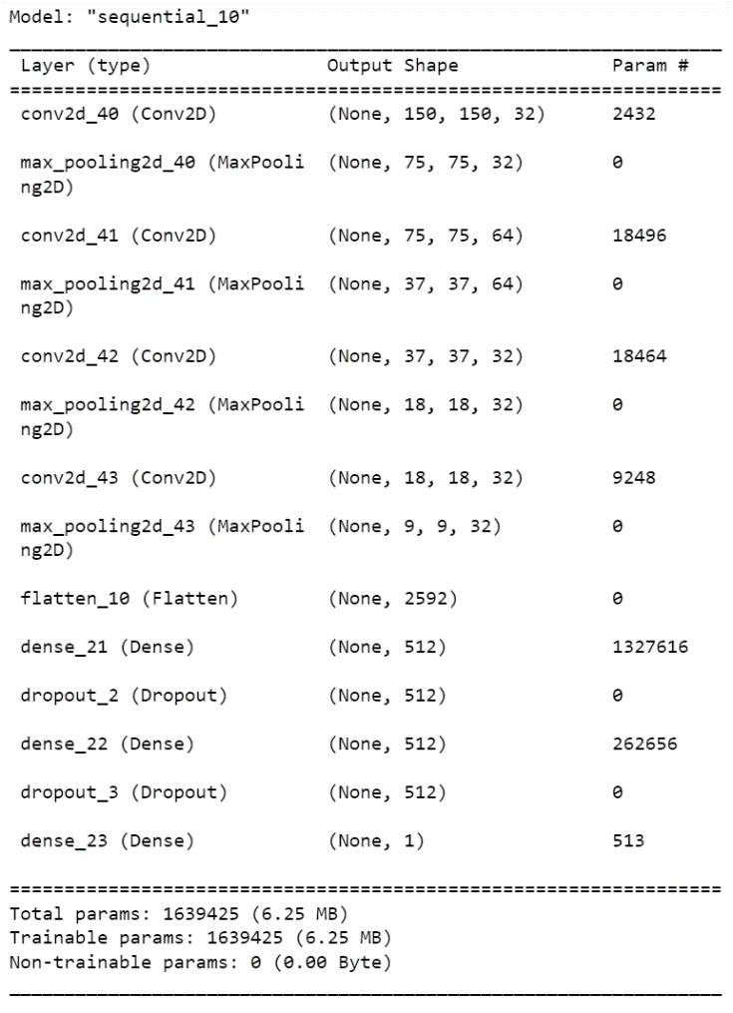the model 3 yielded accuracy score of 0.7916

**Summary**

Out of 3 models, the model 2 significantly outperformed both model 1 and 2. However, it should be noted that the sample size for these models was quite small (60 each, 120 total) and may not yield the same result for the bigger sample set. It also seems indicative that loss/accuracy graph on validation set shows notable fluctuation which seems to indicate that our sample set wasn’t big enough to reduce deviation on each sample. The first model seems to exhibit overfit past ~30 epochs, which indicates that batch size may have been too big for the sample size and the number of epochs should be reduced. Adding regularization for model 3 seems to have worsen the result by a lot. Perhaps given the sample size, losing any information significantly alters the prediction result of less frequent images in the sample.

For further analysis, increasing the sample size should be prioritized to generate more accurate and adaptable model. Once this is achieved, reducing the dimensionality of the model may help improving the result by silencing potential noises in the images via autoencoder or nmf. It would also be recommended to further tuning the model by varying optimizers and convolution layers as well.