**A Report on Open ended problem titled**

## GO CAB

*Submitted for partial fulfillment of IV semester OOP Laboratory*

by

**Team Members:**

**NAME REG.NO.**

* **Akarsh Singh 1SI16CS007**
* **Akshat Agarwal 1SI16CS010**



**Department of Computer Science & Engineering**

**Siddaganga Institute of Technology, Tumakuru-3**

(An Autonomous Institute affiliated to VTU, Accredited by NBA)

**2017-18**

**TABLE OF CONTENTS**

|  |  |  |
| --- | --- | --- |
| **Sl. No.** | **Content** | **Page No.** |
| **1.** | **Abstract** | **2** |
| **2.** | **Functional Modules** | **3** |
| **3.** | **Results and Discussions** | **5** |
| **4.** | **Conclusion** | **11** |
|  |  |  |

**ABSTRACT**

**P**roject is a simple Car Booking System named “**GO CAB**”. It allows User to book a cab.

User has to Sign Up firstly to access booking, If Already existing , User has to Log In with Username And Password.

To Book a Car the User have to provide details such as Type of Car, Source, Destination in the **BOOK NOW** section.

The **GO CAB** service provides four different models of car as per the needs of user, each type with different rental fare and different capacity of seats. Rental fare depends on car type i.e. how much passengers are travelling accordingly.

After selecting type of car, Entering Source and Destination, car will be booked and message will be given about Estimated Fare the Driver reaching source location in suitable time.

The main aim of this project **GO CAB** is to provide a friendly interface for the user to make Car Booking Service easier for all sort of users.

**FUNCTIONAL MODULE**

**T**his project consists of all the basic elements of C++. The project is based on the cab booking system in which provide a friendly interface for the user.

The project is based on a menu driven program, in which three types of menu are generated. First menu is for the sign and login which has the following options to select:

1. Login In
2. Signup
3. Exit

The login section asks the user to identify themselves. If you are a new user you can even signup. The main feature of this login/signup page is that it uses an important data structure called files. Which stores all the user info permanently.

After logging in the user is introduced to a new menu. The menu is as follows:

* + - * 1. Ride Now
        2. Log Out

If the user wants to book a cab they can use Ride Now option. Then the user is asked for the pickup and drop location.

Then the user is met with another menu asking the user, the type of cab they want to book the user are presented with the following options.

1. Micro
2. Mini
3. Prime
4. Ultra

number of passengers is asked. If the number of passengers increase the limit of car, an error message is displayed stating that the maximum number of passengers is exceeds. If no error message is displayed, your booking is confirmed and an itinerary is printed with all the details of your ride.

This program is made using one data structure and other c++ concept :

1. FILES
2. CLASSES
3. FRIEND FUNCTION
4. INHERITANCE
5. POLYMORPHISM
6. OPERATOR OVERLOADING
7. CONSTRUCTORS
8. VIRTUAL FUNCTION
9. ABSTRACT CLASS etc.

**RESULTS AND DISCUSSION**

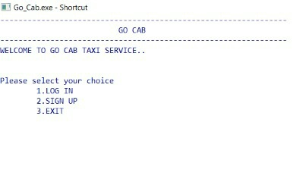

The program gives three options to the user

Login

Sign up

Exit

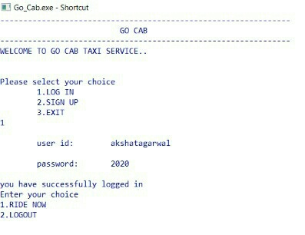

On selecting the LOGIN option, the user has to enter the correct credentials to move further in the program.

On providing the wrong credentials the program prompts to enter the correct User ID and password.

On successful login the program asks the user to book a cab or logout of the program.

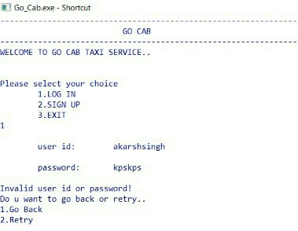

If the user name and the password does not match with the data present in the database, the program does not allow the user to go further until the correct user name and password is entered.

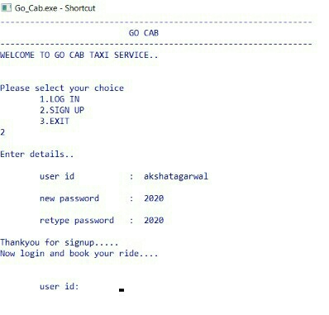

The program also gives the user an option to sign up.

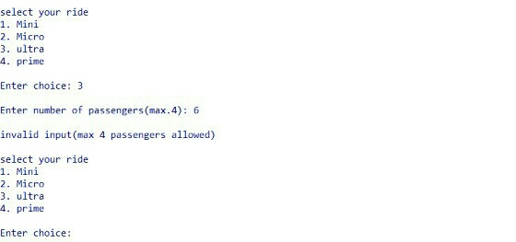

The program asks the user to select the type of CAB depending on the total no of passengers. If the number of passengers are more than the capacity of the CAB, the program raises an error and again prompts to enter the type of ride and the number of passengers.

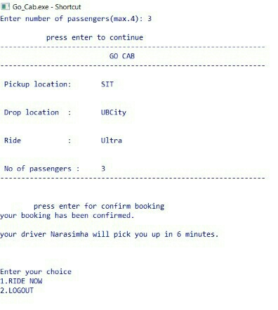

The program then calculates the time of arrival of the CAB and provides the name of the driver to the passenger

CONCLUSION

After a continuous devoted attempt, we have finally completed our program ‘**GO Cab Management**’. The program basically gives idea about a cab booking platform.

**Program Strengths:**

There are many advantages of using this program as it contains various features like:

* It is actually a user friendly software, as it is easy to use by just following the instructions which appear on the screen.
* This program has a login system, so that only authorized users are allowed to access the data.
* In order to keep the record safe, input data should match the name present in the database.

**Program Weakness:**

As we know that, no program can be 100% reliable and efficient, so, there are also some drawbacks:

* As we have used basic programming skills, so, our program cannot perform all the functions as of a professional cab booking software.
* The program is not graphical user interface.
* It is not a multipurpose and a multitasking program. It can’t perform various task at a single time.

**Program Enhancements:**

Users can add extra enhancements in the system as per necessity in the future for fulfillment of their requirements:

* For security purpose, advanced encryption techniques can be applied.
* Graphics can be introduced.