GymBuddy
Find Your Fitness Buddy

COMP-8347: Internet Applications and Distributed Systems
Final Project Report

Group 15
Chen, Mingran · Shaukat, Abdullah · Singh, Harpreet · Thakur, Chetan · Zhang, Yarong

University of Windsor · School of Computer Science
July 20, 2026

1. Introduction & Motivation
GymBuddy is a fitness-partner matching platform built for University of Windsor students and alumni. It was proposed and developed by Group 15 as the final project for COMP-8347 (Internet Applications and Distributed Systems).

Problem
- Many students struggle to stay consistent when training alone.
- Finding peers with a similar fitness level and a matching schedule is hard.
- New students in particular find it difficult to integrate into campus gym life.
- Students with specific requirements (gender preference, niche sports) often struggle to find compatible partners.

Our Solution
GymBuddy connects Windsor students through a web platform built around accountability and consistency. Members build a fitness profile, search for compatible buddies, book one-on-one or group workout sessions, join fitness groups, and rate their workout partners to build trust in the community.

Core Features
- Fitness profiles support photo uploads and fitness-level tracking.
- Members can search for a buddy by keyword with a fitness-level dropdown filter.
- Users can create and manage one-on-one or group workout sessions.
- A 1–5 star rating system is visible on member profiles.
- Members can create or join fitness groups that meet on a regular schedule.
- The site tracks a member's activity through session- and cookie-based history.

2. Steps Followed to Build the Website
1. Project scaffolding
Initialized a Django 5.2 project ("gymbuddy") with five apps (users, workouts, groups, matching and ratings), plus Django REST Framework and JWT authentication for a companion Next.js frontend.
2. Data models
Designed the core models: a custom User (student/alumni roles), UserProfile (bio, profile picture, fitness level/goals, availability), WorkoutSession, WorkoutGroup + GroupMembership, and Rating, with validators, indexes and sensible defaults for each.
3. REST API layer
Built the DRF serializers and API views used by the Next.js frontend: registration, JWT login, profile management, workout session CRUD, the group-matching algorithm, and the ratings endpoints.
4. Django template site (Bootstrap)
Added a server-rendered, session-authenticated site alongside the API: a shared base.html with a Bootstrap 5 navbar (keyword search + predefined dropdown filter), a themed footer, and page templates for every app.
5. Forms
Wrote Django ModelForms/Forms per app: SignUpForm and ProfileForm (with image upload) in users; WorkoutSessionForm and SessionSearchForm in workouts; GroupForm (with image upload) and GroupSearchForm in groups; RatingForm in ratings; and a site-wide ContactForm.
6. Class-based views
Implemented the session/group index and detail pages as class-based views (ListView/DetailView, plus CreateView/UpdateView/DeleteView) as required, replacing function-based index/detail views.
7. Authentication
Wired up Django's built-in auth views for login, logout and the full forgot-password flow (request → emailed link → confirm → complete), styled to match the site theme. Reset emails print to the console for local demos.
8. Sessions & cookies (User History)
Wrote a custom middleware (gymbuddy/middleware.py) that counts page views per day in the visitor's session, keeps a rolling list of recently viewed pages, and sets a last_visit cookie, surfaced on a dedicated History page.
9. Registered vs. guest interface
Gated member-only pages (buddy directory, profile, session/group creation, ratings) behind @login_required / LoginRequiredMixin, while sessions and groups stay browsable for guests.
10. Fixtures
Exported per-app JSON fixtures (users, workouts, groups, ratings) with manage.py dumpdata, and verified they load cleanly into a fresh database with manage.py loaddata.
11. Testing
Wrote and ran an end-to-end smoke test exercising every mandatory feature (signup, wrong-password rejection, login, profile picture upload, session search, group join, rating, and history tracking), with all 34 checks passing (see Section 8).

3. Mandatory Requirements: Where to Find Them
The table below maps each mandatory course requirement to its implementation, for quick reference during grading and the viva.
Requirement | Implementation
Authentication (login / logout / forgot password) | gymbuddy/urls.py (auth routes), apps/users/forms.py (LoginForm, PasswordResetRequestForm, SetNewPasswordForm), templates/registration/
Forms, models, CRUD | apps/*/forms.py, apps/*/models.py; workout sessions and groups support full create/read/update/delete via apps/workouts/views.py and apps/groups/views.py
User sessions & cookies (History) | gymbuddy/middleware.py (VisitHistoryMiddleware), apps/users/views.py:history_view, templates/users/history.html
Search + dropdown filter | Navbar search (templates/base.html); apps/workouts/forms.py:SessionSearchForm, apps/groups/forms.py:GroupSearchForm, apps/users/forms.py:MemberSearchForm
File upload | apps/users/forms.py:ProfileForm (profile_picture), apps/groups/forms.py:GroupForm (group_image); both stored under media/
Registered vs. guest interface | @login_required / LoginRequiredMixin across apps/users, apps/workouts, apps/groups, apps/ratings views; guest-visible pages stay open (home, about, contact, session/group lists)
Class-based index/detail views | apps/workouts/views.py:SessionListView/SessionDetailView, apps/groups/views.py:GroupListView/GroupDetailView
Bootstrap styling + footer | static/vendor/bootstrap/, static/css/site.css, templates/base.html
Fixtures (JSON) | apps/*/fixtures/initial_data.json, loaded via manage.py loaddata
Minimal API use | Only the project's own Django REST Framework API (for the Next.js frontend); no third-party APIs are used

4. Team Roles & Contributions
Roles below extend the division of labor from the group's approved Project Proposal onto the components delivered in this phase. Each member is responsible for being able to run, demonstrate and explain their assigned area during the individual viva.
Member | Primary Role | Contribution
Thakur, Chetan | Project integration & site architecture | Settings/URL routing for the template site, base.html + Bootstrap navbar/footer, home/about/contact pages, VisitHistoryMiddleware (session + cookie history tracking), fixtures generation, and end-to-end testing.
Chen, Mingran | Django backend (Workouts) | WorkoutSession model, WorkoutSessionForm/SessionSearchForm, and the class-based session list/detail/create/update/delete views (apps/workouts).
Shaukat, Abdullah | Auth & Users | Custom User/UserProfile models, SignUpForm/ProfileForm, and the profile, buddy directory and profile-edit views (apps/users).
Singh, Harpreet | Frontend UI | Next.js/Tailwind frontend (frontend/) consuming the DRF API, and UI styling support for the Django template site.
Zhang, Yarong | Groups & Ratings | WorkoutGroup model, GroupForm (image upload) + GroupSearchForm, group join/leave logic, RatingForm and the ratings views (apps/groups, apps/ratings).

5. Technology Stack
Layer | Technology | Notes
Backend | Django 5.2 + Django REST Framework | Models, forms, class-based views, session auth, JWT API for the frontend
Template site | Django Templates + Bootstrap 5 | Server-rendered pages, responsive navbar/footer, forms
Frontend (API client) | Next.js 14 (App Router) | Consumes the DRF API for a richer single-page experience
Database | SQLite (dev) / PostgreSQL-ready | Relational storage for users, sessions, groups, ratings
Auth | Django session auth (template site) + JWT (API) | Login/logout/password reset; token auth for the SPA
Media storage | Local filesystem (media/) | Profile pictures and group images

6. Screenshots

6.1 Guest (Unregistered) View
Guests can browse the home page, workout sessions and groups, and read About/Contact, but member-only actions require an account.
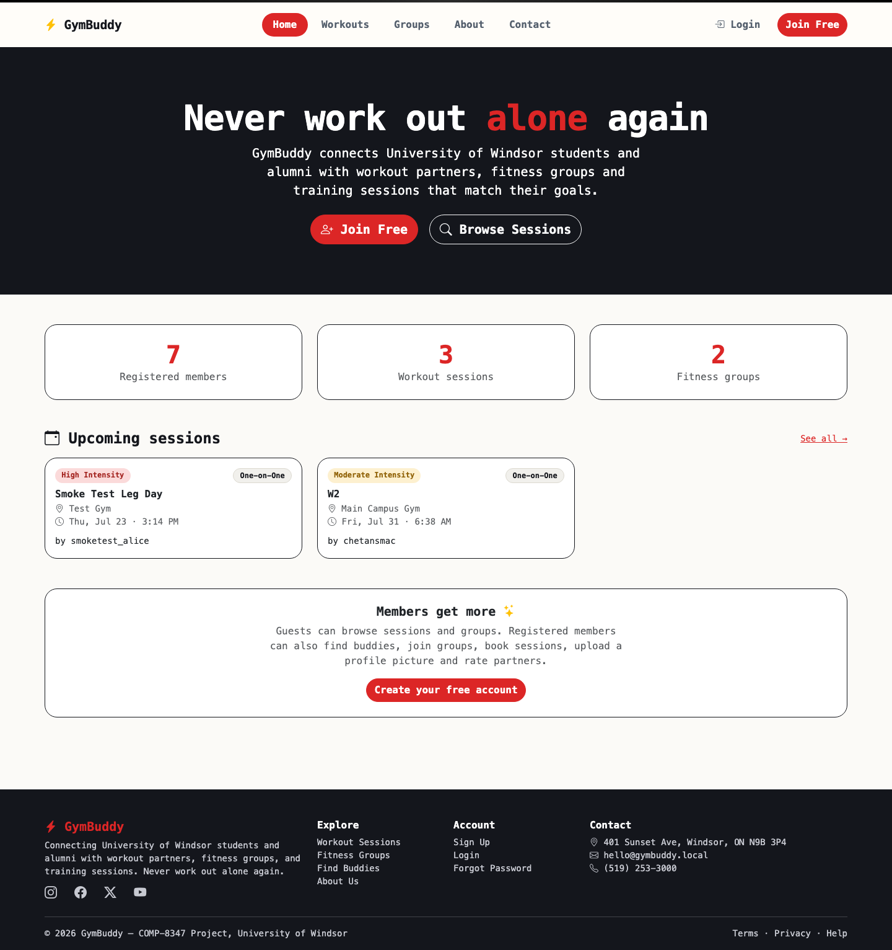
Home page (guest view), showing site stats and upcoming sessions.

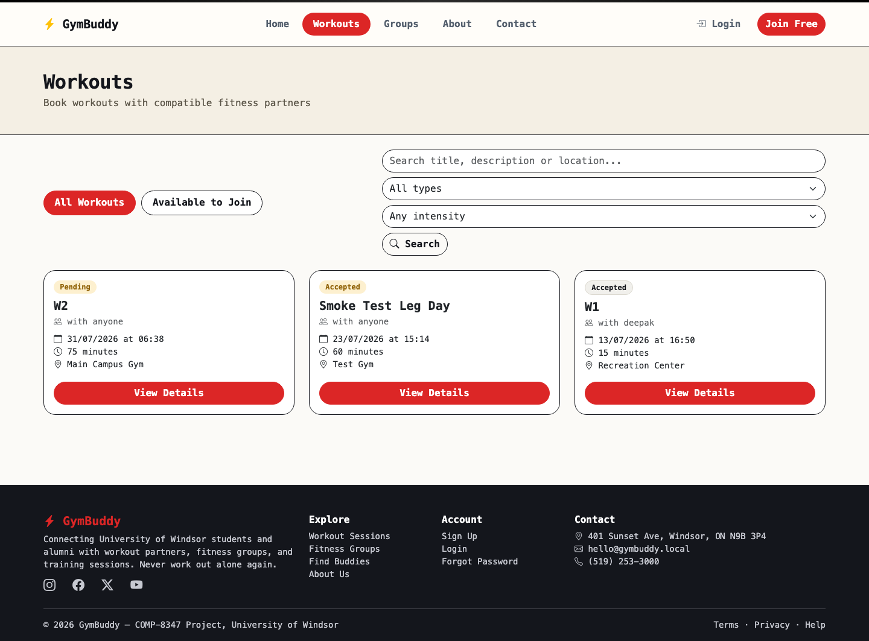
Workout sessions: the public list with a search bar and dropdown filters.

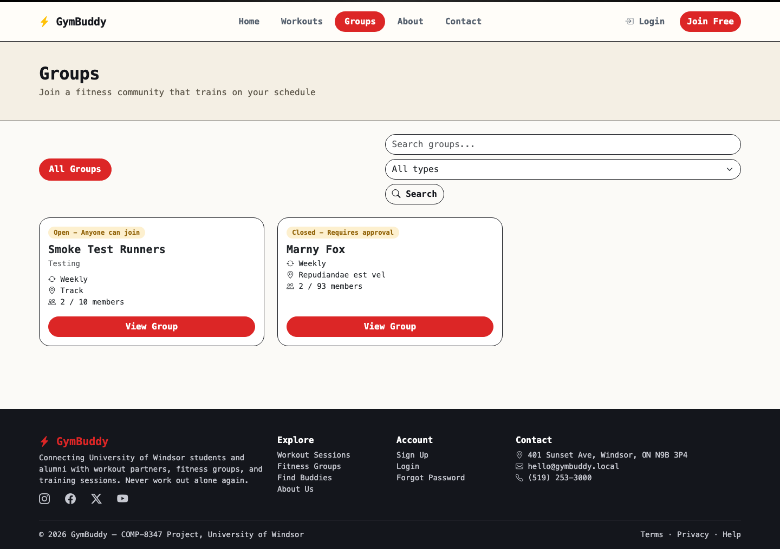
Fitness groups, public list view.

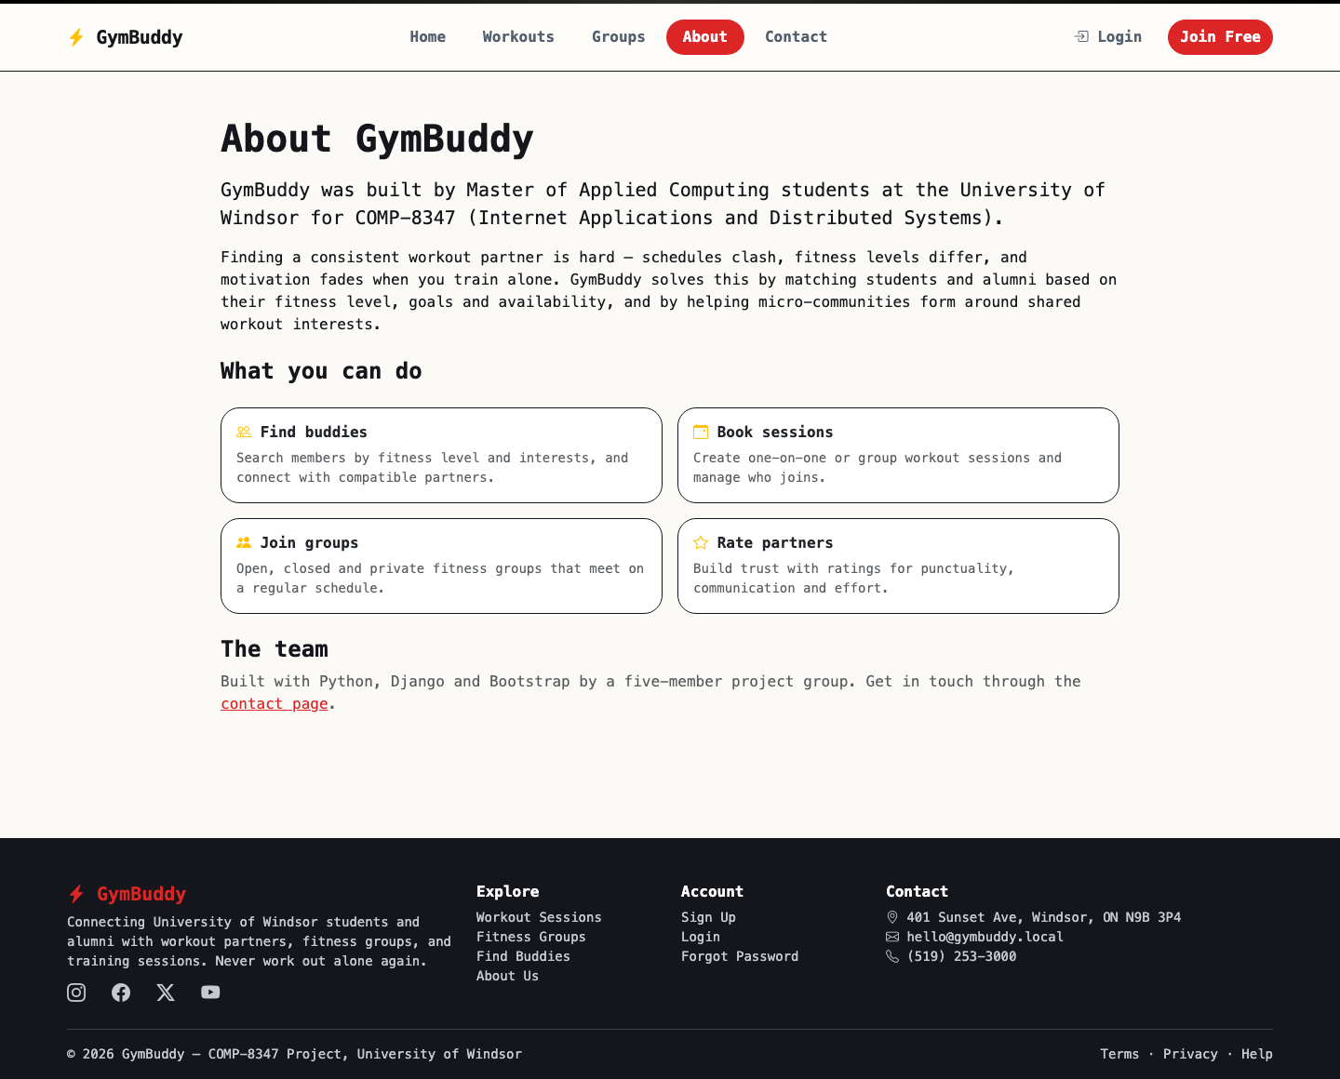
About Us page.

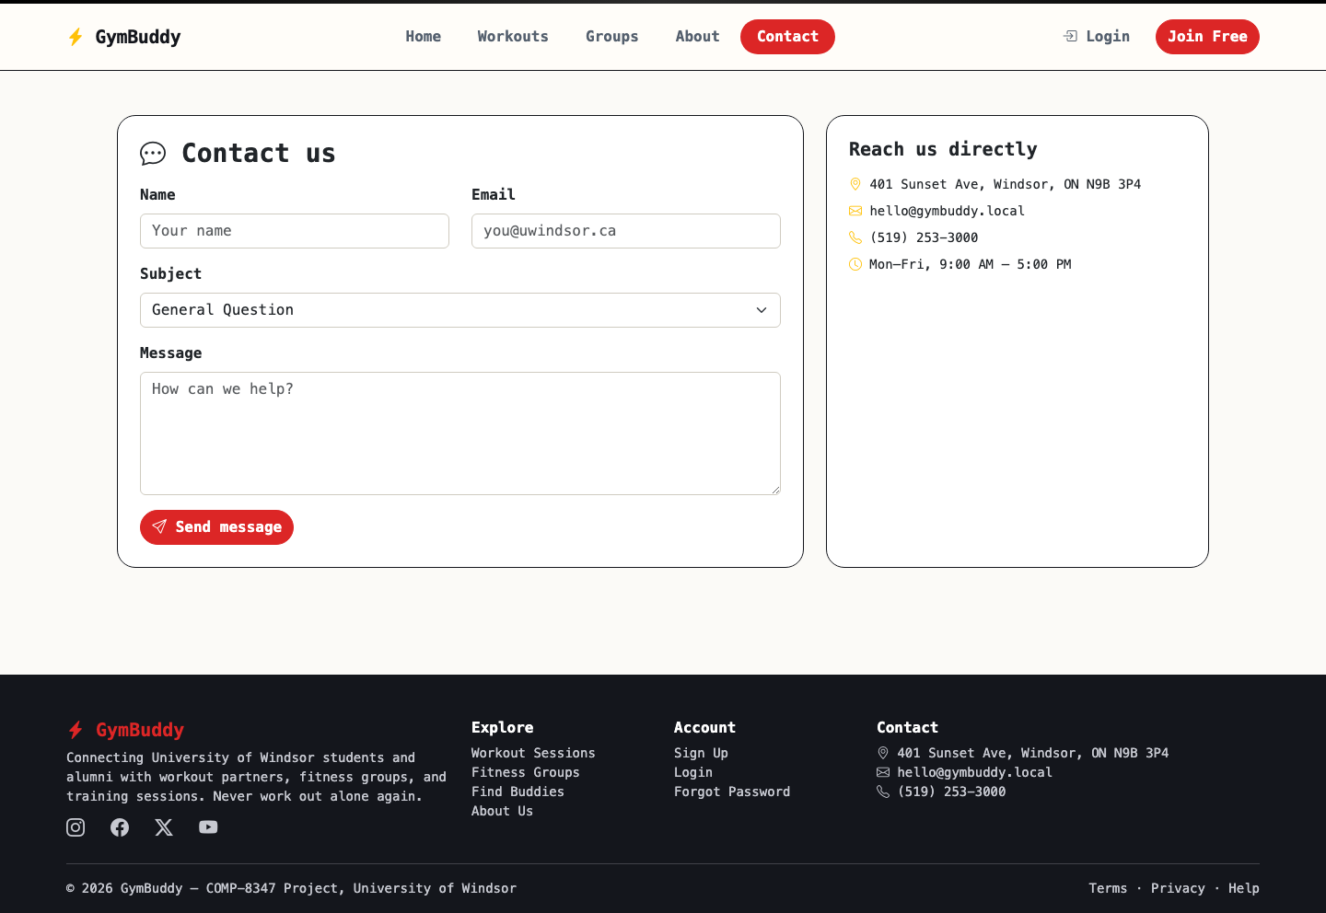
Contact Us page with a working contact form.

6.2 Authentication
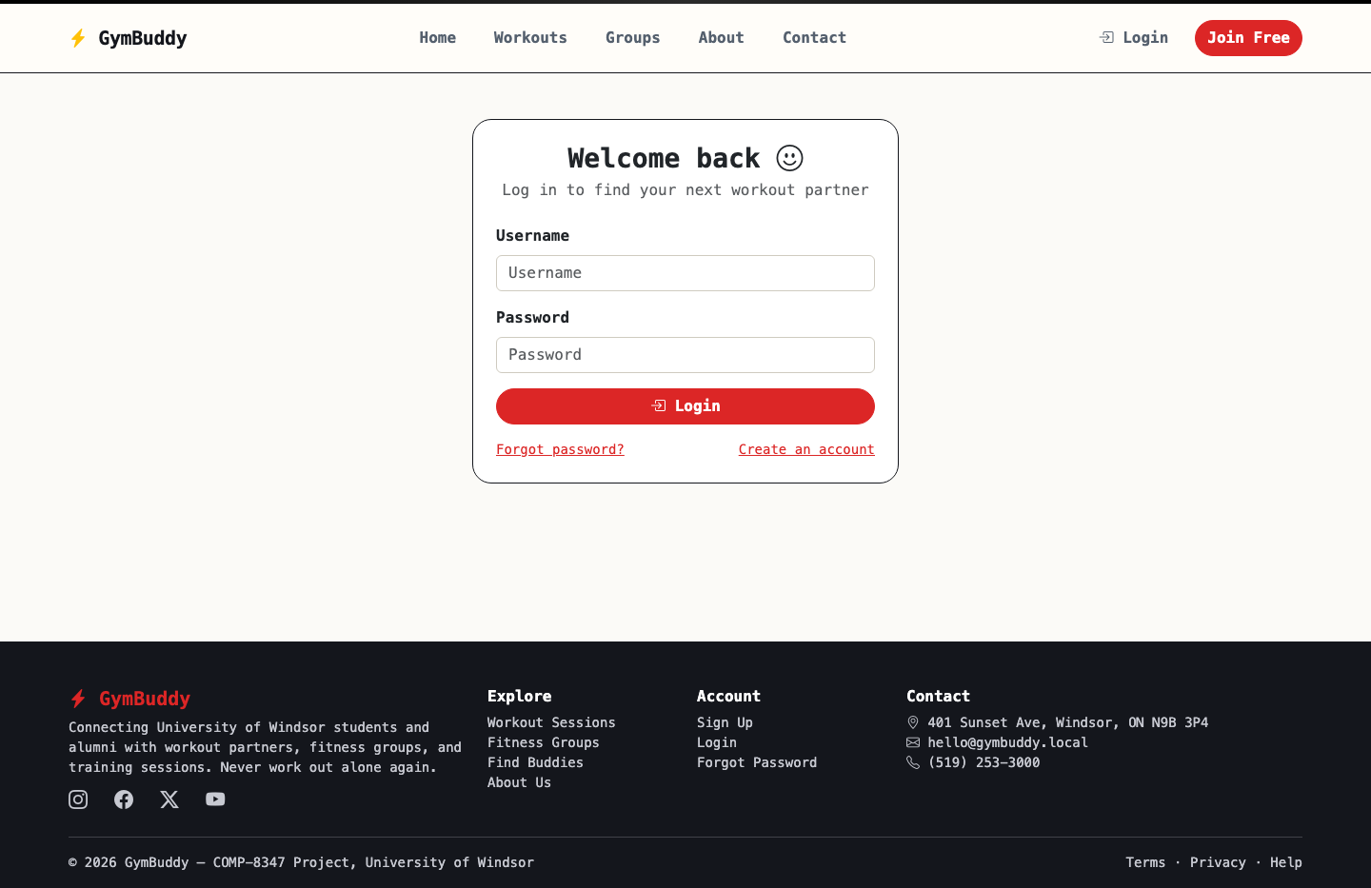
Login page. Invalid credentials are rejected with an inline error.

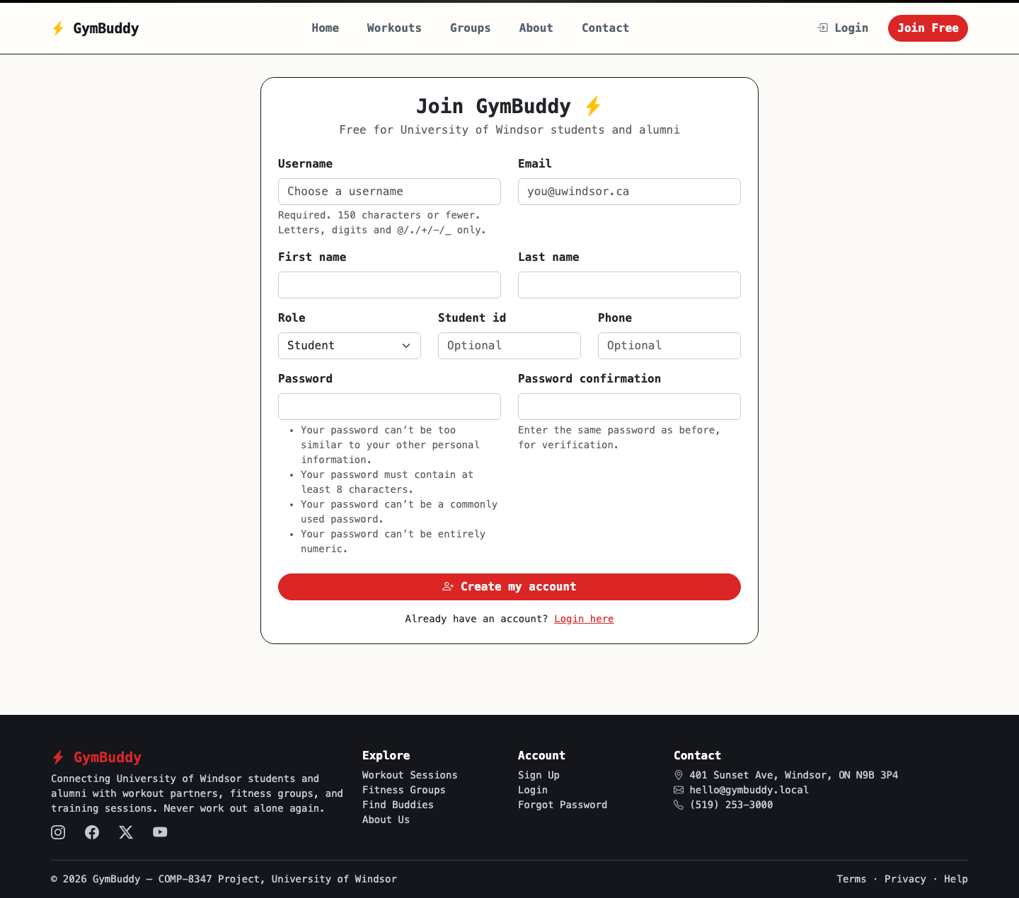
Sign-up page, which registers a new User and UserProfile.

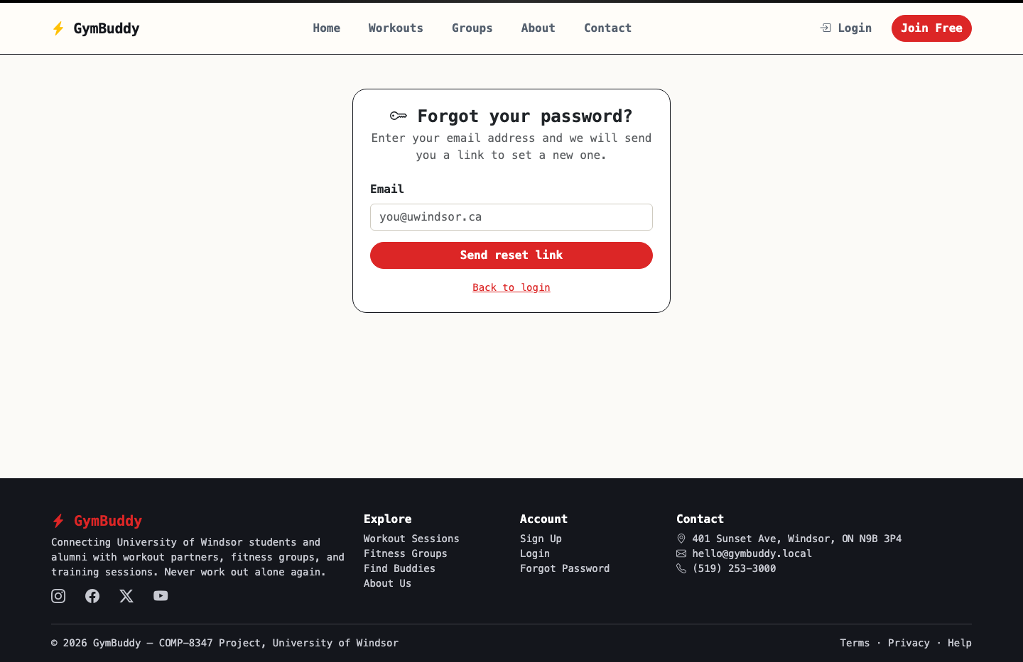
Forgot password: the request step of the full reset flow.

6.3 Registered Member View
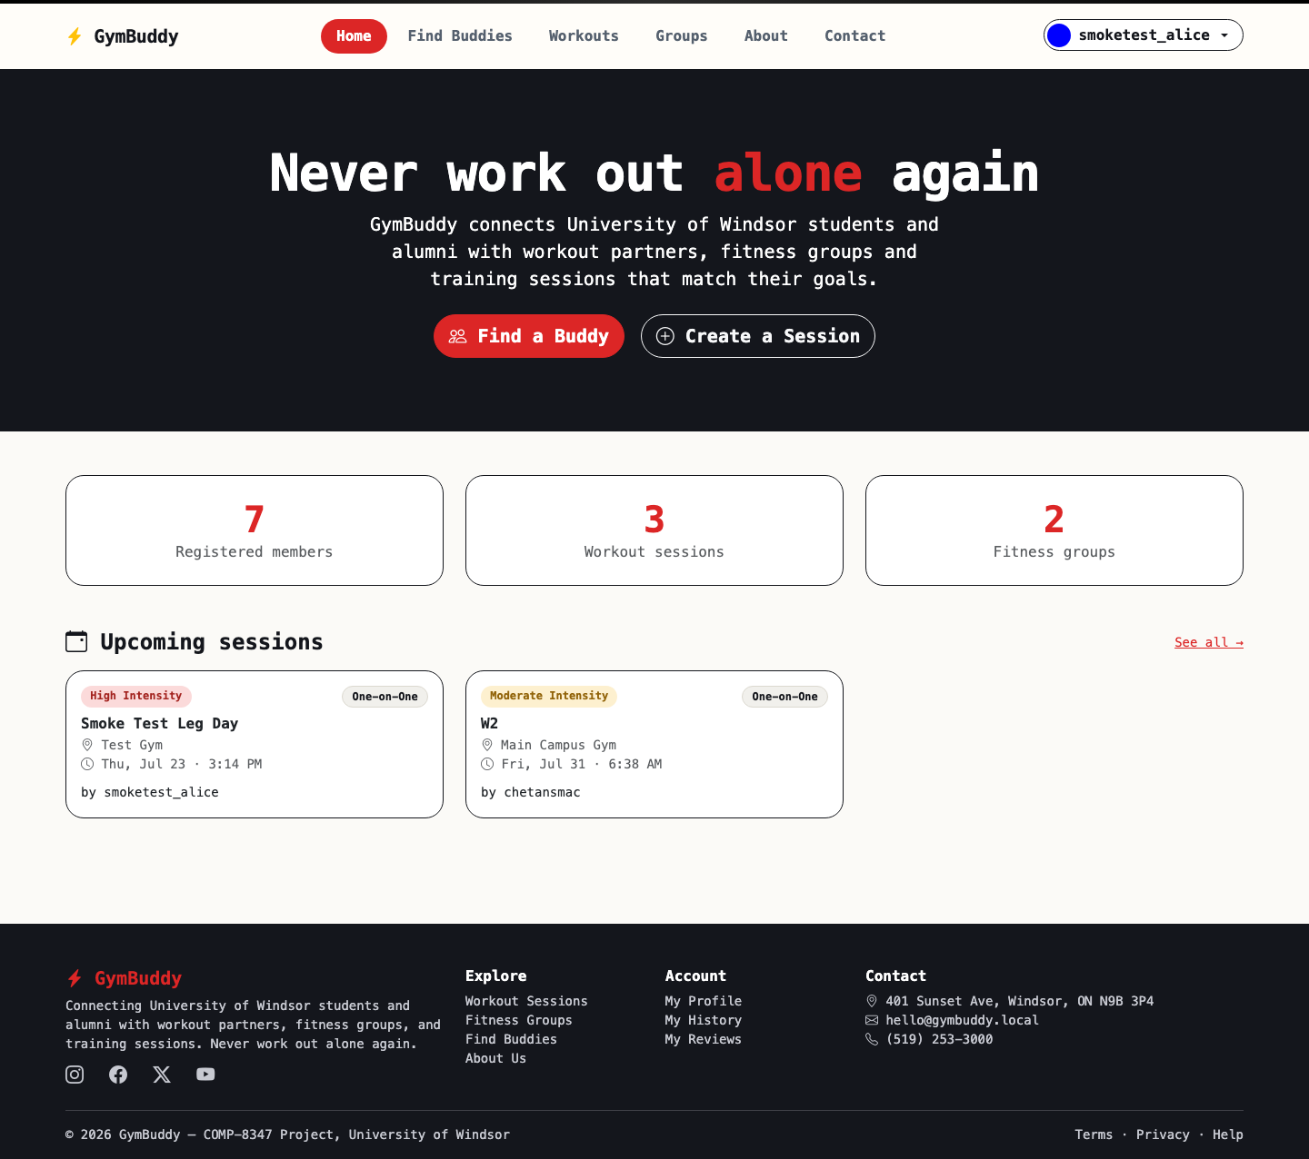
Home page after logging in; the navbar now shows the account menu.

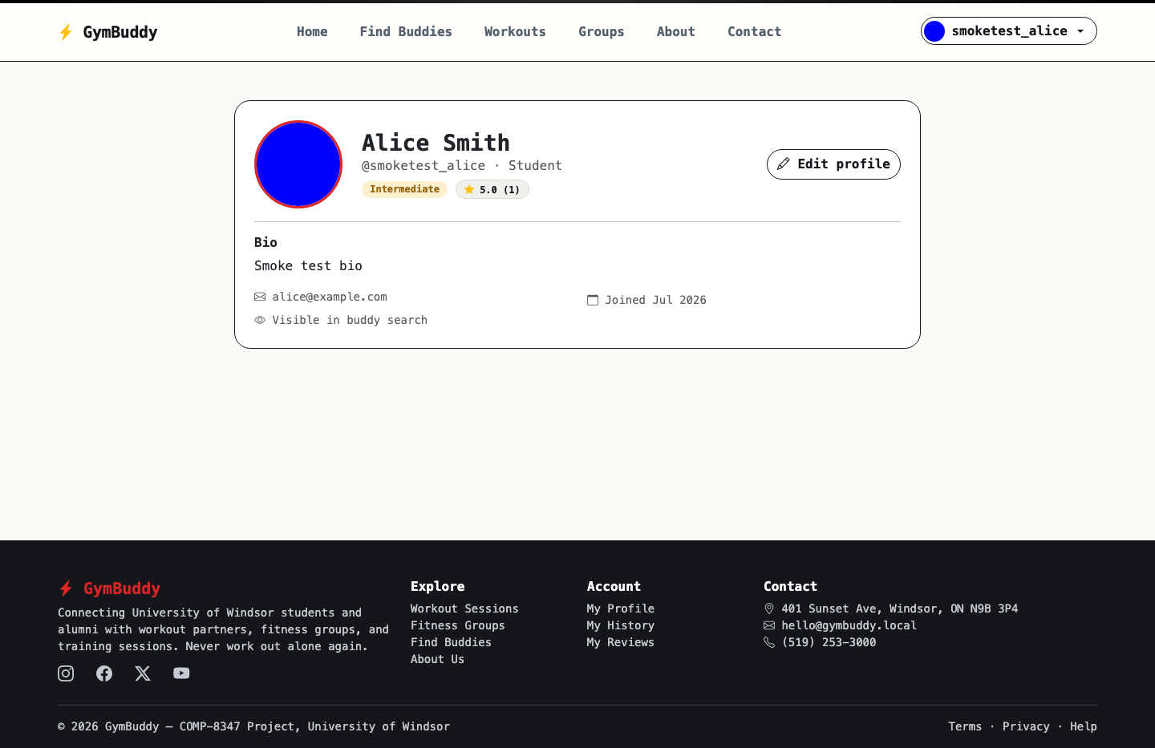
Member profile page, including the uploaded profile picture.

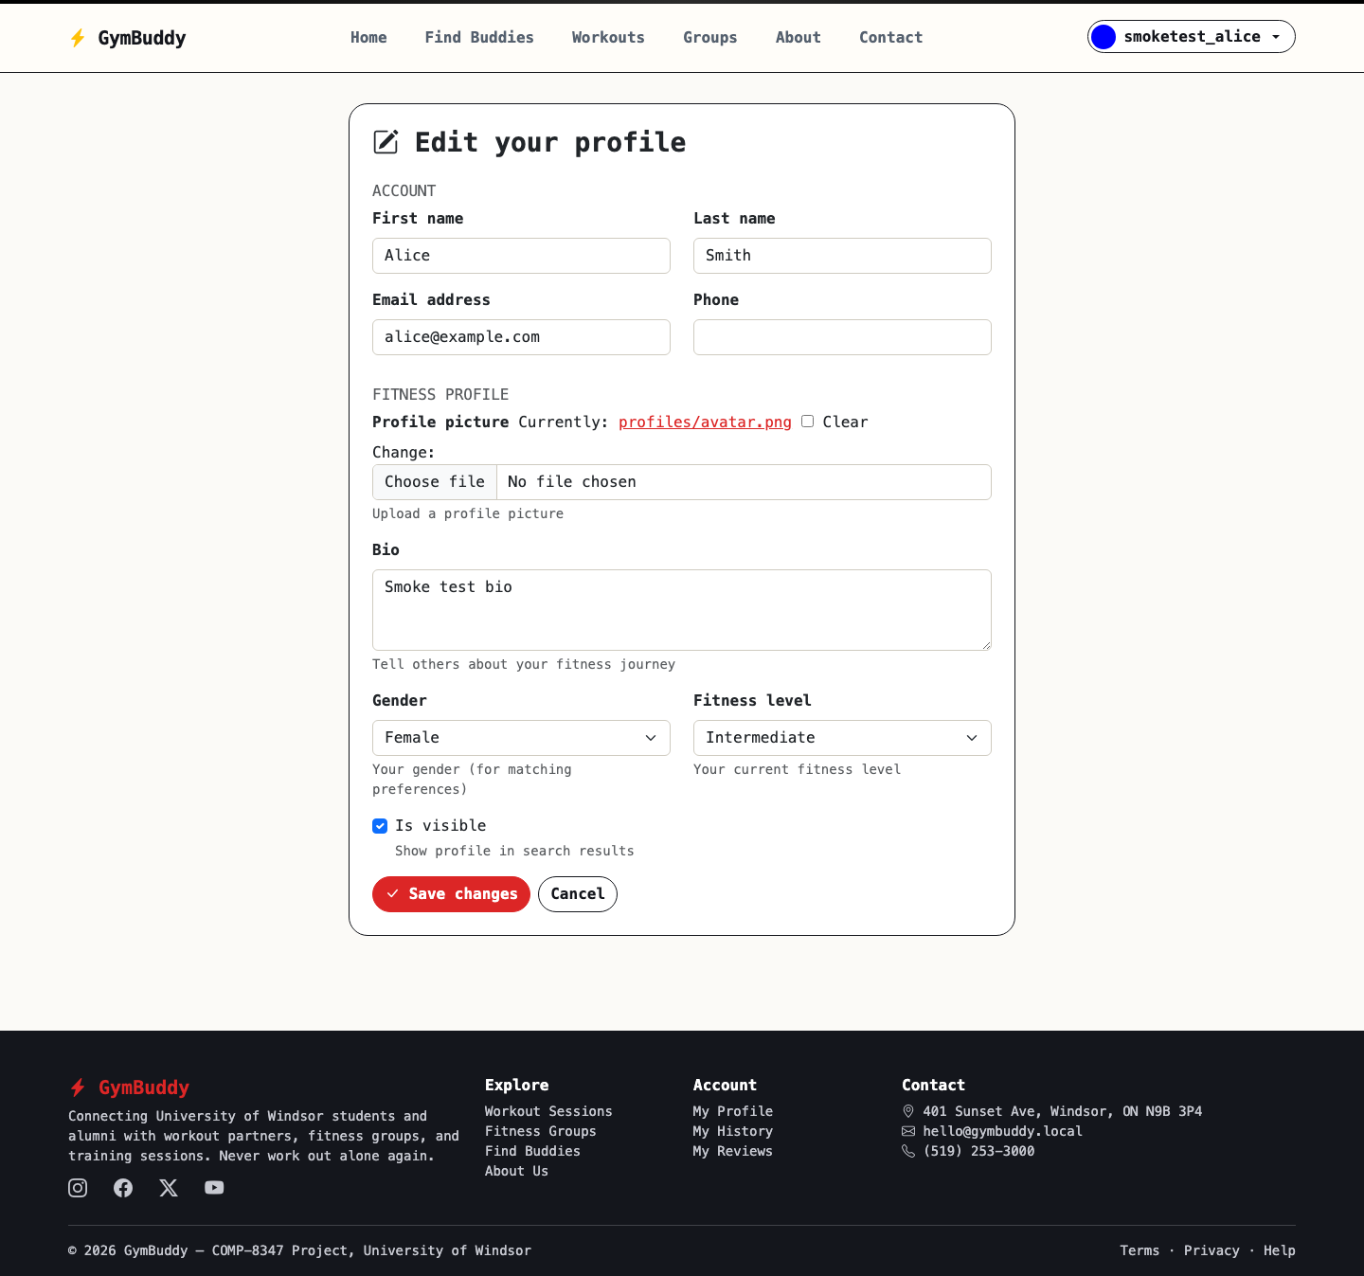
Profile edit form, with account fields plus fitness profile and picture upload.

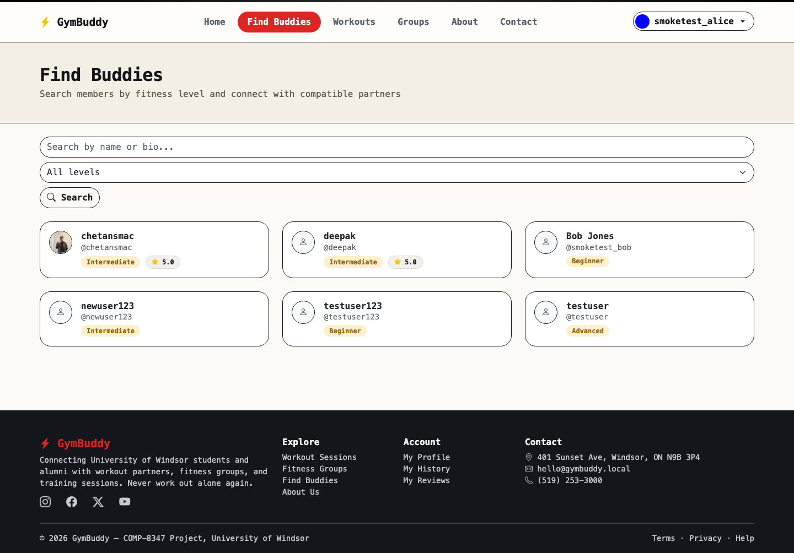
Buddy directory (registered members only), with keyword and fitness-level search.

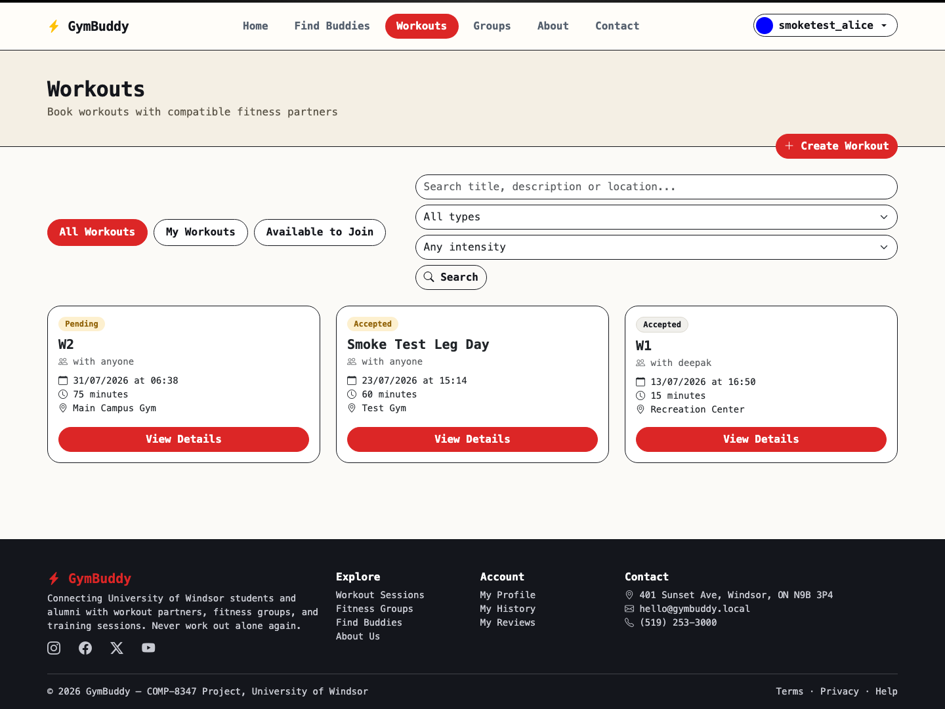
Workout sessions list while logged in, with the "New session" action visible.

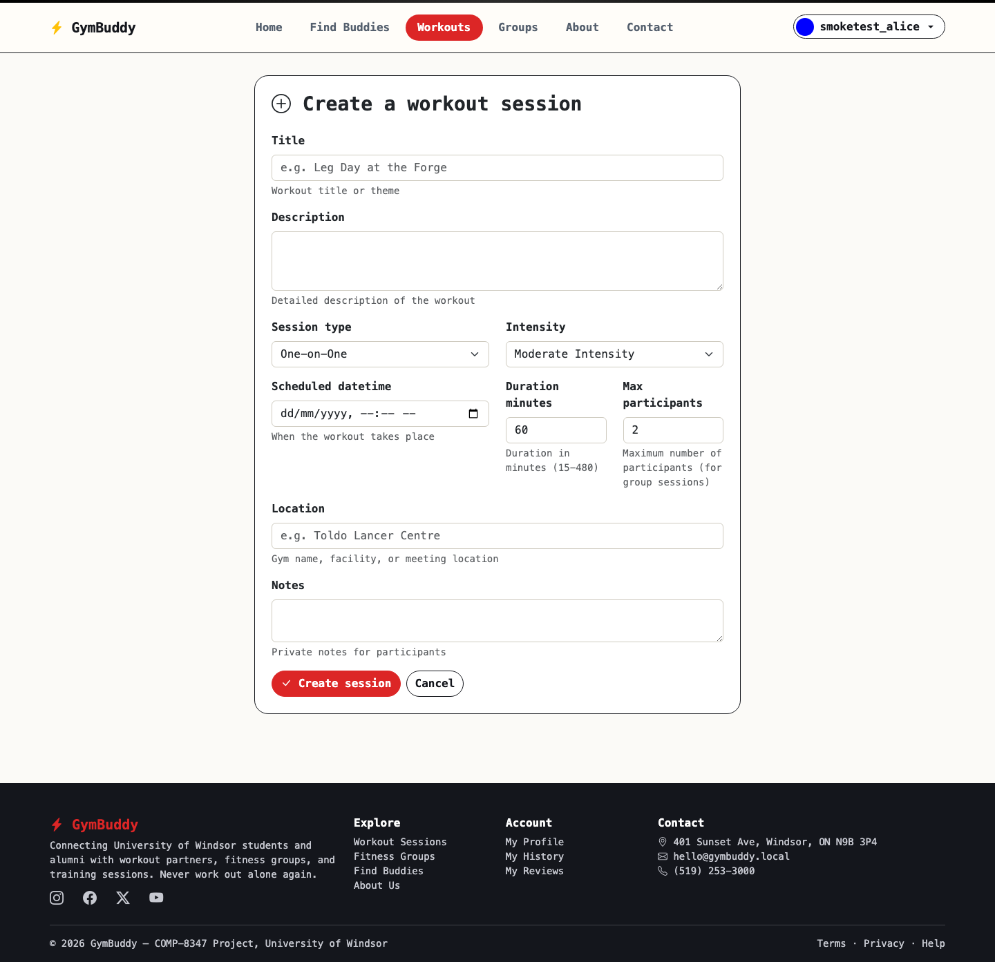
Create Workout Session form.

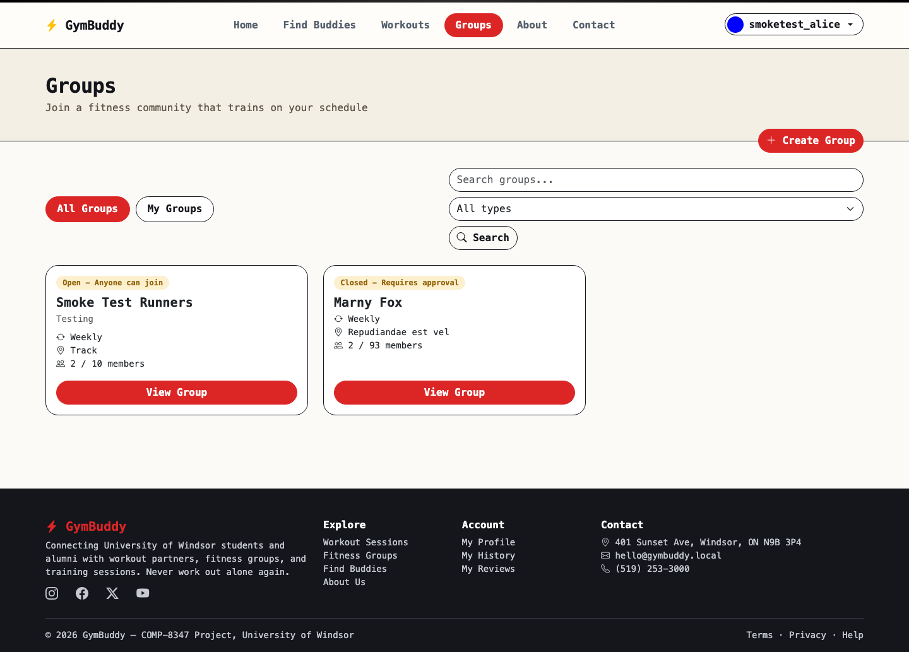
Fitness groups list for logged-in members.

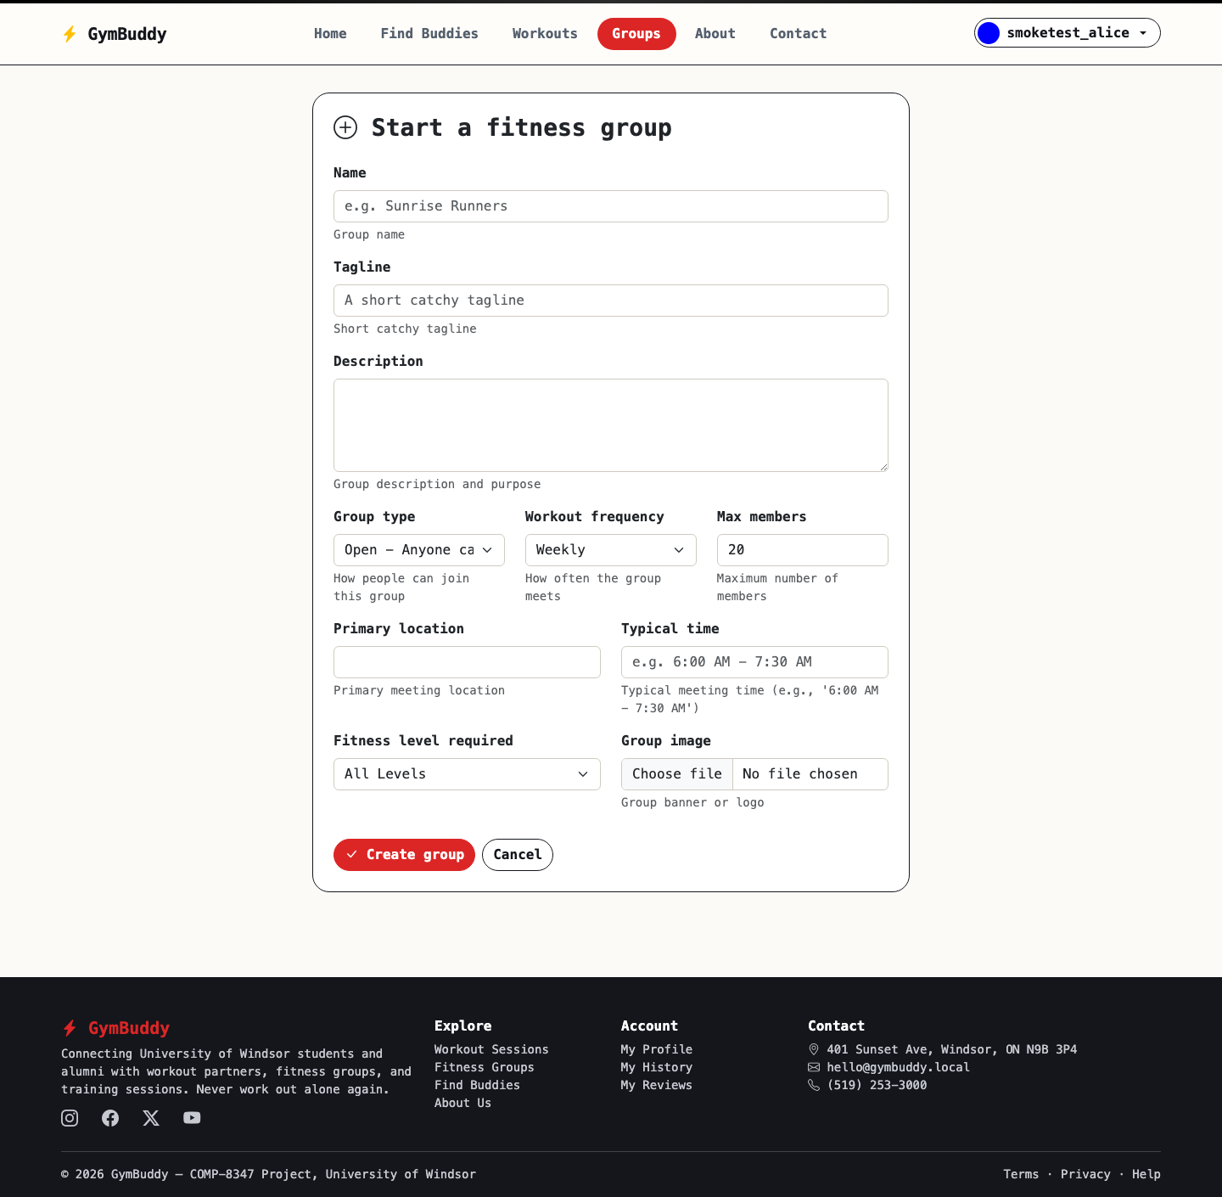
Create Group form, including the group image upload.

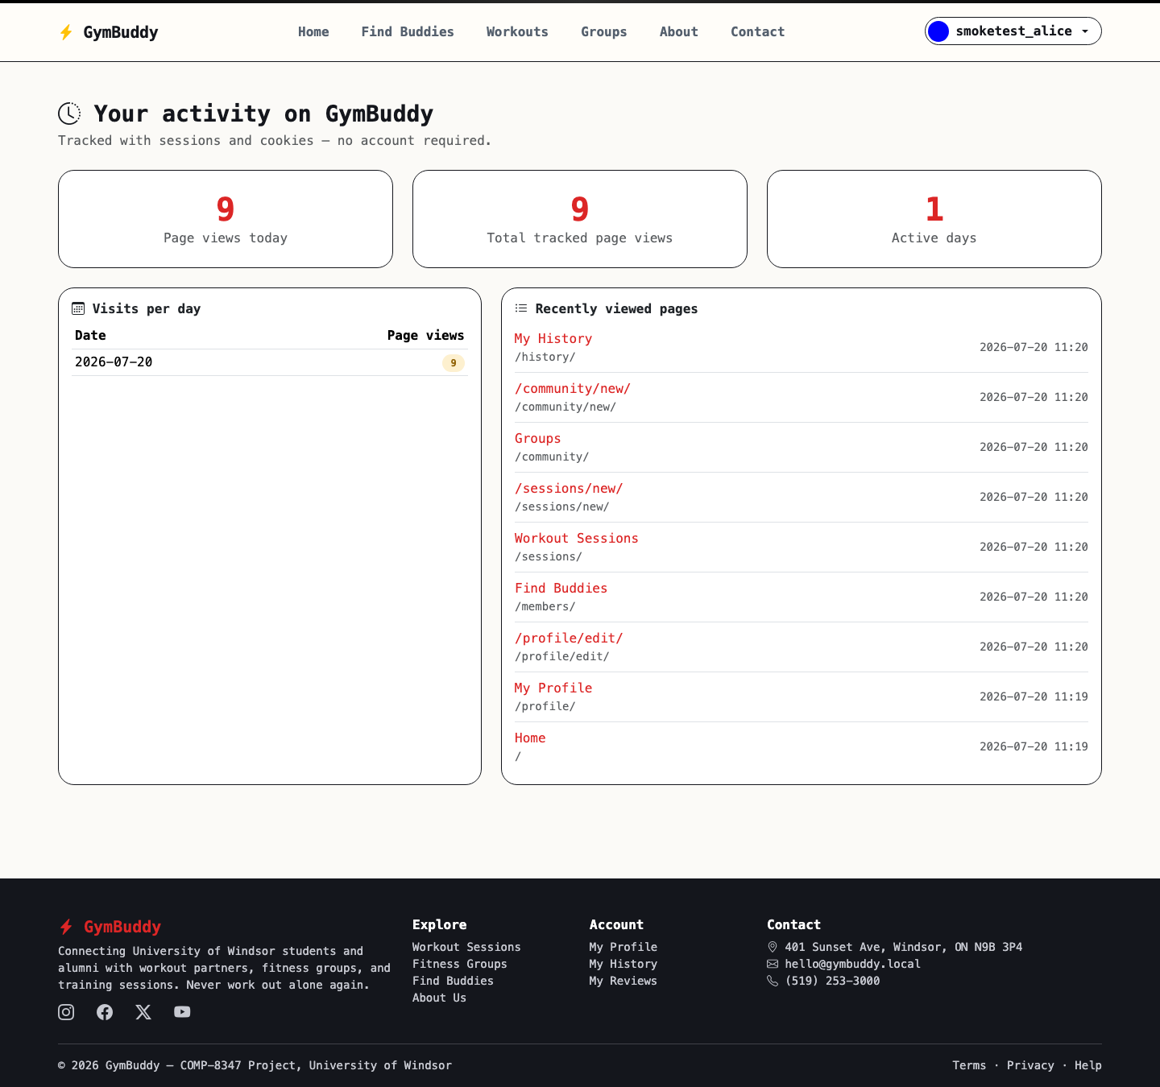
User History page: per-day visit counts, recent pages, and the last_visit cookie.

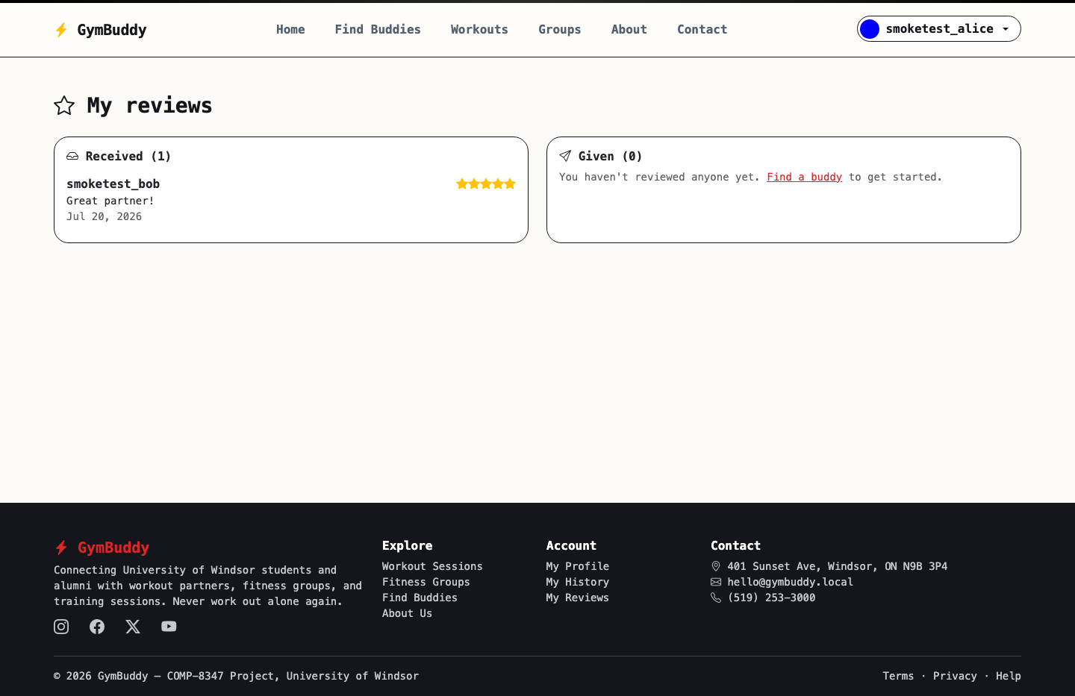
My Reviews page, showing ratings received and given.

7. Setup & Running Instructions

Backend (Django template site + API)
- python -m venv .venv && source .venv/bin/activate
- pip install -r requirements/development.txt
- python manage.py migrate
- python manage.py loaddata initial_data # seeds users, sessions, groups, ratings
- python manage.py createsuperuser # optional, for /admin/
- python manage.py runserver
The template site is served at http://localhost:8000/ and the REST API at http://localhost:8000/api/.

Frontend (optional Next.js client)
- cd frontend
- npm install
- npm run dev
Available at http://localhost:3000/, talking to the same Django API.

8. Testing Summary
An automated end-to-end smoke test was run against the template site (using Django's test client against the real database and templates) to verify every mandatory feature before the demo. All 34 checks passed:
Area | What was verified
Guest access | Home, session list and group list load; member-only pages (buddy directory, session creation) correctly redirect guests to login.
Registration & login | Sign-up creates a User and UserProfile and logs the user in; a wrong password is rejected with a visible form error; the correct password logs in successfully.
Profile & file upload | Editing the profile with a real image file saves both the bio and the uploaded picture to media/.
Workout sessions | Creating a session succeeds; searching by keyword plus the intensity dropdown returns the matching session and an out-of-scope keyword correctly returns zero results without error.
Groups | Creating a group assigns a unique slug; a second member can join an open group and the membership becomes active.
Ratings | Submitting a rating creates the Rating row and correctly recalculates the recipient's average_rating.
History tracking | Browsing the site increments the session-based daily visit count, populates the recent-pages list, and sets the last_visit cookie.
Password reset | Requesting a reset sends an email (console backend) end to end.

Result: 34 / 34 automated checks passed. The team should additionally test manually for the live demo: empty search results, duplicate sign-up emails, and re-rating an existing partner.

9. Links
GitHub repository: [to be added — repository not yet created for this project]
Reminder: add GitHub user comp8347proj as a collaborator before submitting, and make sure commit history shows steady contributions from all five members, not a single end-of-project push.

10. Brightspace Submission Checklist
- This Word document (GymBuddy_Project_Report.docx), uploaded directly — not inside a folder.
- apps/users/views.py, apps/workouts/views.py, apps/groups/views.py, apps/ratings/views.py (or the combined main views.py your course expects) — uploaded individually.
- apps/users/models.py, apps/workouts/models.py, apps/groups/models.py, apps/ratings/models.py — uploaded individually.
- apps/users/forms.py, apps/workouts/forms.py, apps/groups/forms.py, apps/ratings/forms.py — uploaded individually.
- Link to the GitHub repository filled in above.
- Each member has reviewed their assigned code and can explain it unprompted for the viva.

