



SEMESTER –

Academic Year : __________________________________________________
Name : _____________________________________ Roll No : ____________
Subject : ________________________________________________________
Branch : ________________ Division : _________Batch : ________________
Examination Seat No :_____________________________________________





Academic Year 2026-27

CERTIFICATE

This is to certify that Mr./Ms.________________________________________
Roll No. _____ Exam Seat No. _____________Branch ___________________
Semester _____Academic Year _____________has completed Term work
(Practicals / Tutorials / Assignments /Test)in Subject__________________ as
per the syllabus prescribed by the University of Mumbai successfully.

Faculty

Mini Project on
“Legal Contract Clause Extractor”

Submitted in partial fulfillment of the requirements of the degree
of

Bachelor of Engineering in Computer Science &
Engineering (AI & ML) Department

Submitted by
Atharv Bowlekar (02)

Under the guidance of:
Ms. Apurva Jadhav

DEPARTMENT OF COMPUTER SCIENCE AND ENGINEERING
(AI & ML) VIVA INSTITUTE OF TECHNOLOGY
At Shirgoan, Virar (East), Tal. Vasai, Dist. Palghar – 401305
2026-27

Table of Contents
Sr No. | Topics | Page No.
1) | Introduction
2) | Motivation
3) | Objective
4) | Resources & Technology Stack Used
5) | Algorithm & Processing Logic
6) | Flowchart
7) | Source Code Files
8) | Output & Interface Briefing
9) | Conclusion & Future Scope

INTRODUCTION

“Concise briefing of the project topic”
The Legal Contract Intelligence (LCCE) platform is an advanced, full-stack web application designed to apply state-of-the-art Natural Language Processing (NLP) to the legal domain. Historically, the legal field has been highly resistant to automation due to the dense, verbose, and structurally complex nature of legal jargon (often referred to as "legalese"). However, with the advent of Generative AI and Large Language Models (LLMs), it is now possible to programmatically parse, understand, and extract deep semantic meaning from these texts.
LCCE acts as an automated "AI Legal Analyst." The system is engineered to ingest raw unstructured data either via direct text input or by parsing binary PDF documents and process it through a robust backend API. Utilizing a high-performance Generative AI model (Google Gemma), the system systematically deconstructs the contract. It extracts critical metadata (parties involved, monetary values, dates), identifies and categorizes binding obligations, and most importantly, flags predatory or asymmetrical risks. This parsed data is dynamically rendered onto a highly interactive, responsive frontend dashboard utilizing canvas-based data visualizations, and can ultimately be compiled into a professional, downloadable PDF intelligence report.

MOTIVATION

The core motivation for this project stems from a profound societal issue: the inherent and systemic power imbalance in modern legal agreements.
Every day, average consumers, freelancers, and small business owners are forced to sign complex documents such as Master Services Agreements, NDAs, Commercial Leases, and Software EULAs. Large corporations employ dedicated legal teams to draft these contracts in a way that heavily insulates them from liability while placing maximum burden on the signee. Because the average individual lacks the financial resources to hire legal counsel (which can cost upwards of $300 to $500 an hour) for every document they sign, they routinely agree to predatory terms blindly.
These predatory terms often include :
- Asymmetrical Liability Caps : Where the corporation is protected from all damages, but the consumer is fully liable.
- Unilateral Fee-Shifting : Clauses dictating that if a dispute occurs, the consumer must pay the corporation's legal fees regardless of who is at fault.
- Auto-Renewal Traps & Predatory Audits : Hidden clauses that trigger massive financial penalties without fair warning.
The motivation behind LCCE is to democratize legal comprehension. By providing a free, instant, and highly accurate NLP tool, we can translate dense legal jargon into a "Plain English" summary and explicitly warn users of hidden dangers, effectively giving them the power of an expert legal review in seconds.

OBJECTIVE

To successfully build the LCCE platform, the project was broken down into several granular technical objectives:
- Unstructured Data Ingestion: Develop a secure frontend mechanism to handle file uploads, specifically parsing binary PDF files and extracting raw text strings without losing structural integrity.
- Prompt Engineering & JSON Schema Enforcement: Generative AI models naturally output conversational text. A major objective was to engineer a strict system prompt that forces the LLM to return data perfectly formatted to a predefined JSON schema, ensuring the backend Python code can parse it programmatically without crashing.
- NLP Pipeline Integration: Successfully integrate a Generative LLM via the OpenRouter API to perform Named Entity Recognition (NER), text classification, and sentiment/risk analysis.
- Data Visualization UI/UX: Design an enterprise-grade, dark-mode (OLED pitch-black) frontend. Utilize Chart.js to render complex data into intuitive visualizations, specifically a Doughnut chart for the Overall Risk Score and a multi-axis Radar chart for contract Favorability.
- Dynamic PDF Compilation: Implement a backend routing system capable of taking the parsed JSON intelligence data, injecting it into an HTML/CSS template, and converting it into a styled, downloadable A4 PDF report using CSS2.1 paradigms.

RESOURCES AND TECHNOLOGY STACK USED

The project was built utilizing a modern, decoupled architecture :
- Frontend Technologies:
  - HTML5 / CSS3: Utilized advanced custom CSS properties (variables), flexbox/grid layouts, and cubic-bezier transition animations for a premium user experience.
  - Vanilla JavaScript (ES6+): Used for DOM manipulation, asynchronous fetch() API calls, and drag-and-drop file handling.
  - Chart.js: A robust canvas-based charting library used to render the Intelligence Dashboard graphs.
- Backend Technologies:
  - Python (v3.11): The core programming language used for server-side logic.
  - Flask: A lightweight WSGI web application framework used to build the RESTful API endpoints (/api/analyze and /api/export-pdf).
  - xhtml2pdf: A Python library utilized for dynamically converting HTML templates into formatted PDF files.
- NLP & Artificial Intelligence:
  - OpenAI Python SDK: Utilized as the structural client to communicate with the AI model.
  - OpenRouter API: Acts as the routing gateway to access massive open-weight models.
  - Google Gemma (gemma-4-26b-a4b-it): The specific LLM chosen for its blazing-fast inference speed, deep reasoning capabilities, and adherence to strict JSON formatting instructions.

ALGORITHM & PROCESSING LOGIC

Step-by-Step Algorithmic Flow:
- Initialization: The user interface loads. The system waits for an onDrop or onChange event from the file input, or a text paste event.
- Payload Construction: Upon clicking "Analyze", JavaScript intercepts the data. If a PDF is uploaded, it is appended to a FormData object; otherwise, the raw text is used.
- Backend Reception: The Flask route /api/analyze receives the POST request.
- Schema Injection: The backend generates a strict Pydantic BaseModel schema representing the exact data structure required (Risks, Metadata, Favorability, Clauses). This schema is injected into the system prompt.
- Inference Execution: The payload is sent to the Google Gemma model via OpenRouter.
- Retry Logic (Resiliency): If the API returns a 429 (Rate Limit) or 503 (Service Unavailable) error, an exponential backoff algorithm triggers, pausing the thread and retrying the connection up to a maximum limit.
- Data Sanitization: The AI returns a string. The backend strips any markdown formatting (e.g., json) and uses json.loads()` to convert it into a Python dictionary.
- Frontend Rendering: The JSON is returned to the client with a 200 OK status. The JS destroys any old Chart.js instances, creates new ones, iterates through the risk arrays to build DOM elements, and applies highlighting algorithms to the original text.
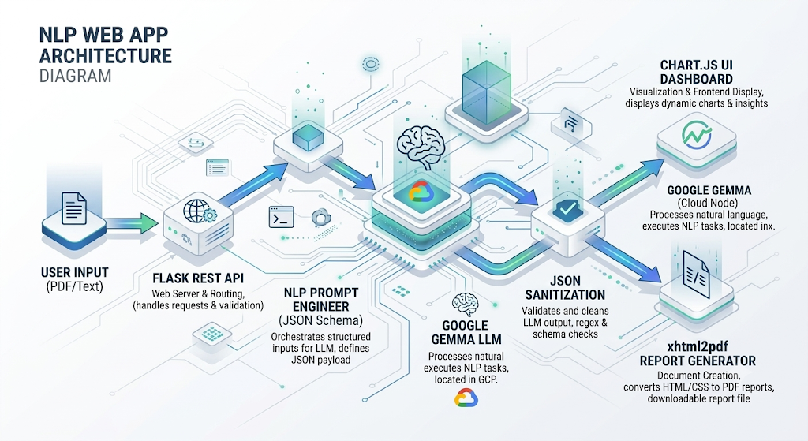
Fig 1.a. NLP Web App Architecture Overview Diagram for understanding the project.
FLOWCHART

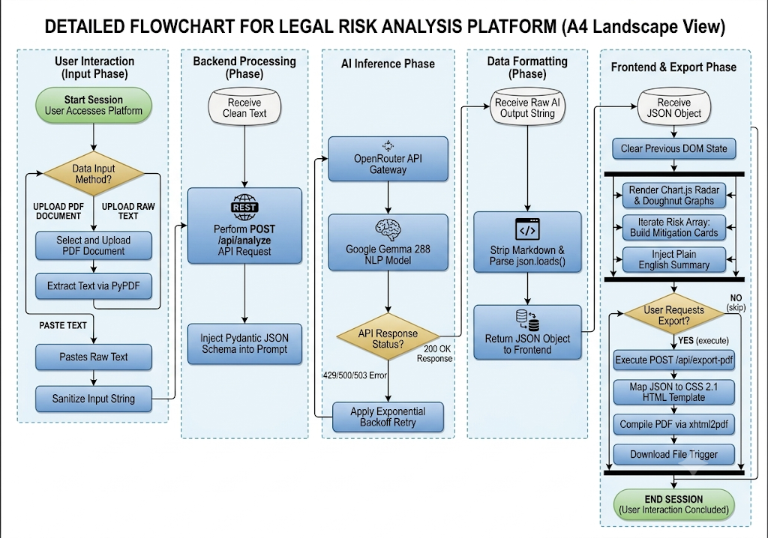
Fig 2.a Flowchart for understanding the Working Mechanism of the project

SOURCE CODE FILES
Index.html :
<!DOCTYPE html>
<html lang="en" data-theme="dark">
<head>
<meta charset="UTF-8">
<meta name="viewport" content="width=device-width, initial-scale=1.0">
<title>LCCE | Legal Contract Intelligence</title>
<link rel="preconnect" href="https://fonts.googleapis.com">
<link rel="preconnect" href="https://fonts.gstatic.com" crossorigin>
<link href="https://fonts.googleapis.com/css2?family=Inter:wght@400;500;600;700&display=swap" rel="stylesheet">
<link rel="stylesheet" href="style.css?v=4">
<script src="https://cdn.jsdelivr.net/npm/chart.js"></script>
</head>
<body>
<nav class="navbar">
<div class="nav-container">
<div class="logo">
<svg width="24" height="24" viewBox="0 0 24 24" fill="none" stroke="currentColor" stroke-width="2" stroke-linecap="round" stroke-linejoin="round"><path d="M12 22s8-4 8-10V5l-8-3-8 3v7c0 6 8 10 8 10z"/></svg>
<span>Automated Contract Intelligence</span>
</div>
<button id="theme-toggle" class="theme-toggle" aria-label="Toggle Theme">
<svg id="moon-icon" class="hidden" width="20" height="20" viewBox="0 0 24 24" fill="none" stroke="currentColor" stroke-width="2"><path d="M21 12.79A9 9 0 1 1 11.21 3 7 7 0 0 0 21 12.79z"></path></svg>
<svg id="sun-icon" width="20" height="20" viewBox="0 0 24 24" fill="none" stroke="currentColor" stroke-width="2"><circle cx="12" cy="12" r="5"></circle><line x1="12" y1="1" x2="12" y2="3"></line><line x1="12" y1="21" x2="12" y2="23"></line><line x1="4.22" y1="4.22" x2="5.64" y2="5.64"></line><line x1="18.36" y1="18.36" x2="19.78" y2="19.78"></line><line x1="1" y1="12" x2="3" y2="12"></line><line x1="21" y1="12" x2="23" y2="12"></line><line x1="4.22" y1="19.78" x2="5.64" y2="18.36"></line><line x1="18.36" y1="5.64" x2="19.78" y2="4.22"></line></svg>
</button>
</div>
</nav>
<main class="app-container">
<!-- Input View -->
<section id="input-view" class="view-section active">
<div class="hero">
<h1>Legal Contract Clause Extractor (LCCE) </h1>
<p>Upload your legal documents to instantly extract obligations, assess risks, and generate plain-English summaries.</p>
</div>

<div class="input-card">
<div class="tabs">
<button class="tab active" data-target="upload-tab">Upload PDF</button>
<button class="tab" data-target="paste-tab">Paste Text</button>
</div>

<div class="tab-content active" id="upload-tab">
<div class="upload-dropzone" id="dropzone">
<svg width="48" height="48" viewBox="0 0 24 24" fill="none" stroke="currentColor" stroke-width="1.5"><path d="M21 15v4a2 2 0 0 1-2 2H5a2 2 0 0 1-2-2v-4"></path><polyline points="17 8 12 3 7 8"></polyline><line x1="12" y1="3" x2="12" y2="15"></line></svg>
<h3>Drag & drop your contract here</h3>
<p>or click to browse from your computer (PDF only)</p>
<input type="file" id="file-input" accept=".pdf" class="hidden-input">
<div id="file-indicator" class="file-indicator hidden">
<span class="file-name" id="file-name"></span>
<button class="icon-btn" id="remove-file-btn">
<svg width="16" height="16" viewBox="0 0 24 24" fill="none" stroke="currentColor" stroke-width="2"><line x1="18" y1="6" x2="6" y2="18"></line><line x1="6" y1="6" x2="18" y2="18"></line></svg>
</button>
</div>
</div>
<div class="tab-actions">
<button id="analyze-btn-upload" class="primary-btn analyze-btn" disabled>
<span class="btn-text">Analyze PDF Document</span>
<div class="spinner hidden"></div>
</button>
</div>
</div>

<div class="tab-content" id="paste-tab">
<textarea id="text-input" class="modern-textarea" placeholder="Paste the raw text of your contract here..."></textarea>
<div class="tab-actions">
<button id="analyze-btn-paste" class="primary-btn analyze-btn" disabled>
<span class="btn-text">Analyze Pasted Text</span>
<div class="spinner hidden"></div>
</button>
</div>
</div>
</div>
<br>
<h3 style="text-align: center;">Developed By : Atharv</h3>
</section>
<!-- Results View -->
<section id="results-view" class="view-section split-layout hidden">
<!-- Left Pane: Original Text -->
<aside class="document-pane">
<div class="pane-header">
<h2>Source Document</h2>
<button id="new-analysis-btn" class="secondary-btn">New Analysis</button>
</div>
<div class="document-content" id="original-text-content">
<!-- Text injected here -->
</div>
</aside>
<!-- Right Pane: Analysis Results -->
<div class="results-pane">
<div class="pane-header">
<h2>AI Analysis</h2>
<button id="download-pdf-btn" class="primary-btn" style="padding: 0.4rem 0.8rem; font-size: 0.85rem; display: flex; align-items: center; gap: 0.4rem;">
<svg width="16" height="16" viewBox="0 0 24 24" fill="none" stroke="currentColor" stroke-width="2"><path d="M21 15v4a2 2 0 0 1-2 2H5a2 2 0 0 1-2-2v-4"></path><polyline points="7 10 12 15 17 10"></polyline><line x1="12" y1="15" x2="12" y2="3"></line></svg>
Download PDF
</button>
</div>
<div class="results-scroll">
<!-- INTELLIGENCE DASHBOARD -->
<div class="result-card" id="dashboard-card" style="display: none;">
<div class="card-header">
<div class="header-title">
<svg width="20" height="20" viewBox="0 0 24 24" fill="none" stroke="currentColor" stroke-width="2"><line x1="18" y1="20" x2="18" y2="10"></line><line x1="12" y1="20" x2="12" y2="4"></line><line x1="6" y1="20" x2="6" y2="14"></line></svg>
<h3>Intelligence Dashboard</h3>
</div>
</div>
<div class="card-body">
<div class="dashboard-grid">
<div class="chart-container">
<h4>Overall Risk Score</h4>
<div class="risk-score-display" id="risk-score-display">--</div>
<div style="position: relative; width: 100%; height: 180px;">
<canvas id="riskChart"></canvas>
</div>
</div>
<div class="chart-container">
<h4>Favorability Radar</h4>
<div style="position: relative; width: 100%; height: 220px;">
<canvas id="radarChart"></canvas>
</div>
</div>
</div>
</div>
</div>
<!-- Metadata Fast Facts -->
<div class="metadata-grid" id="metadata-container">
<!-- Chips injected here -->
</div>
<!-- Risk Analysis -->
<div class="result-card danger-card hidden" id="risks-container">
<div class="card-header">
<div class="header-title">
<svg width="20" height="20" viewBox="0 0 24 24" fill="none" stroke="currentColor" stroke-width="2"><path d="M10.29 3.86L1.82 18a2 2 0 0 0 1.71 3h16.94a2 2 0 0 0 1.71-3L13.71 3.86a2 2 0 0 0-3.42 0z"></path><line x1="12" y1="9" x2="12" y2="13"></line><line x1="12" y1="17" x2="12.01" y2="17"></line></svg>
<h3>Critical Risks Detected</h3>
</div>
<span class="count-badge danger-badge" id="risks-count">0</span>
</div>
<div class="card-body" id="risks-content"></div>
</div>
<!-- Summary moved to bottom -->
<!-- Obligations -->
<div class="result-card warning-card">
<div class="card-header">
<div class="header-title">
<svg width="20" height="20" viewBox="0 0 24 24" fill="none" stroke="currentColor" stroke-width="2"><path d="M14 2H6a2 2 0 0 0-2 2v16a2 2 0 0 0 2 2h12a2 2 0 0 0 2-2V8z"></path><polyline points="14 2 14 8 20 8"></polyline><line x1="16" y1="13" x2="8" y2="13"></line><line x1="16" y1="17" x2="8" y2="17"></line><polyline points="10 9 9 9 8 9"></polyline></svg>
<h3>Binding Obligations</h3>
</div>
<span class="count-badge warning-badge" id="obligations-count">0</span>
</div>
<div class="card-body">
<ul class="interactive-list" id="obligations-list"></ul>
</div>
</div>
<!-- Clauses -->
<div class="result-card neutral-card">
<div class="card-header">
<div class="header-title">
<svg width="20" height="20" viewBox="0 0 24 24" fill="none" stroke="currentColor" stroke-width="2"><polygon points="12 2 2 7 12 12 22 7 12 2"></polygon><polyline points="2 17 12 22 22 17"></polyline><polyline points="2 12 12 17 22 12"></polyline></svg>
<h3>Categorized Clauses</h3>
</div>
</div>
<div class="card-body clause-list" id="clauses-content"></div>
</div>
<!-- Plain English Summary (Highlighted at Bottom) -->
<div class="result-card highlight-card">
<div class="card-header">
<div class="header-title">
<svg width="20" height="20" viewBox="0 0 24 24" fill="none" stroke="currentColor" stroke-width="2"><circle cx="12" cy="12" r="10"></circle><line x1="12" y1="16" x2="12" y2="12"></line><line x1="12" y1="8" x2="12.01" y2="8"></line></svg>
<h3>Plain English Summary</h3>
</div>
</div>
<div class="card-body">
<p id="summary-content" class="prose summary-text"></p>
</div>
</div>
</div>
</div>
</section>
<!-- Toast Notification -->
<div id="toast" class="toast hidden"></div>
</main>
<script src="script.js"></script>
</body>
</html>

Script.js
document.addEventListener('DOMContentLoaded', () => {
// DOM Elements
const themeToggleBtn = document.getElementById('theme-toggle');
const moonIcon = document.getElementById('moon-icon');
const sunIcon = document.getElementById('sun-icon');
const htmlElement = document.documentElement;
const tabs = document.querySelectorAll('.tab');
const tabContents = document.querySelectorAll('.tab-content');
const fileInput = document.getElementById('file-input');
const dropzone = document.getElementById('dropzone');
const fileIndicator = document.getElementById('file-indicator');
const fileNameDisplay = document.getElementById('file-name');
const removeFileBtn = document.getElementById('remove-file-btn');
const textInput = document.getElementById('text-input');
const analyzeBtns = document.querySelectorAll('.analyze-btn');
const newAnalysisBtn = document.getElementById('new-analysis-btn');
const downloadPdfBtn = document.getElementById('download-pdf-btn');
const inputView = document.getElementById('input-view');
const resultsView = document.getElementById('results-view');
const originalTextContent = document.getElementById('original-text-content');
// Chart instances
let riskChartInstance = null;
let radarChartInstance = null;
const toast = document.getElementById('toast');
// Result Containers
const metadataContainer = document.getElementById('metadata-container');
const risksContainer = document.getElementById('risks-container');
const risksContent = document.getElementById('risks-content');
const risksCount = document.getElementById('risks-count');
const summaryContent = document.getElementById('summary-content');
const obligationsList = document.getElementById('obligations-list');
const obligationsCount = document.getElementById('obligations-count');
const clausesContent = document.getElementById('clauses-content')
let currentOriginalText = "";
let currentResultsData = null; // Store results for PDF generation
let selectedFile = null;
// THEME TOGGLE LOGIC
function toggleTheme() {
const currentTheme = htmlElement.getAttribute('data-theme');
const newTheme = currentTheme === 'dark' ? 'light' : 'dark';
htmlElement.setAttribute('data-theme', newTheme);
if (newTheme === 'dark') {
moonIcon.classList.add('hidden');
sunIcon.classList.remove('hidden');
} else {
sunIcon.classList.add('hidden');
moonIcon.classList.remove('hidden');
}
}
themeToggleBtn.addEventListener('click', toggleTheme)
// TAB LOGIC
tabs.forEach(tab => {
tab.addEventListener('click', () => {
tabs.forEach(t => t.classList.remove('active'));
tabContents.forEach(c => c.classList.remove('active'));
tab.classList.add('active');
document.getElementById(tab.dataset.target).classList.add('active');
checkInputValidity();
});
});
// DRAG & DROP LOGIC
dropzone.addEventListener('click', (e) => {
if(e.target !== removeFileBtn && e.target.closest('#remove-file-btn') === null) {
fileInput.click();
}
});
dropzone.addEventListener('dragover', (e) => {
e.preventDefault();
dropzone.style.borderColor = 'var(--accent-primary)';
});
dropzone.addEventListener('dragleave', (e) => {
e.preventDefault();
dropzone.style.borderColor = '';
});
dropzone.addEventListener('drop', (e) => {
e.preventDefault();
dropzone.style.borderColor = '';
if (e.dataTransfer.files.length) {
handleFileSelection(e.dataTransfer.files[0]);
}
});
fileInput.addEventListener('change', (e) => {
if (e.target.files.length) {
handleFileSelection(e.target.files[0]);
}
});
function handleFileSelection(file) {
if (file.type !== 'application/pdf') {
showToast("Only PDF files are supported for upload.");
return;
}
selectedFile = file;
fileNameDisplay.textContent = file.name;
fileIndicator.classList.remove('hidden');
dropzone.querySelector('h3').classList.add('hidden');
dropzone.querySelector('p').classList.add('hidden');
dropzone.querySelector('svg').classList.add('hidden');
checkInputValidity();
}
removeFileBtn.addEventListener('click', (e) => {
e.stopPropagation();
selectedFile = null;
fileInput.value = '';
fileIndicator.classList.add('hidden');
dropzone.querySelector('h3').classList.remove('hidden');
dropzone.querySelector('p').classList.remove('hidden');
dropzone.querySelector('svg').classList.remove('hidden');
checkInputValidity();
});
textInput.addEventListener('input', checkInputValidity);
function checkInputValidity() {
const activeTab = document.querySelector('.tab.active').dataset.target;
if (activeTab === 'upload-tab') {
document.getElementById('analyze-btn-upload').disabled = !selectedFile;
} else {
document.getElementById('analyze-btn-paste').disabled = textInput.value.trim() === '';
}
}
// NEW ANALYSIS LOGIC
newAnalysisBtn.addEventListener('click', () => {
resultsView.classList.remove('active');
setTimeout(() => {
resultsView.classList.add('hidden');
inputView.classList.remove('hidden');
inputView.classList.add('active');
}, 300);
selectedFile = null;
fileInput.value = '';
textInput.value = '';
fileIndicator.classList.add('hidden');
dropzone.querySelector('h3').classList.remove('hidden');
dropzone.querySelector('p').classList.remove('hidden');
dropzone.querySelector('svg').classList.remove('hidden');
checkInputValidity();
});
// API REQUEST LOGIC
const API_URL = 'http://127.0.0.1:5000/api/analyze';
analyzeBtns.forEach(btn => {
btn.addEventListener('click', async () => {
setLoading(true);
hideToast();
const activeTab = document.querySelector('.tab.active').dataset.target;
const formData = new FormData();
if (activeTab === 'upload-tab' && selectedFile) {
formData.append('file', selectedFile);
} else {
formData.append('text', textInput.value.trim());
}
try {
const response = await fetch(API_URL, {
method: 'POST',
body: formData
});
if (!response.ok) {
const errorData = await response.json();
throw new Error(errorData.error || 'Failed to analyze document.');
}
const data = await response.json();
currentOriginalText = data.original_text || textInput.value.trim();
currentResultsData = data; // Cache for PDF download
// Switch Views
inputView.classList.remove('active');
setTimeout(() => {
inputView.classList.add('hidden');
resultsView.classList.remove('hidden');
void resultsView.offsetWidth;
resultsView.classList.add('active');
originalTextContent.textContent = currentOriginalText;
populateResults(data);
}, 300);
} catch (error) {
console.error('Error:', error);
showToast(error.message || "An error occurred connecting to the server.");
} finally {
setLoading(false);
}
});
});
function setLoading(isLoading) {
analyzeBtns.forEach(btn => {
const btnText = btn.querySelector('.btn-text');
const spinner = btn.querySelector('.spinner');
if (isLoading) {
btn.disabled = true;
btnText.textContent = "Analyzing...";
spinner.classList.remove('hidden');
} else {
checkInputValidity();
btnText.textContent = btn.id === 'analyze-btn-upload' ? "Analyze PDF Document" : "Analyze Pasted Text";
spinner.classList.add('hidden');
}
});
}
// PDF EXPORT LOGIC
downloadPdfBtn.addEventListener('click', async () => {
if (!currentResultsData) return;
// Show loading state on button
const originalText = downloadPdfBtn.innerHTML;
downloadPdfBtn.innerHTML = '<div class="spinner"></div> Generating...';
downloadPdfBtn.disabled = true;
hideToast();
try {
const response = await fetch('http://127.0.0.1:5000/api/export-pdf', {
method: 'POST',
headers: { 'Content-Type': 'application/json' },
body: JSON.stringify(currentResultsData)
});
if (!response.ok) {
const errorData = await response.json();
throw new Error(errorData.error || 'Failed to generate PDF.');
}
// Convert response to blob
const blob = await response.blob();
const url = window.URL.createObjectURL(blob);
// Create a temporary link to trigger download
const a = document.createElement('a');
a.href = url;
a.download = "LCCE_Analysis_Report.pdf";
document.body.appendChild(a);
a.click();
window.URL.revokeObjectURL(url);
a.remove();
} catch (error) {
console.error('Export Error:', error);
showToast(error.message || "An error occurred while generating the PDF.");
} finally {
downloadPdfBtn.innerHTML = originalText;
downloadPdfBtn.disabled = false;
}
});
// HIGHLIGHTING LOGIC
function highlightOriginalText(searchString) {
if (!searchString) return;
const escapedSearch = searchString.replace(/[.*+?^${}()|[\]\\]/g, '\\$&').substring(0, 100);
if (currentOriginalText.includes(searchString.substring(0, 50))) {
const regex = new RegExp(`(${escapedSearch}[^<]*)`, 'i');
const highlightedHtml = currentOriginalText.replace(regex, '<span class="highlight" id="scroll-target">$1</span>');
originalTextContent.innerHTML = highlightedHtml;
const target = document.getElementById('scroll-target');
if (target) {
target.scrollIntoView({ behavior: 'smooth', block: 'center' });
setTimeout(() => { originalTextContent.textContent = currentOriginalText; }, 3000);
}
}
}
// POPULATE UI
function populateResults(data) {
// 0. Build Dashboard Charts
try {
document.getElementById('dashboard-card').style.display = 'block';
buildCharts(data);
} catch (e) {
console.error("Dashboard Error:", e);
}
// Metadata
try {
metadataContainer.innerHTML = '';
if (data.metadata) {
const icons = {'Parties': '👥', 'Dates': '📅', 'Monetary Values': '💵'};
for (const [key, values] of Object.entries(data.metadata)) {
if (Array.isArray(values)) {
values.forEach(val => {
const chip = document.createElement('div');
chip.className = 'chip';
chip.innerHTML = `<span>${icons[key] || '📌'}</span><span class="chip-label">${key}</span><span class="chip-val">${val}</span>`;
metadataContainer.appendChild(chip);
});
}
}
}
} catch (e) {
console.error("Metadata Error:", e);
}
// Risks
try {
risksContent.innerHTML = '';
if (data.risks && Array.isArray(data.risks) && data.risks.length > 0) {
risksContainer.classList.remove('hidden');
risksCount.textContent = data.risks.length;
data.risks.forEach(risk => {
const div = document.createElement('div');
div.className = 'risk-item';
div.innerHTML = `
<div class="risk-label">${escapeHtml(risk.risk_type)}</div>
<div class="risk-excerpt">"${escapeHtml(risk.excerpt)}"</div>
<div class="mitigation">
<strong>Mitigation Strategy</strong>
${escapeHtml(risk.mitigation_strategy || "Review and negotiate this clause carefully.")}
</div>
`;
risksContent.appendChild(div);
});
} else {
risksContainer.classList.add('hidden');
}
} catch (e) {
console.error("Risks Error:", e);
}
// Summary
summaryContent.textContent = data.summary || "No summary could be generated.";
// Obligations
try {
obligationsList.innerHTML = '';
if (data.obligations && Array.isArray(data.obligations) && data.obligations.length > 0) {
obligationsCount.textContent = data.obligations.length;
data.obligations.forEach(ob => {
const li = document.createElement('li');
li.textContent = ob;
li.addEventListener('click', () => highlightOriginalText(ob));
obligationsList.appendChild(li);
});
} else {
obligationsCount.textContent = "0";
const li = document.createElement('li');
li.textContent = "No binding obligations detected.";
li.style.pointerEvents = 'none';
obligationsList.appendChild(li);
}
} catch (e) {
console.error("Obligations Error:", e);
}
// Clauses
try {
clausesContent.innerHTML = '';
if (data.clauses && typeof data.clauses === 'object' && !Array.isArray(data.clauses)) {
for (const [type, content] of Object.entries(data.clauses)) {
if (content && content.trim() !== '') {
const clauseDiv = document.createElement('div');
clauseDiv.className = 'clause-item';
clauseDiv.innerHTML = `
<div class="clause-label">${escapeHtml(type)}</div>
<div class="clause-body">${escapeHtml(content)}</div>
`;
clauseDiv.querySelector('.clause-body').addEventListener('click', () => highlightOriginalText(content));
clausesContent.appendChild(clauseDiv);
}
}
}
} catch (e) {
console.error("Clauses Error:", e);
}
}
function buildCharts(data) {
const score = data.overall_risk_score || 0;
document.getElementById('risk-score-display').textContent = score;
let scoreColor = '#22c55e'; // Green
if (score > 40) scoreColor = '#eab308'; // Yellow
if (score > 70) scoreColor = '#ef4444'; // Red
const riskCtx = document.getElementById('riskChart').getContext('2d');
if (riskChartInstance) riskChartInstance.destroy();
riskChartInstance = new Chart(riskCtx, {
type: 'doughnut',
data: {
labels: ['Risk', 'Safe'],
datasets: [{
data: [score, 100 - score],
backgroundColor: [scoreColor, 'rgba(148, 163, 184, 0.2)'],
borderWidth: 0
}]
},
options: {
responsive: true,
maintainAspectRatio: false,
cutout: '80%',
plugins: { legend: { display: false }, tooltip: { enabled: false } },
rotation: 270, // Start from top
circumference: 180, // Half circle
}
});
const fav = data.favorability || {};
const radarCtx = document.getElementById('radarChart').getContext('2d');
if (radarChartInstance) radarChartInstance.destroy();
const isDark = document.body.getAttribute('data-theme') === 'dark';
const gridColor = isDark ? 'rgba(255,255,255,0.1)' : 'rgba(0,0,0,0.1)';
const textColor = isDark ? '#94a3b8' : '#64748b';
radarChartInstance = new Chart(radarCtx, {
type: 'radar',
data: {
labels: ['Liability', 'IP Rights', 'Financials', 'Termination', 'Confidentiality'],
datasets: [{
label: 'Favorability',
data: [
fav.liability || 5,
fav.ip_rights || 5,
fav.financials || 5,
fav.termination || 5,
fav.confidentiality || 5
],
backgroundColor: 'rgba(37, 99, 235, 0.2)',
borderColor: '#2563eb',
pointBackgroundColor: '#2563eb',
borderWidth: 2
}]
},
options: {
responsive: true,
maintainAspectRatio: false,
scales: {
r: {
angleLines: { color: gridColor },
grid: { color: gridColor },
pointLabels: { color: textColor, font: { family: 'Inter', size: 11 } },
ticks: { display: false, min: 0, max: 10 }
}
},
plugins: { legend: { display: false } }
}
});
}
function escapeHtml(unsafe) {
if (!unsafe) return "";
return unsafe
.toString()
.replace(/&/g, "&amp;")
.replace(/</g, "&lt;")
.replace(/>/g, "&gt;")
.replace(/"/g, "&quot;")
.replace(/'/g, "&#039;");
}
function showToast(message) {
toast.textContent = message;
toast.classList.remove('hidden');
setTimeout(hideToast, 4000);
}
function hideToast() { toast.classList.add('hidden'); }
});

Nlp_engine.py
import os
import json
import time
from openai import OpenAI
from pydantic import BaseModel, Field
from dotenv import load_dotenv
# Load environment variables from .env file
load_dotenv()
class Risk(BaseModel):
risk_type: str = Field(description="The category of the risk, e.g., 'Auto-Renewal', 'Asymmetrical Liability'")
excerpt: str = Field(description="A short quote from the text demonstrating the risk")
mitigation_strategy: str = Field(description="A specific, actionable recommendation on how to negotiate or fix this risk")
class Favorability(BaseModel):
liability: int = Field(description="Score 1-10 (10 = Highly Favorable, 1 = Highly Unfavorable)")
ip_rights: int = Field(description="Score 1-10")
financials: int = Field(description="Score 1-10")
termination: int = Field(description="Score 1-10")
confidentiality: int = Field(description="Score 1-10")
class Clause(BaseModel):
clause_type: str = Field(description="The type or name of the clause")
clause_text: str = Field(description="The text of the clause")
class Metadata(BaseModel):
Parties: list[str] = Field(description="Names of the companies or individuals entering the agreement")
Monetary_Values: list[str] = Field(description="Any important monetary values, fees, or compensation mentioned")
Dates: list[str] = Field(description="Important dates, deadlines, or durations")
class ContractAnalysis(BaseModel):
overall_risk_score: int = Field(description="A score from 0 to 100 representing the overall danger/risk of the contract. 0 is completely safe, 100 is extremely predatory.")
favorability: Favorability
metadata: Metadata
risks: list[Risk] = Field(description="List of critical or predatory risks found in the contract")
obligations: list[str] = Field(description="List of the most important strict, binding obligations")
clauses: list[Clause] = Field(description="List of key clauses categorized by their legal type")
summary: str = Field(description="A highly accurate, plain-English executive summary of the document")
def analyze_contract(text: str) -> dict:
if not text.strip():
return {}
api_key = os.getenv("OPENROUTER_API_KEY")
if not api_key or api_key == "your_openrouter_api_key_here":
raise Exception("OpenRouter API Key is missing! Please open the .env file in your project folder, paste your API key, and restart the server.")

client = OpenAI(
base_url="https://openrouter.ai/api/v1",
api_key=api_key,
)
schema_json = json.dumps(ContractAnalysis.model_json_schema(), indent=2;
prompt = f"""
You are an expert legal AI assistant. Carefully analyze the following legal contract or text.
1. Calculate an Overall Risk Score (0-100).
2. Score the contract's favorability (1-10) across Liability, IP Rights, Financials, Termination, and Confidentiality.
3. Extract the parties involved, monetary values, and important dates.
4. Identify any critical or predatory risks and provide an actionable Mitigation Strategy for each.
5. Extract a list of the most important binding obligations.
6. Categorize the major clauses.
7. Provide a 'Plain English Summary'. This must be the simplest form of explanation in the easiest words possible. Explain it like the user has zero legal knowledge and is 10 years old. Do not use any legal jargon:
You MUST output valid JSON that strictly adheres to the following JSON schema:
{schema_json}
Return ONLY the raw JSON object. Do not include markdown blocks like ```json.
Contract Text:
{text}
""”
attempt = 0
while True:
try:
response = client.chat.completions.create(
model='google/gemma-4-26b-a4b-it:free',
messages=[
{"role": "user", "content": prompt}
],
response_format={"type": "json_object"},
temperature=0.1,
)
break
except Exception as e:
error_msg = str(e)
if "503" in error_msg or "429" in error_msg or "502" in error_msg:
attempt += 1
sleep_time = min(2 ** attempt, 8)
print(f"Network issue or High Demand detected. Retrying in {sleep_time} seconds (Attempt {attempt})...")
time.sleep(sleep_time)
else:
raise e
result_text = response.choices[0].message.content
result_text = result_text.strip()
if result_text.startswith("```json"):
result_text = result_text[7:]
if result_text.startswith("```"):
result_text = result_text[3:]
if result_text.endswith("```"):
result_text = result_text[:-3]
result_text = result_text.strip()
result_dict = json.loads(result_text)
if "metadata" in result_dict and "Monetary_Values" in result_dict["metadata"]:
result_dict["metadata"]["Monetary Values"] = result_dict["metadata"].pop("Monetary_Values")
if "clauses" in result_dict and isinstance(result_dict["clauses"], list):
formatted_clauses = {}
for c in result_dict["clauses"]:
formatted_clauses[c.get("clause_type", "Unknown")] = c.get("clause_text", "")
result_dict["clauses"] = formatted_clauses
return result_dict

OUTPUT & INTERFACE BRIEFING

The finished LCCE application provides a highly polished, interactive Graphical User Interface (GUI).
- The Input View: Features a drag-and-drop zone with animated borders and a clean text-area, styled in a deep OLED pitch-black dark theme.
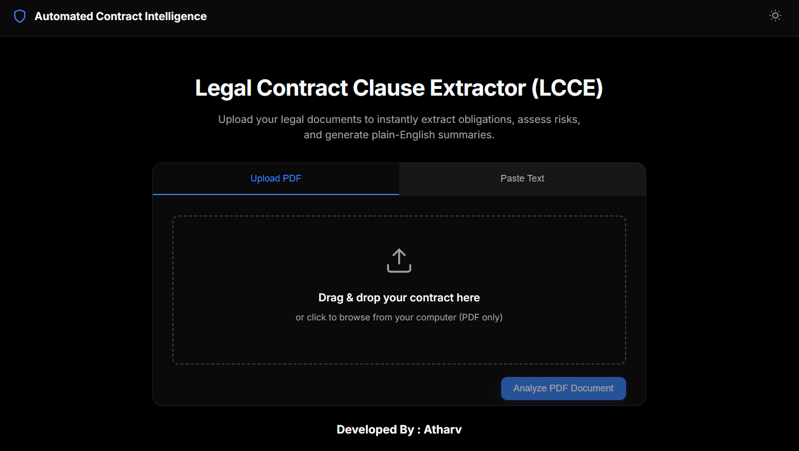
Fig 3.a Dark Mode of the UI. This is the main page of the project
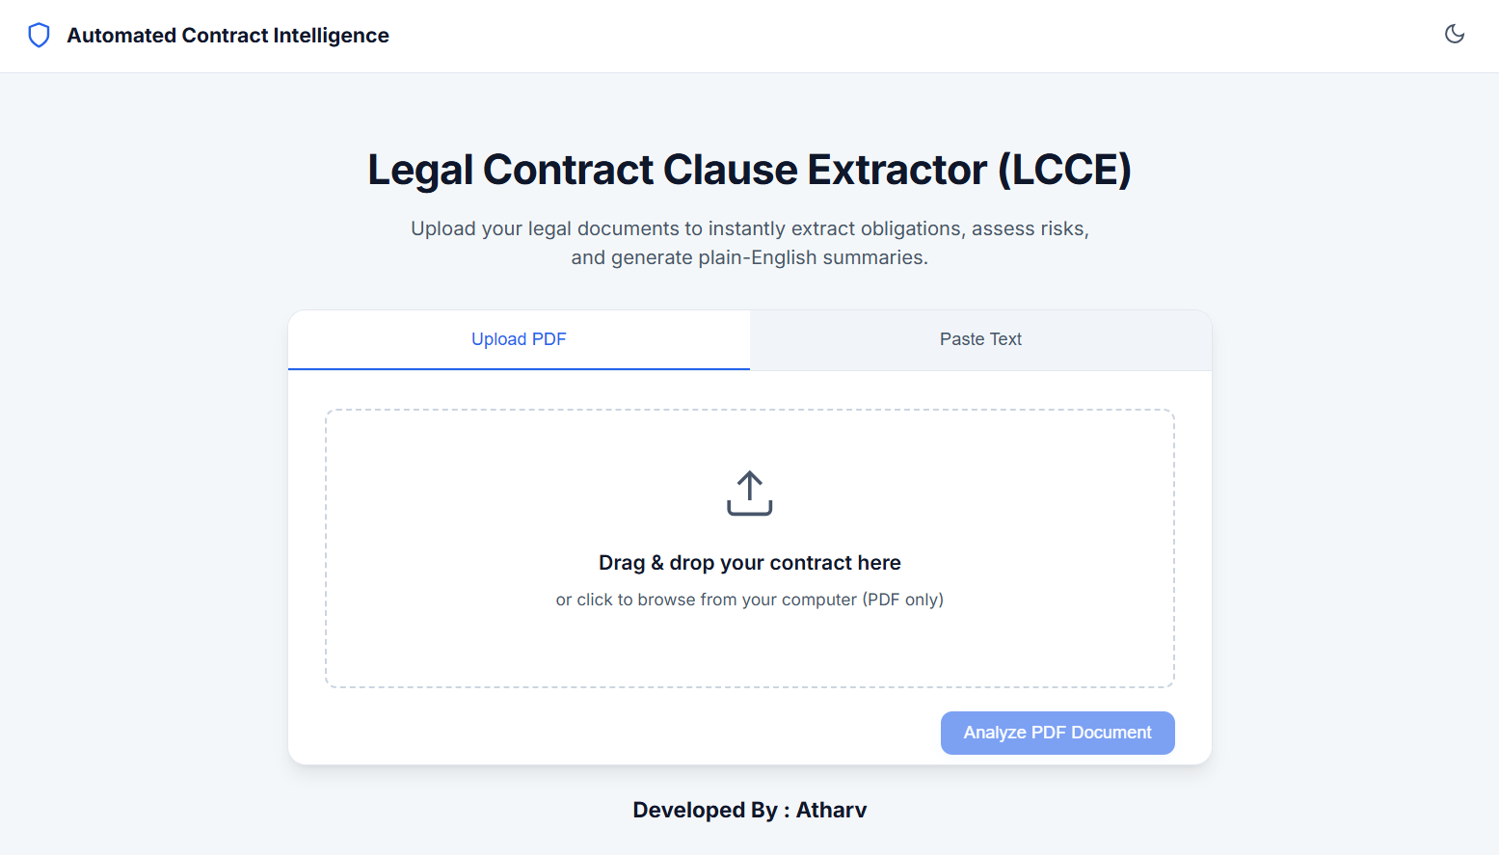
Fig 3.b Light Mode of the UI. Page which has two sections : Upload PDF and Paste Text.
- The Intelligence Dashboard: Upon successful analysis, the view splits into two main panes:
  - Visual Analytics Pane: Displays a massive color-coded (Red/Yellow/Green) numerical Risk Score. Below it sits a dynamic Radar Chart that plots the contract's favorability across five distinct legal axes (Liability, IP Rights, Financials, Termination, Confidentiality).
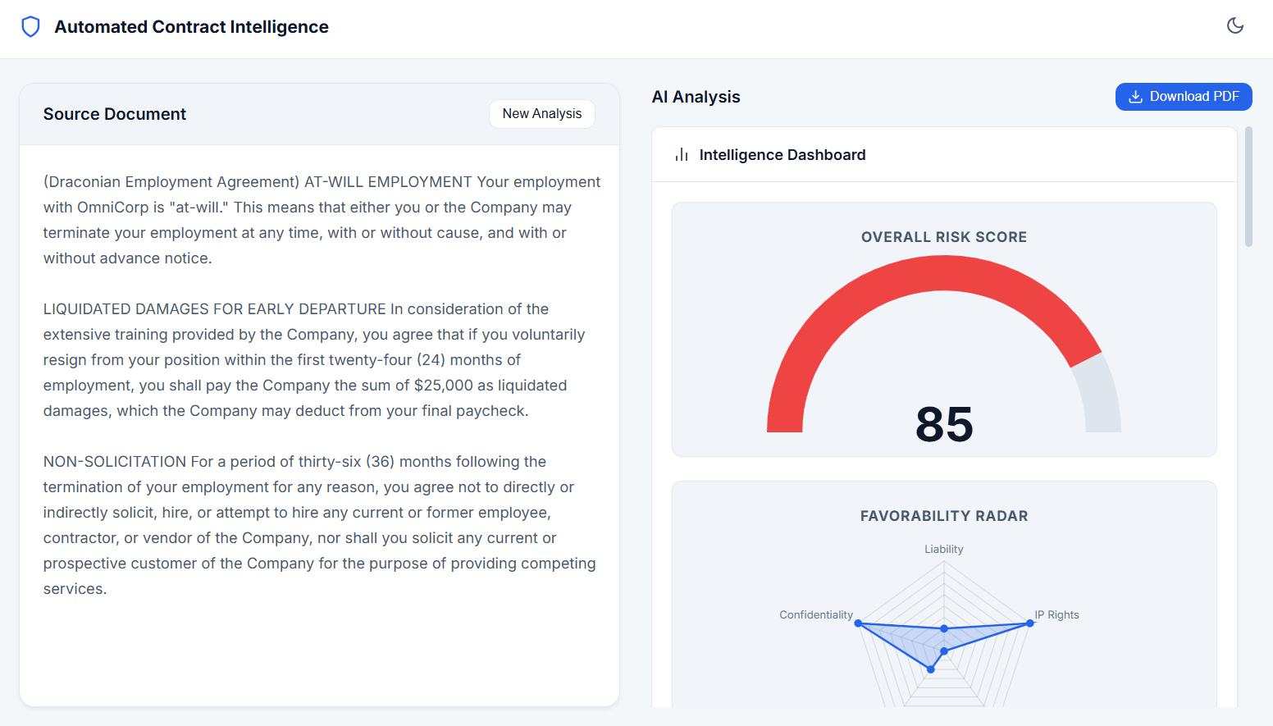
Fig 3.c Provided a PDF Document for observing the Analysis of the project with the help of “Intelligence Dashboard” uses graphs & charts and identifies key insights.
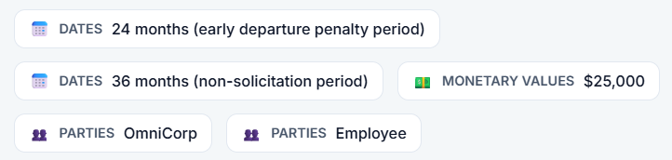
- Insights Pane:
  - Metadata Chips: Highlights extracted entities (Dates, Monetary Values, Parties) using pill-shaped UI chips.
  - Executive Summary: A highlighted, glowing card containing a "10-year-old level" plain-English breakdown of the contract's true meaning.
  - Risk Cards: A list of critical risks extracted from the text. Each risk includes the exact offending quote, categorized by risk type, and features a blue "Mitigation Strategy" box advising the user on how to negotiate or fix the clause.
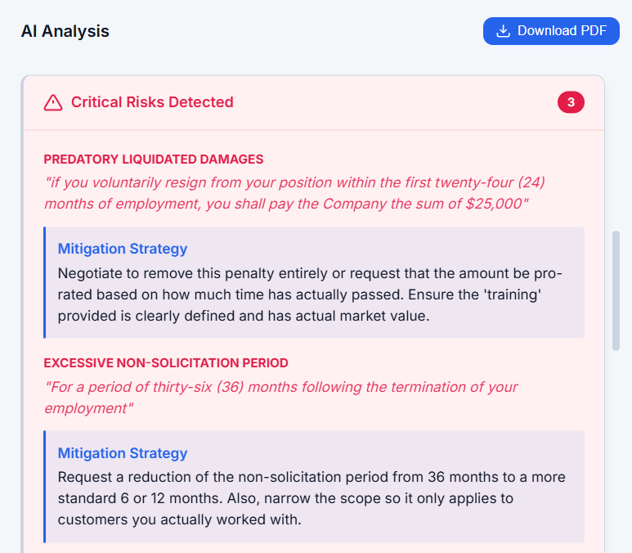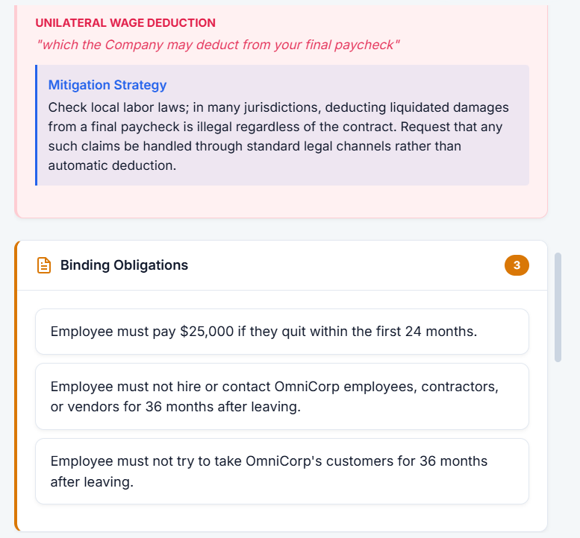
Fig 3.d AI analysis report generated using our NLP and LLM model combination to observe the key details from the Document provided.
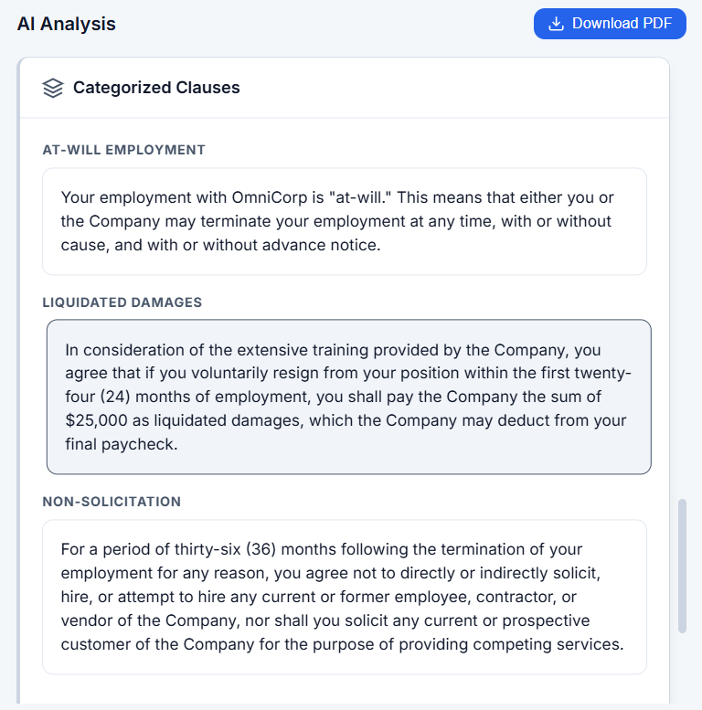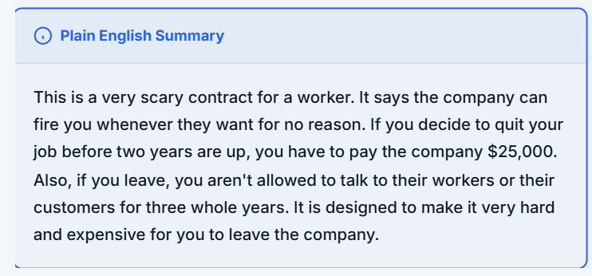
Fig 3.e Depicting Categorized Clauses along with a “Plain English Summary” result. The whole AI analysis report can be downloaded as PDF.
- PDF Reporting Engine: Clicking the download button triggers a backend compilation process that takes all visual insights and arranges them into a professional, multi-page, heavily formatted A4 PDF report, suitable for printing or emailing to a legal team.

CONCLUSION AND FUTURE SCOPE

The LCCE Mini-Project was executed with overwhelming success, meeting and exceeding all defined technical and functional objectives. By bridging a modern Flask/Vanilla JS stack with cutting-edge Generative NLP (Google Gemma), the system successfully automated a task that traditionally requires hours of expensive human labor.
Key Achievements:
- Successfully forced unstructured LLM outputs into highly structured, programmatically parsable JSON schemas.
- Created a resilient backend capable of handling API failures gracefully without crashing the user session.
- Designed an enterprise-grade UI that visualizes complex legal vectors in an easily digestible format.
Future Scope: Moving forward, the project could be expanded by implementing Retrieval-Augmented Generation (RAG). By integrating a vector database (such as Pinecone or Milvus), the AI could compare the uploaded contract against thousands of standard industry contracts to identify "missing clauses" (e.g., pointing out that an NDA is missing a standard time-limit clause). Additionally, fine-tuning a smaller, dedicated local model (like Llama-3-8B) exclusively on legal data could remove the dependency on external cloud APIs entirely, ensuring maximum data privacy for sensitive documents.

