



SEMESTER –

Academic Year : __________________________________________________
Name : _____________________________________ Roll No : ____________
Subject : ________________________________________________________
Branch : ________________ Division : _________Batch : ________________
Examination Seat No :_____________________________________________





Academic Year 2026-27

CERTIFICATE

This is to certify that Mr./Ms.________________________________________
Roll No. _____ Exam Seat No. _____________Branch ___________________
Semester _____Academic Year _____________has completed Term work
(Practicals / Tutorials / Assignments /Test)in Subject__________________ as
per the syllabus prescribed by the University of Mumbai successfully.

Faculty

Mini Project on
“ FinSent – Financial Sentiment Analysis for Market Trend Prediction ”

Submitted in partial fulfillment of the requirements of the degree
of

Bachelor of Engineering in Computer Science &
Engineering (AI & ML) Department

Submitted by
Ananya Parbat (28)

Under the guidance of:
Mr. Alok Jha


DEPARTMENT OF COMPUTER SCIENCE AND ENGINEERING
(AI & ML) VIVA INSTITUTE OF TECHNOLOGY
At Shirgoan, Virar (East), Tal. Vasai, Dist. Palghar – 401305
2026-27

Table of Contents
Sr No. | Topics | Page No.
1) | Introduction
2) | Motivation
3) | Objective
4) | Resources & Technology Stack Used
5) | Algorithm & Processing Logic
6) | Flowchart
7) | Source Code Files
8) | Output & Interface Briefing
9) | Conclusion & Future Scope

INTRODUCTION

The stock market is fundamentally driven by two factors: mathematical data (prices, volumes, financials) and human emotion (news, rumors, and sentiment). In the modern digital era, thousands of financial news articles are published daily. Parsing this massive volume of unstructured text to determine whether the market sentiment for a specific asset is bullish (positive) or bearish (negative) is impossible for a human trader to do in real-time.
FinSent is an advanced Natural Language Processing (NLP) and Financial Technology (FinTech) web application designed to solve this problem. It autonomously fetches real-time market data and news, processes the textual data using Large Language Models (LLMs), and outputs a highly structured dashboard. The application does not just classify news as positive or negative; it uses generative AI to extract key actionable insights, perform automated SWOT (Strengths, Weaknesses, Opportunities, Threats) analyses, and generate peer comparisons, bridging the gap between raw data and actionable trading intelligence.

MOTIVATION

Institutional investors (hedge funds, investment banks) spend tens of thousands of dollars annually on proprietary software like Bloomberg Terminals, which possess built-in AI tools to analyze news sentiment instantly. Retail (individual) investors lack access to these expensive resources, placing them at a severe disadvantage due to "Information Overload."
Standard, traditional NLP algorithms (like VADER or TextBlob) are fundamentally inadequate for financial markets. In finance, words have unique contexts (e.g., "The Federal Reserve cut rates" is generally highly positive for stocks, whereas "cut" is usually negative in standard English). This motivated the creation of a specialized pipeline that leverages modern, context-aware Large Language Models to accurately interpret complex financial jargon and empower retail investors with institutional-grade insights for free.

OBJECTIVES

The primary objectives of the FinSent project are:
- Automated NLP Sentiment Analysis: To accurately classify real-time financial news articles regarding specific stock tickers into Positive, Negative, or Neutral sentiments.
- Actionable Information Extraction: To prompt an LLM to read full articles and extract the single most important "highlight" sentence, saving the user's reading time.
- Generative Fundamental Analysis: To automatically generate a comprehensive AI SWOT Analysis and Peer Comparison table based on the company's real-time financial metrics.
- Advanced UI/UX: To display this data on a highly responsive, aesthetically advanced Glassmorphism dashboard featuring dynamic theming (Light/Dark mode) and contextual color-coding.

RESOURCES & TECHNOLOGY STACK USED

The project utilizes a modern, lightweight, and highly efficient technology stack, enforcing a strict separation of concerns between the backend processing and frontend rendering.
- Backend Framework: Python 3.x with FastAPI (for high-performance, asynchronous RESTful API endpoints).
- Data Aggregation: yfinance library (to fetch live ticker prices, historical data, fundamental ratios, and Yahoo Finance news headlines).
- NLP & LLM Engine: OpenRouter API utilizing the google/gemma-4-26b-a4b-it:free model for text processing, sentiment classification, and generation of structured JSON responses.
- Frontend Structure & Logic: Vanilla HTML5 and Vanilla JavaScript (ES6+).
- Frontend Styling: Pure CSS3 utilizing advanced features such as CSS Variables (for Light/Dark theming), Flexbox/Grid layouts, @keyframes micro-animations, and Glassmorphism effects (backdrop-filter).
- Data Visualization: Chart.js (for rendering dual-axis hybrid Line/Bar charts with Moving Average overlays).
- Iconography: FontAwesome CDN.

ALGORITHM & PROCESSING LOGIC

The core logic of the application operates on a strict request-response lifecycle driven by asynchronous NLP processing:
- Input Acquisition: The user enters a stock ticker (e.g., AAPL) and selects the relevant global market exchange via the frontend UI.
- Data Fetching: The backend receives the API request and utilizes yfinance to scrape the latest news articles and historical price data for the requested ticker.
- Prompt Engineering (NLP Phase): The backend constructs a rigorous prompt containing the news headlines and fundamental data. It instructs the Gemma LLM to:
  - Evaluate the overall sentiment.
  - Perform Entity Recognition to suggest competitor peers.
  - Formulate a SWOT matrix.
  - Extract exactly one sentence as a key "highlight" per news article.
- JSON Enforcement: The LLM is strictly prompted to return the output in a parseable JSON format.
- Data Hydration: The backend parses the LLM's JSON response, merges it with the calculated technical indicators (SMA 50, SMA 200), and returns the payload to the frontend.
- Dynamic Rendering: The vanilla JavaScript engine receives the payload, dynamically injects the data into the HTML DOM, updates the Chart.js instance, and applies contextual CSS classes (e.g., coloring a news highlight box red if the sentiment is NEGATIVE).
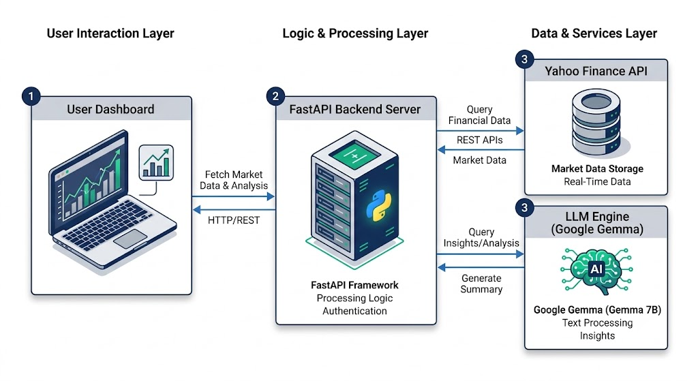
Fig 1.a. Architectural Overview of the project
FLOWCHART
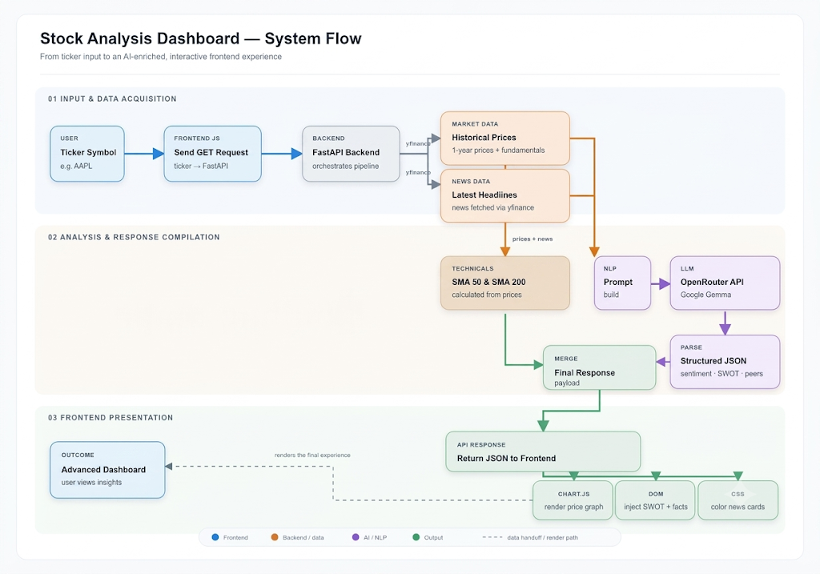
Fig 2.a. Flowchart describing the working mechanism of the project.

SOURCE CODE FILES
Index.html
<!DOCTYPE html>
<html lang="en">
<head>
<meta charset="UTF-8">
<meta name="viewport" content="width=device-width, initial-scale=1.0">
<title>FinSent - Market Trend Prediction</title>
<link rel="stylesheet" href="style.css">
<link href="https://fonts.googleapis.com/css2?family=Inter:wght@300;400;500;600;700&display=swap" rel="stylesheet">
<link rel="stylesheet" href="https://cdnjs.cloudflare.com/ajax/libs/font-awesome/6.4.0/css/all.min.css">
<script src="https://cdn.jsdelivr.net/npm/chart.js"></script>
</head>
<body>
<div class="background-blobs">
<div class="blob blob-1"></div>
<div class="blob blob-2"></div>
</div>
<div class="app-layout">
<aside class="market-sidebar glass">
<div class="sidebar-widget">
<h2>Live Markets</h2>
<ul id="market-indices" class="sidebar-list">
<li style="color: #64748b; font-size: 0.9rem;">Loading...</li>
</ul>
</div>
<div class="sidebar-widget">
<h2>Trending Stocks</h2>
<ul id="trending-stocks" class="sidebar-list">
<li style="color: #64748b; font-size: 0.9rem;">Loading...</li>
</ul>
</div>
<div class="sidebar-widget">
<h2>Sector Performance</h2>
<ul id="sector-perf" class="sidebar-list">
<li style="color: #64748b; font-size: 0.9rem;">Loading...</li>
</ul>
</div>
</aside>
<main class="container">
<header>
<div class="header-content">
<div class="logo-area">
<h1><i class="fa-solid fa-chart-line"></i> FinSent</h1>
<p>Financial Sentiment Analysis for Market Trend Prediction</p>
</div>
<button id="theme-toggle" class="theme-toggle-btn">
<i class="fa-solid fa-moon"></i>
</button>
</div>
</header>
<section class="search-section">
<div class="search-box">
<select id="market-select" class="market-select">
<option value="">US (NASDAQ / NYSE)</option>
<option value=".NS">India (NSE)</option>
<option value=".BO">India (BSE)</option>
<option value=".L">UK (LSE)</option>
<option value=".TO">Canada (TSX)</option>
<option value=".AX">Australia (ASX)</option>
<option value=".DE">Germany (XETRA)</option>
<option value=".T">Japan (TSE)</option>
<option value=".SS">China (SSE)</option>
</select>
<input type="text" id="ticker-input" placeholder="Enter Ticker (e.g., AAPL, RELIANCE)" autocomplete="off">
<button id="analyze-btn">Analyze Sentiment</button>
</div>
<div id="loading" class="hidden">
<div class="spinner"></div>
<p>Analyzing financial news using FinBERT...</p>
</div>
<div id="error-message" class="hidden error"></div>
<div id="volatility-warning" class="hidden warning-banner">
⚠️ HIGH VOLATILITY WARNING: Excessive negative news detected. Proceed with caution.
</div>
</section>
<section id="results-section" class="results-section hidden">
<div class="dashboard-grid">
<div class="card summary-card glass">
<h2>Overall Sentiment</h2>
<div id="overall-sentiment" class="sentiment-badge large">NEUTRAL</div>
<div class="stats-row">
<div class="stat">
<span class="stat-label">Positive</span>
<span id="stat-pos" class="stat-value pos">0</span>
</div>
<div class="stat">
<span class="stat-label">Neutral</span>
<span id="stat-neu" class="stat-value neu">0</span>
</div>
<div class="stat">
<span class="stat-label">Negative</span>
<span id="stat-neg" class="stat-value neg">0</span>
</div>
</div>
</div>
<div class="card chart-card glass">
<h2>30-Day Price Trend</h2>
<div class="chart-container" style="position: relative; flex: 1; width: 100%; min-height: 250px;">
<canvas id="priceChart"></canvas>
</div>
</div>
<div class="card social-card glass">
<h2>Reddit Sentiment (r/wallstreetbets)</h2>
<div id="reddit-sentiment" class="sentiment-badge large">NEUTRAL</div>
<p style="color:#94a3b8; font-size:0.9rem;">Mentions in last week: <span id="reddit-mentions" style="color:white; font-weight:bold;">0</span></p>
</div>
</div>
<!-- V2 Features: Institutional Dashboard -->
<div class="dashboard-grid v2-dashboard" style="grid-template-columns: 1fr; gap: 30px;">
<!-- Fundamental Ratios -->
<div class="card glass">
<h2>Fundamental Analysis</h2>
<div class="fundamentals-grid" id="fundamentals-grid">
<div class="fun-item"><span>Market Cap</span><strong id="f-mcap">-</strong></div>
<div class="fun-item"><span>P/E Ratio</span><strong id="f-pe">-</strong></div>
<div class="fun-item"><span>P/B Ratio</span><strong id="f-pb">-</strong></div>
<div class="fun-item"><span>Debt to Equity</span><strong id="f-de">-</strong></div>
<div class="fun-item"><span>ROE</span><strong id="f-roe">-</strong></div>
<div class="fun-item"><span>Analyst Rec</span><strong id="f-rec" class="highlight">-</strong></div>
<div class="fun-item"><span>Technical Trend</span><strong id="f-trend">-</strong></div>
</div>
</div>
<!-- SWOT Analysis -->
<div class="card glass">
<h2><i class="fa-solid fa-robot"></i> AI SWOT Analysis</h2>
<div class="swot-grid">
<div class="swot-box s"><h3><i class="fa-solid fa-arrow-trend-up"></i> Strengths</h3><ul id="swot-s"></ul></div>
<div class="swot-box w"><h3><i class="fa-solid fa-arrow-trend-down"></i> Weaknesses</h3><ul id="swot-w"></ul></div>
<div class="swot-box o"><h3><i class="fa-solid fa-lightbulb"></i> Opportunities</h3><ul id="swot-o"></ul></div>
<div class="swot-box t"><h3><i class="fa-solid fa-triangle-exclamation"></i> Threats</h3><ul id="swot-t"></ul></div>
</div>
</div>
<!-- Peer Comparison -->
<div class="card glass">
<h2><i class="fa-solid fa-users"></i> Peer Comparison</h2>
<table class="peer-table">
<thead>
<tr>
<th>Ticker</th>
<th>Market Cap</th>
<th>P/E Ratio</th>
<th>Revenue</th>
</tr>
</thead>
<tbody id="peer-tbody">
<!-- Populated by JS -->
</tbody>
</table>
</div>
</div>
<div class="news-section">
<h3>Recent Headlines Analyzed</h3>
<div id="news-list" class="news-list">
<!-- News items will be injected here -->
</div>
</div>
</section>
</main>
</div>
<script src="script.js"></script>
</body>
</html>

Script.js
document.addEventListener('DOMContentLoaded', () => {
const analyzeBtn = document.getElementById('analyze-btn');
const tickerInput = document.getElementById('ticker-input');
const loadingEl = document.getElementById('loading');
const errorEl = document.getElementById('error-message');
const resultsSection = document.getElementById('results-section');
// UI Elements
const overallSentiment = document.getElementById('overall-sentiment');
const statPos = document.getElementById('stat-pos');
const statNeu = document.getElementById('stat-neu');
const statNeg = document.getElementById('stat-neg');
const newsList = document.getElementById('news-list');
const watchlistEl = document.getElementById('watchlist');
const API_URL = 'http://127.0.0.1:8000/api/sentiment';
const DETAILS_API_URL = 'http://127.0.0.1:8000/api/details';
const SIDEBAR_API_URL = 'http://127.0.0.1:8000/api/sidebar';
let currentChart = null;
// Theme Toggle Logic
const themeToggleBtn = document.getElementById('theme-toggle');
const themeIcon = themeToggleBtn.querySelector('i');
// Check saved theme
if (localStorage.getItem('theme') === 'light') {
document.body.classList.add('light-mode');
themeIcon.classList.remove('fa-moon');
themeIcon.classList.add('fa-sun');
}
themeToggleBtn.addEventListener('click', () => {
document.body.classList.toggle('light-mode');
if (document.body.classList.contains('light-mode')) {
localStorage.setItem('theme', 'light');
themeIcon.classList.remove('fa-moon');
themeIcon.classList.add('fa-sun');
} else {
localStorage.setItem('theme', 'dark');
themeIcon.classList.remove('fa-sun');
themeIcon.classList.add('fa-moon');
}
// Update Chart colors if it exists
if(currentChart) {
updateChartColors();
}
});
function updateChartColors() {
const isLight = document.body.classList.contains('light-mode');
const textColor = isLight ? '#475569' : '#94a3b8';
const gridColor = isLight ? 'rgba(0,0,0,0.05)' : 'rgba(255,255,255,0.05)';
currentChart.options.scales.x.ticks.color = textColor;
currentChart.options.scales.y.ticks.color = textColor;
currentChart.options.scales.y.grid.color = gridColor;
currentChart.options.plugins.legend.labels.color = textColor;
const tooltipBg = isLight ? 'rgba(255,255,255,0.95)' : 'rgba(15, 23, 42, 0.9)';
const tooltipTitle = isLight ? '#0f172a' : '#f8fafc';
const tooltipBody = isLight ? '#334155' : '#cbd5e1';
currentChart.options.plugins.tooltip.backgroundColor = tooltipBg;
currentChart.options.plugins.tooltip.titleColor = tooltipTitle;
currentChart.options.plugins.tooltip.bodyColor = tooltipBody;
currentChart.update();
}
// Load Live Market Sidebar data on startup
loadSidebarData();
async function loadSidebarData() {
try {
const res = await fetch(SIDEBAR_API_URL);
const data = await res.json();
if(!data.error) {
populateSidebarList('market-indices', data.indices);
populateSidebarList('trending-stocks', data.trending);
populateSidebarList('sector-perf', data.sectors);
}
} catch (e) {
console.error("Failed to load sidebar data", e);
}
}
function populateSidebarList(elementId, items) {
const el = document.getElementById(elementId);
el.innerHTML = '';
items.forEach(item => {
const name = item.name || item.symbol;
const price = item.price ? `$${item.price}` : '';
const changeClass = item.change >= 0 ? 'pos' : 'neg';
const changeSign = item.change >= 0 ? '+' : '';
const li = document.createElement('li');
li.innerHTML = `
<div class="sidebar-item-header">
<span class="ticker-name">${name}</span>
<span class="ticker-price">${price}</span>
</div>
<div class="ticker-change ${changeClass}">${changeSign}${item.change}%</div>
`;
if (item.symbol) {
li.style.cursor = 'pointer';
li.onclick = () => {
tickerInput.value = item.symbol;
document.getElementById('market-select').value = "";
performAnalysis();
};
}
el.appendChild(li);
});
}
analyzeBtn.addEventListener('click', performAnalysis);
tickerInput.addEventListener('keypress', (e) => {
if (e.key === 'Enter') {
performAnalysis();
}
});
async function performAnalysis() {
const marketSuffix = document.getElementById('market-select').value;
let ticker = tickerInput.value.trim().toUpperCase();
if (!ticker) {
showError("Please enter a stock ticker.");
return;
}
// Append market suffix if one is selected and not already in the ticker
if (marketSuffix && !ticker.endsWith(marketSuffix.toUpperCase())) {
ticker += marketSuffix.toUpperCase();
}
// Reset UI
errorEl.classList.add('hidden');
resultsSection.classList.add('hidden');
loadingEl.classList.remove('hidden');
try {
// Fetch Sentiment and Details in parallel
const [sentimentRes, detailsRes] = await Promise.all([
fetch(`${API_URL}?ticker=${ticker}`),
fetch(`${DETAILS_API_URL}?ticker=${ticker}`)
]);
const sentimentData = await sentimentRes.json();
const detailsData = await detailsRes.json();
if (sentimentData.error) {
showError(sentimentData.error);
return;
}
updateDashboard(sentimentData);
if (!detailsData.error) {
updateV2Dashboard(detailsData);
updateChart(detailsData);
}
loadingEl.classList.add('hidden');
resultsSection.classList.remove('hidden');
} catch (error) {
showError("Failed to connect to the backend server. Is it running?");
loadingEl.classList.add('hidden');
}
}
function updateChart(data) {
const ctx = document.getElementById('priceChart').getContext('2d');
if (currentChart) {
currentChart.destroy();
}
const gradient = ctx.createLinearGradient(0, 0, 0, 300);
gradient.addColorStop(0, 'rgba(96, 165, 250, 0.4)'); // Light blue, semi-transparent
gradient.addColorStop(1, 'rgba(96, 165, 250, 0.0)'); // Transparent at bottom
currentChart = new Chart(ctx, {
type: 'line',
data: {
labels: data.dates,
datasets: [
{
type: 'bar',
label: 'Volume',
data: data.volumes,
backgroundColor: 'rgba(148, 163, 184, 0.1)',
yAxisID: 'y1'
},
{
type: 'line',
label: 'Closing Price',
data: data.prices,
borderColor: '#60a5fa', // Vibrant blue
backgroundColor: gradient,
borderWidth: 3,
pointBackgroundColor: '#fff',
pointBorderColor: '#60a5fa',
pointBorderWidth: 2,
pointRadius: 0,
pointHoverRadius: 6,
fill: true,
tension: 0.4, // Smooth curves
yAxisID: 'y'
},
{
type: 'line',
label: 'SMA 50',
data: data.sma50,
borderColor: '#f59e0b', // Amber
borderWidth: 1.5,
borderDash: [5, 5],
pointRadius: 0,
fill: false,
yAxisID: 'y'
},
{
type: 'line',
label: 'SMA 200',
data: data.sma200,
borderColor: '#ef4444', // Red
borderWidth: 1.5,
pointRadius: 0,
fill: false,
yAxisID: 'y'
}]
},
options: {
responsive: true,
maintainAspectRatio: false,
interaction: {
mode: 'index',
intersect: false,
},
plugins: {
legend: { display: true, labels: { color: '#cbd5e1' } },
tooltip: {
backgroundColor: 'rgba(15, 23, 42, 0.9)',
titleColor: '#f8fafc',
bodyColor: '#cbd5e1',
borderColor: 'rgba(255, 255, 255, 0.1)',
borderWidth: 1,
padding: 12
}
},
scales: {
x: {
ticks: { color: '#64748b', maxTicksLimit: 6 },
grid: { display: false } // Hide vertical grid lines
},
y: {
position: 'left',
ticks: { color: '#64748b', callback: function(value) { return '$' + value; } },
grid: { color: 'rgba(255,255,255,0.05)', drawBorder: false, borderDash: [5, 5] }
},
y1: {
position: 'right',
display: false,
grid: { display: false }
}
}
}
});
}
function updateV2Dashboard(data) {
// Fundamentals
document.getElementById('f-mcap').textContent = formatNumber(data.fundamentals.marketCap);
document.getElementById('f-pe').textContent = data.fundamentals.trailingPE;
document.getElementById('f-pb').textContent = data.fundamentals.priceToBook;
document.getElementById('f-de').textContent = data.fundamentals.debtToEquity;
document.getElementById('f-roe').textContent = data.fundamentals.returnOnEquity + '%';
document.getElementById('f-rec').textContent = data.fundamentals.recommendation;
document.getElementById('f-trend').textContent = data.trend;
document.getElementById('f-trend').className = data.trend === 'Bullish' ? 'highlight' : (data.trend === 'Bearish' ? 'neg' : '');
// SWOT
const populateList = (id, items) => {
const el = document.getElementById(id);
el.innerHTML = '';
(items || ['N/A']).forEach(item => {
const li = document.createElement('li');
li.textContent = item;
el.appendChild(li);
});
};
populateList('swot-s', data.swot.Strengths);
populateList('swot-w', data.swot.Weaknesses);
populateList('swot-o', data.swot.Opportunities);
populateList('swot-t', data.swot.Threats);
// Peers
const tbody = document.getElementById('peer-tbody');
tbody.innerHTML = '';
data.peers.forEach(p => {
const tr = document.createElement('tr');
tr.innerHTML = `
<td><strong>${p.ticker}</strong></td>
<td>${formatNumber(p.marketCap)}</td>
<td>${p.pe}</td>
<td>${formatNumber(p.revenue)}</td>
`;
tbody.appendChild(tr);
});
}
function formatNumber(num) {
if (num === 'N/A' || !num) return num;
if (num >= 1e12) return (num / 1e12).toFixed(2) + 'T';
if (num >= 1e9) return (num / 1e9).toFixed(2) + 'B';
if (num >= 1e6) return (num / 1e6).toFixed(2) + 'M';
return num;
}
function updateDashboard(data) {
// Volatility Warning
const warningEl = document.getElementById('volatility-warning');
if (data.volatility_warning) {
warningEl.classList.remove('hidden');
} else {
warningEl.classList.add('hidden');
}
// Reddit Sentiment
const redditSentimentEl = document.getElementById('reddit-sentiment');
const redditMentionsEl = document.getElementById('reddit-mentions');
if (data.reddit_sentiment) {
redditSentimentEl.textContent = data.reddit_sentiment.status;
redditSentimentEl.className = `sentiment-badge large ${data.reddit_sentiment.status}`;
redditMentionsEl.textContent = data.reddit_sentiment.mentions;
}
overallSentiment.textContent = data.overall_sentiment;
overallSentiment.className = `sentiment-badge large ${data.overall_sentiment}`;
statPos.textContent = data.stats.positive;
statNeu.textContent = data.stats.neutral;
statNeg.textContent = data.stats.negative;
newsList.innerHTML = '';
if (data.news.length === 0) {
newsList.innerHTML = '<p style="color: #94a3b8;">No recent news found to analyze.</p>';
return;
}
data.news.forEach(item => {
const newsCard = document.createElement('div');
newsCard.className = `news-card glass ${item.sentiment}`;
const confPercent = (item.confidence * 100).toFixed(1) + '%';
// Format Date
let dateStr = '';
if (item.pubDate) {
const dateObj = new Date(item.pubDate);
dateStr = ' • ' + dateObj.toLocaleDateString(undefined, { month: 'short', day: 'numeric', hour: '2-digit', minute: '2-digit' });
}
newsCard.innerHTML = `
<div class="news-content">
<h4 class="news-title">
<a href="${item.link}" target="_blank" rel="noopener noreferrer">${item.title}</a>
</h4>
<div class="news-meta">
<span>Source: ${item.publisher || 'Unknown'}${dateStr}</span>
</div>
${item.highlight ? `<div class="news-highlight">💡 <span>${item.highlight}</span></div>` : ''}
</div>
<div class="news-sentiment">
<span class="sentiment-badge ${item.sentiment}">${item.sentiment}</span>
<span class="confidence">${confPercent} conf</span>
</div>
`;
newsList.appendChild(newsCard);
});
}
function showError(message) {
errorEl.textContent = message;
errorEl.classList.remove('hidden');
loadingEl.classList.add('hidden');
}
});
App.py
from fastapi import FastAPI
from fastapi.middleware.cors import CORSMiddleware
import yfinance as yf
from transformers import AutoTokenizer, AutoModelForSequenceClassification
import torch
app = FastAPI()
app.add_middleware(
CORSMiddleware,
allow_origins=["*"],
allow_credentials=True,
allow_methods=["*"],
allow_headers=["*"],
)
print("Loading FinBERT model...")
tokenizer = AutoTokenizer.from_pretrained("ProsusAI/finbert")
model = AutoModelForSequenceClassification.from_pretrained("ProsusAI/finbert")
labels = ["positive", "negative", "neutral"]
print("Model loaded successfully!")
def analyze_sentiment(text):
inputs = tokenizer(text, return_tensors="pt", padding=True, truncation=True)
with torch.no_grad():
outputs = model(**inputs)
probabilities = torch.nn.functional.softmax(outputs.logits, dim=-1)
sentiment_idx = torch.argmax(probabilities).item()
confidence = probabilities[0][sentiment_idx].item()
return labels[sentiment_idx], confidence
import requests
from bs4 import BeautifulSoup
import re
def scrape_article_text(url):
try:
headers = {'User-Agent': 'Mozilla/5.0'}
res = requests.get(url, headers=headers, timeout=5)
soup = BeautifulSoup(res.text, 'html.parser')
paragraphs = soup.find_all('p')
text = ' '.join([p.get_text() for p in paragraphs])
# Return first 500 characters to stay within BERT token limits
return text[:500] if text else None
except:
return None
def fetch_reddit_sentiment(ticker):
try:
headers = {'User-Agent': 'FinSentBot/1.0'}
# Search WSB for the ticker
url = f"https://www.reddit.com/r/wallstreetbets/search.json?q={ticker}&restrict_sr=on&sort=new&t=week"
res = requests.get(url, headers=headers, timeout=5)
data = res.json()
posts = data.get('data', {}).get('children', [])
if not posts: return {"status": "neutral", "mentions": 0}
pos = 0
neg = 0
for post in posts[:5]: # Analyze top 5 recent posts
title = post['data']['title']
sent, _ = analyze_sentiment(title)
if sent == "positive": pos += 1
if sent == "negative": neg += 1
overall = "neutral"
if pos > neg: overall = "positive"
elif neg > pos: overall = "negative"
return {"status": overall, "mentions": len(posts)}
except:
return {"status": "neutral", "mentions": 0}
import os
def get_llm_highlight(text):
if not text: return None
# User provided API key directly
api_key = "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"
headers = {
"Authorization": f"Bearer {api_key}",
"Content-Type": "application/json",
"HTTP-Referer": "http://localhost:5500",
"X-Title": "FinSent"
}
data = {
"model": "google/gemma-4-26b-a4b-it:free", # Google Gemma 4 26B model requested by user
"messages": [
{"role": "user", "content": f"Extract the single most important, impactful sentence from the following financial text that drives its sentiment. Return ONLY that sentence and nothing else. No intro, no quotes, no conversational text.\n\nText: {text[:1500]}"}
]
}
try:
res = requests.post("https://openrouter.ai/api/v1/chat/completions", headers=headers, json=data, timeout=8)
if res.status_code != 200:
return f"API Error: {res.status_code} - {res.text[:100]}"
return res.json()['choices'][0]['message']['content'].strip()
except Exception as e:
return f"Failed to generate highlight: {str(e)}"
@app.get("/api/sentiment")
def get_sentiment(ticker: str):
try:
stock = yf.Ticker(ticker)
news_items = stock.news
if not news_items:
return {"ticker": ticker, "error": "No news found for this ticker."}
# Sort news from newest to oldest based on pubDate
try:
news_items = sorted(news_items, key=lambda x: x.get('content', {}).get('pubDate', ''), reverse=True)
except Exception:
pass # Fallback to original order if sorting fails
results = []
positive_count = 0
negative_count = 0
neutral_count = 0
all_related_orgs = set()
for item in news_items[:10]:
content = item.get('content', {})
title = content.get('title', '')
link = content.get('canonicalUrl', {}).get('url', '')
publisher = content.get('provider', {}).get('displayName', '')
pub_date = content.get('pubDate', '')
if title:
# Feature 1: Web Scraping for Full Text
full_text = scrape_article_text(link) or content.get('summary', '') or title
sentiment, confidence = analyze_sentiment(full_text)
# Highlight Extraction using OpenRouter
ai_highlight = get_llm_highlight(full_text)
# Feature 2 (NER) skipped due to system DLL restrictions
all_related_orgs.add("NER Disabled (System Policy)")
results.append({
"title": title,
"link": link,
"publisher": publisher,
"pubDate": pub_date,
"sentiment": sentiment,
"confidence": confidence,
"highlight": ai_highlight
})
if sentiment == "positive":
positive_count += 1
elif sentiment == "negative":
negative_count += 1
else:
neutral_count += 1
total = len(results)
overall_sentiment = "neutral"
volatility_warning = False
if total > 0:
if positive_count > negative_count and positive_count >= neutral_count:
overall_sentiment = "positive"
elif negative_count > positive_count and negative_count >= neutral_count:
overall_sentiment = "negative"
# Feature 3: Extreme Event Alerts (Volatility Warning)
if (negative_count / total) >= 0.6:
volatility_warning = True
# Feature 4: Social Sentiment
reddit_data = fetch_reddit_sentiment(ticker)
return {
"ticker": ticker.upper(),
"overall_sentiment": overall_sentiment,
"volatility_warning": volatility_warning,
"reddit_sentiment": reddit_data,
"related_entities": list(all_related_orgs)[:8], # Top 8 organizations
"stats": {
"total": total,
"positive": positive_count,
"negative": negative_count,
"neutral": neutral_count
},
"news": results
}
except Exception as e:
return {"error": str(e)}
import json
@app.get("/api/details")
def get_details(ticker: str):
try:
stock = yf.Ticker(ticker)
# 1. Technicals & History (1 year for SMA 200)
hist = stock.history(period="1y")
if hist.empty:
return {"error": "No historical data found."}
# Calculate moving averages
hist['SMA50'] = hist['Close'].rolling(window=50).mean()
hist['SMA200'] = hist['Close'].rolling(window=200).mean()
# Take last 30 days for chart display
hist_30 = hist.tail(30)
dates = hist_30.index.strftime('%Y-%m-%d').tolist()
prices = hist_30['Close'].round(2).tolist()
volumes = hist_30['Volume'].tolist()
# Replace NaNs with None for JSON serialization
sma50 = [round(x, 2) if not (x != x) else None for x in hist_30['SMA50']]
sma200 = [round(x, 2) if not (x != x) else None for x in hist_30['SMA200']]
current_price = prices[-1]
c_sma50 = hist['SMA50'].iloc[-1]
c_sma200 = hist['SMA200'].iloc[-1]
if c_sma50 != c_sma50 or c_sma200 != c_sma200: # Check NaN
trend = "Neutral"
elif current_price > c_sma50 and c_sma50 > c_sma200:
trend = "Bullish"
elif current_price < c_sma50 and c_sma50 < c_sma200:
trend = "Bearish"
else:
trend = "Neutral"
# 2. Fundamentals
info = stock.info
fundamentals = {
"marketCap": info.get("marketCap", "N/A"),
"trailingPE": round(info.get("trailingPE", 0), 2) if info.get("trailingPE") else "N/A",
"priceToBook": round(info.get("priceToBook", 0), 2) if info.get("priceToBook") else "N/A",
"debtToEquity": round(info.get("debtToEquity", 0), 2) if info.get("debtToEquity") else "N/A",
"returnOnEquity": round(info.get("returnOnEquity", 0)*100, 2) if info.get("returnOnEquity") else "N/A",
"recommendation": info.get("recommendationKey", "N/A").replace('_', ' ').title()
}
# 3. SWOT & Peers via LLM
summary = info.get("longBusinessSummary", "")[:2000]
api_key = "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"
headers = {"Authorization": f"Bearer {api_key}", "Content-Type": "application/json", "HTTP-Referer": "http://localhost:5500"}
prompt = f"Analyze '{ticker}' based on this summary: {summary}. Return ONLY a raw JSON object (no markdown, no backticks) with keys: 'SWOT' (dict with 'Strengths', 'Weaknesses', 'Opportunities', 'Threats' - lists of 2 strings each) and 'peers' (list of 3 competitor stock tickers)."
data = {
"model": "google/gemma-4-26b-a4b-it:free",
"messages": [{"role": "user", "content": prompt}]
}
swot_data = {}
peers_list = []
try:
res = requests.post("https://openrouter.ai/api/v1/chat/completions", headers=headers, json=data, timeout=12)
res_content = res.json()['choices'][0]['message']['content'].strip()
if res_content.startswith("```json"): res_content = res_content[7:]
if res_content.startswith("```"): res_content = res_content[3:]
if res_content.endswith("```"): res_content = res_content[:-3]
parsed = json.loads(res_content.strip())
swot_data = parsed.get("SWOT", {})
peers_list = parsed.get("peers", [])
except:
swot_data = {"Strengths": ["Data unavailable"], "Weaknesses": ["Data unavailable"], "Opportunities": ["Data unavailable"], "Threats": ["Data unavailable"];
# 4. Peer Data Fetch
peer_data = []
for p in peers_list[:3]:
try:
p_info = yf.Ticker(p).info
peer_data.append({
"ticker": p,
"marketCap": p_info.get("marketCap", "N/A"),
"pe": round(p_info.get("trailingPE", 0), 2) if p_info.get("trailingPE") else "N/A",
"revenue": p_info.get("totalRevenue", "N/A")
})
except:
pass
return {
"dates": dates,
"prices": prices,
"volumes": volumes,
"sma50": sma50,
"sma200": sma200,
"trend": trend,
"fundamentals": fundamentals,
"swot": swot_data,
"peers": peer_data
}
except Exception as e:
return {"error": str(e)}
@app.get("/api/sidebar")
def get_sidebar_data():
try:
# 1. Market Indices
indices = yf.Tickers("^GSPC ^IXIC ^VIX BTC-USD")
indices_data = []
for symbol, ticker in indices.tickers.items():
try:
info = ticker.fast_info
change = ((info.last_price - info.previous_close) / info.previous_close) * 100
name_map = {"^GSPC": "S&P 500", "^IXIC": "NASDAQ", "^VIX": "VIX", "BTC-USD": "Bitcoin"}
indices_data.append({
"name": name_map.get(symbol, symbol),
"price": round(info.last_price, 2),
"change": round(change, 2)
})
except: pass
# 2. Trending / Most Active (Popular proxies)
trending = yf.Tickers("NVDA TSLA AAPL AMD META")
trending_data = []
for symbol, ticker in trending.tickers.items():
try:
info = ticker.fast_info
change = ((info.last_price - info.previous_close) / info.previous_close) * 100
trending_data.append({
"symbol": symbol,
"price": round(info.last_price, 2),
"change": round(change, 2)
})
except: pass
# 3. Sectors (ETFs proxy)
sectors = yf.Tickers("XLK XLV XLE XLF")
sector_data = []
for symbol, ticker in sectors.tickers.items():
try:
info = ticker.fast_info
change = ((info.last_price - info.previous_close) / info.previous_close) * 100
name_map = {"XLK": "Tech", "XLV": "Health", "XLE": "Energy", "XLF": "Finance"}
sector_data.append({
"name": name_map.get(symbol, symbol),
"change": round(change, 2)
})
except: pass
return {
OUTPUT & INTERFACE BRIEFING

The user interface is engineered to mimic high-end institutional trading software. Key interface components include:
- The Market Sidebar: A real-time, persistent widget displaying overall market health (S&P 500, NASDAQ, Bitcoin), trending retail stocks, and sector ETF performances.
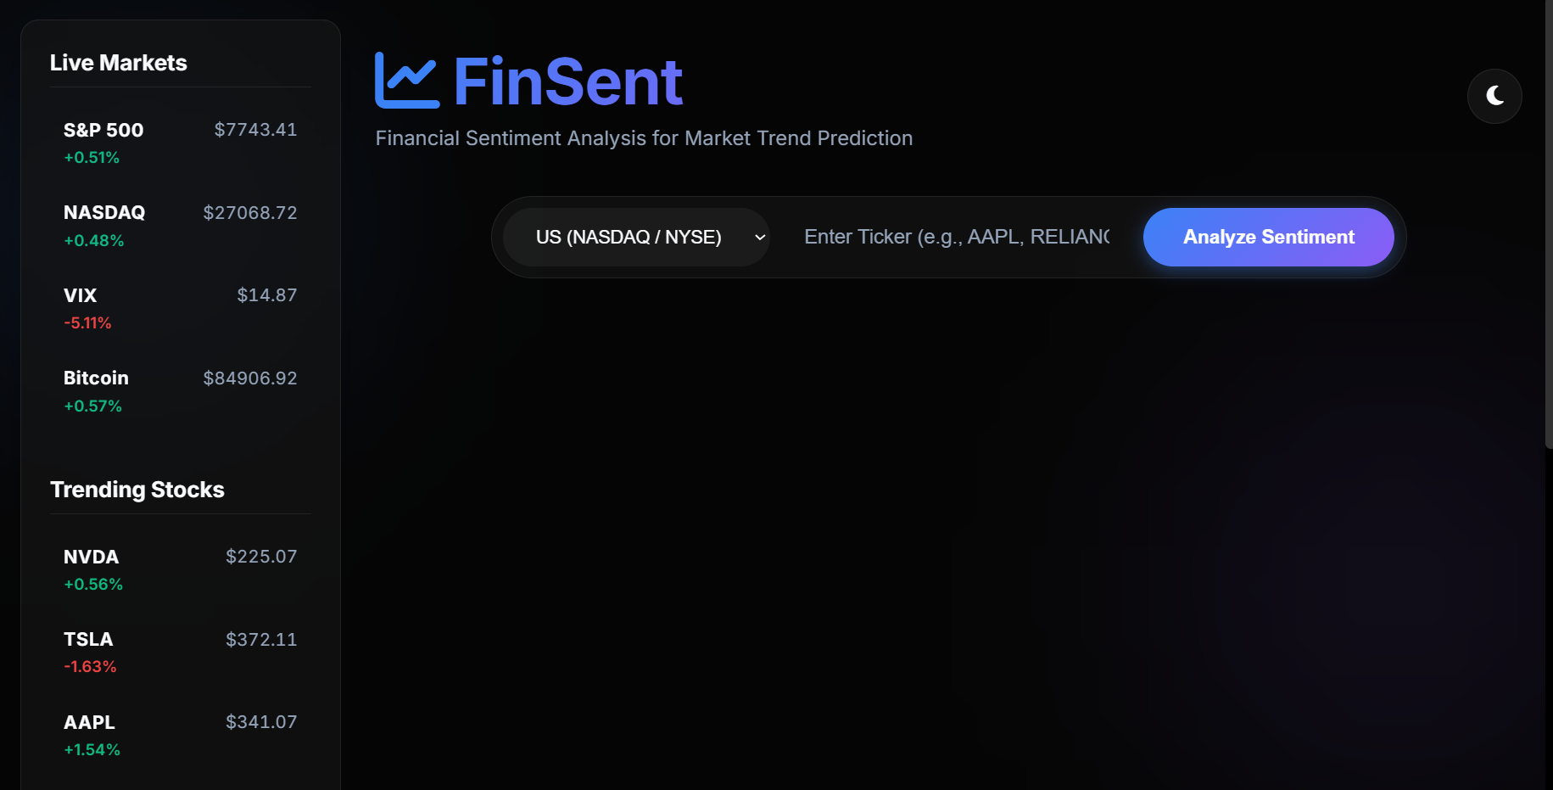
Fig 3.a. Dark Mode UI of the project
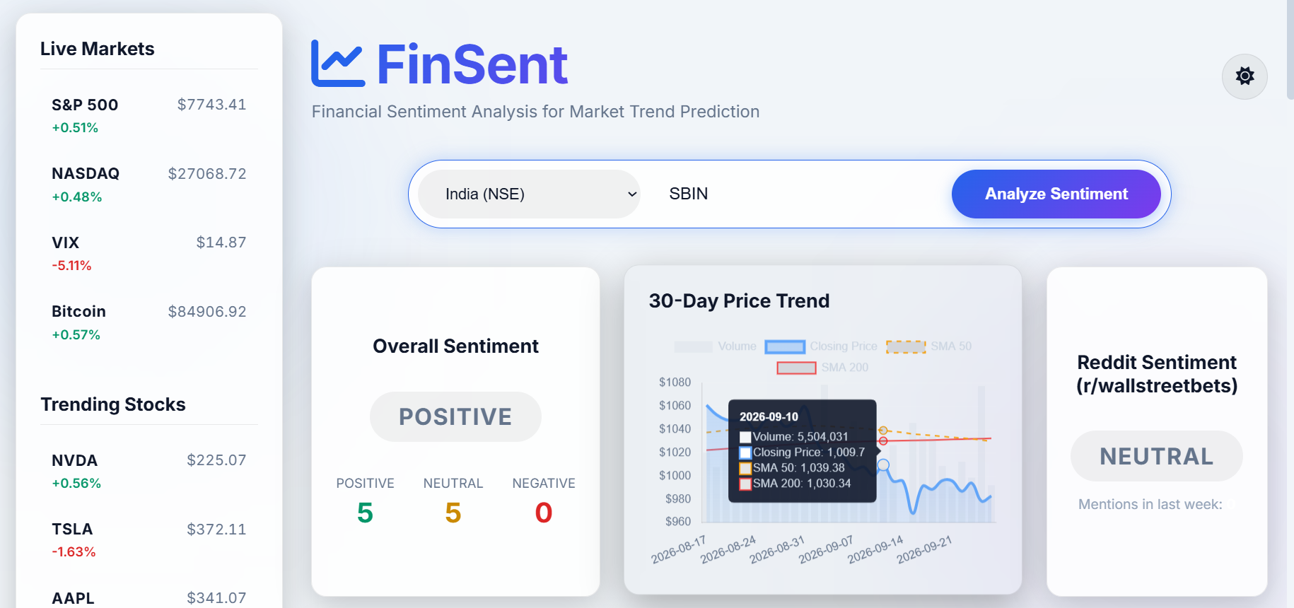
Fig 3.b. Light Mode UI of the project. This is the landing page which provides a sidebar and search engine for shares using Stock Tickers.
- Search & Theme Header: A centralized search bar with an integrated dropdown for global exchanges. A theme toggle switch dynamically switches the entire CSS variable scope between a "Pitch Black" neon dark mode and a sleek light mode.
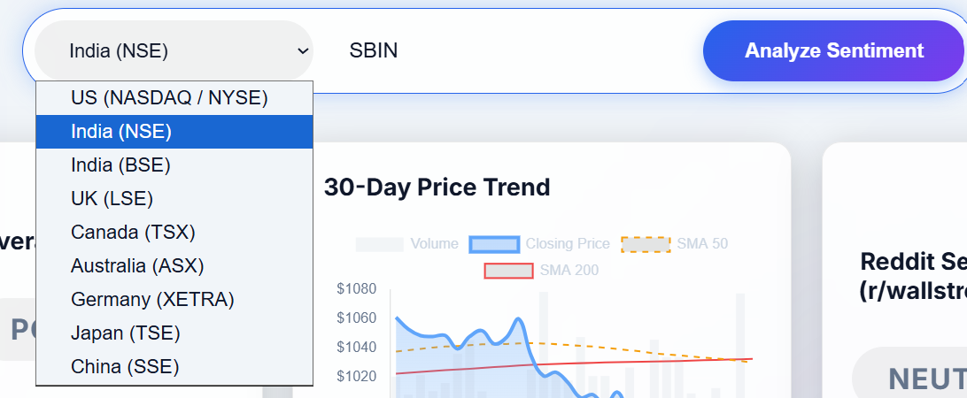
Fig 3.c. Dropdown list shows all the available markets in our project
- Summary & Charting: Displays the aggregate sentiment badge alongside a 30-day interactive price/volume chart overlaid with SMA 50 and SMA 200 trendlines.
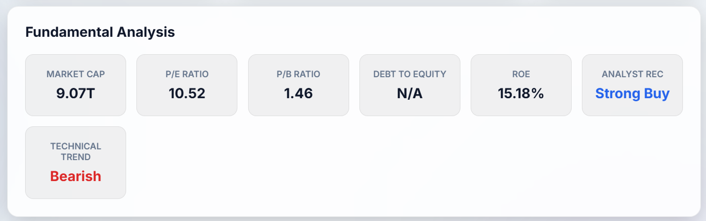
Fig 3.d. Fundamental Analysis of a Selected Share (SBIN)
- V2 Analytical Dashboard:
  - Fundamentals Grid: Displays Market Cap, P/E, Debt to Equity, and Analyst Recommendations.
  - AI SWOT Analysis: A 4-quadrant colored grid generated by the LLM detailing the company's internal strengths and external threats.
  - Peer Comparison Table: Automatically identifies competitors and compares their market cap and revenue.
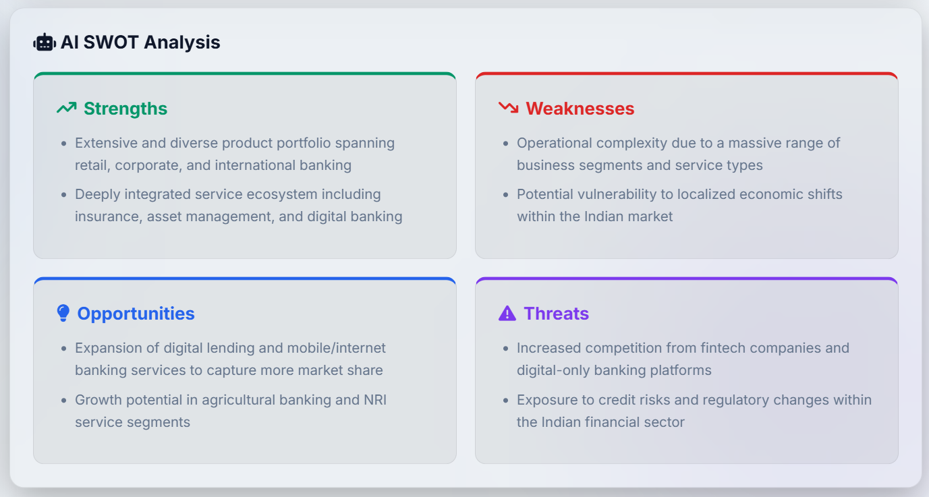
Fig 3.e. AI SWOT Analysis of the searched Stock
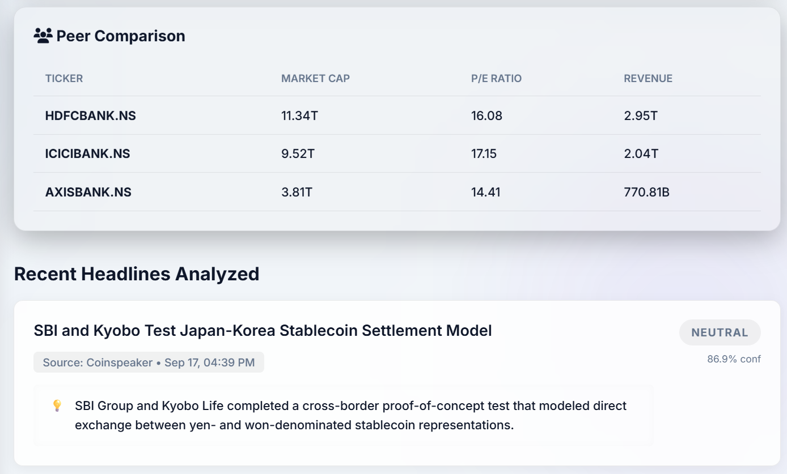
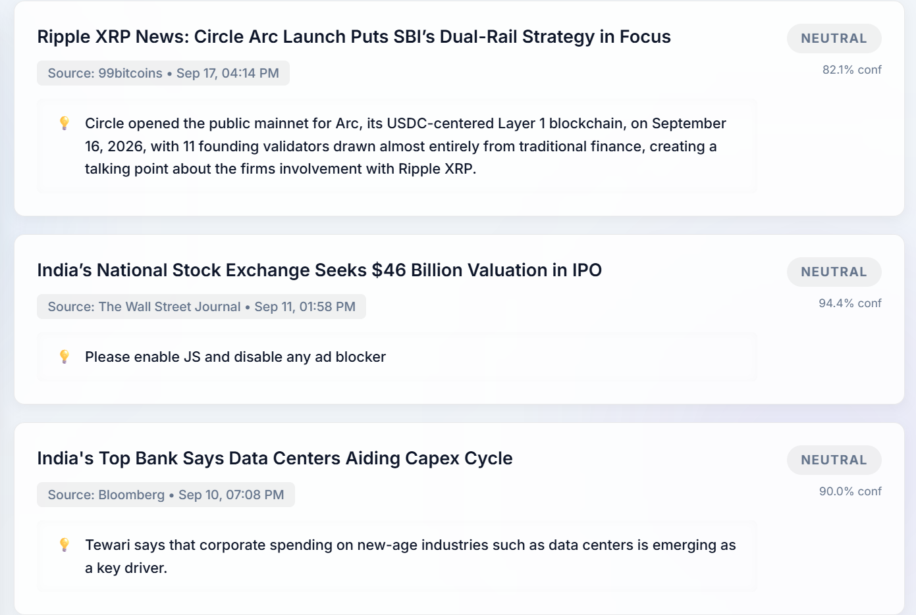
Fig 3.f. Peer Comparison along with Recent Headlines of the Share Stock searched using our NLP Engine.
- Contextual News Feed: Displays recent headlines with AI-extracted "hint" boxes. The highlight boxes dynamically change their background and border colors (Green, Red, Yellow) based on the LLM's classification of the article's sentiment.
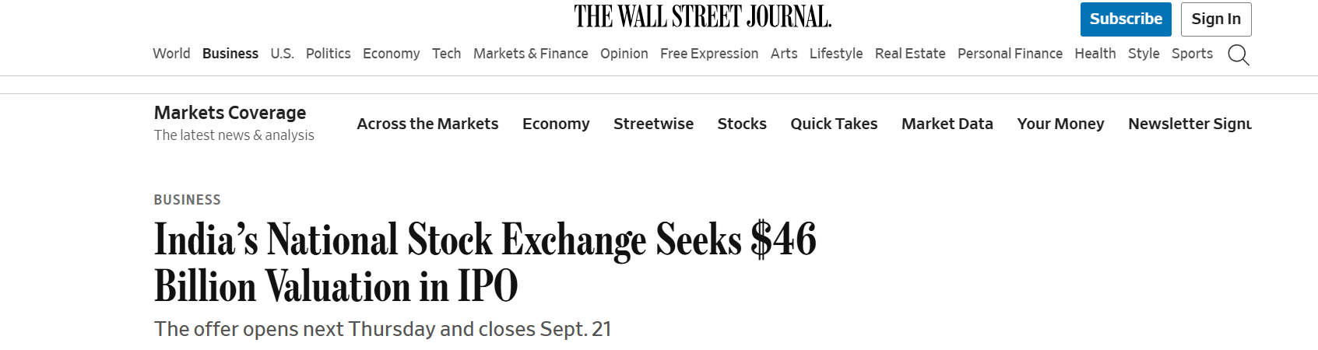
CONCLUSION & FUTURE SCOPE

Conclusion
The FinSent project successfully demonstrates how Natural Language Processing and generative LLMs can be integrated into a lightweight web application to solve real-world financial problems. By automating the extraction of sentiment, SWOT analyses, and key highlights, the application effectively mitigates information overload for retail investors. The project achieved a robust, responsive, and aesthetically advanced dashboard without relying on heavy frontend frameworks, relying entirely on optimized Vanilla JS and CSS.

Future Scope
While highly functional, the system has several avenues for future expansion:
- Alternative Institutional Data (SEC Filings): Expanding the NLP pipeline to automatically scrape and analyze the sentiment of SEC 10-K/10-Q EDGAR filings and Quarterly Earnings Call audio transcripts.
- Real-Time WebSockets: Replacing standard REST API calls with WebSockets to stream live stock prices and breaking news alerts instantly to the dashboard without requiring a page refresh.
- Automated Trading Webhooks: Connecting the sentiment analysis pipeline to a broker API (like Alpaca or Zerodha) to autonomously execute paper trades based on sudden spikes in highly positive or highly negative news sentiment.

