DESIGN DOCUMENT · V3 · AGENTS, TOOLS & ORCHESTRATION IN FULL
IQR — Intelligent Quality Review for SOX 404 Controls
A compiled-plan agentic platform that validates SOX 404 evidence packages end-to-end. This document names every agent, every tool, and the exact point in the workflow where each is invoked — plus the adversarial sentinel, the blinded verifier, the evaluation harness, the Golden Library lifecycle, and the console a reviewer actually uses.

Executive summary

The problem
Today the team validates SOX 404 evidence with a large language model used generatively: the evidence package goes in as text, and the model writes up its assessment. The work gets done - but the same package can produce a different response every run. Numbers are read and judged by the same model in one breath, there is no citation trail back to the exact cell or email line a conclusion came from, and no way to replay how a verdict was reached. For a SOX control, non-reproducible validation is not a quality issue - it fails audit by construction. And the evidence itself is hard: nested packages where approval emails hold ZIPs holding macro workbooks, screenshot-laden documents, and certified report extracts.

The solution
IQR moves from generative AI to agentic AI - the same model intelligence, restructured for audit. A validation plan is compiled once per control from its SOX 404 document and frozen after SME approval; the runtime executes the plan, never improvises. Agents carry the high-attention, multi-step work - but they act through deterministic tools: every number, timestamp, and sign-off fact is extracted and computed by Python that returns a citation, never generated by the model. An adversarial sentinel screens each package for manipulation patterns before checks run; a blinded verifier re-performs every finding from its citations alone; a mechanical citation gate rejects any claim whose evidence locator does not resolve. Same package + same plan = same verdict, every time - with a replayable ledger of every decision.

Why quality keeps rising
Every run is measured. A five-gate evaluation harness (defect recall, false-exception rate, 100% citation validity, abstention correctness, reproducibility) gates every release - and every human override becomes a new regression case in the Golden Library, so the system is permanently tested against its own history. Validation quality compounds instead of drifting.

Where it stands
Validated against real evidence packages: control 10032 runs end-to-end with every check passing on cited real cells, the full offline test suite is green, and the console lets a reviewer run a control without knowing anything about the machinery. The model seat is swappable by configuration - an approved internal endpoint in production, a deterministic stub offline - so the platform is never blocked on a vendor.

01 The three laws
Every design decision in IQR descends from three laws. When a choice conflicts with one of them, the choice loses:
- Numbers are computed by deterministic Python, never by a model.
- Every claim in output carries a resolvable evidence locator.
- Same input produces the same verdict.
This is why the system splits into three layers: a document-intelligence layer that makes every fact in a messy evidence package addressable; a reasoning layer of scoped agents that decide where answers live and what they mean; and an action layer of deterministic tools that do all extraction and arithmetic, returning citations. Agents may only obtain numbers, timestamps, and text by calling tools — never by generating them.

02 Architecture at a glance
TWO PHASES, ONE GOVERNED LEARNING LOOP
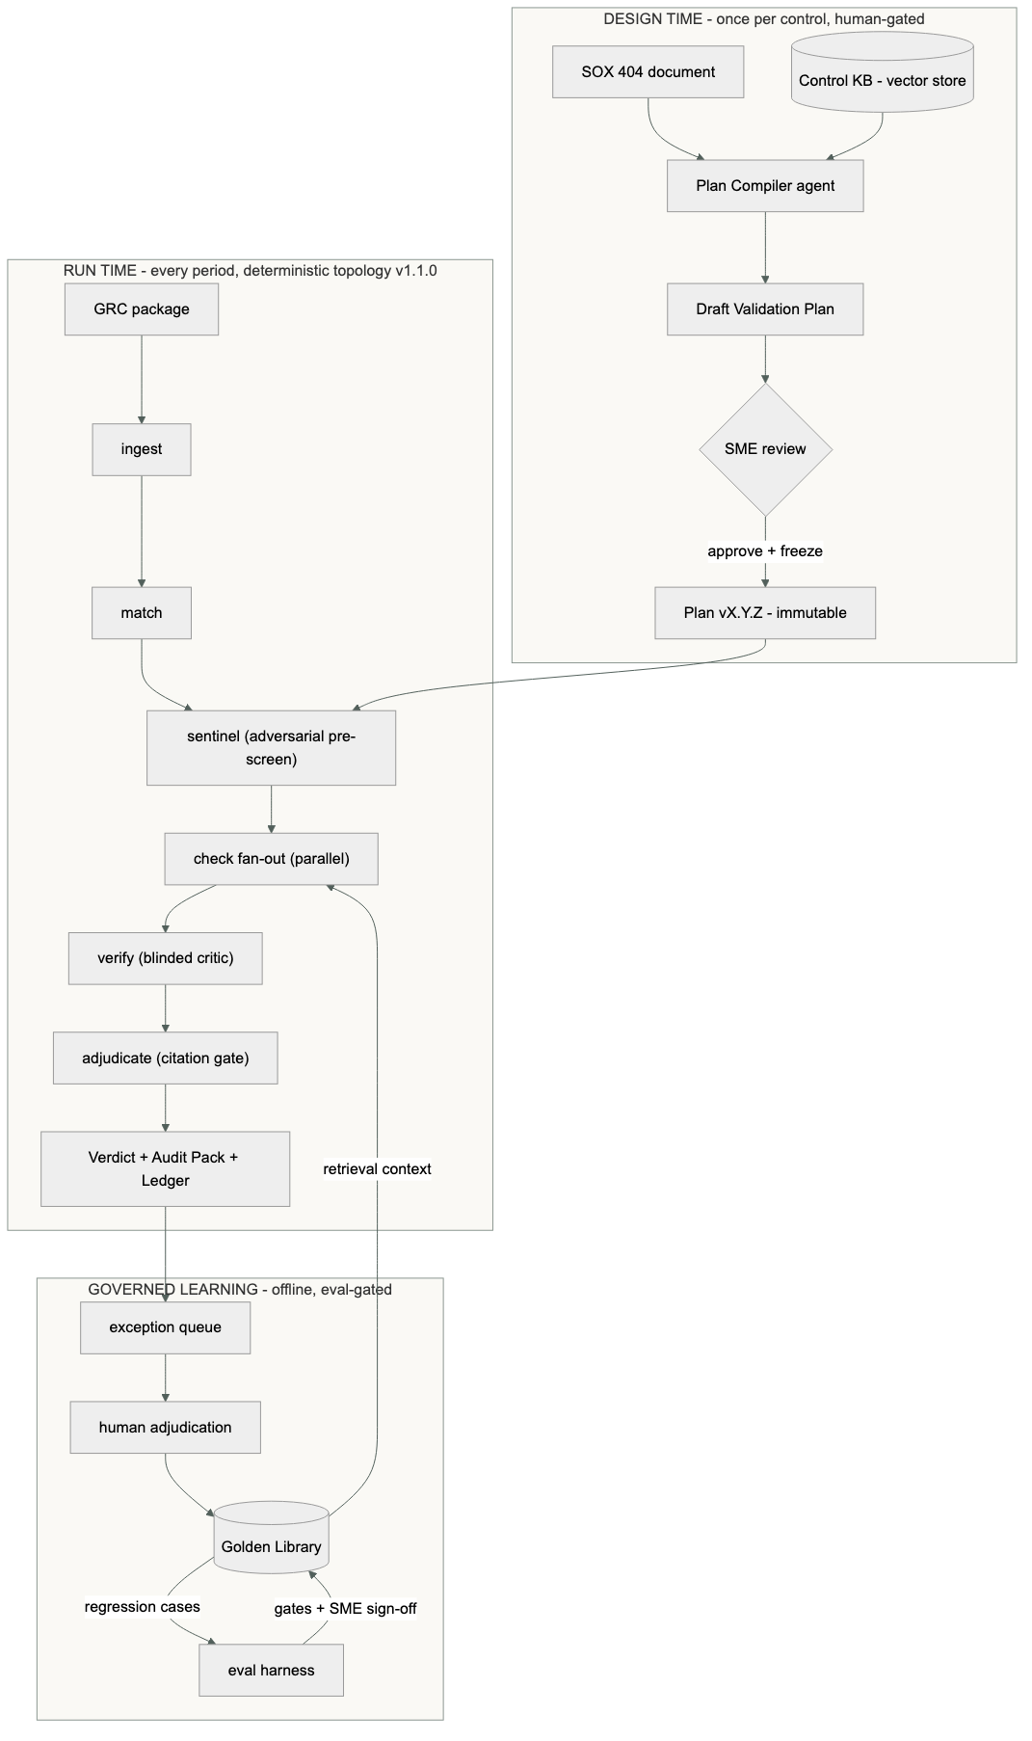
COMPONENT | CHOICE
Runtime stack | Python 3.12 · LangGraph · openpyxl / pyxlsb / extract-msg / python-docx · Tesseract OCR · FastAPI console on 127.0.0.1
Storage | Content-addressed evidence store (SHA-256 blobs, immutable) · versioned plan store · append-only JSONL run ledgers
Model seat | Single adapter; backend by environment (DaVinci · Claude · offline stub) — see §08

03 Document-intelligence layer
GRC packages are nested trees — an Outlook email holding a ZIP holding macro workbooks; a Word 404 with a 184 MB Excel workbook embedded as an OLE object; screenshots inside workbook tabs; SharePoint links standing in for files. The contract: every fact becomes addressable, every failure becomes a recorded error, and nothing is silently skipped.
ARTIFACT | EXTRACTOR | FACTS PRODUCED | LOCATOR
.xlsx / .xlsm | openpyxl dual-pass (values + formulas); >60 MB streams read-only with truncation sentinel | CellFacts (value, is_formula, formula), embedded images | cell: hash+Sheet!Cell
.xlsb | pyxlsb binary parse | CellFacts (cached values) | cell
.docx | python-docx; >30 MB streams XML; word/media → images; word/embeddings → child artifacts, recursive | paragraphs, images, nested workbooks | doc: hash+paragraph
.msg | extract-msg: headers, body, attachments incl. nested ZIPs | EmailFact (sender, date, subject, numbered lines), children | email: msg-id+line
.eml | stdlib email parser | EmailFact + attachments | email
.zip | recursive walk, depth-capped; >50 MB entries stream chunk-wise | custody node + children | file: hash
images | PIL + Tesseract OCR on demand | ImageFact (dims, OCR text) | image: hash+region
.url / .lnk | flagged, never followed | placeholder leaf → sentinel HIGH | file
Every leaf is SHA-256 hashed into an immutable content-addressed store at ingest — the chain of custody. Re-ingesting identical bytes yields identical hashes, which makes citations stable across runs and packages diffable across periods.

04 Agent & tool roster
Six reasoning seats, ten deterministic tools. Each agent is scoped: it sees only its inputs, may call only its listed tools, and everything it does lands in the ledger.
AGENT | INVOKED | SEES | TOOLS | EMITS
Plan Compiler | Design time, per control | 404 doc + Control-KB retrievals | doc readers, KB retrieval | Draft plan → human review
Temporal agent | Per temporal check | check params + matched evidence | cell_read, email_signoff_facts, timestamp_order | Finding + citations
Sign-off / SoD agent | Per signoff check | params, preparer, prepared-at cell | email_signoff_facts, cell_read | Finding + citations
Vision agent | Per vision check | image hashes + target cell | ocr_labeled_number, cell_read | Finding + citations
Blinded Verifier | Per finding | ONLY {check, verdict, citations} — reasoning structurally absent | same tools, re-performs from citations | agree / disagree → exception queue
Plan-draft harness | Offline only | Golden Library + Control KB | retrieval, doc readers | candidate amendments — never runtime
The Anomaly Sentinel is deliberately not an LLM agent. Its six detectors are deterministic Python (law 1: the adversary must not hallucinate accusations either). It sits in the topology as its own stage — see §06.
TOOL | CONTRACT | RETURNS
cell_read / range_read | graph, file_hash, sheet, cell(s) | value(s) + cell citation; CellNotFound is loud
recompute | op ∈ {sum_equals, product_equals, delta_zero, equals}, sources, target, tolerance | ok / computed / delta — pure arithmetic
timestamp | raw string + plan-pinned timezone | UTC-normalized datetime; ordering
email_parse | graph, message-id | sender, UTC date, approval line + text, line-cited
ocr_read / find_labeled_number | graph, image hash (+ label) | OCR text / value + image citation
citation.resolve | citation, graph | True only if the locator dereferences — the gate

05 A run, tool call by tool call
Control 10032 against the real April FY26 package — exactly what the ledger records:
SEQUENCE — WHO CALLS WHAT, IN ORDER
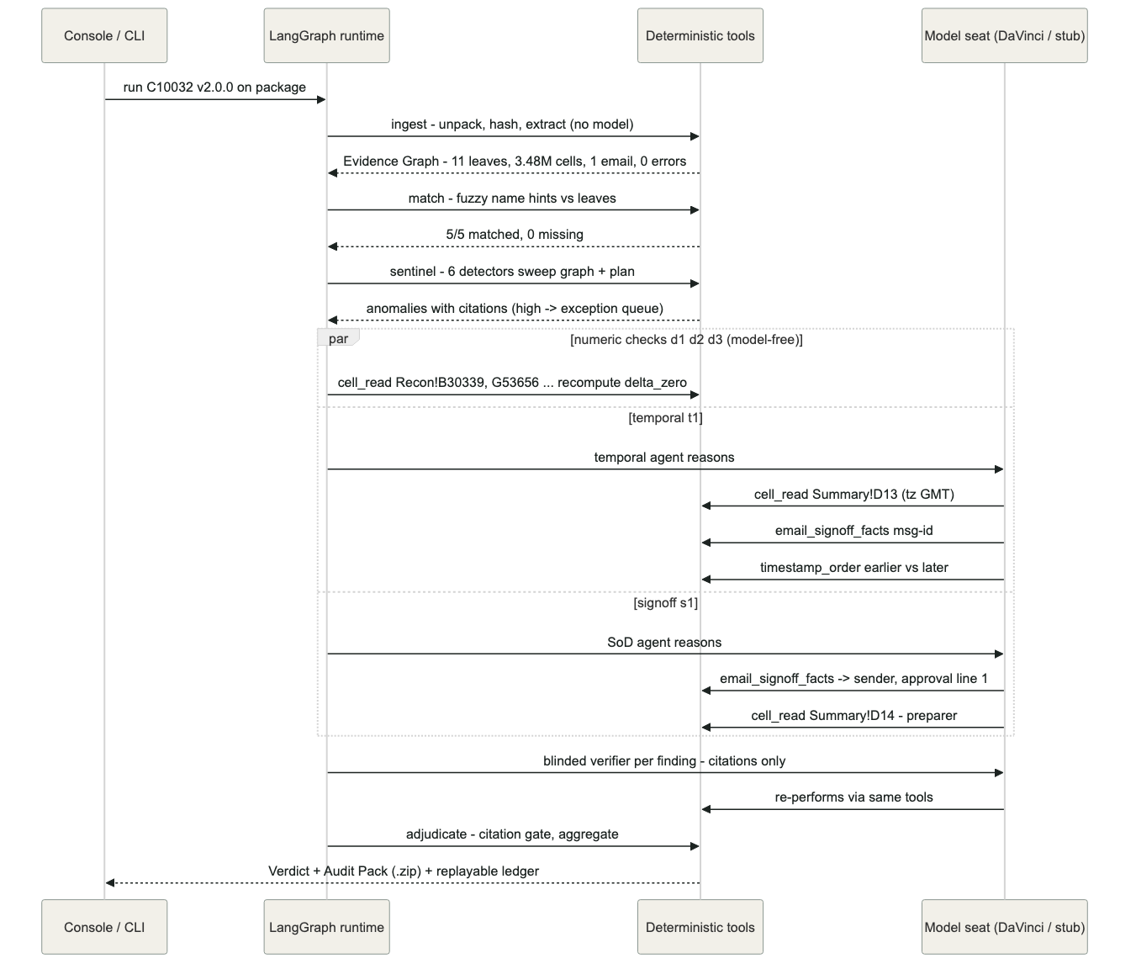
Replay any run with python -m iqr.cli explain <run_id> — the ledger holds every event above with arguments and results.

06 Adversarial layer

Anomaly Sentinel — before the checks (topology v1.1.0)
The sentinel attacks the package: the patterns a well-formed pack uses to hide problems. Six deterministic detectors, every anomaly cited:
DETECTOR | HUNTS | SEVERITY
period_conflict | Prior-quarter artifacts recycled into this period's pack (Q126 vs Q226); respects plan scope exclusions | WARN
duplicate_artifact | Identical bytes under multiple names — nobody re-ran anything | info, on the record
placeholder | SharePoint links posing as attachments, zero-byte leaves, unreadable containers | HIGH
pasted_constant | A recon delta that is a typed constant, not a formula — the classic faked reconciliation | WARN
tolerance_edge | Deltas parked within 10× of tolerance — passes, but barely | WARN
single_actor | Approval email sent by the declared preparer — SoD collapsed before the check runs | HIGH
High-severity anomalies become exceptions in the verdict and route to the human queue — a package can never sail through clean while carrying a link placeholder where evidence should be.

Blinded Verifier — after the checks
The verifier attacks the findings. Its input type contains only {check, claimed verdict, citations} — the executor's reasoning is structurally absent (enforced by the type, tested by the suite). It re-performs each conclusion from the cited evidence alone using the same deterministic tools. Agreement → the finding stands, marked verified. Disagreement → exception queue; humans arbitrate, never a silent overwrite.

07 Multi-agent orchestration
Orchestration is LangGraph with a fixed, versioned topology — currently v1.1.0: ingest → match → sentinel → check×N (parallel) → verify → adjudicate. The topology serializes to a SHA-256 signature recorded in every run ledger, so any change to the orchestration itself is a diffable, versioned event.
- Fan-out: each check in the frozen plan becomes an independent branch (LangGraph Send); parallelizable checks run concurrently. A crashed check abstains loudly as a gap — it can never sink the run or be mistaken for a pass.
- Typed state: the evidence graph and findings flow as structured state — never re-dumped into prompt text. What an agent cannot see, it cannot leak or be biased by (this is how the verifier's blindness is enforced).
- Grounding: check/verify agents may retrieve from the Golden Library (how was this pattern judged before); the Plan Compiler retrieves from the Control KB. Retrieval-anchored, never free-associating.
- No runtime planner: the plan chose the checks at design time. The autonomous planner (Option 3) exists only as an offline drafting harness behind the eval gate.

08 Model seat: DaVinci
One adapter, complete(system, prompt) → JSON, temperature 0, backend chosen by environment: DaVinci in production, Claude in the lab, deterministic stub offline/CI. The fallback chain degrades to stub on outage — the close calendar is never blocked. The ledger records which backend answered every call, making each run attributable to its model version. Precedent: the Python + DaVinci pattern already runs NextGen Collections in production; IQR adds LangGraph orchestration, not a new platform.
What changes per environment: two lines of .env — IQR_MODEL and the endpoint URL + key. Nothing else. The demo and the entire test suite run with no keys at all.

09 Evaluation harness
The harness answers one question before anything ships: does the system still catch what it must catch, refuse what it must refuse, and reproduce what it produced?
ONE EVAL RUN
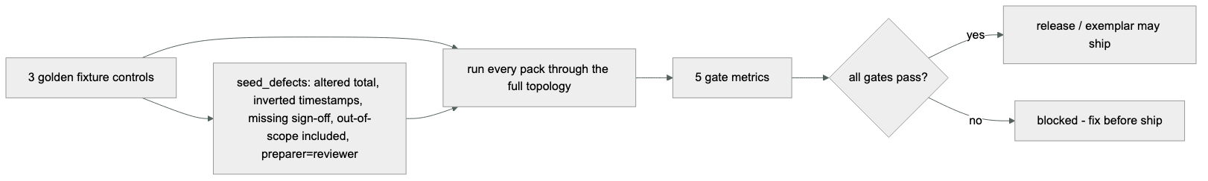
GATE METRIC | MEANING | GATE
Defect recall | Seeded defects caught (each seeded pack must NOT pass clean) | 100% of seeded classes
False-exception rate | Clean packs wrongly flagged | bounded, tracked
Citation validity | Every claim's locator resolves against the graph | 100% — hard gate
Abstention correctness | Missing evidence → gap, never pass or invention | 100%
Reproducibility | Same pack + plan → identical verdict fingerprint | exact
Run it from the console's Evaluation tab, VS Code (launch config), or python -m iqr.cli eval. The same harness is the regression gate for the Golden Library.

10 Golden Library lifecycle
HOW THE SYSTEM LEARNS WITHOUT DRIFTING
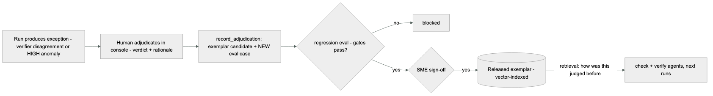
Two properties make this audit-defensible: every human override becomes an eval case (the system is permanently tested against its own history), and nothing learns silently — an exemplar enters the runtime path only through the eval gate plus SME sign-off, versioned.

11 The console (what users see)
A reviewer should never need to know what a package_ref is. The console (a single static page over the local API on 127.0.0.1:8400) walks them through it:
- Run a control — cards for every approved plan. Selecting one shows exactly what evidence that plan expects — each required item with its description and the name patterns the matcher looks for — plus what the plan excludes from scope. This is the answer to “what do I upload?”: the frozen plan itself tells them.
- Provide evidence — drag-and-drop upload or point at a folder already on the machine.
- Live run — the ledger streams into the page as it happens: ingest counts, match results, sentinel anomalies, each check's tool calls, verifier agreement, the citation gate.
- Verdict — findings table with verdict chips, citations (Recon!B30339, email line 1), gaps, exceptions, and the one-click audit-pack download.
- Evaluation — run the harness, see the five gates.
- Governance — the exception queue feeding the Golden Library, and the approved-plan register.
From VS Code: open the repo, press F5 — launch configs exist for the console, a real-package run, and the eval harness. python -m iqr.cli serve does the same from any terminal.

12 The seven invariants (these are the product)
# | INVARIANT | ENFORCED BY
1 | No model math — numeric paths contain zero model calls | model-call counter asserted untouched in tests
2 | Citation gate — non-resolving citations never enter a verdict | mechanical gate + fabricated-locator test
3 | Reproducibility — same pack + plan → identical verdict | fingerprint equality across runs, temperature 0
4 | Honest missing — absent required evidence → gap, never pass | match node contract + tests
5 | Scope respected — excluded items never flagged | match + sentinel honor exclusions; tested
6 | Blinded verify — critic never sees executor reasoning | input type structurally excludes it; tested
7 | Chain of custody — SHA-256 at ingest, hash in citations | content-addressed store + tests

13 POC status on real evidence
Validated against the actual April/Q2 FY26 packages (full detail: docs/REAL_VALIDATION.md):
CONTROL 10032 CHECK | VERDICT | CITATION
BPC↔ODW grand totals agree | PASS 8.28e-06 ≤ 0.01 | Recon!B30339 · G53656
Delta sums ≈ 0 both sides | PASS | Recon!D2 · I2
Stat accounts net to zero | PASS | Stat acct check!D5,E5
Certified run before approval | PASS GMT in-cell | Summary!D13 vs .msg date
Segregation of duties | PASS | Summary!D14 vs .msg sender
Approval language | PASS | .msg body line 1
Reviewer checklist attached | PRESENT | nested in .msg
10075: 6-email sign-off chain parsed with line citations (including “one exception noted and immediately resolved”), 44-tab IPE ingested, 245 images extracted. 23024: the 404's 184 MB embedded rebate workbook surfaced as first-class evidence via streaming OLE ingestion. Plan v2.0.0 for 10032 is frozen with real locators; the full E2E run executes through the console/CLI.
Honest limits: OCR reads provenance (system banners, hostnames, report names) reliably, not small-font digits — numeric ties come from certified workbook cells by design. Timezone semantics are pinned per control by the SME in the plan. Free-text 404 compilation needs the production model seat.

14 Deployment
The step-by-step deployment guide (prerequisites, install, offline gates, model configuration, console, troubleshooting, production hardening) is maintained as its own document: IQR Deployment Guide (docs/DEPLOYMENT.md and the companion Word document).

