NPM initialisation

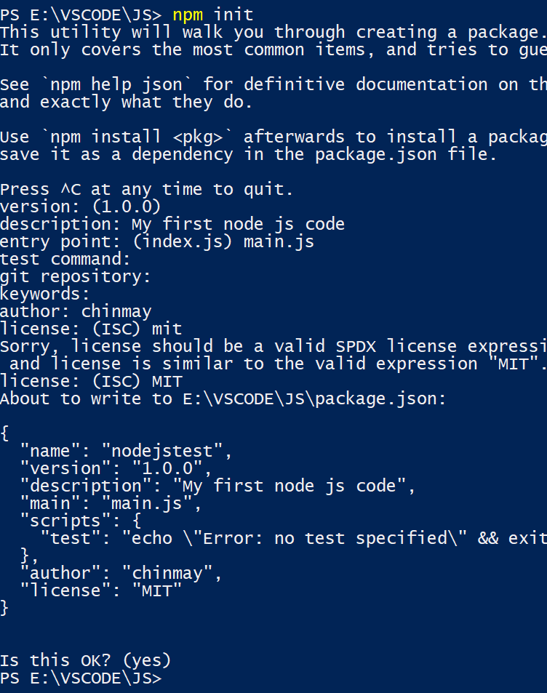

Global Variable:-

Require

Target file:-

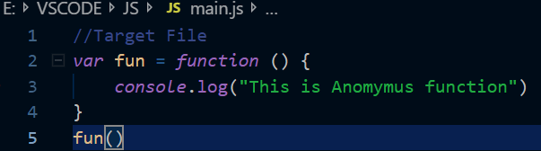

Source file:-

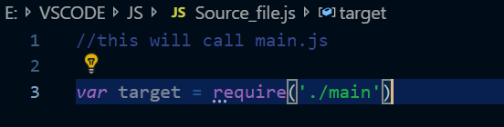

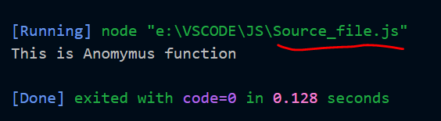

Creating a server using http module:-

*const* http = require("http");

*const* server = http.createServer(*function* (*req*, *res*) {

res.write("Node JS Server Running.")

res.end();

}).listen(3000);

Output:-

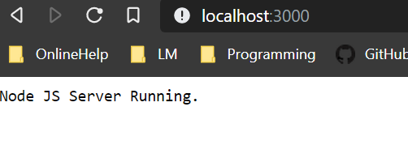

Adding few more details

*const* http = require("http");

*const* server = http.createServer(*function* (*req*, *res*) {

//res.writeHead(200, { "content-type": "text/plain" }) this will also print tags as text in browser

res.writeHead(200, { "content-type": "text/html" })

res.write("<h1>Node JS Server Running.</h1>")

res.end();

}).listen(3000, () *=>* *console*.log("Server running on port 3000"));

Output:-

In terminal :-

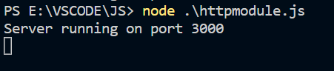

In browser:-

