Chittaranjan Saha
18th Nov 2025
Offers Implementation

Table of Contents
Database (SQL Server) 2
General Quaries 2
Tables 5
Placeholders Table 5
Offers Table 6
Customers Table 10
CustomerOffers Table 11
PlaceholderOffers Table 13
Bits Table 14
CustomerOfferStatsDaily Table 15
Functions 16
fn_IsCustomerValid Function 16
fn_IsPlaceholderValid 17
Store Procedures 18
GetCustomerDetails 18
GetOfferDetails 20
GetPlaceholderDetails 22
InsertBit 24
GetBitDetails 26
GetCustomerOffer 28
Trigger 32
Trg_UpdateClickViewStatusDaily 32

Database (SQL Server)

CREATE DATABASE SampleOffersAPI;
GO
USE SampleOffersAPI;

Database used – Microsoft SQL Server
Local Project path - C:\Users\sahac\Desktop\Education\Codes\Others\Personal Projects\Offers Implementation-API\Database

General Quaries

-- Get all offers for a given customer
SELECT
c.Cust_ID,
c.Cust_Fed_ID,
c.Cust_Name,
o.Offer_ID,
o.Offer_Name
FROM CustomerOffers co
INNER JOIN Offers o ON co.Offer_ID = o.Offer_ID
INNER JOIN Customers c ON co.Cust_Fed_ID = c.Cust_Fed_ID
WHERE c.Cust_Fed_ID = '6049382751';

-- Get customer and placeholder details
SELECT
c.Cust_Fed_ID AS cust_fed_id,
p.Placeholder_Guid AS placeholder_guid,
p.Placeholder_Name AS placeholder_name,
p.Channel_Name AS channel_name,
p.Channel_Type AS channel_type,
p.Placeholder_Offer_Limit AS placeholder_offer_limit,
p.Placeholder_Meta AS placeholder_meta
FROM Customers c
INNER JOIN Placeholders p ON p.Placeholder_Guid = '55C5AA3B-AB8B-F011-9F57-64D69AE7FAE4'
WHERE c.Cust_Fed_ID = '6049382751';

-- Get default offers for a placeholder
SELECT
o.Offer_Guid,
o.Offer_Name,
o.Offer_Description,
o.Offer_Type,
o.Offer_Priority,
o.Offer_View_Threshold,
o.Offer_Click_Threshold,
o.Offer_Banner_Type,
o.Offer_Content,
o.Offer_Extra_Content,
o.Offer_Meta
FROM PlaceholderOffers po
INNER JOIN Placeholders p2 ON p2.Placeholder_ID = po.Placeholder_ID
INNER JOIN Offers o ON o.Offer_ID = po.Offer_ID
WHERE p2.Placeholder_Guid = '55C5AA3B-AB8B-F011-9F57-64D69AE7FAE4'
AND o.Offer_Type = 'Default'
AND o.Offer_Visibility_Flag = 1;

-- Get sum of views and click counts for last three days
SELECT
Cust_Fed_ID,
Offer_Guid,
SUM(View_Count) AS Views3Days,
SUM(Click_Count) AS Clicks3Days
FROM CustomerOfferStatsDaily
WHERE Stat_Date >= CAST(DATEADD(DAY, -2, CAST(GETDATE() AS DATE)) AS DATE)
GROUP BY Cust_Fed_ID, Offer_Guid

-- Get sum of views and click counts for last three days
WITH Stats3Days AS (
SELECT
Cust_Fed_ID,
Offer_Guid,
SUM(View_Count) AS Views3Days,
SUM(Click_Count) AS Clicks3Days
FROM CustomerOfferStatsDaily
WHERE Stat_Date >= CAST(DATEADD(DAY, -2, CAST(GETDATE() AS DATE)) AS DATE)
GROUP BY Cust_Fed_ID, Offer_Guid
)

SELECT DISTINCT
o.Offer_Guid AS offer_guid,
o.Offer_Name AS offer_name,
o.Offer_Description AS offer_description,
o.Offer_Type AS offer_type,
o.Offer_Priority AS offer_priority,
o.Offer_View_Threshold AS offer_view_threshold,
o.Offer_Click_Threshold AS offer_click_threshold,
o.Offer_Banner_Type AS offer_banner_type,
o.Offer_Content AS offer_content,
o.Offer_Extra_Content AS offer_extra_content,
o.Offer_Meta AS offer_meta
FROM CustomerOffers co
INNER JOIN Offers o ON co.Offer_ID = o.Offer_ID
INNER JOIN PlaceholderOffers po ON o.Offer_ID = po.Offer_ID
INNER JOIN Placeholders p2 ON po.Placeholder_ID = p2.Placeholder_ID
LEFT JOIN Stats3Days s ON co.Cust_Fed_ID = s.Cust_Fed_ID AND o.Offer_Guid = s.Offer_Guid
WHERE
co.Cust_Fed_ID = '6049382751'
AND p2.Placeholder_Guid = '55C5AA3B-AB8B-F011-9F57-64D69AE7FAE4'
AND o.Offer_Visibility_Flag = 1
AND ISNULL(s.Views3Days, 0) < o.Offer_View_Threshold
AND ISNULL(s.Clicks3Days, 0) < o.Offer_Click_Threshold

--Outputs is a single JSON object containing alll the offers for that placeholder
SELECT
c.Cust_Fed_ID AS cust_fed_id,
p.Placeholder_Guid AS placeholder_guid,
p.Placeholder_Name AS placeholder_name,
p.Channel_Name AS channel_name,
p.Channel_Type AS channel_type,
p.Placeholder_Offer_Limit AS placeholder_offer_limit,
p.Placeholder_Meta AS placeholder_meta
FROM Customers c
INNER JOIN CustomerOffers co ON c.cust_fed_id = co.cust_fed_id
INNER JOIN Placeholders p ON p.Placeholder_Guid = '55C5AA3B-AB8B-F011-9F57-64D69AE7FAE4'
WHERE c.cust_fed_id = '9283746150'
FOR JSON PATH, WITHOUT_ARRAY_WRAPPER

--JSON Output of above quary after beautifying
{
"cust_fed_id": "9283746150",
"placeholder_guid": "55C5AA3B-AB8B-F011-9F57-64D69AE7FAE4",
"placeholder_name": "Offer For You",
"channel_name": "NLI",
"channel_type": "Web",
"placeholder_offer_limit": 2,
"placeholder_meta": "{\"service_type\":\"Retail\",\"placeholder_description\":\"\"}"
}

Tables

Placeholders Table

CREATE TABLE Placeholders
(
Placeholder_ID INT PRIMARY KEY IDENTITY,
Placeholder_Guid UNIQUEIDENTIFIER NOT NULL UNIQUE DEFAULT NEWSEQUENTIALID(),
Placeholder_Name VARCHAR(100) NOT NULL,
Channel_Name VARCHAR(100),
Channel_Type VARCHAR(100) CHECK (Channel_Type IN ('Web', 'Mobile', 'Other')),
Placeholder_Offer_Limit INT CHECK (Placeholder_Offer_Limit >= 0),
Placeholder_Creation_Date DATETIME DEFAULT GETDATE(),
Placeholder_Meta NVARCHAR(MAX) NULL,
Placeholder_Is_Active BIT NOT NULL DEFAULT 1
);

INSERT INTO Placeholders
(Placeholder_Name, Channel_Name, Channel_Type, Placeholder_Offer_Limit, Placeholder_Meta, Placeholder_Is_Active)
VALUES
('Home Page Banner', 'NLI', 'Web', 15, N'{"service_type":"Retail","placeholder_description":""}', 1),
('Hero Banner', 'iMobile', 'Mobile', 3, N'{"service_type":"Retail","placeholder_description":""}', 1),
('What''s New', 'RIB', 'Web', 8, N'{"service_type":"Retail%","placeholder_description":""}', 1),
('Offer For You', 'NLI', 'Web', 2, N'{"service_type":"Retail","placeholder_description":""}', 0),
('Marchent Dashboard', 'InstaBIZ', 'Mobile', 4, N'{"service_type":"Corporate","placeholder_description":""}', 1),
('Notification', 'NLI', 'Web', 6, N'{"service_type":"Retail","placeholder_description":""}', 1),
('FT Success', 'InstaBIZ', 'Mobile', 10, N'{"service_type":"Corporate","placeholder_description":""}', 1),
('GST Success', 'CIB', 'Web', 7, N'{"service_type":"Corporate","placeholder_description":""}', 1),
('Loans', 'RIB', 'Web', 12, N'{"service_type":"Retail","placeholder_description":""}', 0),
('Rewards', 'iMobile', 'Mobile', 15, N'{"service_type":"Retail","placeholder_description":""}', 1);

SELECT * FROM Placeholders;

-- DROP TABLE Placeholders;

Output –
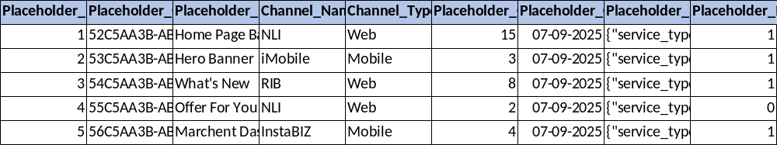

Offers Table

CREATE TABLE Offers
(
Offer_ID INT PRIMARY KEY IDENTITY,
Offer_GUID UNIQUEIDENTIFIER NOT NULL UNIQUE DEFAULT NEWSEQUENTIALID(),
Offer_Name VARCHAR(100),
Offer_Description VARCHAR(500) NULL,
Offer_Type VARCHAR(100),
Offer_Start_Date DATETIME NOT NULL,
Offer_End_Date DATETIME NOT NULL,
Offer_Priority INT,
Offer_View_Threshold INT,
Offer_Click_Threshold INT,
Offer_Banner_Type VARCHAR(100),
Offer_Content NVARCHAR(MAX) NULL,
Offer_Extra_Content NVARCHAR(MAX) NULL,
Offer_Meta NVARCHAR(MAX) NULL,
Last_Modification_Date DATETIME NOT NULL DEFAULT GETDATE(),
Offer_Visibility_Flag BIT NOT NULL DEFAULT 1,
CONSTRAINT CK_Offers_Date CHECK (Offer_End_Date >= Offer_Start_Date)
);

INSERT INTO Offers
(Offer_Name, Offer_Description, Offer_Type, Offer_Start_Date, Offer_End_Date, Offer_Priority, Offer_View_Threshold, Offer_Click_Threshold, Offer_Banner_Type, Offer_Content, Offer_Extra_Content, Offer_Meta, Offer_Visibility_Flag)
VALUES

('Pre-Approved Home Loan Offer','Offer Description','NBA','2025-09-01','2026-12-31',1,10,3,'Static', N'{"redirection_URL":"https://www.example.com/offers/123","image_URL":{"mobile":"https://cdn.example.com/images/offer_mobile.jpg","desktop":"https://cdn.example.com/images/offer_desktop.jpg","tablet":"https://cdn.example.com/images/offer_tablet.jpg"},"offer_text":"Get 20% off on your first purchase!"}', '', N'{"product":"HL"}',1),

('Personal Loan Asset Offer','Offer Description','NBA','2025-09-01','2026-12-31',2,10,3,'Static', N'{"redirection_URL":"https://www.example.com/offers/123","image_URL":{"mobile":"https://cdn.example.com/images/offer_mobile.jpg","desktop":"https://cdn.example.com/images/offer_desktop.jpg","tablet":"https://cdn.example.com/images/offer_tablet.jpg"},"offer_text":"Get 20% off on your first purchase!"}','',N'{"product":"PL"}',1),

('Forex Offer','Offer Description','NBA','2025-09-01','2026-12-31',3,10,3,'Static', N'{"redirection_URL":"https://www.example.com/offers/123","image_URL":{"mobile":"https://cdn.example.com/images/offer_mobile.jpg","desktop":"https://cdn.example.com/images/offer_desktop.jpg","tablet":"https://cdn.example.com/images/offer_tablet.jpg"},"offer_text":"Get 20% off on your first purchase!"}', '',N'{"product":"Forex"}',1),

('Credit Card Upgrade Offer','Offer Description','NBA','2025-09-01','2026-12-31',4,10,3,'Static',
N'{"redirection_URL":"https://www.example.com/offers/123","image_URL":{"mobile":"https://cdn.example.com/images/offer_mobile.jpg","desktop":"https://cdn.example.com/images/offer_desktop.jpg","tablet":"https://cdn.example.com/images/offer_tablet.jpg"},"offer_text":"Get 20% off on your first purchase!"}', '',N'{"product":"CC"}',1),

('Gold Loan Offer','Offer Description','NBA','2025-09-01','2026-12-31',5,10,3,'Static',
N'{"redirection_URL":"https://www.example.com/offers/123","image_URL":{"mobile":"https://cdn.example.com/images/offer_mobile.jpg","desktop":"https://cdn.example.com/images/offer_desktop.jpg","tablet":"https://cdn.example.com/images/offer_tablet.jpg"},"offer_text":"Get 20% off on your first purchase!"}', '',N'{"product":"GL"}',1),

('Scan & Pay Offer','Offer Description','NBA','2025-09-01','2026-12-31',6,10,3,'Static',
N'{"redirection_URL":"https://www.example.com/offers/123","image_URL":{"mobile":"https://cdn.example.com/images/offer_mobile.jpg","desktop":"https://cdn.example.com/images/offer_desktop.jpg","tablet":"https://cdn.example.com/images/offer_tablet.jpg"},"offer_text":"Get 20% off on your first purchase!"}', '',N'{"product":"SP"}',1),

('Real Time MF Investment','Offer Description','NBA','2025-09-01','2026-12-31',7,10,3,'Static', N'{"redirection_URL":"https://www.example.com/offers/123","image_URL":{"mobile":"https://cdn.example.com/images/offer_mobile.jpg","desktop":"https://cdn.example.com/images/offer_desktop.jpg","tablet":"https://cdn.example.com/images/offer_tablet.jpg"},"offer_text":"Get 20% off on your first purchase!"}', '',N'{"product":"MF"}',1),

('Pay to Contact Offer','Offer Description','NBA','2025-09-01','2026-12-31',8,10,3,'Static', N'{"redirection_URL":"https://www.example.com/offers/123","image_URL":{"mobile":"https://cdn.example.com/images/offer_mobile.jpg","desktop":"https://cdn.example.com/images/offer_desktop.jpg","tablet":"https://cdn.example.com/images/offer_tablet.jpg"},"offer_text":"Get 20% off on your first purchase!"}', '',N'{"product":"PC"}',1),

('Mutual Fund Offer','Offer Description','NBA','2025-09-01','2026-12-31',9,10,3,'Static',
N'{"redirection_URL":"https://www.example.com/offers/123","image_URL":{"mobile":"https://cdn.example.com/images/offer_mobile.jpg","desktop":"https://cdn.example.com/images/offer_desktop.jpg","tablet":"https://cdn.example.com/images/offer_tablet.jpg"},"offer_text":"Get 20% off on your first purchase!"}', '',N'{"product":"MF"}',1),

('iWish Offer','Offer Description','NBA','2025-09-01','2026-12-31',10,10,3,'Static',
N'{"redirection_URL":"https://www.example.com/offers/123","image_URL":{"mobile":"https://cdn.example.com/images/offer_mobile.jpg","desktop":"https://cdn.example.com/images/offer_desktop.jpg","tablet":"https://cdn.example.com/images/offer_tablet.jpg"},"offer_text":"Get 20% off on your first purchase!"}', '',N'{"product":"iWish"}',1),

('Two Wheeler Loan Offer','Offer Description','NBA','2025-09-01','2026-12-31',11,10,3,'Static', N'{"redirection_URL":"https://www.example.com/offers/123","image_URL":{"mobile":"https://cdn.example.com/images/offer_mobile.jpg","desktop":"https://cdn.example.com/images/offer_desktop.jpg","tablet":"https://cdn.example.com/images/offer_tablet.jpg"},"offer_text":"Get 20% off on your first purchase!"}', '',N'{"product":"TWL"}',1),

('Fastag Offer','Offer Description','NBA','2025-09-01','2026-12-31',12,10,3,'Static',
N'{"redirection_URL":"https://www.example.com/offers/123","image_URL":{"mobile":"https://cdn.example.com/images/offer_mobile.jpg","desktop":"https://cdn.example.com/images/offer_desktop.jpg","tablet":"https://cdn.example.com/images/offer_tablet.jpg"},"offer_text":"Get 20% off on your first purchase!"}', '',N'{"product":"Fastag"}',1),

('Education Loan Offer','Offer Description','NBA','2025-09-01','2026-12-31',13,10,3,'Static', N'{"redirection_URL":"https://www.example.com/offers/123","image_URL":{"mobile":"https://cdn.example.com/images/offer_mobile.jpg","desktop":"https://cdn.example.com/images/offer_desktop.jpg","tablet":"https://cdn.example.com/images/offer_tablet.jpg"},"offer_text":"Get 20% off on your first purchase!"}', '',N'{"product":"EL"}',1),

('Electricity Billpay Offer','Offer Description','NBA','2025-09-01','2026-12-31',14,10,3,'Static', N'{"redirection_URL":"https://www.example.com/offers/123","image_URL":{"mobile":"https://cdn.example.com/images/offer_mobile.jpg","desktop":"https://cdn.example.com/images/offer_desktop.jpg","tablet":"https://cdn.example.com/images/offer_tablet.jpg"},"offer_text":"Get 20% off on your first purchase!"}', '',N'{"product":"BBPS"}',1),

('Credit Card Limit Increase Offer','Offer Description','NBA','2025-09-01','2026-12-31',15,10,3,'Static', N'{"redirection_URL":"https://www.example.com/offers/123","image_URL":{"mobile":"https://cdn.example.com/images/offer_mobile.jpg","desktop":"https://cdn.example.com/images/offer_desktop.jpg","tablet":"https://cdn.example.com/images/offer_tablet.jpg"},"offer_text":"Get 20% off on your first purchase!"}', '',N'{"product":"CLI"}',1),

('Consumer EMI Offer','Offer Description','NBA','2025-09-01','2026-12-31',16,10,3,'Static',
N'{"redirection_URL":"https://www.example.com/offers/123","image_URL":{"mobile":"https://cdn.example.com/images/offer_mobile.jpg","desktop":"https://cdn.example.com/images/offer_desktop.jpg","tablet":"https://cdn.example.com/images/offer_tablet.jpg"},"offer_text":"Get 20% off on your first purchase!"}', '',N'{"product":"EMI"}',1),

('BBPS Electricity Offer','Offer Description','NBA','2025-09-01','2026-12-31',17,10,3,'Static',
N'{"redirection_URL":"https://www.example.com/offers/123","image_URL":{"mobile":"https://cdn.example.com/images/offer_mobile.jpg","desktop":"https://cdn.example.com/images/offer_desktop.jpg","tablet":"https://cdn.example.com/images/offer_tablet.jpg"},"offer_text":"Get 20% off on your first purchase!"}', '',N'{"product":"BBPS"}',1),

('Debit Card Upgrade Offer','Offer Description','NBA','2025-09-01','2026-12-31',18,10,3,'Static', N'{"redirection_URL":"https://www.example.com/offers/123","image_URL":{"mobile":"https://cdn.example.com/images/offer_mobile.jpg","desktop":"https://cdn.example.com/images/offer_desktop.jpg","tablet":"https://cdn.example.com/images/offer_tablet.jpg"},"offer_text":"Get 20% off on your first purchase!"}', '',N'{"product":"DCU"}',1),

('Auto Loan Default Offer','Offer Description','Default','2025-09-01','2026-12-31',19,10,3,'Static', N'{"redirection_URL":"https://www.example.com/offers/123","image_URL":{"mobile":"https://cdn.example.com/images/offer_mobile.jpg","desktop":"https://cdn.example.com/images/offer_desktop.jpg","tablet":"https://cdn.example.com/images/offer_tablet.jpg"},"offer_text":"Get 20% off on your first purchase!"}', '',N'{"product":"AL"}',1),

('Demat Default Offer','Offer Description','Default','2025-09-01','2026-12-31',20,10,3,'Static', N'{"redirection_URL":"https://www.example.com/offers/123","image_URL":{"mobile":"https://cdn.example.com/images/offer_mobile.jpg","desktop":"https://cdn.example.com/images/offer_desktop.jpg","tablet":"https://cdn.example.com/images/offer_tablet.jpg"},"offer_text":"Get 20% off on your first purchase!"}', '',N'{"product":"Demat"}',1);

SELECT * FROM Offers;

-- Update default offers threshold
UPDATE Offers
SET Offer_Visibility_Flag = 0
WHERE Offer_ID = 19

-- Validate JSON field
SELECT ISJSON(Offer_Content)
FROM Offers
WHERE Offer_ID = 19;

-- Update specific Offer Content
UPDATE Offers
SET Offer_Content = N'{
"redirection_URL": "https://www.chittaranjansaha.com",
"image_URL": {
"mobile": "https://raw.githubusercontent.com/git-chittaranjan/offers-implementation-api/main/Frontend/Contents/Desktop/Demat_Default_Offer.gif",
"desktop": "https://raw.githubusercontent.com/git-chittaranjan/offers-implementation-api/main/Frontend/Contents/Desktop/Demat_Default_Offer.gif",
"tablet": "https://raw.githubusercontent.com/git-chittaranjan/offers-implementation-api/main/Frontend/Contents/Desktop/Demat_Default_Offer.gif"
},
"offer_text": "Demat_Default_Offer.gif"
}'
WHERE Offer_ID = 20;

-- DROP TABLE Offers;

Output –
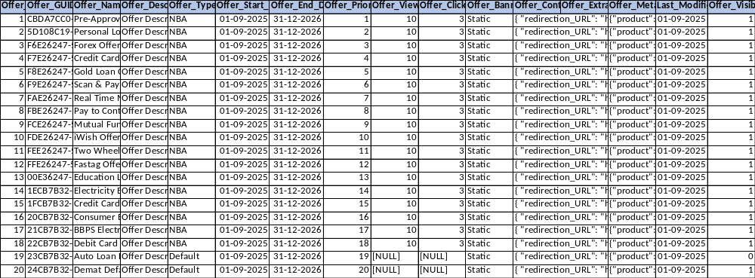

Notes –
- Check for Offer_Type, Default offers will not have suppression
- Check for Offer_Start_Date, Offer_End_Date for offers to return in APIs
- Offer_Priority for ranking offers
- Offer_View_Threshold and Offer_Click_Threshold are for suppression
- Offer_content contains the offers content o be displayed
- Offer_Visibility_Flag is to check active offers

Customers Table

CREATE TABLE Customers
(
Cust_ID INT IDENTITY,
Cust_Fed_ID VARCHAR(100) PRIMARY KEY,
Cust_Name VARCHAR(100),
Cust_Data NVARCHAR(MAX),
Cust_Entry_Date DATETIME NOT NULL DEFAULT GETDATE(),
Cust_Is_Active BIT NOT NULL DEFAULT 1
);

INSERT INTO Customers (Cust_Fed_ID, Cust_Name, Cust_Data)
VALUES
('4839201746', 'Rahul Sharma', N'{"age": 32, "city": "Mumbai", "gender": "Male"}'),
('9283746150', 'Ananya Gupta', N'{"age": 28, "city": "Delhi", "gender": "Female"}'),
('7152903846', 'Vikram Singh', N'{"age": 40, "city": "Bengaluru", "gender": "Male"}'),
('6049382751', 'Priya Nair', N'{"age": 35, "city": "Chennai", "gender": "Female"}'),
('8391046275', 'Arjun Mehta', N'{"age": 30, "city": "Kolkata", "gender": "Male"}');

SELECT * FROM Customers ORDER BY Cust_ID;

-- DROP TABLE Customers;

UPDATE Customers
SET Cust_Is_Active = 0
WHERE Cust_Fed_ID = '8391046275'

Output –
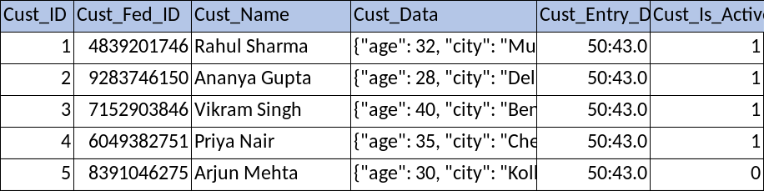

Notes –
- Check for Customer_Is_Active status

CustomerOffers Table

CREATE TABLE CustomerOffers
(
Cust_Fed_ID VARCHAR(100) NOT NULL,
Offer_ID INT NOT NULL,
Offer_Guid UNIQUEIDENTIFIER NOT NULL,
Assigned_Date DATETIME DEFAULT GETDATE(),
PRIMARY KEY (Cust_Fed_ID, Offer_ID),
FOREIGN KEY (Cust_Fed_ID) REFERENCES Customers(Cust_Fed_ID),
FOREIGN KEY (Offer_ID) REFERENCES Offers(Offer_ID)
);

INSERT INTO CustomerOffers (Cust_Fed_ID, Offer_ID, Assigned_Date)
VALUES
('4839201746', 1, '2025-08-01'), ('4839201746', 3, '2025-08-05'),
('4839201746', 5, '2025-08-06'), ('4839201746', 7, '2025-08-12'),
('4839201746', 9, '2025-08-19'), ('4839201746', 11, '2025-08-20'),
('4839201746', 13, '2025-08-20'), ('4839201746', 15, '2025-08-20'),
('4839201746', 17, '2025-08-20'), ('9283746150', 2, '2025-08-03'),
('9283746150', 4, '2025-08-14'), ('9283746150', 6, '2025-08-14'),
('9283746150', 8, '2025-08-14'), ('9283746150', 10, '2025-08-14'),
('9283746150', 12, '2025-08-14'), ('9283746150', 14, '2025-08-14'),
('9283746150', 16, '2025-08-14'), ('9283746150', 18, '2025-08-14'),
('7152903846', 3, '2025-08-07'), ('7152903846', 6, '2025-08-08'),
('7152903846', 9, '2025-08-11'), ('7152903846', 12, '2025-08-11'),
('7152903846', 15, '2025-08-11'), ('7152903846', 18, '2025-08-11'),
('6049382751', 1, '2025-08-04'), ('6049382751', 3, '2025-08-10'),
('6049382751', 5, '2025-08-16'), ('6049382751', 7, '2025-08-18'),
('6049382751', 9, '2025-08-18'), ('6049382751', 10, '2025-08-18'),
('6049382751', 12, '2025-08-18'), ('6049382751', 14, '2025-08-18'),
('6049382751', 16, '2025-08-18'), ('6049382751', 18, '2025-08-18'),
('8391046275', 1, '2025-08-13'), ('8391046275', 2, '2025-08-15'),
('8391046275', 3, '2025-08-17'), ('8391046275', 4, '2025-08-17'),
('8391046275', 5, '2025-08-17'), ('8391046275', 6, '2025-08-17'),
('8391046275', 7, '2025-08-17'), ('8391046275', 8, '2025-08-17'),
('8391046275', 9, '2025-08-17'), ('8391046275', 10, '2025-08-17'),
('8391046275', 11, '2025-08-17'), ('8391046275', 12, '2025-08-17'),
('8391046275', 13, '2025-08-17'), ('8391046275', 14, '2025-08-17'),
('8391046275', 15, '2025-08-17'), ('8391046275', 16, '2025-08-17'),
('8391046275', 17, '2025-08-17'), ('8391046275', 18, '2025-08-17');

SELECT * FROM CustomerOffers;

SELECT
c.Cust_ID,
c.Cust_Fed_ID,
c.Cust_Name,
o.Offer_ID,
o.Offer_GUID,
o.Offer_Name
FROM CustomerOffers co
INNER JOIN Offers o ON co.Offer_ID = o.Offer_ID
INNER JOIN Customers c ON co.Cust_Fed_ID = c.Cust_Fed_ID
WHERE c.Cust_Fed_ID = '9283746150';

-- DROP TABLE CustomerOffers;

Output –
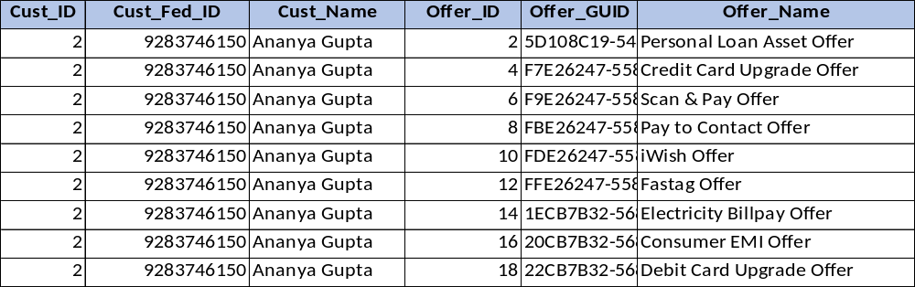
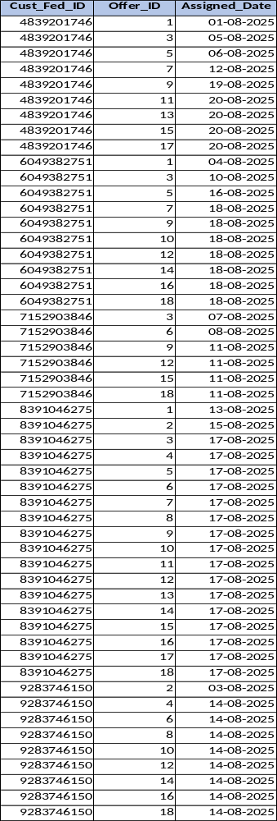

PlaceholderOffers Table

CREATE TABLE PlaceholderOffers
(
Offer_ID INT NOT NULL,
Placeholder_ID INT NOT NULL,
PRIMARY KEY (Offer_ID, Placeholder_ID),
FOREIGN KEY (Offer_ID) REFERENCES Offers(Offer_ID),
FOREIGN KEY (Placeholder_ID) REFERENCES Placeholders(Placeholder_ID)
);

INSERT INTO PlaceholderOffers (Placeholder_ID, Offer_ID) VALUES
(1, 1), (1, 2), (1, 3), (1, 4), (1, 5), (1, 6), (1, 7), (1, 8), (1, 9), (1, 10),
(1, 11), (1, 12), (1, 13), (1, 14), (1, 15), (1, 16), (1, 17), (1, 18), (1, 19), (1, 20),
(2, 3), (2, 6), (2, 9), (2, 12), (2, 15), (2, 18), (2, 19), (2, 20), (3, 1), (3, 2), (3, 3), (3, 4), (3, 5), (3, 6), (3, 7), (3, 8), (3, 9), (3, 10), (3, 15), (3, 16), (3, 17), (3, 18), (4, 2), (4, 4), (4, 6), (4, 8), (4, 10), (4, 12), (4, 14), (4, 16), (4, 18), (4, 20), (5, 1), (5, 3), (5, 5), (5, 7), (5, 9), (5, 11), (5, 13), (5, 15), (5, 17), (5, 19);

SELECT * FROM PlaceholderOffers;

SELECT
p.Placeholder_ID,
p.Placeholder_Guid,
p.Placeholder_Name,
p.Channel_Name,
o.Offer_ID,
o.Offer_Name
FROM PlaceholderOffers po
INNER JOIN Placeholders p ON po.Placeholder_ID = p.Placeholder_ID
INNER JOIN Offers o ON po.Offer_ID = o.Offer_ID
WHERE p.Placeholder_ID = 5;

-- DROP TABLE PlaceholderOffers;

Output –
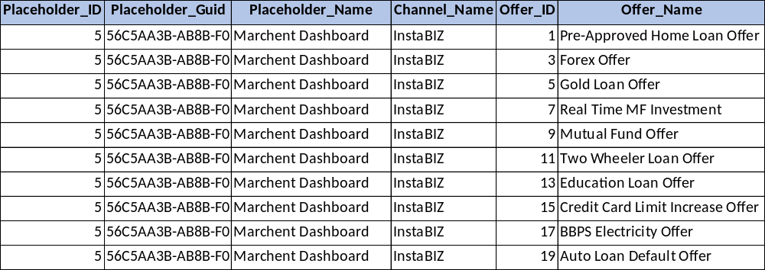

Bits Table

CREATE TABLE Bits
(
Bit_ID INT PRIMARY KEY IDENTITY,
Bit_Guid UNIQUEIDENTIFIER NOT NULL UNIQUE DEFAULT NEWSEQUENTIALID(),
Cust_Fed_ID VARCHAR(100),
Offer_Guid UNIQUEIDENTIFIER,
Offer_Name VARCHAR(100),
Bit_Type VARCHAR(100) NOT NULL CHECK (Bit_Type IN ('VIEW','CLICK')),
Channel_Name VARCHAR(100),
Placeholder_Guid UNIQUEIDENTIFIER,
Placeholder_Name VARCHAR(100),
Action_Timestamp DATETIME2 DEFAULT SYSDATETIME()
);

INSERT INTO Bits (Cust_Fed_ID, Offer_Guid, Offer_Name, Bit_Type, Channel_Name, Placeholder_Guid, Placeholder_Name)
VALUES
('4839201746', 'CBDA7CC0-5387-F011-9F57-64D69AE7FAE4', 'Pre-Approved Home Loan Offer', 'CLICK', 'RIB', '54C5AA3B-AB8B-F011-9F57-64D69AE7FAE4', 'What''s New'),
('4839201746', 'CBDA7CC0-5387-F011-9F57-64D69AE7FAE4', 'Pre-Approved Home Loan Offer', 'VIEW', 'iMobile', '53C5AA3B-AB8B-F011-9F57-64D69AE7FAE4', 'Hero Banner'),
('4839201746', 'CBDA7CC0-5387-F011-9F57-64D69AE7FAE4', 'Pre-Approved Home Loan Offer', 'CLICK', 'RIB', '54C5AA3B-AB8B-F011-9F57-64D69AE7FAE4', 'What''s New'),
('4839201746', 'CBDA7CC0-5387-F011-9F57-64D69AE7FAE4', 'Pre-Approved Home Loan Offer', 'VIEW', 'NLI', '52C5AA3B-AB8B-F011-9F57-64D69AE7FAE4', 'Home Page Banner'),
('6049382751', 'F8E26247-5587-F011-9F57-64D69AE7FAE4', 'Gold Loan Offer', 'CLICK', 'NLI', '52C5AA3B-AB8B-F011-9F57-64D69AE7FAE4', 'Home Page Banner'),
('6049382751', 'F8E26247-5587-F011-9F57-64D69AE7FAE4', 'Gold Loan Offer', 'VIEW', 'NLI', '52C5AA3B-AB8B-F011-9F57-64D69AE7FAE4', 'Home Page Banner'),
('6049382751', 'F8E26247-5587-F011-9F57-64D69AE7FAE4', 'Gold Loan Offer', 'VIEW', 'NLI', '52C5AA3B-AB8B-F011-9F57-64D69AE7FAE4', 'Home Page Banner'),
('6049382751', 'F8E26247-5587-F011-9F57-64D69AE7FAE4', 'Gold Loan Offer', 'CLICK', 'NLI', '52C5AA3B-AB8B-F011-9F57-64D69AE7FAE4', 'Home Page Banner'),
('6049382751', 'F8E26247-5587-F011-9F57-64D69AE7FAE4', 'Gold Loan Offer', 'VIEW', 'NLI', '52C5AA3B-AB8B-F011-9F57-64D69AE7FAE4', 'Home Page Banner');

INSERT INTO Bits (Cust_Fed_ID, Offer_Guid, Offer_Name, Bit_Type, Channel_Name, Placeholder_Guid, Placeholder_Name) VALUES
('6049382751', 'F6E26247-5587-F011-9F57-64D69AE7FAE4', 'Forex Offer', 'VIEW', 'InstaBIZ', '56C5AA3B-AB8B-F011-9F57-64D69AE7FAE4', 'Marchent Dashboard')

SELECT * FROM Bits

-- DROP TABLE Bits

Output –
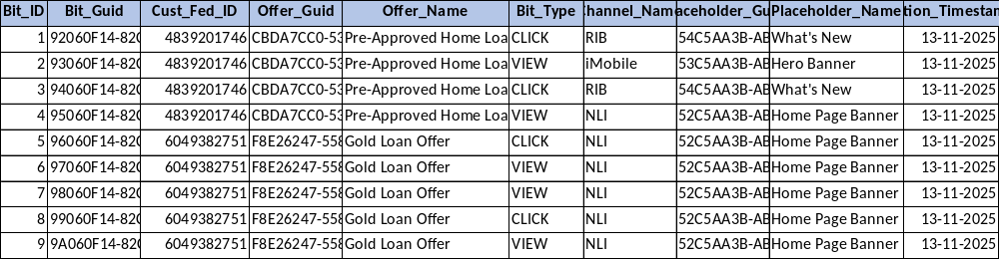

CustomerOfferStatsDaily Table

CREATE TABLE CustomerOfferStatsDaily (
Stat_Date DATE NOT NULL,
Cust_Fed_ID VARCHAR(100) NOT NULL,
Offer_Guid UNIQUEIDENTIFIER NOT NULL,
View_Count INT DEFAULT 0,
Click_Count INT DEFAULT 0,
CONSTRAINT PK_CustomerOfferStatsDaily
PRIMARY KEY (Stat_Date, Cust_Fed_ID, Offer_Guid)
);

--DROP TABLE CustomerOfferStatsDaily

SELECT * FROM CustomerOfferStatsDaily

Output –
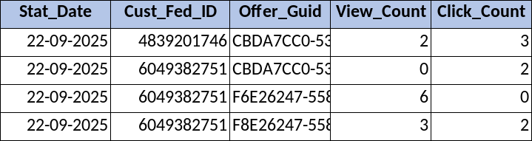

The table CustomerOfferStatsDaily stores daily aggregated statistics of how many times each customer viewed or clicked a particular offer. The trigger trg_UpdateClickViewStatusDaily, which runs after new records are inserted into the Bits table, automatically:
- Groups the newly inserted Bits records by date, customer, and offer.
- Calculates how many VIEW events and how many CLICK events happened.
- Updates the CustomerOfferStatsDaily table:
  - If a record for that date + customer + offer already exists → add (increment) the view and click counts.
  - If not → insert a new daily record with the counts.
  - MERGE operation to either update existing daily totals or insert a new record if none exists yet.

Functions

fn_IsCustomerValid Function

CREATE OR ALTER FUNCTION fn_IsCustomerValid
(
@Cust_Fed_ID VARCHAR(100)
)
RETURNS INT
AS
BEGIN
DECLARE @Result INT = 0;

-- EXISTS: checks if subquery returns at least one row (TRUE if yes, FALSE if no)
-- IF EXISTS: run BEGIN...END only if matching rows exist, else go to ELSE
IF EXISTS (SELECT 1 FROM Customers WHERE Cust_Fed_ID = @Cust_Fed_ID)
BEGIN
-- Customer exists
IF EXISTS (
SELECT 1
FROM Customers
WHERE Cust_Fed_ID = @Cust_Fed_ID
AND Cust_Is_Active = 1
)
BEGIN
SET @Result = 1; -- Exists & Active
END
ELSE
BEGIN
SET @Result = 0; -- Exists but Inactive
END
END
ELSE
BEGIN
SET @Result = -1; -- Not Found
END

RETURN @Result;
END;

-- ============================== Function Execution ==============================
DECLARE @Status INT;
SET @Status = dbo.fn_IsCustomerValid('715290384');

SELECT @Status AS CustomerStatus;

IF @Status = 1
PRINT 'Customer exists and is active.';
ELSE IF @Status = 0
PRINT 'Customer exists but is inactive.';
ELSE
PRINT 'Customer does not exist.';

Output for Cust_Fed_ID ('715290384') –

fn_IsPlaceholderValid

CREATE OR ALTER FUNCTION fn_IsPlaceholderValid
(
@Placeholder_Guid UNIQUEIDENTIFIER
)
RETURNS INT
AS
BEGIN
DECLARE @Result INT = 0;

-- EXISTS: checks if subquery returns at least one row (TRUE if yes, FALSE if no)
-- IF EXISTS: run BEGIN...END only if matching rows exist, else go to ELSE
IF EXISTS (SELECT 1 FROM Placeholders WHERE Placeholder_Guid = @Placeholder_Guid)
BEGIN
-- Placeholder exists
IF EXISTS (
SELECT 1
FROM Placeholders
WHERE Placeholder_Guid = @Placeholder_Guid
AND Placeholder_Is_Active = 1
)
BEGIN
SET @Result = 1; -- Exists & Active
END
ELSE
BEGIN
SET @Result = 0; -- Exists but Inactive
END
END
ELSE
BEGIN
SET @Result = -1; -- Not Found
END

RETURN @Result;
END;

-- ============================== Function Execution ==============================
DECLARE @Status INT;
SET @Status = dbo.fn_IsPlaceholderValid('54C5AA3B-AB8B-F011-9F57-64D69AE7FAE4');

SELECT @Status AS PlaceholderStatus;

IF @Status = 1
PRINT 'Placeholder exists and is active.';
ELSE IF @Status = 2
PRINT 'Placeholder exists but is inactive.';
ELSE
PRINT 'Placeholder does not exist.';

Output for Placeholder_Guid ('54C5AA3B-AB8B-F011-9F57-64D69AE7FAE4') –

Store Procedures

GetCustomerDetails

CREATE PROCEDURE GetCustomerDetails
@Cust_Fed_ID VARCHAR(100),
@StatusCode INT OUTPUT -- 0 = Success, 1 = Customer Not Found, -1 = Error
AS
BEGIN
SET NOCOUNT ON;

BEGIN TRY
-- Check if customer exists
IF EXISTS (
SELECT 1 FROM Customers
WHERE Cust_Fed_ID = @Cust_Fed_ID
)
BEGIN
SET @StatusCode = 0; -- Success

SELECT
Cust_Fed_ID,
Cust_Name,
Cust_Data,
Cust_Entry_Date,
Cust_Is_Active,
'Success' AS Message
FROM Customers
WHERE Cust_Fed_ID = @Cust_Fed_ID;
END
ELSE
BEGIN
SET @StatusCode = 1; -- Not Found

SELECT
@Cust_Fed_ID AS Cust_Fed_ID,
CAST(NULL AS NVARCHAR(100)) AS Cust_Name,
CAST(NULL AS NVARCHAR(MAX)) AS Cust_Data,
CAST(NULL AS DATETIME) AS Cust_Entry_Date,
CAST(NULL AS BIT) AS Cust_Is_Active,
'No customer found with the given Customer Fed ID' AS Message;
END
END TRY

BEGIN CATCH
SET @StatusCode = -1; -- Error

SELECT
@Cust_Fed_ID AS Cust_Fed_ID,
CAST(NULL AS NVARCHAR(100)) AS Cust_Name,
CAST(NULL AS NVARCHAR(MAX)) AS Cust_Data,
CAST(NULL AS DATETIME) AS Cust_Entry_Date,
CAST(NULL AS BIT) AS Cust_Is_Active,
N'Error: ' + ERROR_MESSAGE() AS Message; -- fixed
END CATCH

RETURN @StatusCode; -- optional but cleaner
END;

-- ============================== SP Execution ==============================

DECLARE @Status INT;

EXEC GetCustomerDetails
@Cust_Fed_ID = '4839201746',
@StatusCode = @Status OUTPUT;

SELECT @Status AS StatusCode;

Output –
- If Cust_Fed_ID exists (@Status = 0)
- If Cust_Fed_ID does not exists (@Status = 1)

GetOfferDetails

CREATE OR ALTER PROCEDURE GetOfferDetails
@Offer_Guid UNIQUEIDENTIFIER,
@StatusCode INT OUTPUT -- 0 = Success, 1 = Offer Not Found, -1 = Error
AS
BEGIN
SET NOCOUNT ON;

BEGIN TRY
-- Check if offer exists
IF EXISTS (
SELECT 1 FROM Offers
WHERE Offer_Guid = @Offer_Guid
)
BEGIN
SET @StatusCode = 0; -- Success

SELECT
Offer_GUID,
Offer_Name,
Offer_Description,
Offer_Type,
Offer_Start_Date,
Offer_End_Date,
Offer_Priority,
Offer_View_Threshold,
Offer_Click_Threshold,
Offer_Banner_Type,
Offer_Content,
Offer_Extra_Content,
Offer_Meta,
Last_Modification_Date,
Offer_Visibility_Flag,
'Success' AS Message
FROM Offers
WHERE Offer_Guid = @Offer_Guid;
END
ELSE
BEGIN
SET @StatusCode = 1; -- Not Found

SELECT
@Offer_Guid AS Offer_GUID,
CAST(NULL AS VARCHAR(100)) AS Offer_Name,
CAST(NULL AS VARCHAR(500)) AS Offer_Description,
CAST(NULL AS VARCHAR(100)) AS Offer_Type,
CAST(NULL AS DATETIME) AS Offer_Start_Date,
CAST(NULL AS DATETIME) AS Offer_End_Date,
CAST(NULL AS INT) AS Offer_Priority,
CAST(NULL AS INT) AS Offer_View_Threshold,
CAST(NULL AS INT) AS Offer_Click_Threshold,
CAST(NULL AS VARCHAR(100)) AS Offer_Banner_Type,
CAST(NULL AS NVARCHAR(MAX)) AS Offer_Content,
CAST(NULL AS NVARCHAR(MAX)) AS Offer_Extra_Content,
CAST(NULL AS NVARCHAR(MAX)) AS Offer_Meta,
CAST(NULL AS DATETIME) AS Last_Modification_Date,
CAST(NULL AS BIT) AS Offer_Visibility_Flag,
'No offer found with the given Offer ID.' AS Message;
END
END TRY

BEGIN CATCH
SET @StatusCode = -1; -- Error

SELECT
@Offer_Guid AS Offer_GUID,
CAST(NULL AS VARCHAR(100)) AS Offer_Name,
CAST(NULL AS VARCHAR(500)) AS Offer_Description,
CAST(NULL AS VARCHAR(100)) AS Offer_Type,
CAST(NULL AS DATETIME) AS Offer_Start_Date,
CAST(NULL AS DATETIME) AS Offer_End_Date,
CAST(NULL AS INT) AS Offer_Priority,
CAST(NULL AS INT) AS Offer_View_Threshold,
CAST(NULL AS INT) AS Offer_Click_Threshold,
CAST(NULL AS VARCHAR(100)) AS Offer_Banner_Type,
CAST(NULL AS NVARCHAR(MAX)) AS Offer_Content,
CAST(NULL AS NVARCHAR(MAX)) AS Offer_Extra_Content,
CAST(NULL AS NVARCHAR(MAX)) AS Offer_Meta,
CAST(NULL AS DATETIME) AS Last_Modification_Date,
CAST(NULL AS BIT) AS Offer_Visibility_Flag,
N'Error: ' + ERROR_MESSAGE() AS Message;
END CATCH
END;

-- ============================== SP Execution ==============================

DECLARE @Status INT;

EXEC GetOfferDetails
@Offer_Guid = 'CBDA7CC0-5387-F011-9F57-64D69AE7FAE4',
@StatusCode = @Status OUTPUT;

SELECT @Status AS StatusCode;

Output for valid offer guid –
Output for invalid offer guid –

GetPlaceholderDetails

CREATE OR ALTER PROCEDURE GetPlaceholderDetails
@Placeholder_Guid UNIQUEIDENTIFIER,
@StatusCode INT OUTPUT -- 0 = Success, 1 = Not Found, -1 = Error
AS
BEGIN
SET NOCOUNT ON;

BEGIN TRY
-- Check if placeholder exists
IF EXISTS (
SELECT 1 FROM Placeholders
WHERE Placeholder_Guid = @Placeholder_Guid
)
BEGIN
SET @StatusCode = 0; -- Success

SELECT
Placeholder_Guid,
Placeholder_Name,
Channel_Name,
Channel_Type,
Placeholder_Offer_Limit,
Placeholder_Creation_Date,
Placeholder_Meta,
Placeholder_Is_Active,
'Success' AS Message
FROM Placeholders
WHERE Placeholder_Guid = @Placeholder_Guid;
END
ELSE
BEGIN
SET @StatusCode = 1; -- Not Found

SELECT
@Placeholder_Guid AS Placeholder_Guid,
CAST(NULL AS NVARCHAR(100)) AS Placeholder_Name,
CAST(NULL AS NVARCHAR(100)) AS Channel_Name,
CAST(NULL AS NVARCHAR(100)) AS Channel_Type,
CAST(NULL AS INT) AS Placeholder_Offer_Limit,
CAST(NULL AS DATETIME) AS Placeholder_Creation_Date,
CAST(NULL AS NVARCHAR(MAX)) AS Placeholder_Meta,
CAST(NULL AS BIT) AS Placeholder_Is_Active,
'No Placeholder found with the given Placeholder ID.' AS Message;
END
END TRY

BEGIN CATCH
SET @StatusCode = -1; -- Error

SELECT
@Placeholder_Guid AS Placeholder_Guid,
CAST(NULL AS NVARCHAR(100)) AS Placeholder_Name,
CAST(NULL AS NVARCHAR(100)) AS Channel_Name,
CAST(NULL AS NVARCHAR(100)) AS Channel_Type,
CAST(NULL AS INT) AS Placeholder_Offer_Limit,
CAST(NULL AS DATETIME) AS Placeholder_Creation_Date,
CAST(NULL AS NVARCHAR(MAX)) AS Placeholder_Meta,
CAST(NULL AS BIT) AS Placeholder_Is_Active,
N'Error: ' + ERROR_MESSAGE() AS Message;
END CATCH
END;

-- ============================== SP Execution ==============================

DECLARE @Status INT;

EXEC GetPlaceholderDetails
@Placeholder_Guid = '54C5AA3B-AB8B-F011-9F57-64D69AE7FAE4',
@StatusCode = @Status OUTPUT;

SELECT @Status AS StatusCode;

Output with valid placeholder guid –

Output with invalid placeholder guid –

InsertBit

CREATE OR ALTER PROCEDURE InsertBit
@Cust_Fed_ID VARCHAR(100) = NULL,
@Offer_Guid UNIQUEIDENTIFIER = NULL,
@Offer_Name VARCHAR(100) = NULL,
@Bit_Type VARCHAR(100), -- mandatory
@Channel_Name VARCHAR(100) = NULL,
@Placeholder_Guid UNIQUEIDENTIFIER = NULL, -- fixed typo
@Placeholder_Name VARCHAR(100) = NULL,
@InsertedBitGuid UNIQUEIDENTIFIER OUTPUT, -- return newly inserted GUID
@StatusCode INT OUTPUT, -- 0 = Success, -1 = Error
@ErrorMessage NVARCHAR(4000) OUTPUT

AS
BEGIN
SET NOCOUNT ON;

BEGIN TRY

DECLARE @NewGuid TABLE (Bit_Guid UNIQUEIDENTIFIER);

-- Insert without specifying Bit_Guid (default NEWSEQUENTIALID() will generate it)
INSERT INTO Bits
(
Cust_Fed_ID,
Offer_Guid,
Offer_Name,
Bit_Type,
Channel_Name,
Placeholder_Guid,
Placeholder_Name
)
OUTPUT INSERTED.Bit_Guid INTO @NewGuid -- capture and insert auto-generated GUID into temp table
VALUES
(
@Cust_Fed_ID,
@Offer_Guid,
@Offer_Name,
@Bit_Type,
@Channel_Name,
@Placeholder_Guid,
@Placeholder_Name
);

-- Success
-- Set the output variable from the table variable
SELECT TOP 1 @InsertedBitGuid = Bit_Guid FROM @NewGuid;
SET @StatusCode = 0;
SET @ErrorMessage = NULL;
END TRY
BEGIN CATCH
SET @InsertedBitGuid = NULL;
SET @StatusCode = -1;
SET @ErrorMessage = ERROR_MESSAGE();
END CATCH
END;

-- ============================== SP Execution ==============================

DECLARE @InsertedBitGuid UNIQUEIDENTIFIER,
@StatusCode INT,
@ErrorMessage NVARCHAR(4000);

EXEC InsertBit
@Cust_Fed_ID = '8391046275',
@Offer_Guid = 'F8E26247-5587-F011-9F57-64D69AE7FAE4',
@Offer_Name = 'Gold Loan Offer',
@Bit_Type = 'VIEW',
@Channel_Name = 'NLI',
@Placeholder_Guid = '52C5AA3B-AB8B-F011-9F57-64D69AE7FAE4',
@Placeholder_Name = 'Home Page Banner',
@InsertedBitGuid = @InsertedBitGuid OUTPUT,
@StatusCode = @StatusCode OUTPUT,
@ErrorMessage = @ErrorMessage OUTPUT;

SELECT @InsertedBitGuid AS BitGuid, @StatusCode AS StatusCode, @ErrorMessage AS ErrorMessage;

Output after entering the bit –
BitGuid | StatusCode | ErrorMessage
33DCFBBB-19C5-F011-9F79-CD6F5F8138AD | 0 | [NULL]

GetBitDetails

CREATE OR ALTER PROCEDURE GetBitDetails
@Bit_Guid UNIQUEIDENTIFIER,
@StatusCode INT OUTPUT -- 0 = Success, 1 = Not Found, -1 = Error
AS
BEGIN
SET NOCOUNT ON;

BEGIN TRY
-- Check if Bit exists
IF EXISTS (
SELECT 1 FROM Bits
WHERE Bit_Guid = @Bit_Guid
)
BEGIN
SET @StatusCode = 0; -- Success

SELECT
Bit_Guid,
Cust_Fed_ID,
Offer_Guid,
Offer_Name,
Bit_Type,
Channel_Name,
Placeholder_Guid,
Placeholder_Name,
Action_Timestamp,
'Success' AS Message
FROM Bits
WHERE Bit_Guid = @Bit_Guid;
END
ELSE
BEGIN
SET @StatusCode = 1; -- Not Found

SELECT
@Bit_Guid AS Bit_Guid,
CAST(NULL AS VARCHAR(100)) AS Cust_Fed_ID,
CAST(NULL AS UNIQUEIDENTIFIER) AS Offer_Guid,
CAST(NULL AS VARCHAR(100)) AS Offer_Name,
CAST(NULL AS VARCHAR(100)) AS Bit_Type,
CAST(NULL AS VARCHAR(100)) AS Channel_Name,
CAST(NULL AS UNIQUEIDENTIFIER) AS Placeholder_Guid,
CAST(NULL AS VARCHAR(100)) AS Placeholder_Name,
CAST(NULL AS DATETIME) AS Action_Timestamp,
'No Bit found with the given Bit ID' AS Message;
END
END TRY

BEGIN CATCH
SET @StatusCode = -1; -- Error

SELECT
@Bit_Guid AS Bit_Guid,
CAST(NULL AS VARCHAR(100)) AS Cust_Fed_ID,
CAST(NULL AS UNIQUEIDENTIFIER) AS Offer_Guid,
CAST(NULL AS VARCHAR(100)) AS Offer_Name,
CAST(NULL AS VARCHAR(100)) AS Bit_Type,
CAST(NULL AS VARCHAR(100)) AS Channel_Name,
CAST(NULL AS UNIQUEIDENTIFIER) AS Placeholder_Guid,
CAST(NULL AS VARCHAR(100)) AS Placeholder_Name,
CAST(NULL AS DATETIME) AS Action_Timestamp,
N'Error: ' + ERROR_MESSAGE() AS Message;
END CATCH
END;

-- =================================== SP Execution ===================================

DECLARE @Status INT;

EXEC GetBitDetails
@Bit_Guid = '442994FF-EA8B-F011-9F57-64D69AE7FAE4',
@StatusCode = @Status OUTPUT;

SELECT @Status AS StatusCode;

Output value for valid Bit Guid –

Output for invalid Bit Guid –

GetCustomerOffer

What is best option
- Option 1 - Return JSON data directly from sql server database
- Option 2 - Return a table and then convert the data into JSON using ASP.NET Core code

Best Option: Option 2 — Return a Table and Convert to JSON in ASP.NET Core
Performance & Scalability
SQL Server is optimized for set-based operations, not heavy JSON formatting.
ASP.NET Core is faster and more scalable for serialization using System.Text.Json.
Maintainability
Application-layer JSON generation is easier to debug and change.
SQL JSON queries become complex and harder to maintain for large data models.
Flexibility
In ASP.NET Core you can:
- Shape JSON dynamically
- Add fields, remove fields
- Apply mapping profiles (AutoMapper)
- Version APIs easily
SQL cannot do these cleanly.
Error Handling
ASP.NET Core provides proper model validation, exception handling, and logging.
SQL Server gives limited error visibility when generating JSON.
Security
Better control of:
- Filtering
- Data masking
- Authorization
before outputting JSON.

When Option 1 is OK (Return JSON directly)
- Response is small and predictable
- No transformation is needed
- Your SQL already uses FOR JSON PATH cleanly
- You want a very lightweight API layer
Example scenario: simple fetch + direct respond REST API without business logic.
Summary Table
Factor | Option 1: JSON in SQL | Option 2: JSON in API (Best)
Performance | ❌ Slower | ✅ Faster
Code Maintainability | ❌ Hard | ✅ Easy
Debugging | ❌ Limited | ✅ Strong
API Flexibility | ❌ Low | ✅ High
Error Handling | ❌ Poor | ✅ Great
Complex Data Models | ❌ Painful | ✅ Easy

Table 1: Customer + Placeholder metadata
Table 2: Offer list (each row = one offer)

CREATE OR ALTER PROCEDURE GetCustomerOffers
@Cust_Fed_ID VARCHAR(100),
@Placeholder_Guid UNIQUEIDENTIFIER,
@StatusCode INT OUTPUT,
@Message NVARCHAR(500) OUTPUT
AS
BEGIN
SET NOCOUNT ON;

BEGIN TRY
-----------------------------------------------------------
-- CUSTOMER VALIDATION
-----------------------------------------------------------
IF dbo.fn_IsCustomerValid(@Cust_Fed_ID) = 0
BEGIN
SET @StatusCode = 0;
SET @Message = 'Customer is inactive';
RETURN;
END

IF dbo.fn_IsCustomerValid(@Cust_Fed_ID) = -1
BEGIN
SET @StatusCode = 0;
SET @Message = 'Customer not found';
RETURN;
END

-----------------------------------------------------------
-- PLACEHOLDER VALIDATION
-----------------------------------------------------------
IF dbo.fn_IsPlaceholderValid(@Placeholder_Guid) = 0
BEGIN
SET @StatusCode = 0;
SET @Message = 'Placeholder is inactive';
RETURN;
END

IF dbo.fn_IsPlaceholderValid(@Placeholder_Guid) = -1
BEGIN
SET @StatusCode = 0;
SET @Message = 'Placeholder not found';
RETURN;
END

-----------------------------------------------------------
-- TABLE 1: CUSTOMER + PLACEHOLDER DETAILS
-----------------------------------------------------------
SELECT
c.Cust_Fed_ID AS cust_fed_id,
p.Placeholder_Guid AS placeholder_guid,
p.Placeholder_Name AS placeholder_name,
p.Channel_Name AS channel_name,
p.Channel_Type AS channel_type,
p.Placeholder_Offer_Limit AS placeholder_offer_limit,
p.Placeholder_Meta AS placeholder_meta
FROM Customers c
INNER JOIN Placeholders p ON p.Placeholder_Guid = @Placeholder_Guid
WHERE c.Cust_Fed_ID = @Cust_Fed_ID;

-----------------------------------------------------------
-- TABLE 2: OFFER LIST
-----------------------------------------------------------
;WITH Stats3Days AS (
SELECT
Cust_Fed_ID,
Offer_Guid,
SUM(View_Count) AS Views3Days,
SUM(Click_Count) AS Clicks3Days
FROM CustomerOfferStatsDaily
WHERE Stat_Date >= CAST(DATEADD(DAY, -2, CAST(GETDATE() AS DATE)) AS DATE)
GROUP BY Cust_Fed_ID, Offer_Guid
)

SELECT DISTINCT
o.Offer_Guid AS offer_guid,
o.Offer_Name AS offer_name,
o.Offer_Description AS offer_description,
o.Offer_Type AS offer_type,
o.Offer_Priority AS offer_priority,
o.Offer_View_Threshold AS offer_view_threshold,
o.Offer_Click_Threshold AS offer_click_threshold,
o.Offer_Banner_Type AS offer_banner_type,
o.Offer_Content AS offer_content,
o.Offer_Extra_Content AS offer_extra_content,
o.Offer_Meta AS offer_meta
FROM CustomerOffers co
INNER JOIN Offers o ON co.Offer_ID = o.Offer_ID
INNER JOIN PlaceholderOffers po ON o.Offer_ID = po.Offer_ID
INNER JOIN Placeholders p2 ON po.Placeholder_ID = p2.Placeholder_ID
LEFT JOIN Stats3Days s ON co.Cust_Fed_ID = s.Cust_Fed_ID
AND o.Offer_Guid = s.Offer_Guid
WHERE co.Cust_Fed_ID = @Cust_Fed_ID
AND p2.Placeholder_Guid = @Placeholder_Guid
AND o.Offer_Visibility_Flag = 1
AND ISNULL(s.Views3Days,0) < o.Offer_View_Threshold
AND ISNULL(s.Clicks3Days,0) < o.Offer_Click_Threshold

UNION

-----------------------------------------------------------
-- TABLE 2: OFFER LIST (Default Offers)
-----------------------------------------------------------

SELECT
o.Offer_Guid,
o.Offer_Name,
o.Offer_Description,
o.Offer_Type,
o.Offer_Priority,
o.Offer_View_Threshold,
o.Offer_Click_Threshold,
o.Offer_Banner_Type,
o.Offer_Content,
o.Offer_Extra_Content,
o.Offer_Meta
FROM PlaceholderOffers po
INNER JOIN Placeholders p2 ON p2.Placeholder_ID = po.Placeholder_ID
INNER JOIN Offers o ON o.Offer_ID = po.Offer_ID
WHERE p2.Placeholder_Guid = @Placeholder_Guid
AND o.Offer_Type = 'Default'
AND o.Offer_Visibility_Flag = 1;

-----------------------------------------------------------
-- SUCCESS STATUS
-----------------------------------------------------------
SET @StatusCode = 1;
SET @Message = 'Success';

END TRY
BEGIN CATCH
SET @StatusCode = 0;
SET @Message = 'Error: ' + ERROR_MESSAGE();
END CATCH
END

-- ============================== SP Execution ==============================

DECLARE @Status INT;
DECLARE @Msg NVARCHAR(500);

EXEC GetCustomerOffers
@Cust_Fed_ID = '6049382751',
@Placeholder_Guid = '56C5AA3B-AB8B-F011-9F57-64D69AE7FAE4',
@StatusCode = @Status OUTPUT,
@Message = @Msg OUTPUT;

SELECT @Status AS StatusCode,@Msg AS Message;

The above query will return a dataset which will have two tables
Output of Table 1 (Customer + Placeholder)

Output of table 2 (Offer Table)
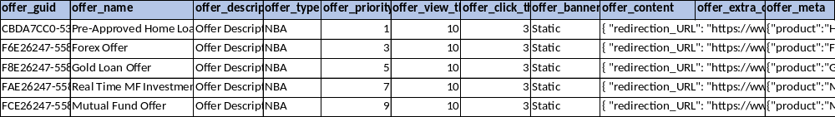

Trigger

Trg_UpdateClickViewStatusDaily

CREATE TRIGGER trg_UpdateClickViewStatusDaily
ON Bits
AFTER INSERT
AS
BEGIN
SET NOCOUNT ON;

MERGE CustomerOfferStatsDaily AS target
USING (
SELECT
CAST(Action_Timestamp AS DATE) AS Stat_Date,
Cust_Fed_ID,
Offer_Guid,
SUM(CASE WHEN Bit_Type='VIEW' THEN 1 ELSE 0 END) AS ViewCnt,
SUM(CASE WHEN Bit_Type='CLICK' THEN 1 ELSE 0 END) AS ClickCnt
FROM inserted
GROUP BY CAST(Action_Timestamp AS DATE), Cust_Fed_ID, Offer_Guid
) AS src
ON (target.Stat_Date = src.Stat_Date
AND target.Cust_Fed_ID = src.Cust_Fed_ID
AND target.Offer_Guid = src.Offer_Guid)
WHEN MATCHED THEN
UPDATE SET
View_Count = target.View_Count + src.ViewCnt,
Click_Count = target.Click_Count + src.ClickCnt
WHEN NOT MATCHED THEN
INSERT (Stat_Date, Cust_Fed_ID, Offer_Guid, View_Count, Click_Count)
VALUES (src.Stat_Date, src.Cust_Fed_ID, src.Offer_Guid, src.ViewCnt, src.ClickCnt);
END;

-- ============================== SP Execution ==============================

EXEC sp_helptext 'trg_UpdateClickViewStatusDaily'

Use – This trigger automatically updates daily offer interaction statistics whenever new records are inserted into the Bits table. It aggregates VIEW and CLICK events from the inserted rows, groups them by date, customer, and offer, and then performs a MERGE operation on CustomerOfferStatsDaily. If a matching record already exists, it increments the existing view and click counters. If no matching record is found, it inserts a new daily stats row. This ensures real-time, consistent, and consolidated tracking of user interactions without requiring additional application-level logic.
Note – A trigger is tied to a table. So, if the table is dropped & recreated → trigger disappears. So if you delete the Bits table then this trigger will also get deleted.

