**Eclipse plugin – ShowFileOnDisk**

**Installation instructions:**

1. Download the local update site <https://github.com/hs2501/ShowFileOnDisk/blob/master/ShowFileOnDisk.site.zip>
2. Extract the zip file on your local file system.
3. Now install the software from local site in your Eclipse (Help -> Install).

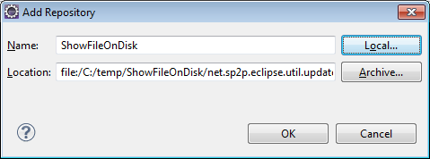

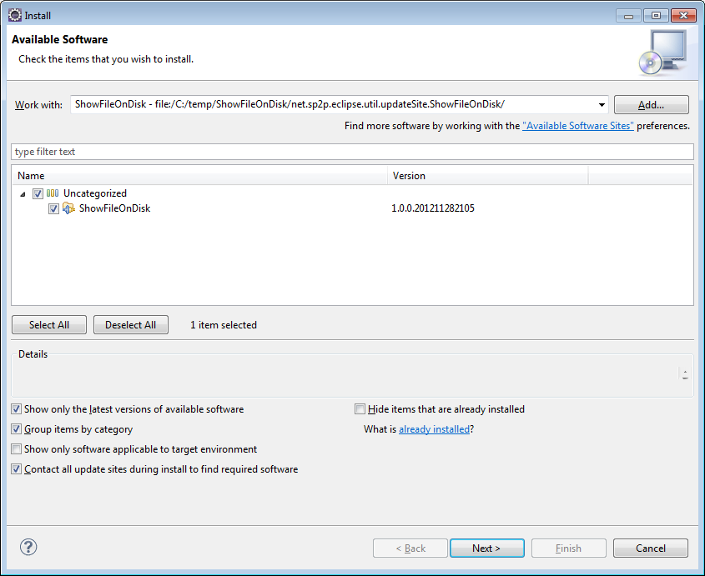

1. Now verify the installation by opening view “Project Explorer” and right click on any file/folder.

