**Agile : is approach in software development where team collaborate to solve the problem.testing and development can se done simultaneously. We can change the requirement anytime**

* **JIRA:** Jira is a issue and project tool develope by the atlassian .
  + **Key feature of JIRA:**
    - **Issue Tracking:**
    - **Project management:**
    - **Dashborad and reporting**
    - **Integration**
    - **Permission and security**
    - **Secrum and Kanban support**
* **JIRA Project:**In Jira project is the collection of the task
* **Key Element in Jira:**
  + **Issue:** Big project are break down in a small goal are called as the issue.
  + **Kanban vs secrum:**
    - **Kanban:** It is used for continuous integration for the long period of time.
    - **Secrum:** It break the task into a small chunk and has time bound.
* **JIRA Board:** it display the column of issue and the workflow to be completed.
* **Types of board:**
  + [**Scrum Board**](https://www.atlassian.com/software/jira/features/scrum-boards) – This board is great for teams that like to work in sprints, or time-boxed periods when a team works to complete a set amount of work.
  + [**Kanban Board**](https://www.atlassian.com/software/jira/features/kanban-boards) – This board is great for teams who’s primary objective is to manage the flow of work.
* **Issue:** Big project is break down in a small goal .
  + **Epic:** Represents a larger body of work. Epics are often represented as a collection of multiple issues.
  + **Task**:Represents a task that needs to be done. Tasks are used as ‘catch-alls’ and when the work cannot be accurately represented by the other issue types.  
    *Example(s): Make lemonade. Create sign. Set-up stand.*
  + **Story:**Represents a requirement expressed from the perspective of the user.  
    *Example: As a lemonade enthusiast, I’d like to have a really cold, crisp drink.*
  + **Bug:**Represents a problem that needs to be fixed.  
    *Example: The lemonade is too sour.*
  + **Sub-tas**k:Represents a more granular decomposition of the work required to complete a standard issue. A sub-task can be created for all issue types.  
    *Example: Squeeze lemons.*
* **Parent and child issue**
* **Linked Issue:** As with any project, there may be dependencies between your tasks. You can easily represent this association in Jira Software by linking issues together. Associations that come out-of-the-box are:
* **Workflow:**
  + **To Do**
  + **In Progress**
  + **Done**
* **DOR definition of rule and DOD definition of Done**
  + **DOR : no of rules that we have define.(issue or task)**
  + **DOD:no of rules that we define for the developer (PR)**
* **POC_2 create a project:**
  + Create a project - > software development - > select secrum/Kanban
  + Create issue.
* **Poc_7: In Jira Project your code should be visible (Integrate JIRA with Bitbucket)**
  + **Bitbucket - > Create a workspace - > connect the jira and bitbucket**
  + 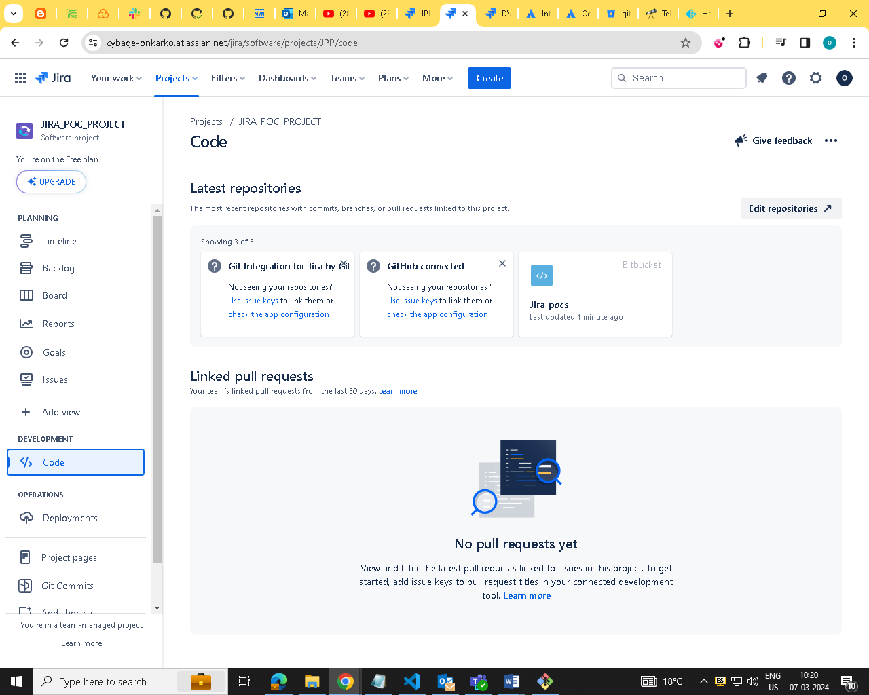
  + 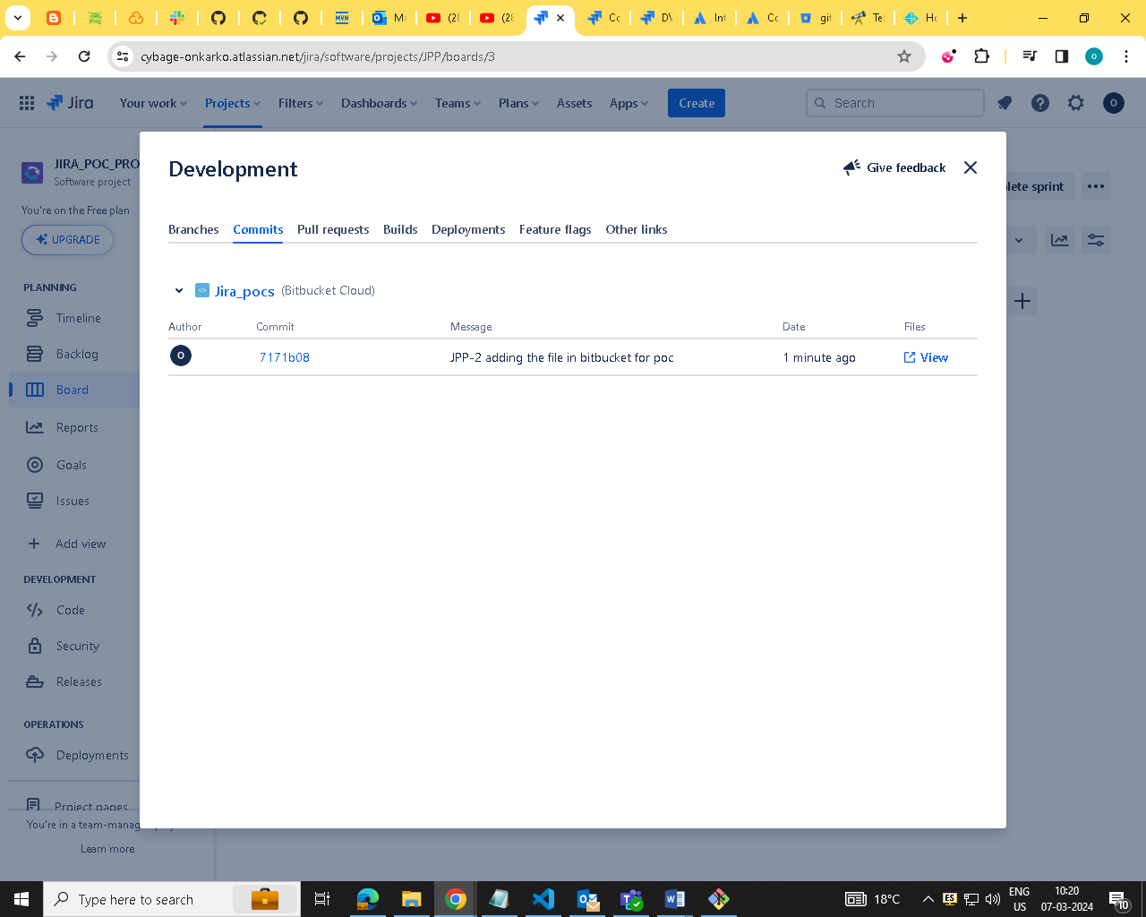
* **Poc_8:From JIRA issue you should be able to create branches on bitbucket** 
  + 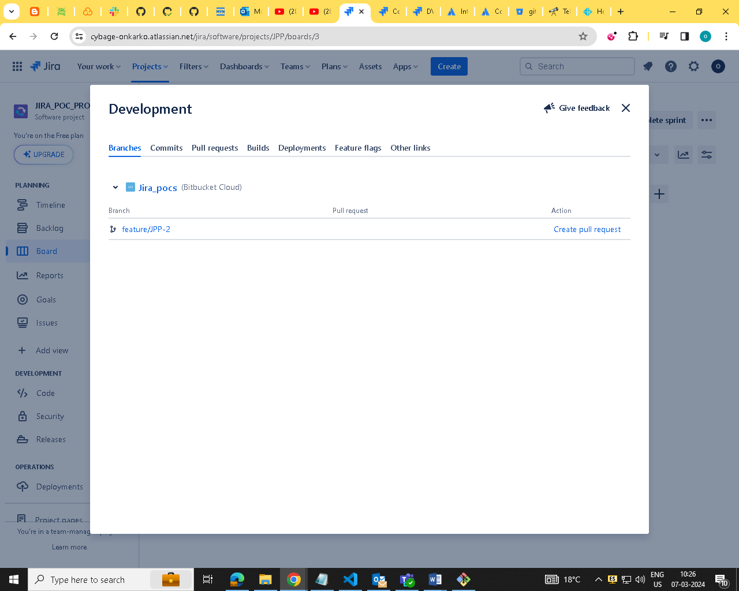

**Poc_9:Integrate JIRA with Github**

