GIVEN:

The UCI-Madelon dataset is a randomly generated dataset with 2000 observations of training data where each observation has 500 features.

-1000 of the features have a target of +1;
-1000 of these features have a target of -1

GOAL:
1. Perform data cleaning and benchmark accuracy analysis using 4 testing methods. This tells is a classification metric and shows us how accurately each observation can predict its target, in an unsupervised learning atmosphere. 3 sets of 10% of the datapoints were used to perform these tests.

2. Perform regression testing within the training data, in order to determine how each feature can be predicted by the other features. This process tells us which (20) features are relevant, not only to the target, but perhaps to each other.

3. Now that we have trimmed down the number of features in our dataset from 500 to 20, we prepare another classification model to see how the effect of feature extraction has improved our accuracy score.

4. The intent of this project, as I understood it, was not to finely tune our classification models. I intended to keep the model creation as simple as possible in order to observe an equal comparison between the end result and the benchmark analysis.

Initial Project Flow Diagram:
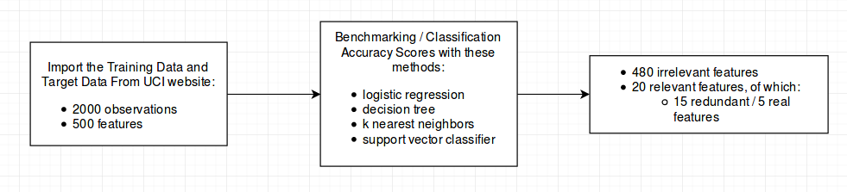

STEP 1 : Benchmarking

Set up 4 separate classification models in order to obtain preliminary accuracy scores.
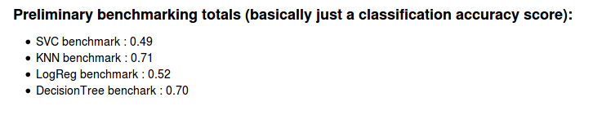
These 4 classification metrics are observed below.
We table these results and will use them later for comparison.

STEP 2: FEATURE SELECTION

Three separate regression models were used to test for feature relevance.

-SelectKBest
-KNN Regression
-Lasso

Based on the scoring metrics for each model, 20 features were returned as being relevant, and interestingly enough, the same 20 were selected from each model. Below is a snapshot of the .head() of the trimmed DataFrame of 20 features.

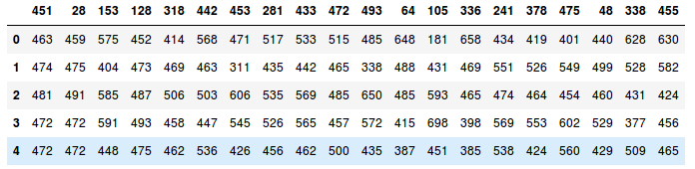

A heatmap was created, and the intention was to show how the 20 features are correlated to each other. Looking closely, this shows how different “clusters” of feature score the exact same to each other. I found these results to be quite interesting. The heatmap and the observations are below.
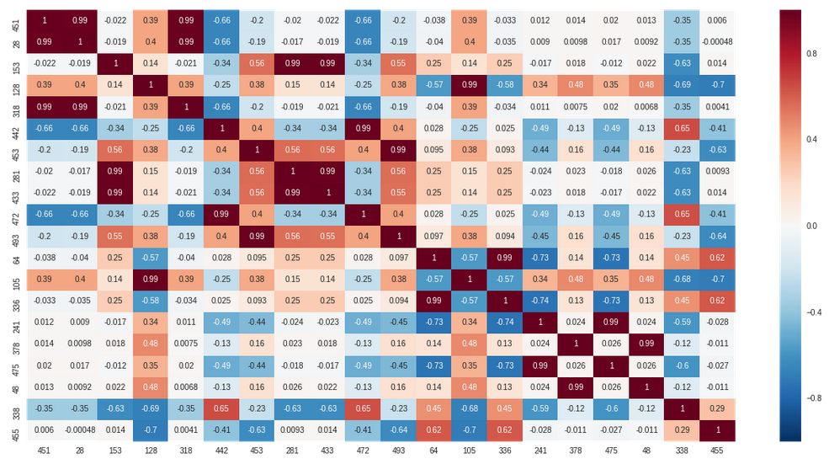
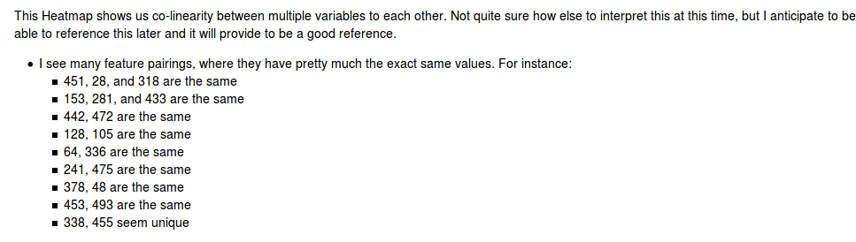
In order to verify what was observed, I used 2 separate methods, SelectKBest and SelectPercentile, in order to observe the p-values for each of the 20 features. Again, we see “clusters” of similarly scored features pop out.

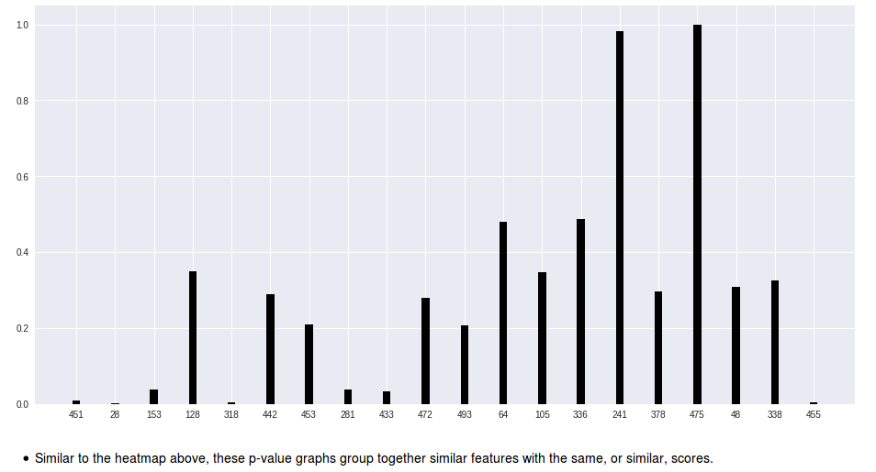

Using the “clusters” as described above, I could assume that these clusters would contain 1 relevant feature along with at least 1 redundant feature.

Step 4 : Model creation and Validation Testing

The validation data had to be brought in for this step. Validation data consists of the same number of features (500), but with only 600 observations. Using the 20 relevant features, the validation data had to be trimmed in order to match the exact same features as our training data. Again, those relevant features are:

The validation data also had target values of either +1 or -1.

Performing the exact same testing methods and the benchmarking (STEP 1), we could see that all of the testing methods increased in their accuracy scores. Below, you will see the preliminary benchmarking scores followed by the accuracy scores after feature selection.

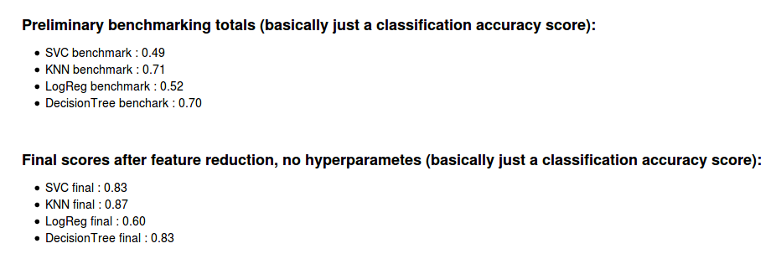

The K-Nearest-Neighbors Classifier model performs consistently the best, only slightly above the DecisionTree Classifier model.

But the final takeaway is that feature selection increased our Classification accuracy from 0.71 to 0.87 (specifically for the KNN model).

Please reference the 4 Jupyter notebooks for the UCI_madelon exercise for much more details.
Quick synopsis from the Madelon DataBase

The Madelon information from the database contains 200,000 with 1000 features and a randomly selected target, either 0 or 1. Using a 90% confidence level and a 1% margin of error, this computes to a sample size of 6,506 observations can be used for our analysis.

Using the exact same procedures and methods as with the above dataset, I used Classification metrics to obtain the preliminary benchmarking scores:

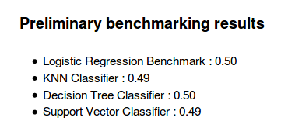

We notice that these benchmarking accuracy scores are not as accurate as for the smaller dataset. I attribute this to a much larger dataset with many more features, there is much more noise for each target to manipulate though. Using the same procedures as above, I was able to reduce the noise to the following relevant features: and corresponding r2 scores:

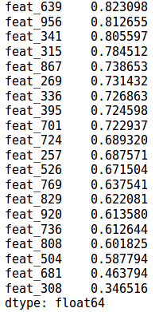

After narrowing the dataframe to these 20 features and setting up Classification models, we were able to increase our accuracy scores, as seen below:

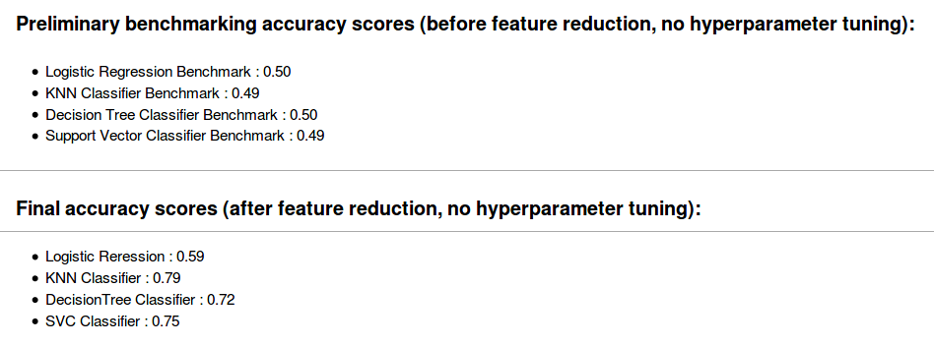

Similar to our dataset downloaded from the UCI madelon website, the KNN Classifier model performed the best, even on the large Madelon dataset. The accuracy scores were lower for the large dataset however, and this is likely attributed to the fact that it is a much larger dataset.

Please reference the 4 Jupyter notebooks for more information.

