TryHackMe – Brooklyn Nine Nine
Penetration Testing Walkthrough Report
Prepared by: Manoj Bora
Platform: TryHackMe | Room: Brooklyn Nine Nine | Difficulty: Easy
Date: 25 September 2026

1. Objective
This report covers my walkthrough of the TryHackMe room "Brooklyn Nine Nine", an easy Linux boot2root box themed around the Brooklyn 99 TV show. The room has two intended routes to root. I went with the steganography route — enumerate the target, find a foothold hidden inside an image, get user access, capture the user flag, then escalate to root through a sudo misconfiguration.

2. Tools Used
- Nmap — port scanning
- Firefox (view-source) — manual web inspection
- StegSeek — steganography passphrase cracking
- Steghide — steganography extraction
- SSH — remote access
- sudo -l — privilege enumeration
- GTFOBins — privilege escalation reference
- nano (abused via sudo) — privilege escalation vector

3. Walkthrough

Reconnaissance
1. Ran an Nmap SYN scan against the target (nmap -sS <target-ip>). 3 ports came back open — 21 (FTP), 22 (SSH), 80 (HTTP).
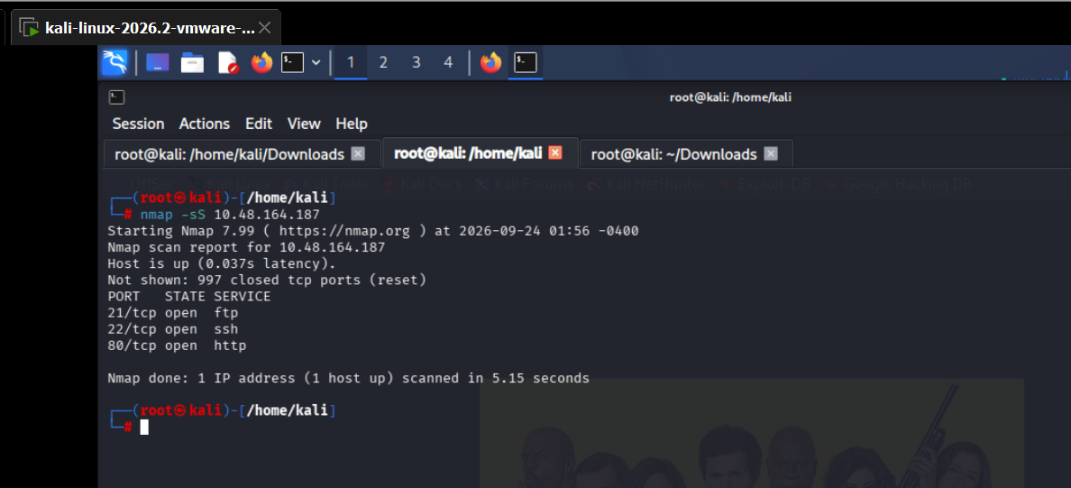

Web Enumeration
2. Port 80 was open, so checked the page in the browser first, then looked at the page source (view-source). Found an HTML comment: "Have you ever heard of steganography?" The CSS also referenced a background image, brooklyn99.jpg.
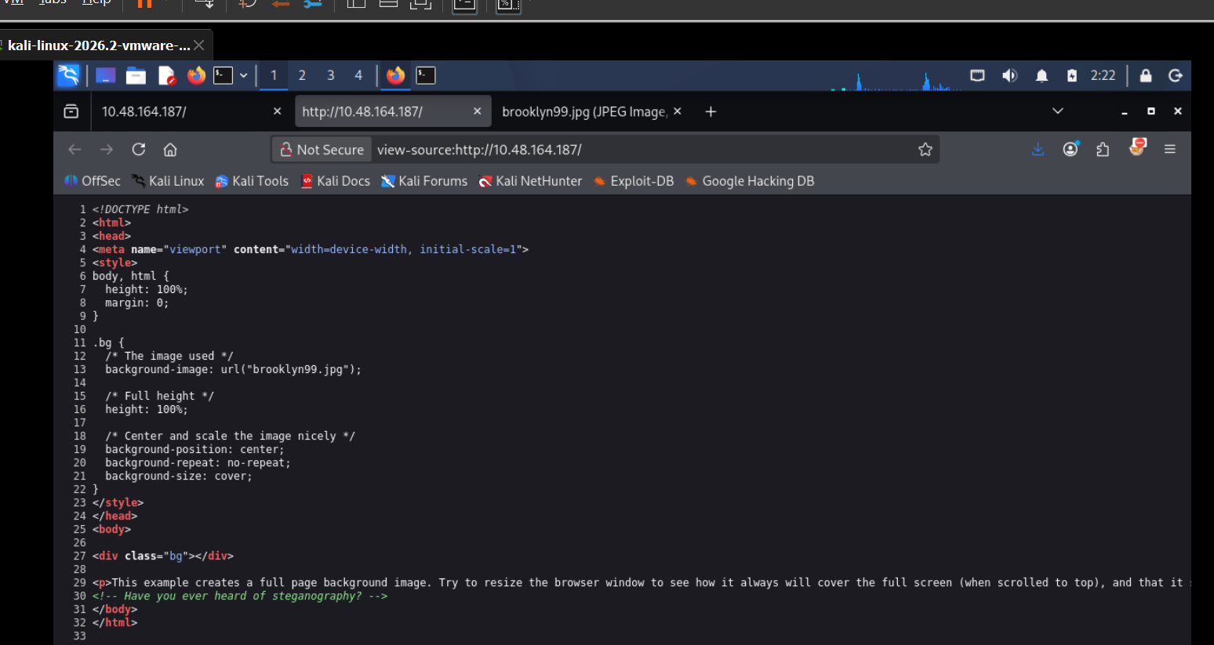
3. Browsed directly to the image at /brooklyn99.jpg. It was just the Brooklyn 99 cast photo — but the comment made it clear the image itself was worth digging into.
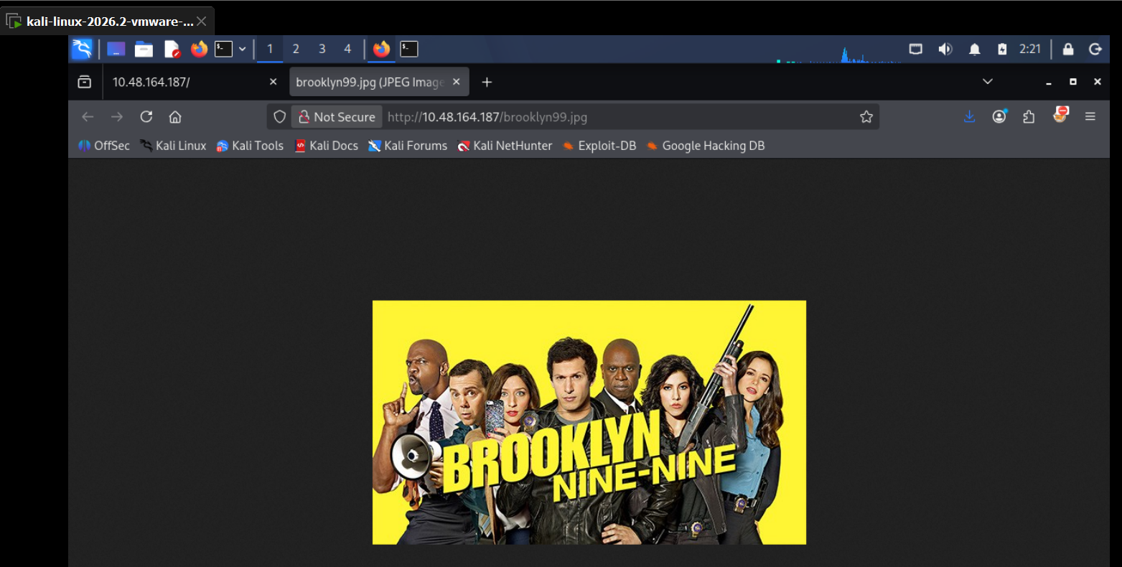

Steganography
4. Downloaded brooklyn99.jpg and ran StegSeek against it with the rockyou.txt wordlist (stegseek brooklyn99.jpg /usr/share/wordlists/rockyou.txt). It cracked the passphrase — "admin" — and reported the original hidden filename as note.txt, auto-extracting it to brooklyn99.jpg.out.
5. Re-ran steghide --extract -sf brooklyn99.jpg with the cracked passphrase to pull the hidden file out properly, giving note.txt.
6. Read note.txt — it contained a plaintext credential: Holt's Password: fluffydog12@ninenine.
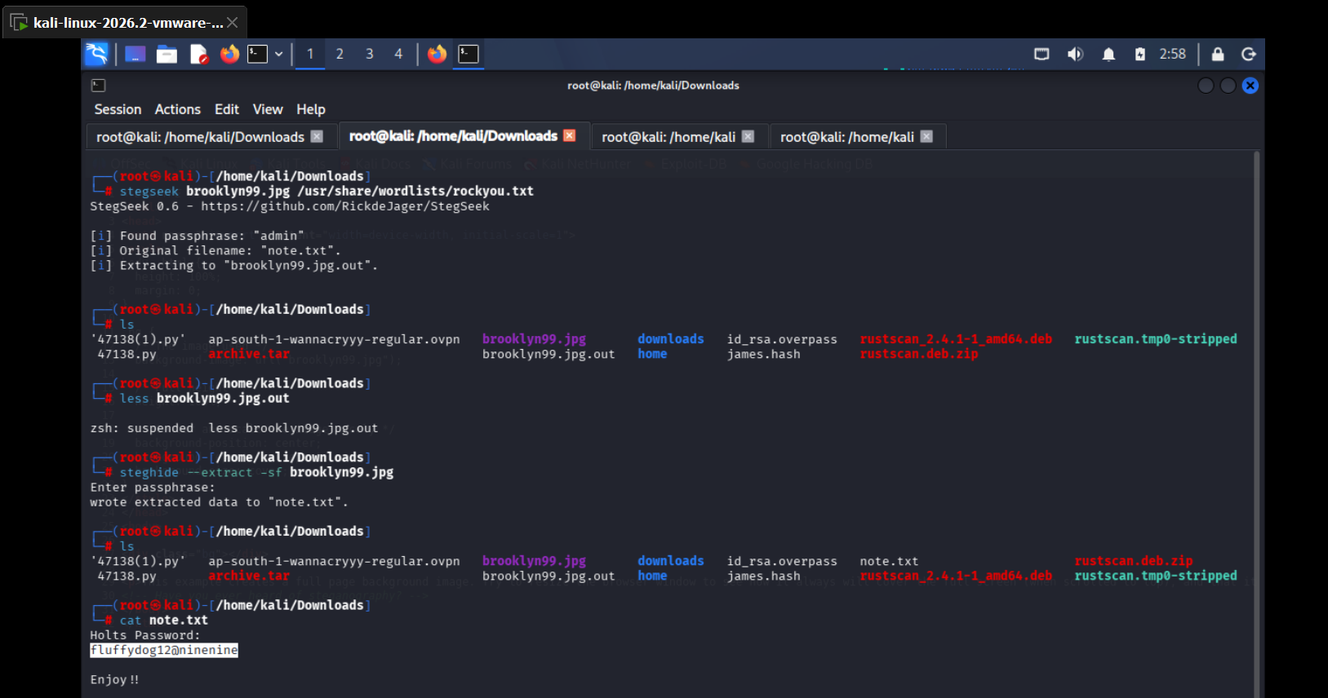

Gaining Access (SSH)
7. SSH'd in as holt using the password from note.txt (ssh holt@<target-ip>) — login succeeded straight away.
8. Listed the home directory and read user.txt to get the user flag.
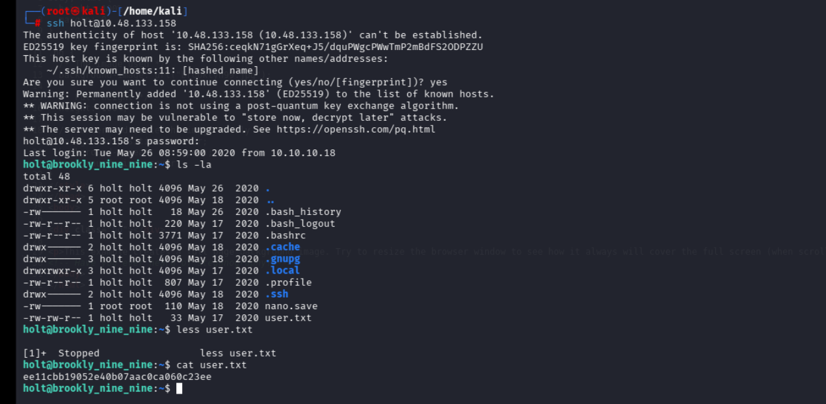

Privilege Escalation
9. Checked sudo rights with sudo -l. holt was allowed to run /bin/nano as root with NOPASSWD — no restrictions on arguments.
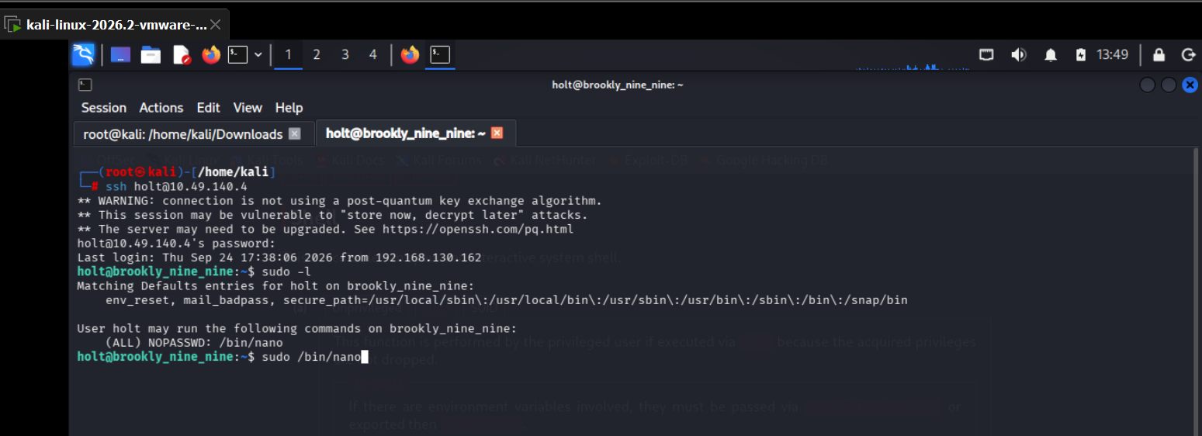
10. Looked up nano on GTFOBins. It confirmed nano can be abused for a shell escape: open nano, press Ctrl+R then Ctrl+X to bring up the "Execute Command" prompt, then run reset; sh 1>&0 2>&0 to spawn a shell with the caller's privileges.
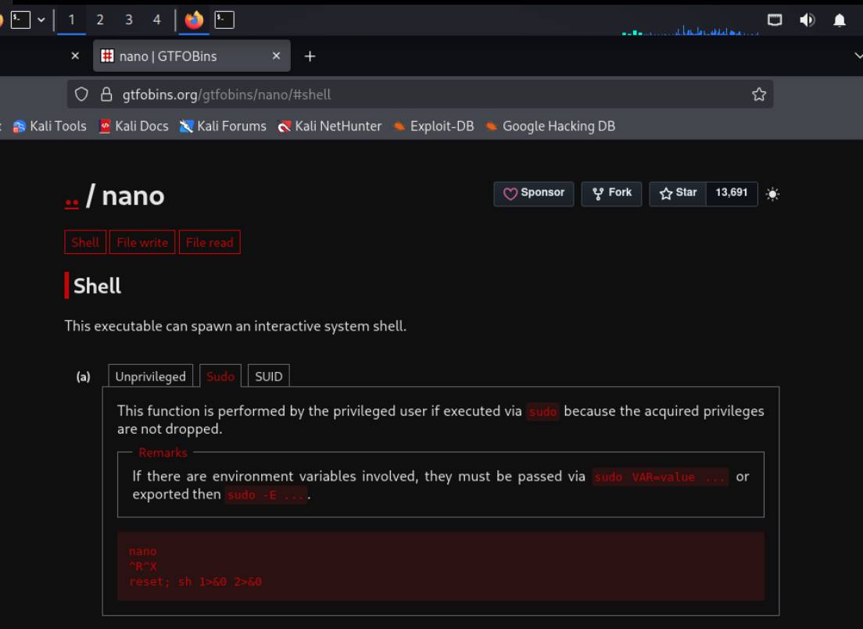
11. Ran sudo /bin/nano, pressed Ctrl+R then Ctrl+X, and typed reset; sh 1>&0 2>&0 into the Execute Command prompt.
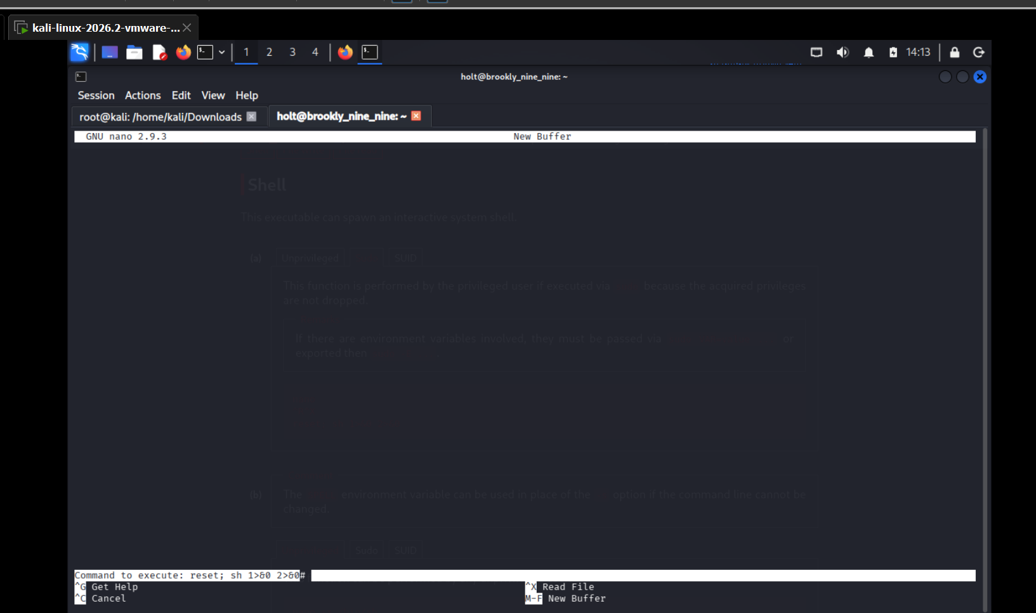
12. This dropped straight into a root shell. Confirmed with whoami — root. Navigated to /root and read root.txt for the root flag, signed by the room's creator, Fsociety2006.
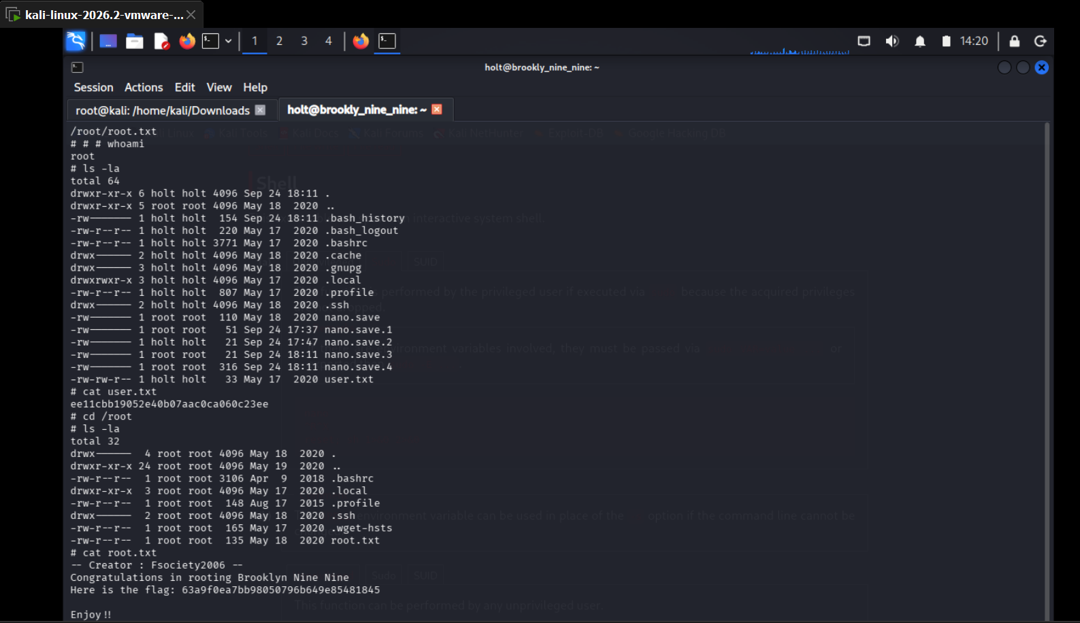

4. Flags Captured
User Flag: ee11cbb19052e40b07aac0ca060c23ee
Root Flag: 63a9f0ea7bb98050796b649e85481845

5. Findings & Vulnerabilities
Summary of the weaknesses that made this box solvable, rated by how much impact they had on the compromise:
Finding | Severity
HTML comment on the web server hinted at steganography, with no access control stopping anyone from finding it | Low
Sensitive image was protected with a weak, wordlist-crackable steganography passphrase ("admin"), broken instantly with StegSeek | Medium
Hidden note stored a real account password in plaintext, and that same weak, guessable password was accepted directly over SSH | High
Sudo misconfiguration allowed a low-privileged user to run /bin/nano as root with no restrictions, giving an instant root shell via a known GTFOBins technique | Critical

6. Conclusion
Brooklyn Nine Nine was a short, beginner-friendly box built around steganography and a classic sudo/GTFOBins privilege escalation. The main takeaways were to always check page source and any hosted images for hidden clues, never store real credentials in a note protected only by a weak passphrase, and to keep sudo rules tightly scoped — letting a user run an editor like nano as root with no restrictions is an instant path to full compromise.

