| **CTU – GINATILAN EXTENSION CAMPUS** | |
| --- | --- |
|  | OJT Form 6  October 2012  Revision: 0 |

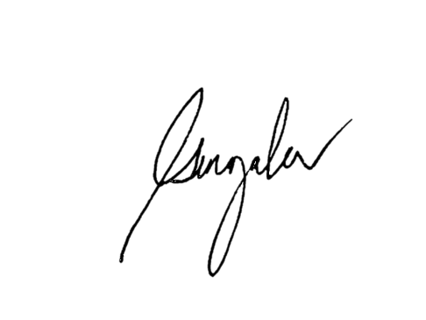**DAILY/WEEKLY/MONTHLY PERFORMANCE REPORT**

| **Name of Student Trainee:** | | Nel Gonzales | | |
| --- | --- | --- | --- | --- |
| **Course, Year & Major:** | | Bachelor of Industrial Technology Major in Computer Technology 4A | | |
| **Cooperating Agency:** | | LGU Ginatilan | **Inclusive Date:** | **From**: 07122024 |
| **Department Assigned:** | | IT Support Intern | | **To**: 07192024 |
| **Summary of Activities:** | |  | **Learning/Insights:** |  |
| We’re having an orientation to basic operations and duties. We tried to fix the printer at the accounting office in the Ginatilan municipal hall. We formatted the PC in Comlab 3. | | | The orientation helped familiarize us with basic operations and duties, while hands-on tasks like fixing the printer at the accounting office and formatting a PC in Comlab 3 enhanced our problem-solving and technical skills. These activities emphasized the importance of troubleshooting, teamwork, and effective communication, giving us valuable real-world experience in maintaining office equipment and ensuring systems run smoothly. | |
| Prepared by:  _________________________________  **Student Signature over Printed Name** | | | | |
| **CA (Cooperating Agency) Remarks:** | | | | |
|  | | | | |
|  |  | |  | **Signature Over Printed Name** |
| **OJT Chairman/Supervisor Remarks:** | | | | |
|  | | | | |
|  | | | | **Signature Over Printed Name** |

