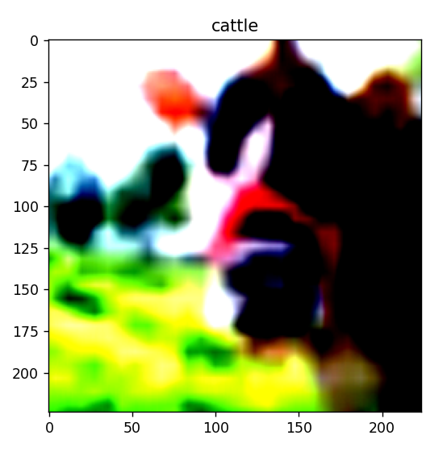
Vit_l_32
Layer3
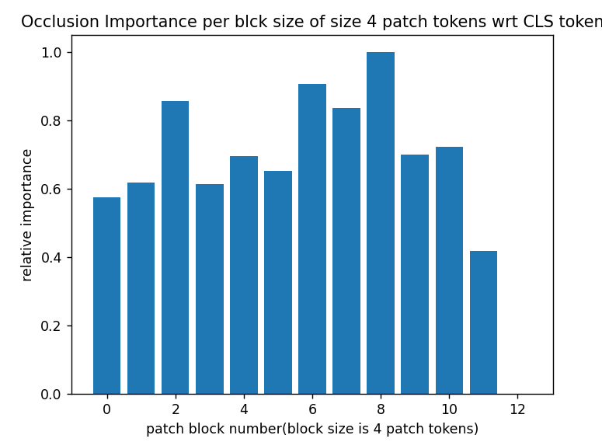Representation capacity at CLS token: 341.6295

Laye7
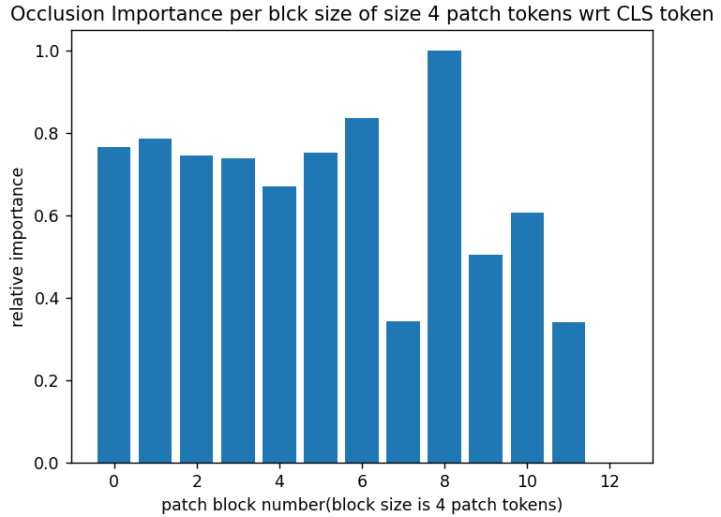
Representation capacity at CLS token: 347.1399

Layer 8
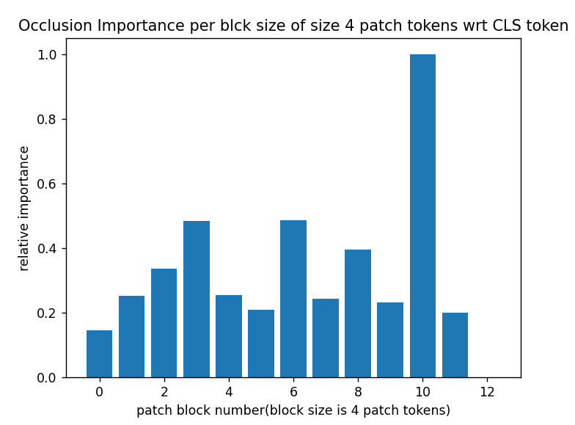Representation capacity at CLS token: 339.9188

Layer 11
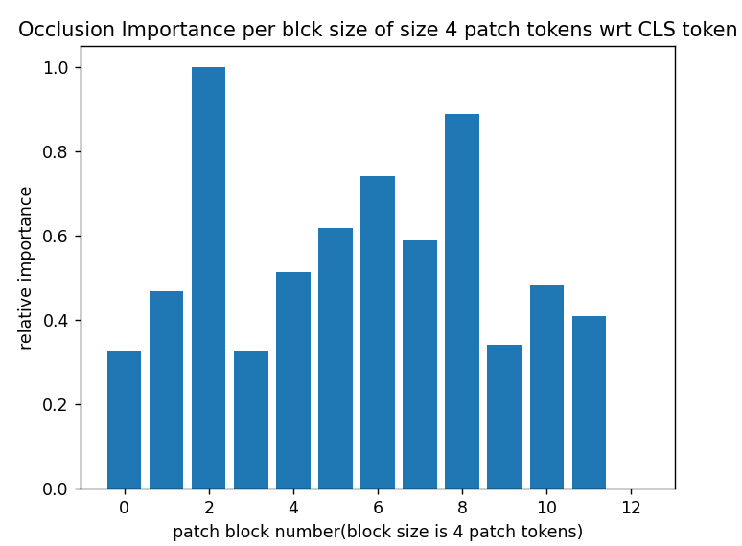Representation capacity at CLS token: 329.7154

