RESNET-34, CIFAR100, eval and inference

Normal(avgpool)
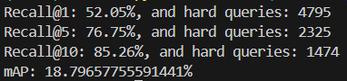

CGAP with RMS
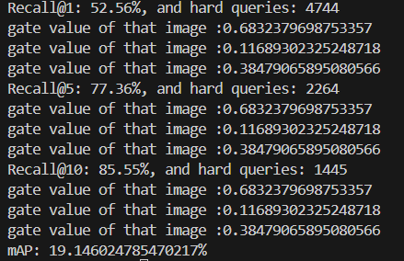

CGAP with MP
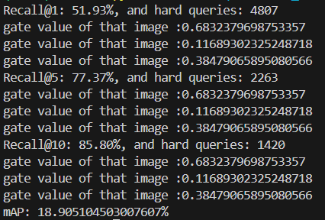

Mountain, jungle, seal (3 sampled images)
Gating is image dependent
Hard queries were reduced, new unseen data perhaps, mAP increased but image retrieval suggests topk were inaccurate with at least 1 image matching classes.
Patterns learned were loose only shape, colour, and background could be generalised.

MP is between avgpool and using RMS

Probing with postproc_toll
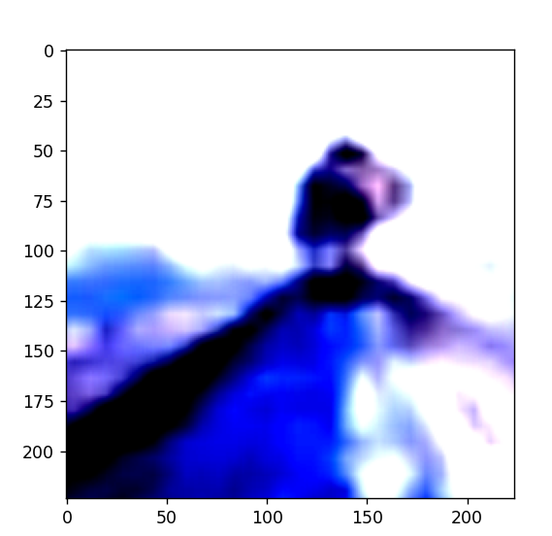
NORMAL
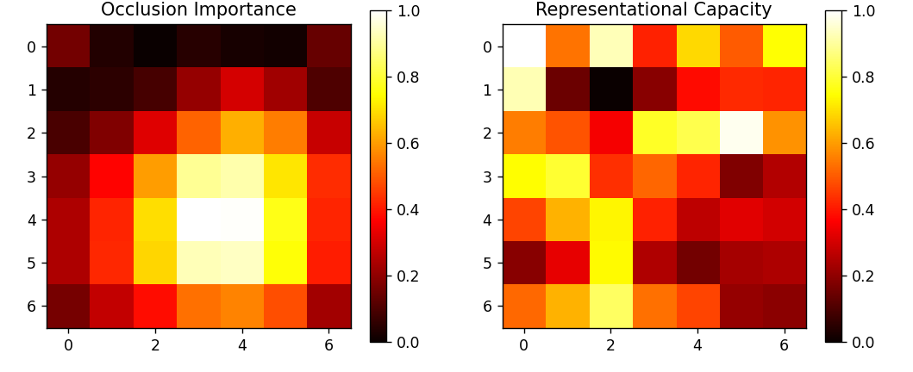
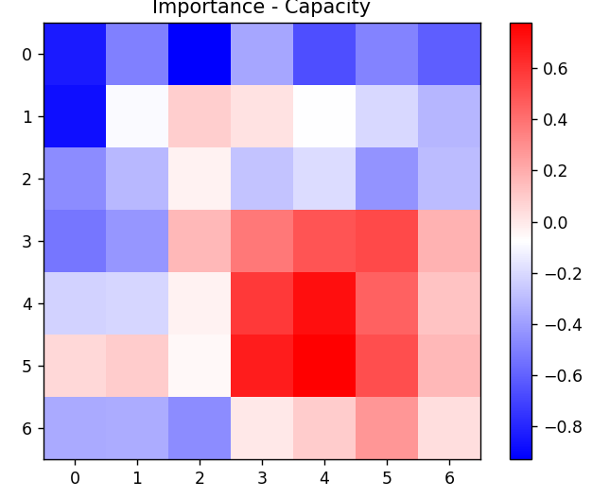

CGAP with RMS

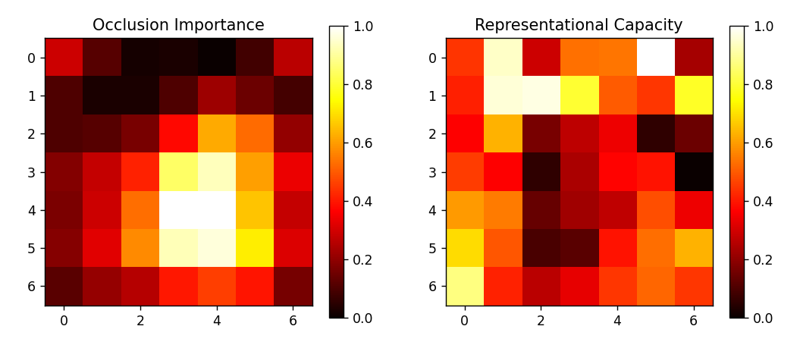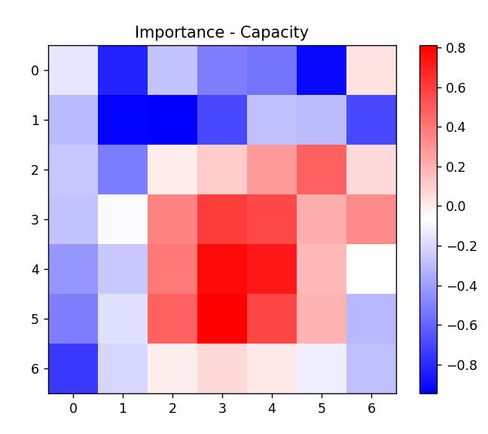

CGAP with MP
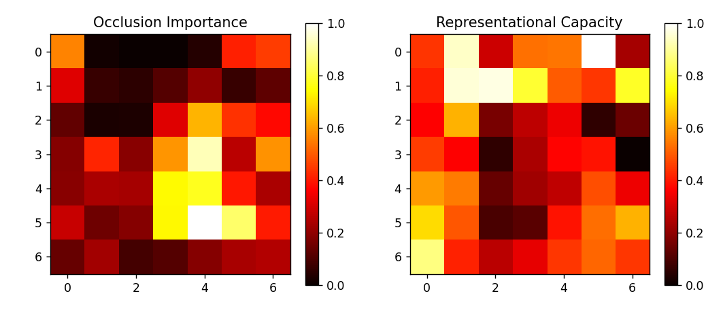
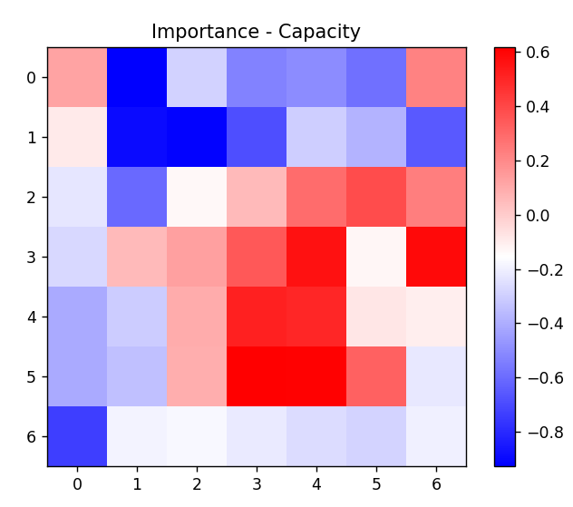

Importance gets more concentred and selectively compressed.
Compared to GAP, MaxPool shows stronger selectivity, while CGAP with an RMS-preserving branch provides the best balance. CGAP delays pooling until spatial evidence stabilizes, leading to importance maps that are more concentrated on semantically relevant regions. At the same time, non-critical regions retain representational richness but exert less influence on the final embedding.
semantic evidence compacts spatially; aggressive pooling becomes safe without destroying expressive structure.
CGAP with RMS concentrates post-pooling influence onto fewer spatial regions, effectively reducing the dimensional support of semantically relevant features while preserving overall representational richness.

