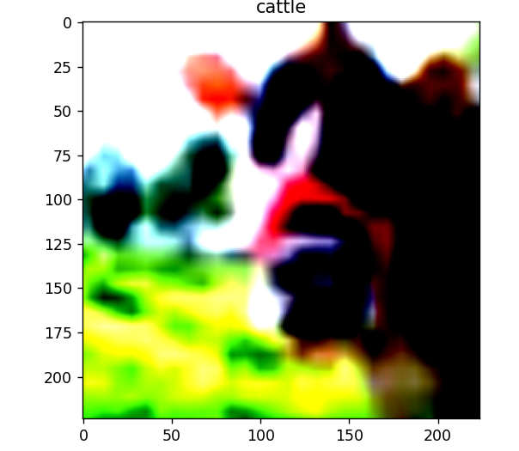
RESNET 34
Layer2
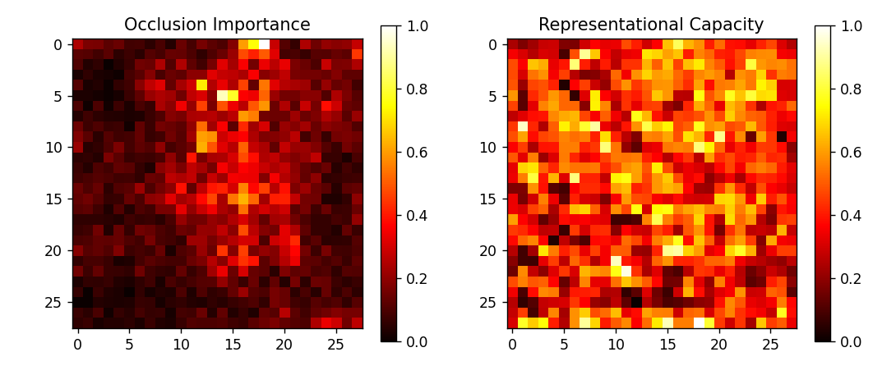
Understanindg still forming and capacity is spread, still exploratory stage

Layer3
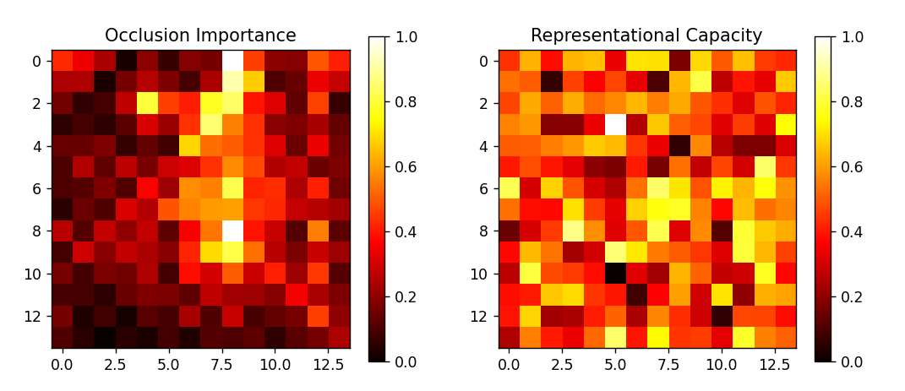
Better than layer 2, same type shi

Layer4
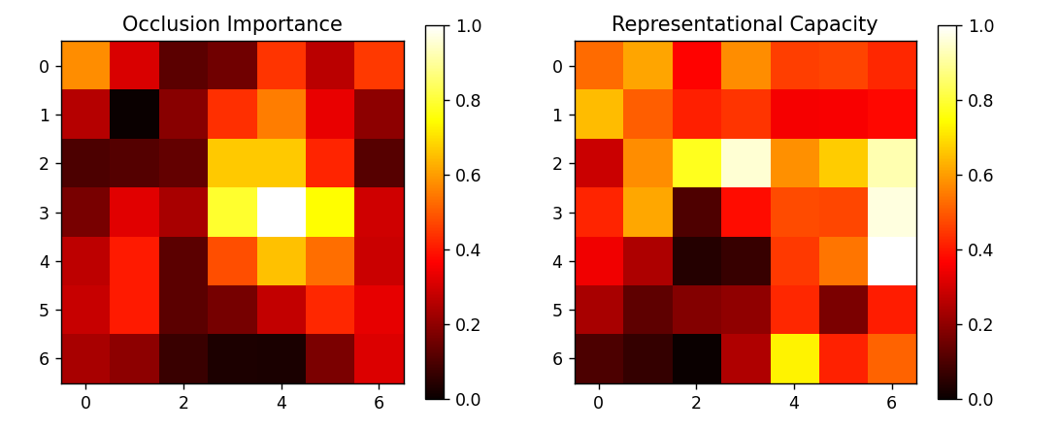
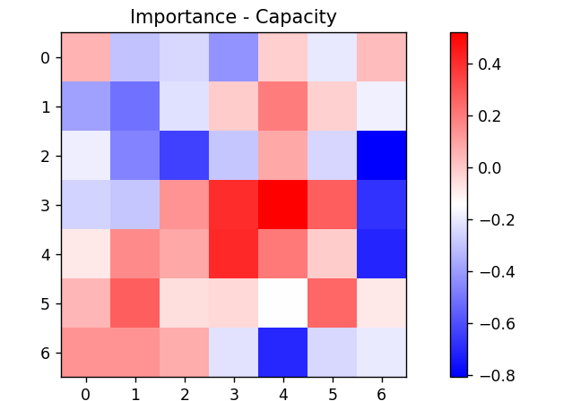
In late layers, regions with high task importance exhibit low representational capacity, indicating compact and highly compressible encodings consistent with lower effective dimensionality.
Ref : https://arxiv.org/pdf/1905.12784

