

**NATIONAL UNIVERSITY OF MODERN LANGUAGES**

**DATABASE MANAGEMENT SYSTEM ASSIGNMENT - 2**

**NAME: Abdul Rafay**

**ROLL NO:** FL23791

**PROGRAM:** BSSE (4th Semester)

**COURSE:** DATABASE MANAGEMENT SYSTEM

**SUBMITTED TO:** Sir Waqar

**DATE: May 18, 2025 DAY: SUNDAY**

**Title: Designing an ER Model and Relational Schema for a University Management System**

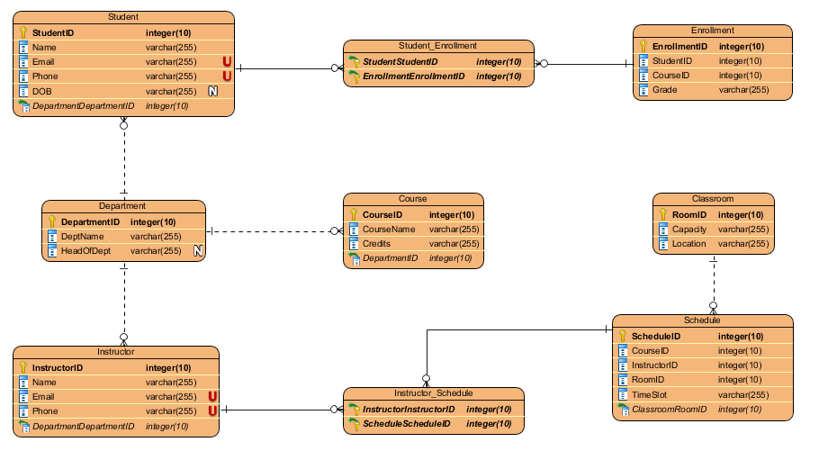**ER Diagram :**

**Converting ER Into Relational DATABASE :**

|  |  |
| --- | --- |
| STUDENT (  StudentID INT PRIMARY KEY,  Name VARCHAR(100) NOT NULL,  Email VARCHAR(100) UNIQUE NOT NULL,  Phone VARCHAR(20),  DOB DATE,  DepartmentID INT,  FOREIGN KEY (DepartmentID)  REFERENCES DEPARTMENT(DepartmentID)  ) | INSTRUCTOR (  InstructorID INT PRIMARY KEY,  Name VARCHAR(100) NOT NULL,  Email VARCHAR(100) UNIQUE NOT NULL,  Phone VARCHAR(20),  DepartmentID INT,  FOREIGN KEY (DepartmentID)  REFERENCES DEPARTMENT(DepartmentID)  ) |
| DEPARTMENT (  DepartmentID INT PRIMARY KEY,  DeptName VARCHAR(100) UNIQUE  NOT NULL,  HeadOfDept VARCHAR(100)  ) | COURSE (  CourseID INT PRIMARY KEY,  CourseName VARCHAR(100) NOT NULL,  Credits INT,  DepartmentID INT,  FOREIGN KEY (DepartmentID)  REFERENCES DEPARTMENT(DepartmentID)  ) |
| CLASSROOM (  RoomID INT PRIMARY KEY,  Capacity INT CHECK (Capacity > 0),  Location VARCHAR(100)  ) | ENROLLMENT (  EnrollmentID INT PRIMARY KEY,  StudentID INT,  CourseID INT,  Grade VARCHAR(2),  FOREIGN KEY (StudentID)  REFERENCES STUDENT(StudentID),  FOREIGN KEY (CourseID)  REFERENCES COURSE(CourseID),  ) |
| SCHEDULE (  ScheduleID INT PRIMARY KEY,  CourseID INT,  InstructorID INT,  RoomID INT,  TimeSlot VARCHAR(50),  FOREIGN KEY (CourseID)  REFERENCES COURSE(CourseID),  FOREIGN KEY (InstructorID)  REFERENCES INSTRUCTOR(InstructorID),  FOREIGN KEY (RoomID)  REFERENCES CLASSROOM(RoomID)  ) |  |