

**NATIONAL UNIVERSITY OF MODERN LANGUAGES**

**Data Base Management System lab report - 10**

**NAME: Abdul Rafay**

**ROLL NO:** FL23791

**PROGRAM:** BSSE (4th Semester)

**COURSE:** DBMS

**SUBMITTED TO:** Sir Waqar

**DATE: 5 April 2025 DAY: SATURDAY**

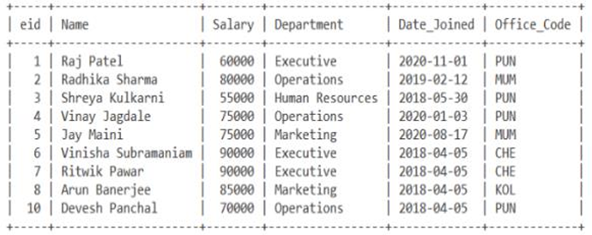**Lab Task 1**

***script***

*CREATE TABLE employee (*

*eid INTEGER PRIMARY KEY,*

*name VARCHAR(100),*

*salary INTEGER,*

*department VARCHAR(50),*

*date_joined DATE,*

*office_code VARCHAR(10)*

*);*

*INSERT INTO employee (eid, name, salary, department, date_joined, office_code) VALUES*

*(1, 'Raj Patel', 60000, 'Executive', '2020-11-01', 'PUN'),*

*(2, 'Radhika Sharma', 80000, 'Operations', '2019-02-12', 'MUM'),*

*(3, 'Shreya Kulkarni', 55000, 'Human Resources', '2018-05-30', 'PUN'),*

*(4, 'Vinay Jagdale', 75000, 'Operations', '2020-01-03', 'PUN'),*

*(5, 'Jay Maini', 75000, 'Marketing', '2020-08-17', 'MUM'),*

*(6, 'Vinisha Subramaniam', 90000, 'Executive', '2018-04-05', 'CHE'),*

*(7, 'Ritwik Pawar', 90000, 'Executive', '2018-04-05', 'CHE'),*

*(8, 'Arun Banerjee', 85000, 'Marketing', '2018-04-05', 'KOL'),*

*(10, 'Devesh Panchal', 70000, 'Operations', '2018-04-05', 'PUN');*

