

**NATIONAL UNIVERSITY OF MODERN LANGUAGES**

**Data Base Management Lab Report - 2**

**NAME: Abdul Rafay**

**ROLL NO:** FL23791

**PROGRAM:** BSSE (4th Semester)

**COURSE:** DATA BASE MANAGEMENT

**SUBMITTED TO:** Sir M Waqar

**DATE: 5 May 2025 DAY: Monday**

**Q1. Write an SQL query to display all records from city table**

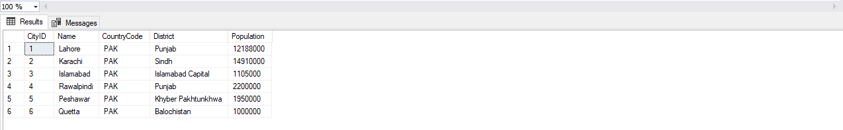

**Q2. Write an SQL Query to display the following records. Give reasoning also that**

**which table would be used get the following records**

* **Name**
* **local name**
* **government form**
* **Head of state**
* **Capital**



**Q3. Describe the structure of country language table and city table and also explain in your words about the output result**

|  |  |
| --- | --- |
| CREATE TABLE countrylanguage (  CountryCode CHAR(3),  Language VARCHAR(30),  IsOfficial CHAR(1),  Percentage FLOAT,  FOREIGN KEY (CountryCode) REFERENCES country(CountryCode)  ); | CREATE TABLE city (  CityID INT PRIMARY KEY,  Name VARCHAR(50),  CountryCode CHAR(3),  District VARCHAR(50),  Population INT  ); |

**Q4. Consider country table and use arithmetic operators within SQL query to calculate 10 % on population column**

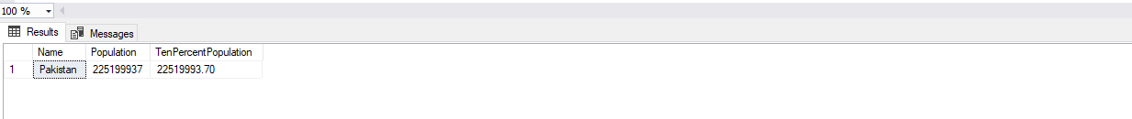

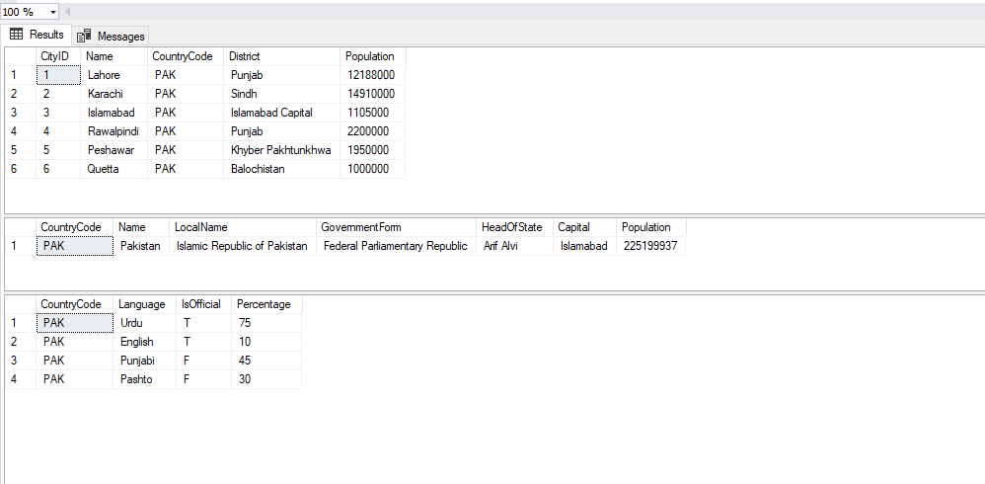

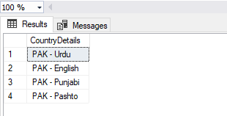**Q5. Consider country language table. Write SQL query to concatenate columns i.e. Country code and language .Also use column alias to rename the concatenated column as country details column**