

**NATIONAL UNIVERSITY OF MODERN LANGUAGES**

**Data Base Management Lab Report - 3**

**NAME: Abdul Rafay**

**ROLL NO:** FL23791

**PROGRAM:**  BSSE (4th Semester)

**COURSE:** DATA BASE MANAGEMENT

**SUBMITTED TO:** Sir M Waqar

**DATE: 5 May 2025                                                                                                                       DAY: Monday**

**Lab Report 3**

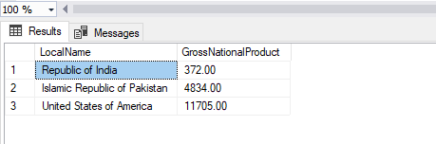**Q1. Write a Single Query to display local name and Gross National Product for Countries who specifically are in range of 372.00,4834,11705,60,650) Or those Countries who’s Local Name starts off with B**

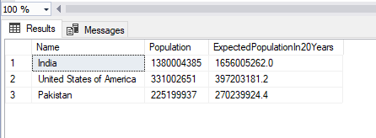**Q2. Write an SQL Query to display Population, Expected Population after twenty years and Red Zone Areas with Population Exceeding 250,000.Also display information in descending order**

**Q3 Select Name, Capital, Region and Independence Year from Country Table Where Year Must be Equal to ‘1991’ and The Name Must be Start with ‘A’ and Capital Must be Less Than 500.**

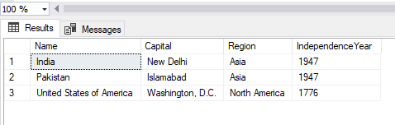

**Q4 Select Surface Area and Population from Country Table Where Population Must be Equal to 500000 and Surface Area should Between 1000(lower) And 5000(Higher)**

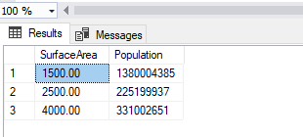

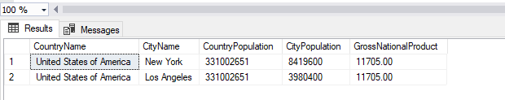**Q5.Write a single query which uses majority of concepts taught in lab 2 and lab 03**