

**NATIONAL UNIVERSITY OF MODERN LANGUAGES**

**Data Base Management Lab Report - 6**

**NAME: Abdul Rafay**

**ROLL NO:** FL23791

**PROGRAM:**  BSSE (4th Semester)

**COURSE:** DATA BASE MANAGEMENT

**SUBMITTED TO:** Sir M Waqar

**DATE: 5 May 2025                                                                                                                       DAY: Monday**

**Lab Report**

**Q1. Write a single sql query to display employee first name, last name and job joined together, similarly display length of employee email address, and the numeric position of letter A in the employee last name, for all employees whose employee number is 1002 and job is president**

CREATE TABLE Employee (

Employee_ID INT PRIMARY KEY,

Employee_FirstName VARCHAR(50),

Employee_LastName VARCHAR(50),

Job VARCHAR(50),

Employee_Email VARCHAR(100)

);

 CREATE TABLE Customer (

Customer_ID INT PRIMARY KEY,

Customer_FirstName VARCHAR(50),

Customer_LastName VARCHAR(50),

Customer_Address VARCHAR(100),

Customer_State CHAR(2),

Customer_CreditLimit DECIMAL(10, 2),

Customer_Email VARCHAR(100)

);

CREATE TABLE Orders (

Order_ID INT PRIMARY KEY,

Order_Date DATE,

Customer_ID INT,

Order_Price DECIMAL(10, 2),

FOREIGN KEY (Customer_ID) REFERENCES Customer(Customer_ID)

);

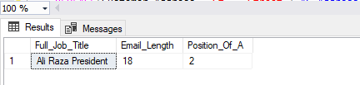**Q2. Write a query to display the last names of all customers who have the letter p in their first name and the letter A at the 5th position in their last name.**

**Q3. Write a single query which covers all character manipulation functions such as substring ,instring, concat, upper case, trim,replace and lpad or rpad and should use where clause as well as comparison operators**

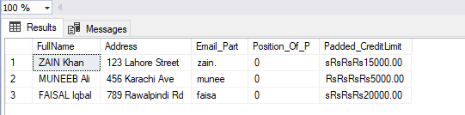

**Q4.Format the credit limit column to be 15 character long ,left padded with Rs of only those customers whose last name is king and their credit limit is greater than 10000 .Also label column as credit balance**

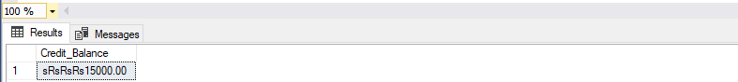

**Q5. Consider order table and round off the price of only those orders whose order number is 10100**

