

**NATIONAL UNIVERSITY OF MODERN LANGUAGES**

**Data Base Management Lab Report - 7**

**NAME: Abdul Rafay**

**ROLL NO:** FL23791

**PROGRAM:**  BSSE (4th Semester)

**COURSE:** DATA BASE MANAGEMENT

**SUBMITTED TO:** Sir M Waqar

**DATE: 5 May 2025                                                                                                                       DAY: Monday**

**Lab Report**

CREATE TABLE Orders (

Order_ID INT PRIMARY KEY,

Order_Price DECIMAL(10, 2),

Order_Date DATE,

Ship_Date DATE

);

INSERT INTO Orders (Order_ID, Order_Price, Order_Date, Ship_Date)

VALUES

(10100, 500.75, '2025-05-01', '2025-05-03'),

(10101, 750.50, '2025-05-02', '2025-05-05'),

(10102, 300.30, '2025-05-10', '2025-05-12');

**Output :**

**Q1.Consider order table and round off the price of only those orders whose order number is 10100**

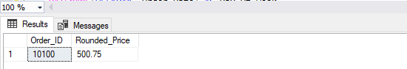

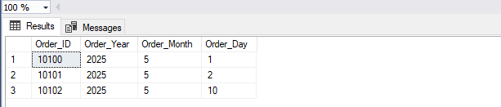**Q2.Consider three major scenarios on classic model database in which major data format and time functions are covered?**

**Q3. Explain following functions and also explain how sql queries are written for them**

**• Time difference()**

**• Time stamp()**

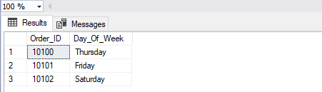**• Sysdate()**

