

**NATIONAL UNIVERSITY OF MODERN LANGUAGES**

**Software Design and Architecture Final Project**

**NAMES: Abdul Rafay**

**Ahmed Raza**

**Zohaib Ijaz**

**Nazish Khan**

**Saveera Bhatti**

**PROGRAM:** BSSE (4th Semester)

**COURSE:** SOFTWARE DESIGN AND ARCHITECTURE

**SUBMITTED TO:** Sir Anas Bilal

**DATE: 26 May 2025 DAY: Sunday**

Table of Contents

1. Domain Model Diagram 4

2. Class Diagram 4

3. Use Case Diagrams 5

7

8

9

10

11

12

4. Sequence Diagrams 13

6. State Machine Diagrams 20

35

36

7. Component Diagram 37

8. Deployment Diagram 38

Use Case Descriptions 39

Use Case 1: Manage Products 39

Use Case 2: Manage Orders 39

Use Case 3: Manage Suppliers 40

Use Case 4: Manage Stock Inventory 40

Use Case 5: Generate Reports 41

Use Case 6: Add Customer 41

Use Case 7: Update Customer 42

Use Case 8: Delete Customer 42

Use Case 9: View Customer Details 43

Use Case 10: Search Customers 43

Use Case 11: Search Products 44

Use Case 12: View Product Details 44

Use Case 13: Filter Products by Category 45

Use Case 14: Delete Order 46

Use Case 15: Search Orders 46

Use Case 16: Cancel Order 47

Use Case 17: Manage Vendors 47

Use Case 18: Update Vendor Info 48

Use Case 19: Manage Warranty Claims 48

Use Case 20: Track Product Shipments 49

CRC – Cards 50

Activity Diagram 50

High level Architecture : 51

# 1. Domain Model Diagram

# 2. Class Diagram

# 3. Use Case Diagrams

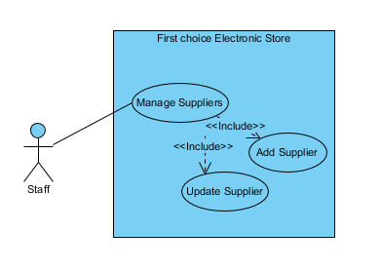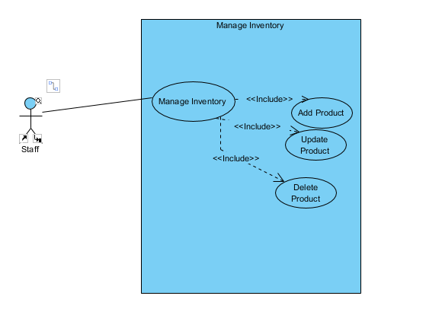

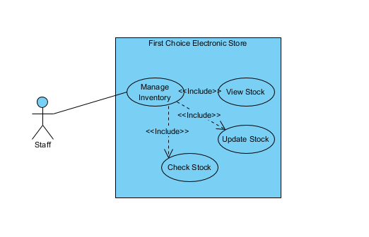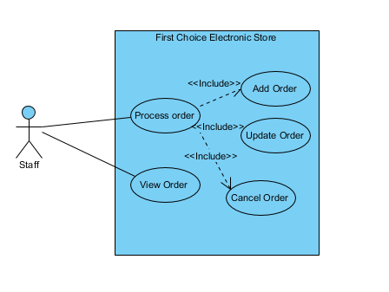

\

# 

# 

# 

# 

# 

# 

# 4. Sequence Diagrams

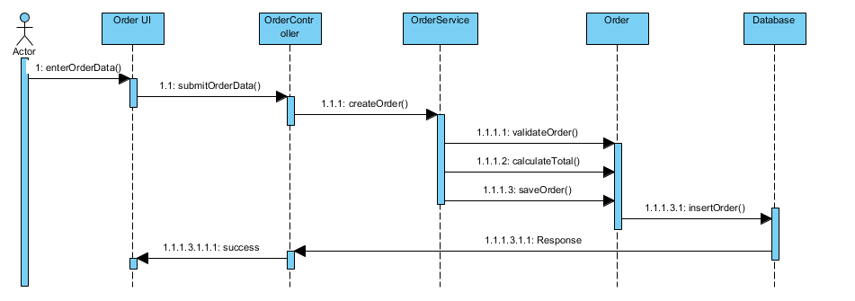

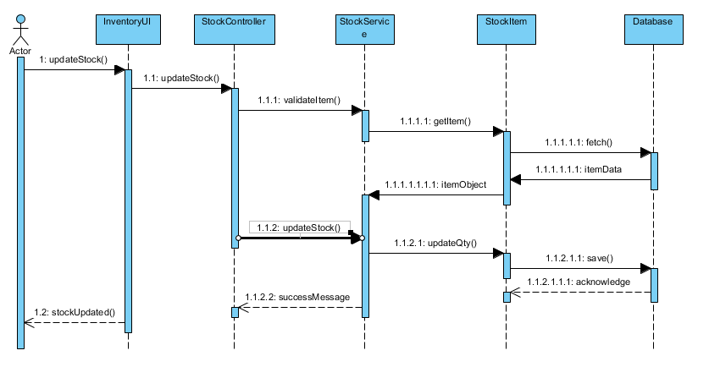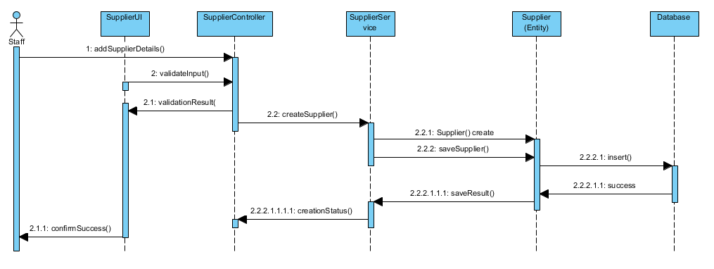

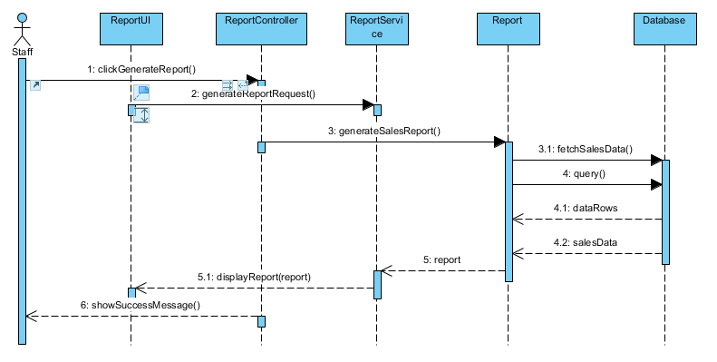

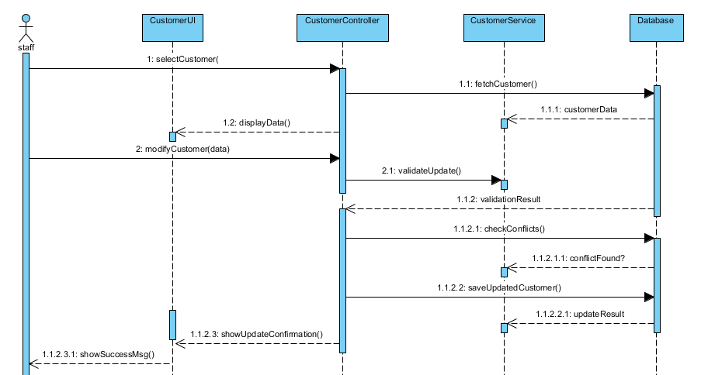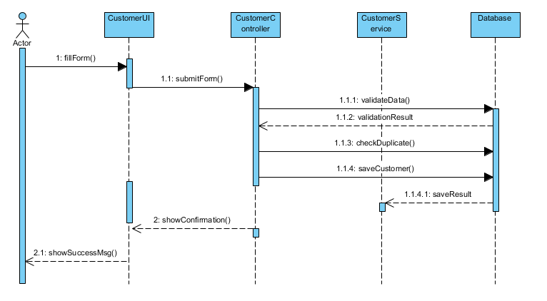

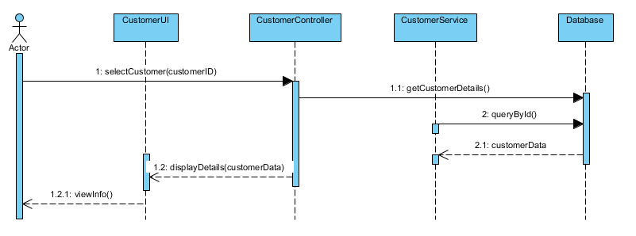

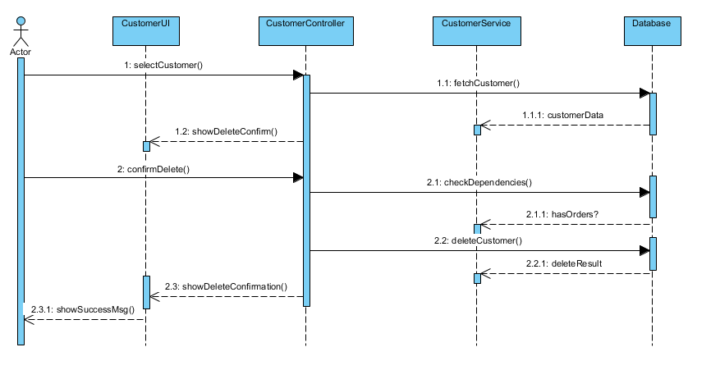

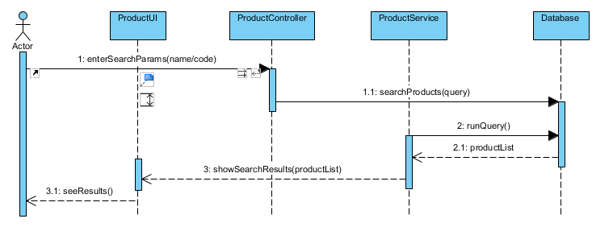

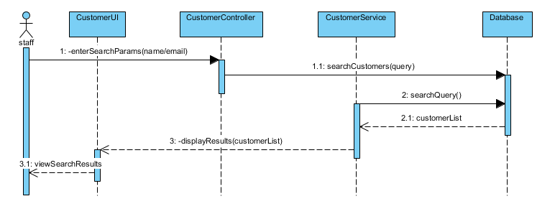

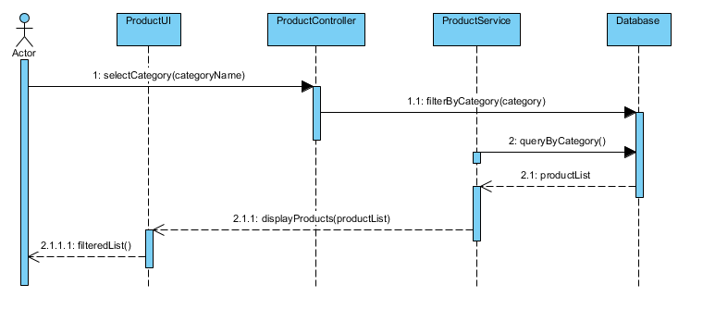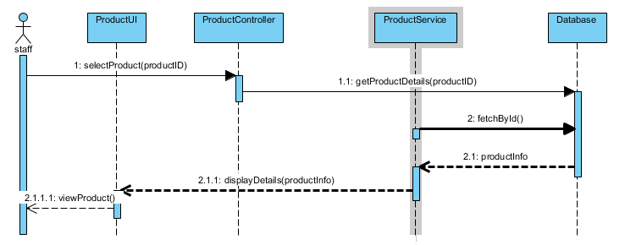

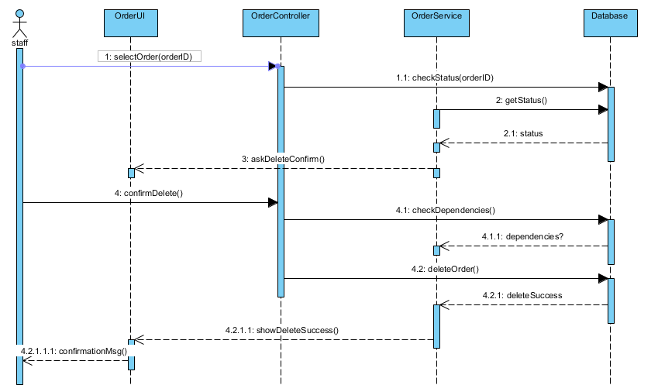

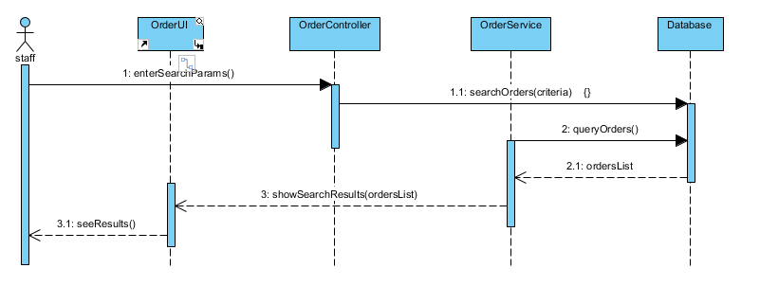

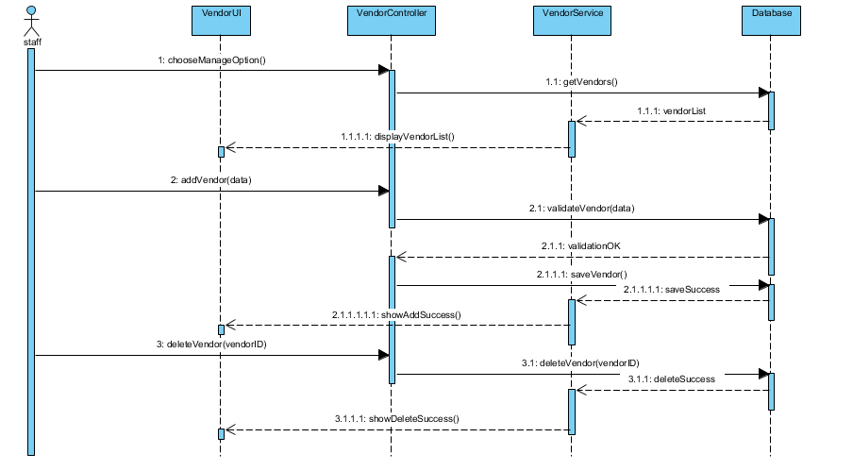

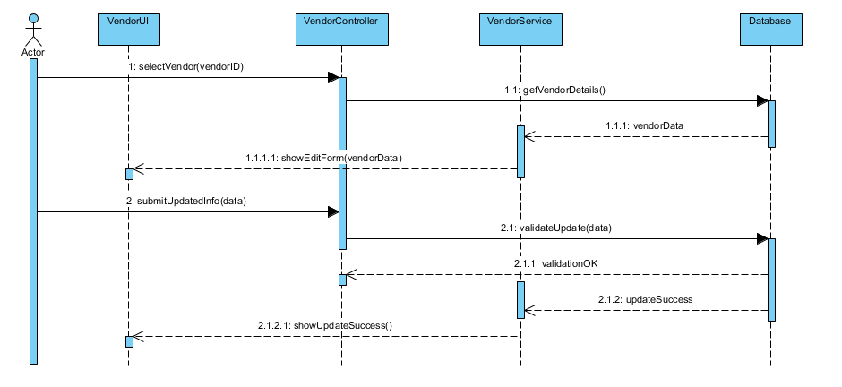

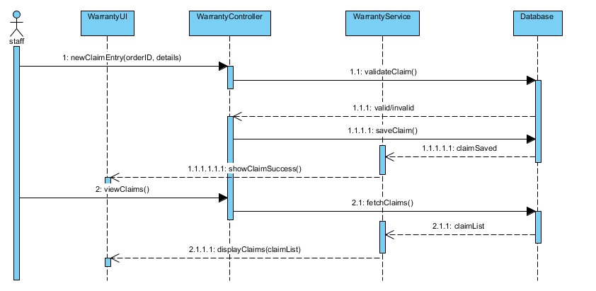

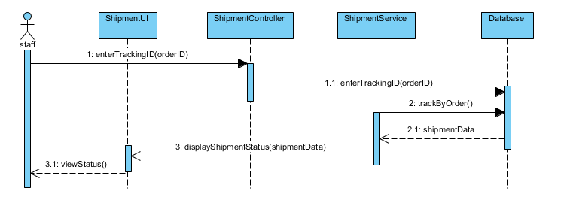

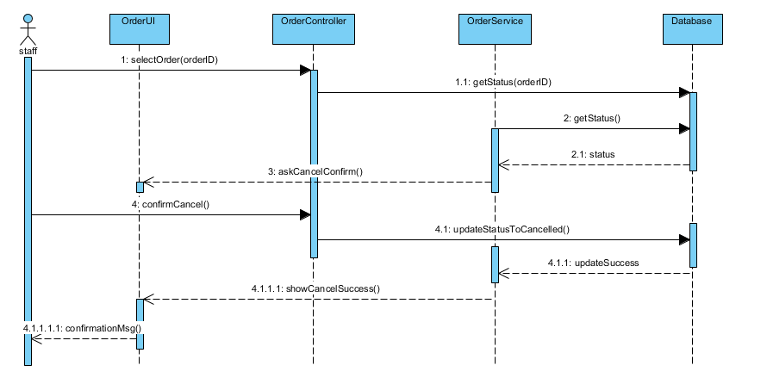

# 6. State Machine Diagrams

Add your screenshots or diagrams for '6. State Machine Diagrams' here.

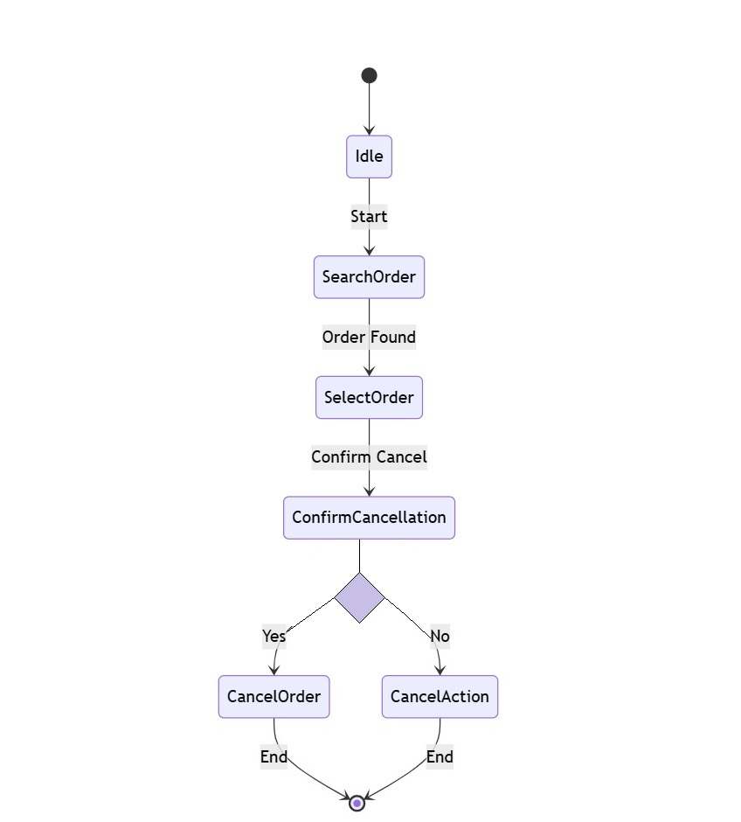

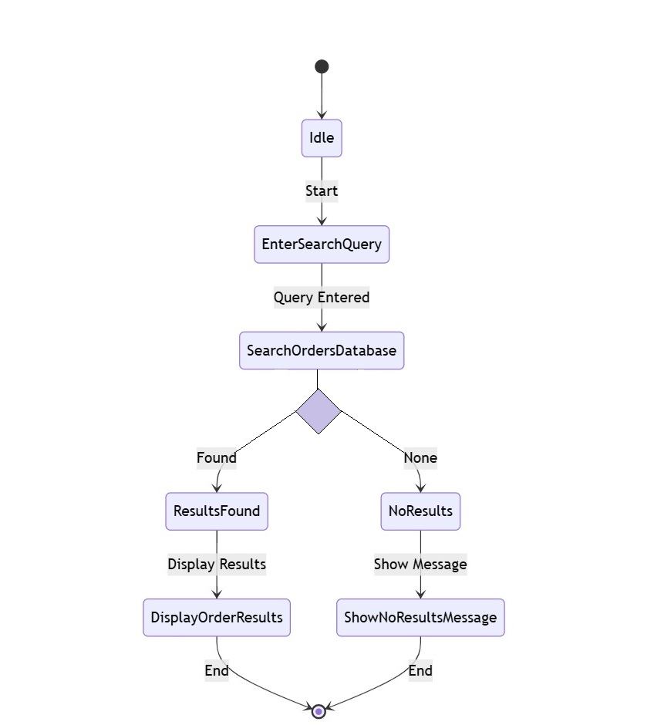

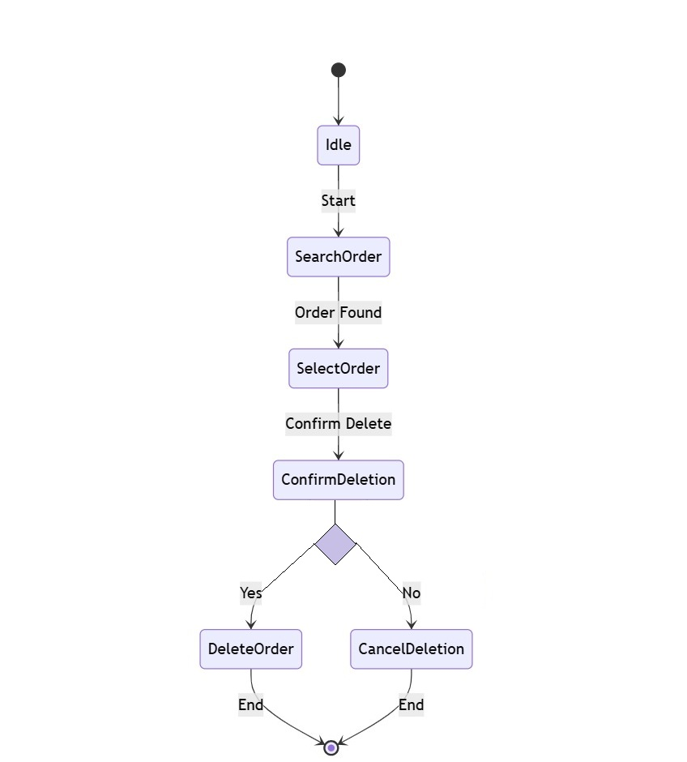

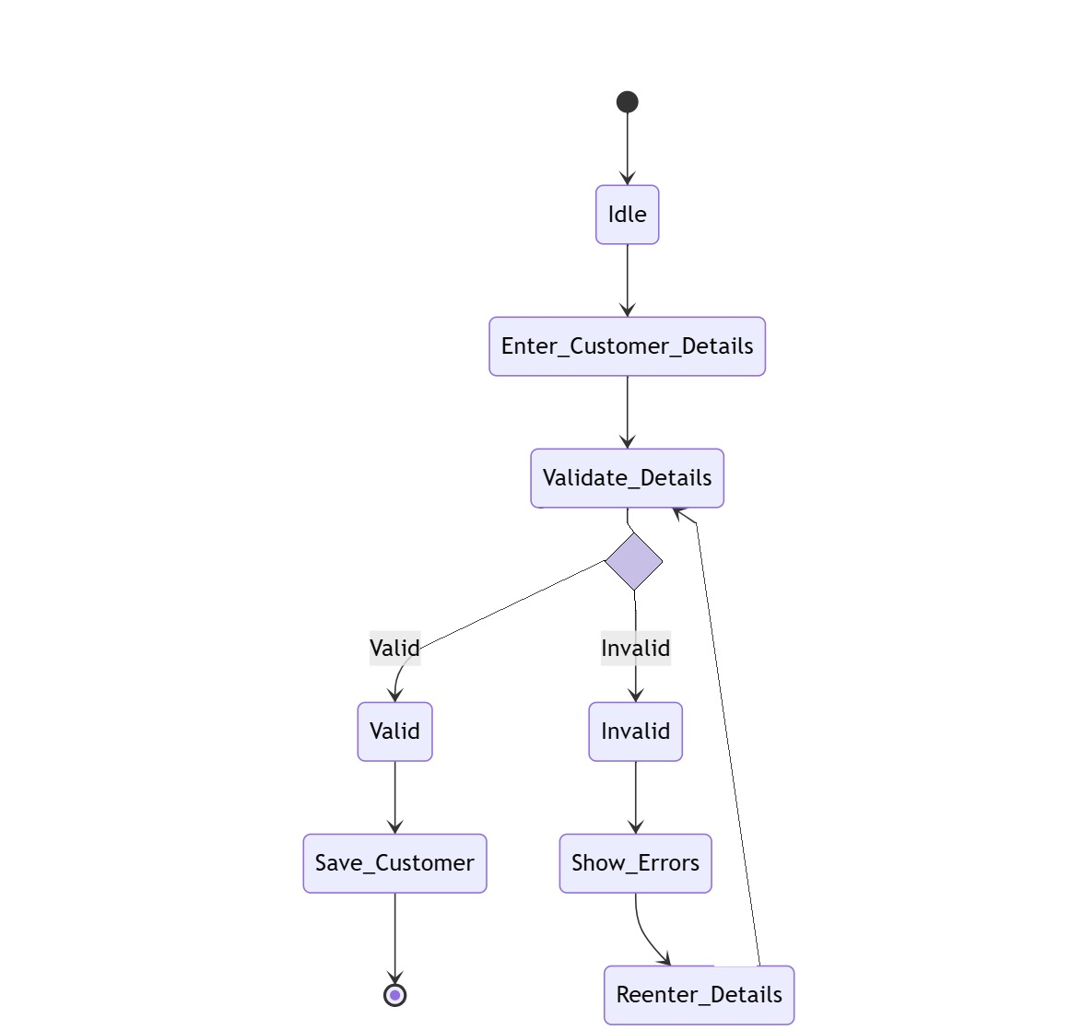

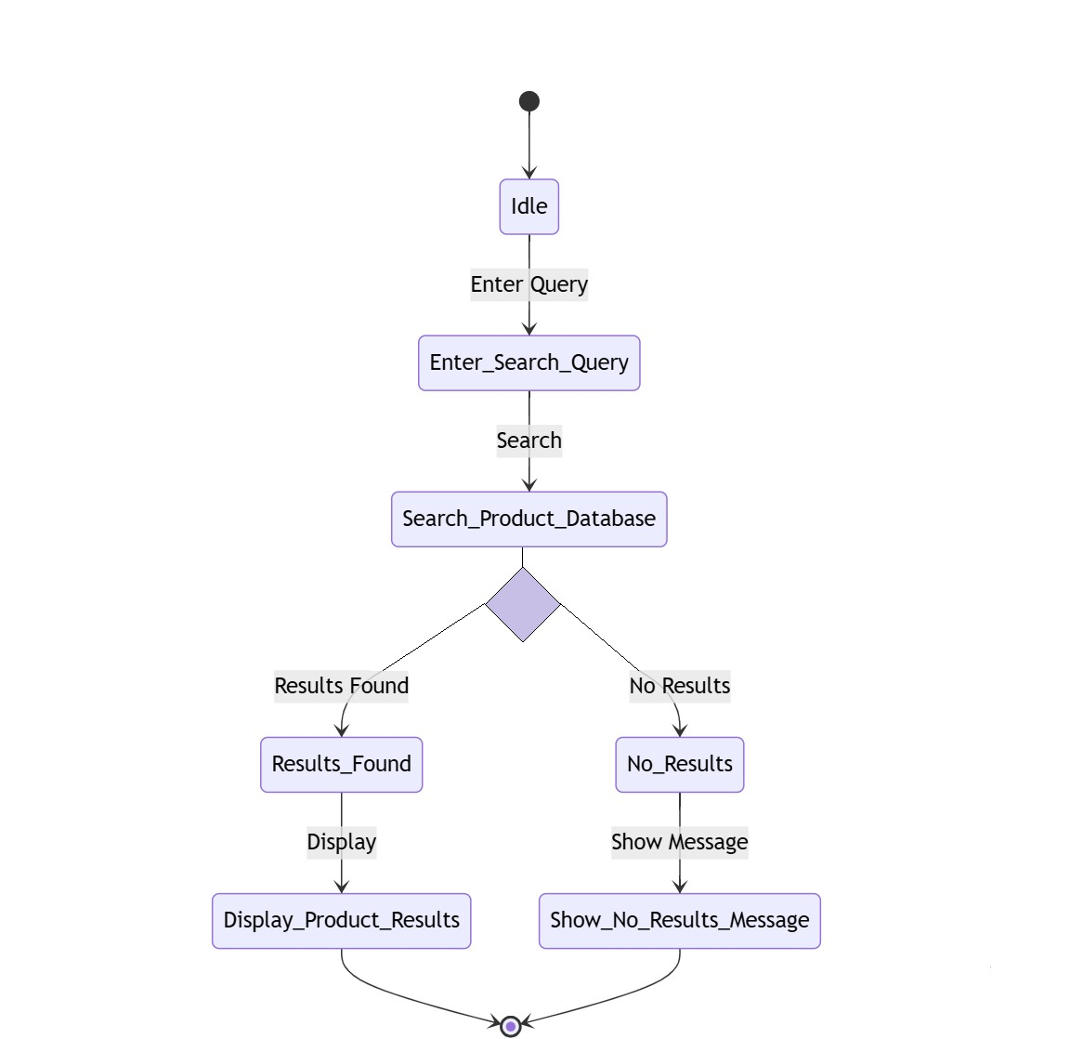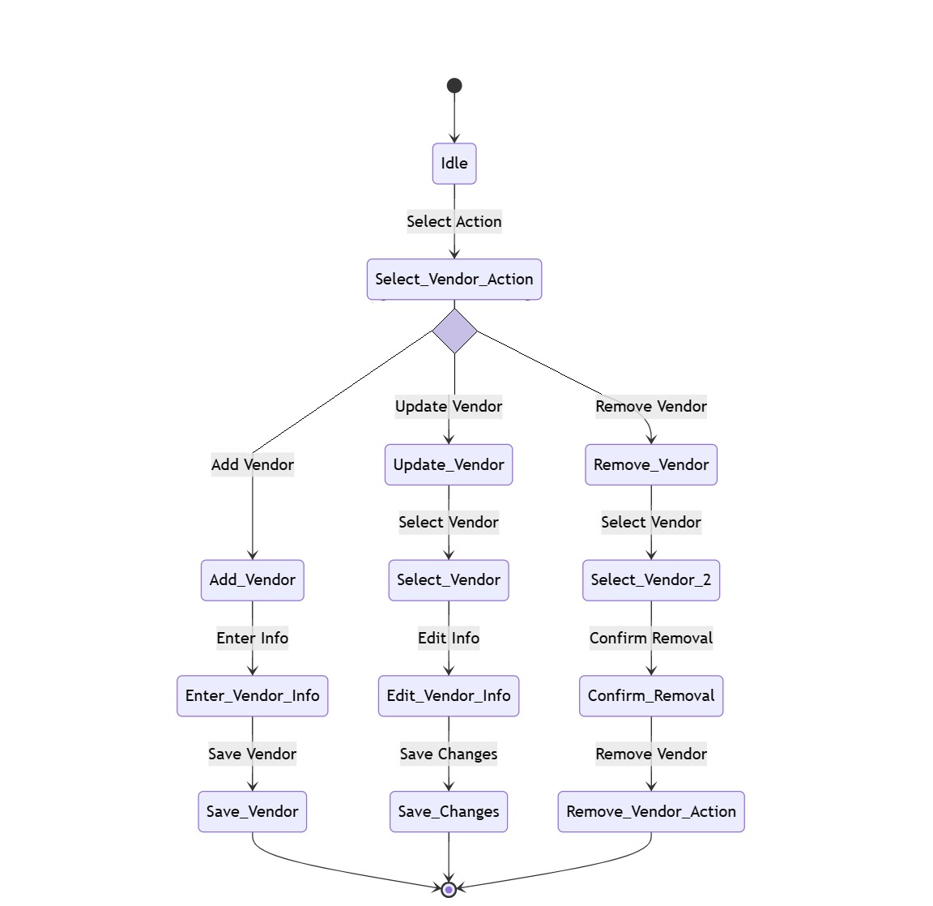

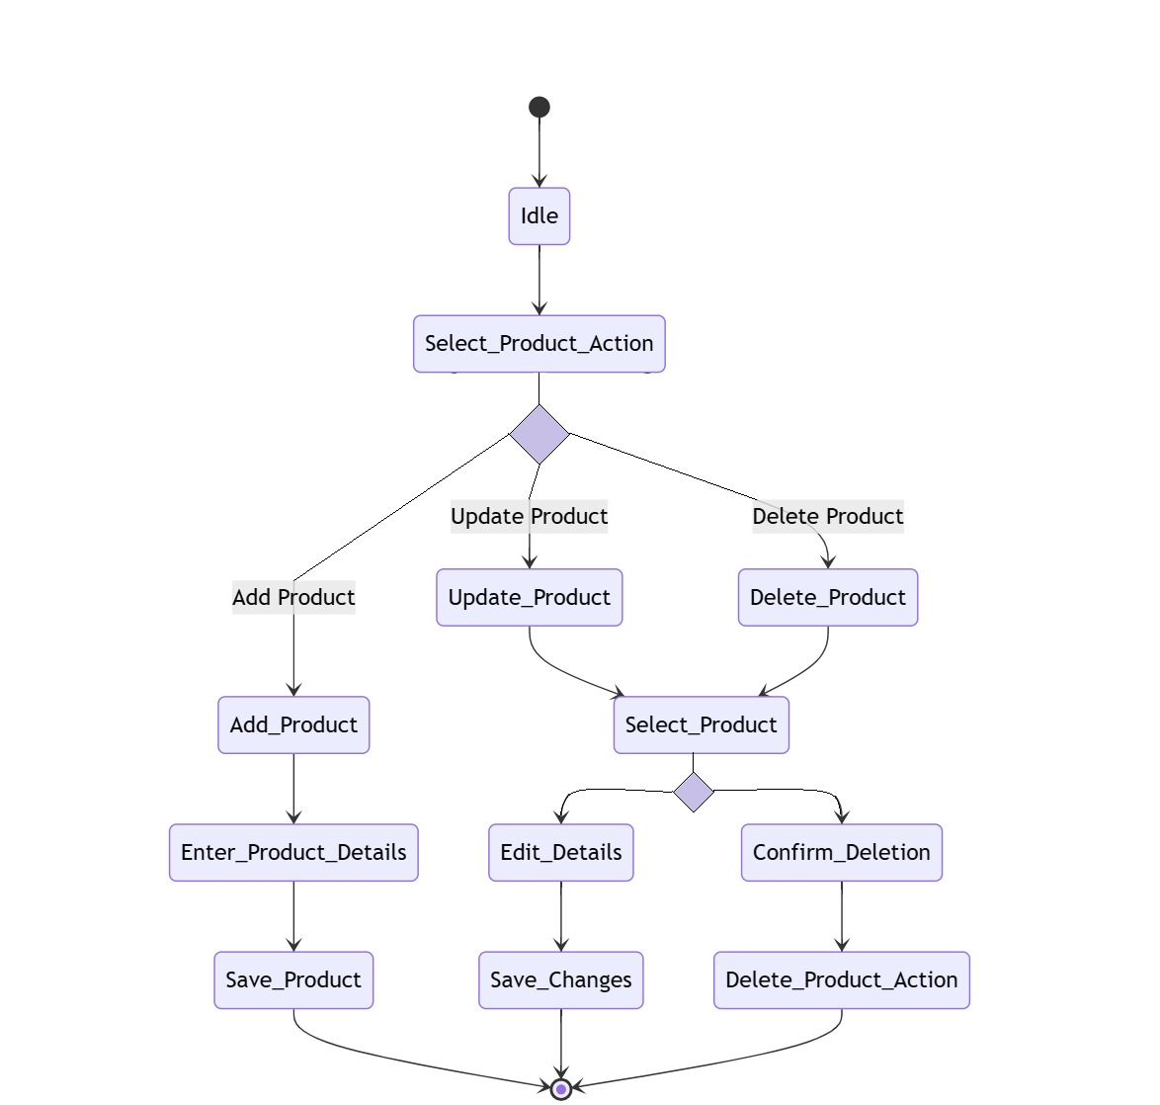

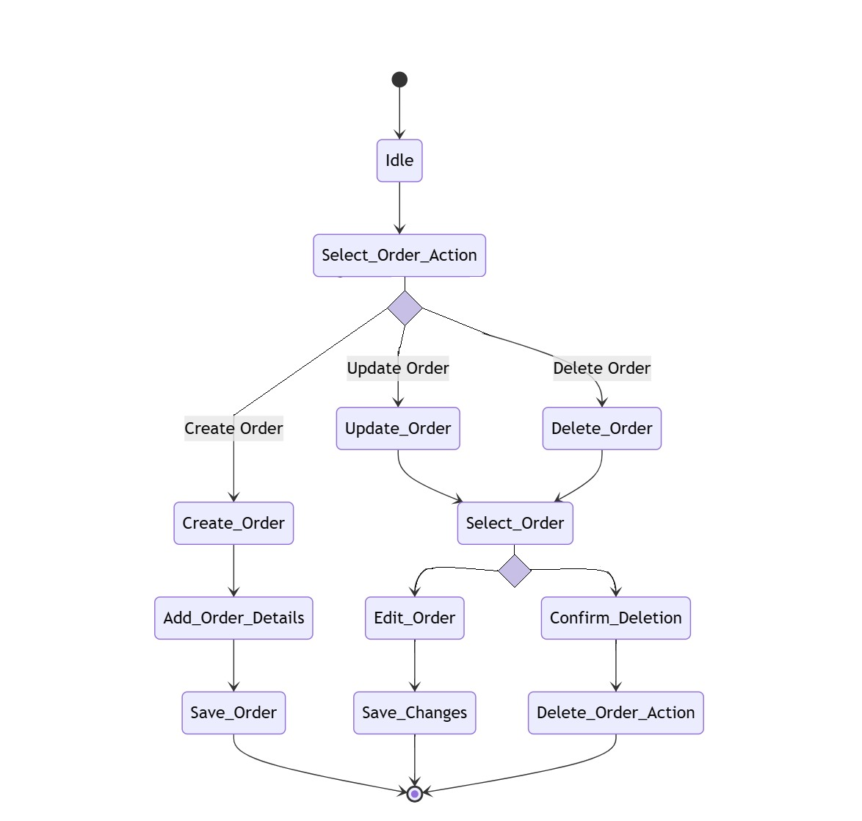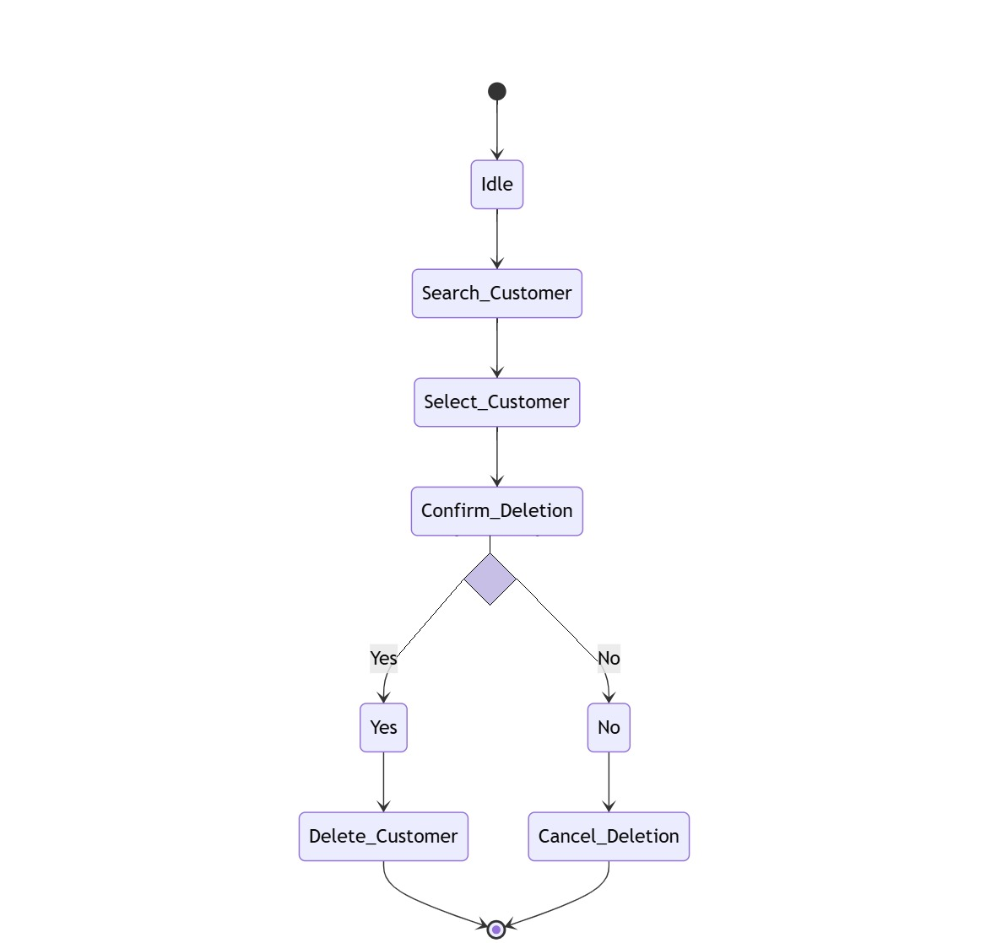

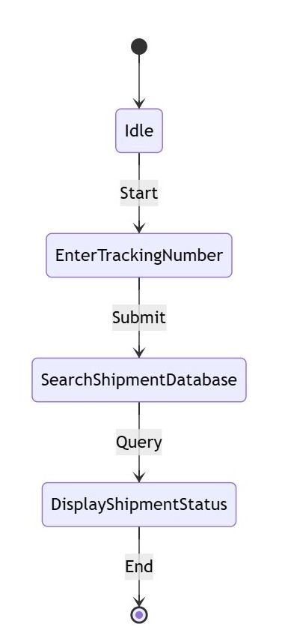

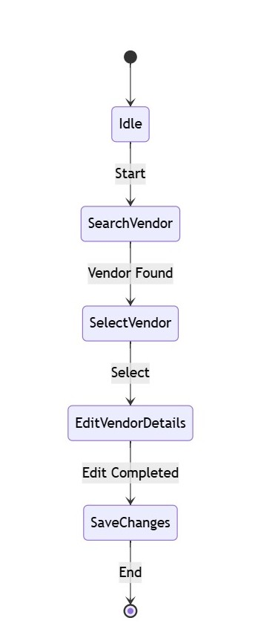

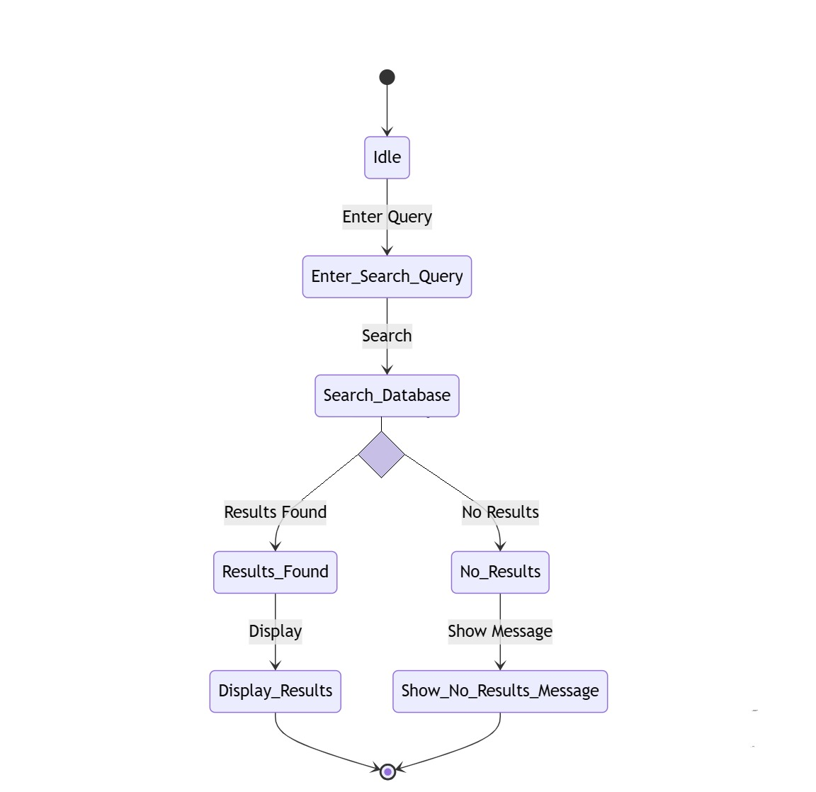

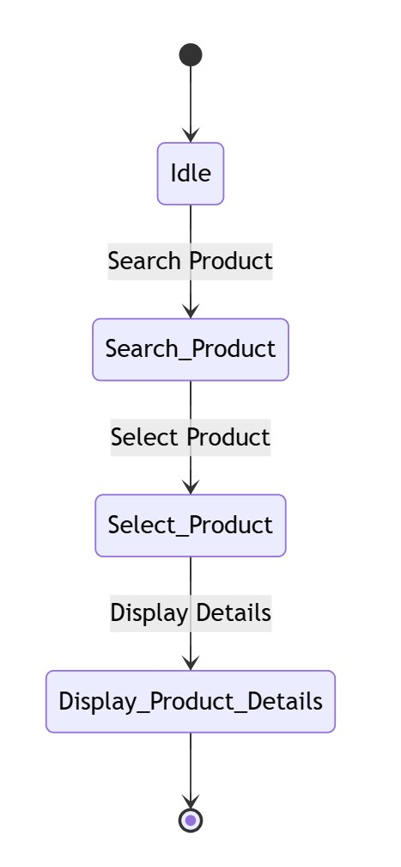

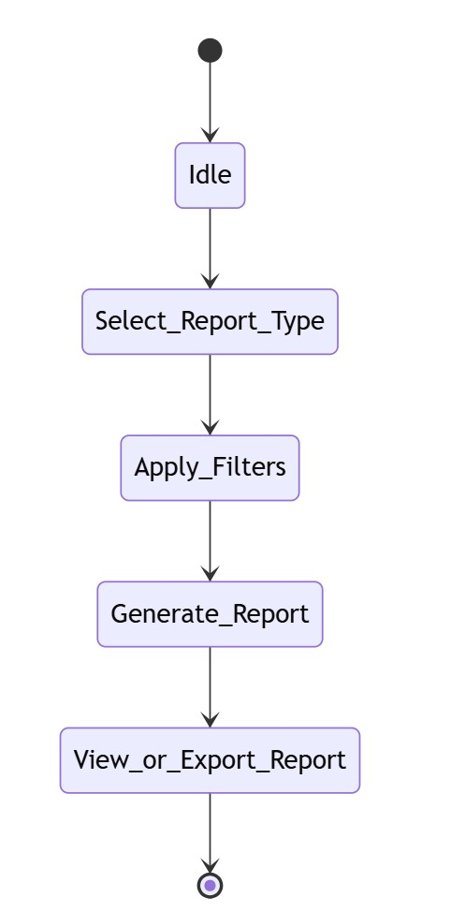

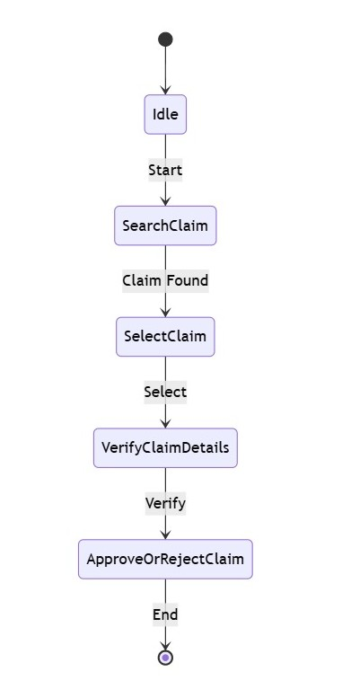

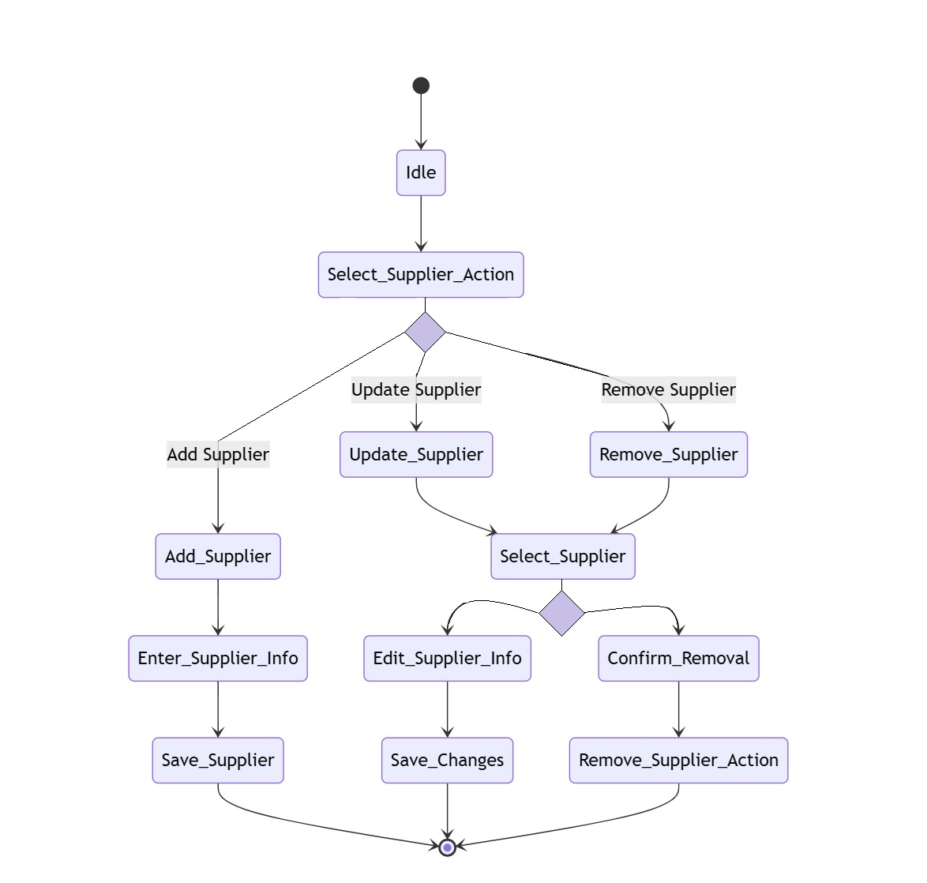

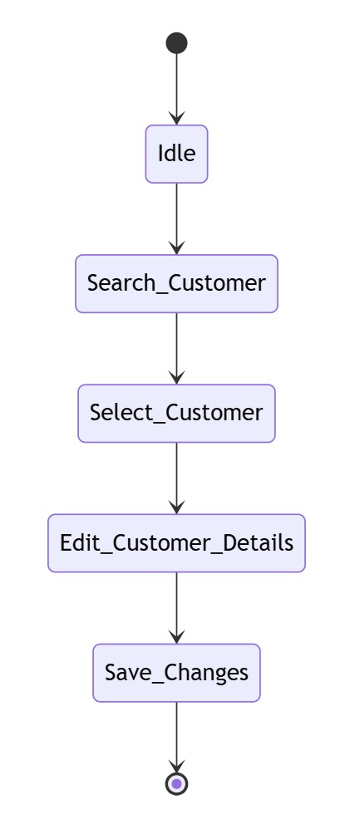

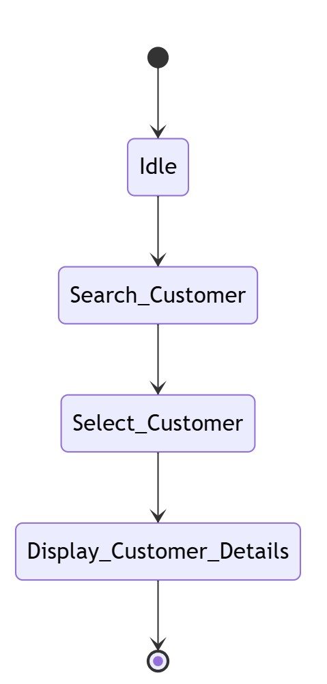

# 

# 

# 7. Component Diagram

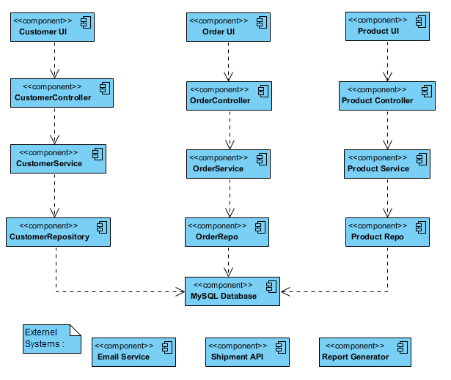

# 8. Deployment Diagram

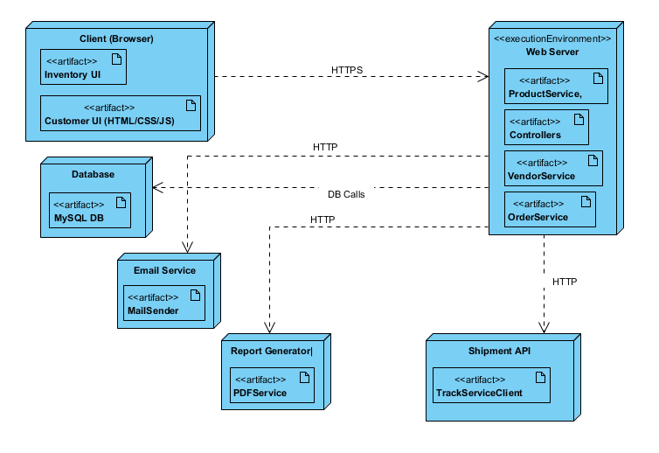

# Use Case Descriptions

## Use Case 1: Manage Products

Brief Description: System shall allow staff to add, update, and delete product details.

Actors: Staff, System

Preconditions: Staff must be authenticated and authorized to perform the action.

Postconditions: Action completed successfully, and changes are reflected in the system.

* Basic Flow:

1. Staff accesses the respective module via UI.

2. Staff selects 'Manage Products' functionality.

3. System displays relevant form/data.

4. Staff performs the operation (add/update/delete/search/etc.).

5. System processes the request and displays success confirmation.

* Alternative Flow:

1. If input is invalid, system shows validation error.

2. If database is unreachable, system shows connection error message.

3. If operation fails due to constraints, system logs the issue and notifies the user.

## Use Case 2: Manage Orders

Brief Description: System shall allow staff to create and update customer orders.

Actors: Staff, System

Preconditions: Staff must be authenticated and authorized to perform the action.

Postconditions: Action completed successfully, and changes are reflected in the system.

* Basic Flow:

1. Staff accesses the respective module via UI.

2. Staff selects 'Manage Orders' functionality.

3. System displays relevant form/data.

4. Staff performs the operation (add/update/delete/search/etc.).

5. System processes the request and displays success confirmation.

* Alternative Flow:

1. If input is invalid, system shows validation error.

2. If database is unreachable, system shows connection error message.

3. If operation fails due to constraints, system logs the issue and notifies the user.

## Use Case 3: Manage Suppliers

Brief Description: System shall allow staff to add and update supplier information.

Actors: Staff, System

Preconditions: Staff must be authenticated and authorized to perform the action.

Postconditions: Action completed successfully, and changes are reflected in the system.

* Basic Flow:

1. Staff accesses the respective module via UI.

2. Staff selects 'Manage Suppliers' functionality.

3. System displays relevant form/data.

4. Staff performs the operation (add/update/delete/search/etc.).

5. System processes the request and displays success confirmation.

* Alternative Flow:

1. If input is invalid, system shows validation error.

2. If database is unreachable, system shows connection error message.

3. If operation fails due to constraints, system logs the issue and notifies the user.

## Use Case 4: Manage Stock Inventory

Brief Description: System shall allow staff to view and update stock levels.

Actors: Staff, System

Preconditions: Staff must be authenticated and authorized to perform the action.

Postconditions: Action completed successfully, and changes are reflected in the system.

* Basic Flow:

1. Staff accesses the respective module via UI.

2. Staff selects 'Manage Stock Inventory' functionality.

3. System displays relevant form/data.

4. Staff performs the operation (add/update/delete/search/etc.).

5. System processes the request and displays success confirmation.

* Alternative Flow:

1. If input is invalid, system shows validation error.

2. If database is unreachable, system shows connection error message.

3. If operation fails due to constraints, system logs the issue and notifies the user.

## Use Case 5: Generate Reports

Brief Description: System shall allow staff to generate product and sales reports.

Actors: Staff, System

Preconditions: Staff must be authenticated and authorized to perform the action.

Postconditions: Action completed successfully, and changes are reflected in the system.

* Basic Flow:

1. Staff accesses the respective module via UI.

2. Staff selects 'Generate Reports' functionality.

3. System displays relevant form/data.

4. Staff performs the operation (add/update/delete/search/etc.).

5. System processes the request and displays success confirmation.

* Alternative Flow:

1. If input is invalid, system shows validation error.

2. If database is unreachable, system shows connection error message.

3. If operation fails due to constraints, system logs the issue and notifies the user.

## Use Case 6: Add Customer

Brief Description: System shall allow staff to add a new customer into the database.

Actors: Staff, System

Preconditions: Staff must be authenticated and authorized to perform the action.

Postconditions: Action completed successfully, and changes are reflected in the system.

* Basic Flow:

1. Staff accesses the respective module via UI.

2. Staff selects 'Add Customer' functionality.

3. System displays relevant form/data.

4. Staff performs the operation (add/update/delete/search/etc.).

5. System processes the request and displays success confirmation.

* Alternative Flow:

1. If input is invalid, system shows validation error.

2. If database is unreachable, system shows connection error message.

3. If operation fails due to constraints, system logs the issue and notifies the user.

## Use Case 7: Update Customer

Brief Description: System shall allow staff to update customer details.

Actors: Staff, System

Preconditions: Staff must be authenticated and authorized to perform the action.

Postconditions: Action completed successfully, and changes are reflected in the system.

* Basic Flow:

1. Staff accesses the respective module via UI.

2. Staff selects 'Update Customer' functionality.

3. System displays relevant form/data.

4. Staff performs the operation (add/update/delete/search/etc.).

5. System processes the request and displays success confirmation.

* Alternative Flow:

1. If input is invalid, system shows validation error.

2. If database is unreachable, system shows connection error message.

3. If operation fails due to constraints, system logs the issue and notifies the user.

## Use Case 8: Delete Customer

Brief Description: System shall allow staff to remove customer records.

Actors: Staff, System

Preconditions: Staff must be authenticated and authorized to perform the action.

Postconditions: Action completed successfully, and changes are reflected in the system.

* Basic Flow:

1. Staff accesses the respective module via UI.

2. Staff selects 'Delete Customer' functionality.

3. System displays relevant form/data.

4. Staff performs the operation (add/update/delete/search/etc.).

5. System processes the request and displays success confirmation.

* Alternative Flow:

1. If input is invalid, system shows validation error.

2. If database is unreachable, system shows connection error message.

3. If operation fails due to constraints, system logs the issue and notifies the user.

## Use Case 9: View Customer Details

Brief Description: System shall allow staff to view complete customer information.

Actors: Staff, System

Preconditions: Staff must be authenticated and authorized to perform the action.

Postconditions: Action completed successfully, and changes are reflected in the system.

* Basic Flow:

1. Staff accesses the respective module via UI.

2. Staff selects 'View Customer Details' functionality.

3. System displays relevant form/data.

4. Staff performs the operation (add/update/delete/search/etc.).

5. System processes the request and displays success confirmation.

* Alternative Flow:

1. If input is invalid, system shows validation error.

2. If database is unreachable, system shows connection error message.

3. If operation fails due to constraints, system logs the issue and notifies the user.

## Use Case 10: Search Customers

Brief Description: System shall allow staff to search customers using filters.

Actors: Staff, System

Preconditions: Staff must be authenticated and authorized to perform the action.

Postconditions: Action completed successfully, and changes are reflected in the system.

* Basic Flow:

1. Staff accesses the respective module via UI.

2. Staff selects 'Search Customers' functionality.

3. System displays relevant form/data.

4. Staff performs the operation (add/update/delete/search/etc.).

5. System processes the request and displays success confirmation.

* Alternative Flow:

1. If input is invalid, system shows validation error.

2. If database is unreachable, system shows connection error message.

3. If operation fails due to constraints, system logs the issue and notifies the user.

## Use Case 11: Search Products

Brief Description: System shall allow staff to search products by name or category.

Actors: Staff, System

Preconditions: Staff must be authenticated and authorized to perform the action.

Postconditions: Action completed successfully, and changes are reflected in the system.

* Basic Flow:

1. Staff accesses the respective module via UI.

2. Staff selects 'Search Products' functionality.

3. System displays relevant form/data.

4. Staff performs the operation (add/update/delete/search/etc.).

5. System processes the request and displays success confirmation.

* Alternative Flow:

1. If input is invalid, system shows validation error.

2. If database is unreachable, system shows connection error message.

3. If operation fails due to constraints, system logs the issue and notifies the user.

## Use Case 12: View Product Details

Brief Description: System shall allow staff to view product information.

Actors: Staff, System

Preconditions: Staff must be authenticated and authorized to perform the action.

Postconditions: Action completed successfully, and changes are reflected in the system.

* Basic Flow:

1. Staff accesses the respective module via UI.

2. Staff selects 'View Product Details' functionality.

3. System displays relevant form/data.

4. Staff performs the operation (add/update/delete/search/etc.).

5. System processes the request and displays success confirmation.

* Alternative Flow:

1. If input is invalid, system shows validation error.

2. If database is unreachable, system shows connection error message.

3. If operation fails due to constraints, system logs the issue and notifies the user.

## Use Case 13: Filter Products by Category

Brief Description: System shall allow staff to filter product listings by category.

Actors: Staff, System

Preconditions: Staff must be authenticated and authorized to perform the action.

Postconditions: Action completed successfully, and changes are reflected in the system.

* Basic Flow:

1. Staff accesses the respective module via UI.

2. Staff selects 'Filter Products by Category' functionality.

3. System displays relevant form/data.

4. Staff performs the operation (add/update/delete/search/etc.).

5. System processes the request and displays success confirmation.

* Alternative Flow:

1. If input is invalid, system shows validation error.

2. If database is unreachable, system shows connection error message.

3. If operation fails due to constraints, system logs the issue and notifies the user.

## Use Case 14: Delete Order

Brief Description: System shall allow staff to delete a customer order.

Actors: Staff, System

Preconditions: Staff must be authenticated and authorized to perform the action.

Postconditions: Action completed successfully, and changes are reflected in the system.

* Basic Flow:

1. Staff accesses the respective module via UI.

2. Staff selects 'Delete Order' functionality.

3. System displays relevant form/data.

4. Staff performs the operation (add/update/delete/search/etc.).

5. System processes the request and displays success confirmation.

* Alternative Flow:

1. If input is invalid, system shows validation error.

2. If database is unreachable, system shows connection error message.

3. If operation fails due to constraints, system logs the issue and notifies the user.

## Use Case 15: Search Orders

Brief Description: System shall allow staff to search and view orders.

Actors: Staff, System

Preconditions: Staff must be authenticated and authorized to perform the action.

Postconditions: Action completed successfully, and changes are reflected in the system.

* Basic Flow:

1. Staff accesses the respective module via UI.

2. Staff selects 'Search Orders' functionality.

3. System displays relevant form/data.

4. Staff performs the operation (add/update/delete/search/etc.).

5. System processes the request and displays success confirmation.

* Alternative Flow:

1. If input is invalid, system shows validation error.

2. If database is unreachable, system shows connection error message.

3. If operation fails due to constraints, system logs the issue and notifies the user.

## Use Case 16: Cancel Order

Brief Description: System shall allow staff to cancel an existing order.

Actors: Staff, System

Preconditions: Staff must be authenticated and authorized to perform the action.

Postconditions: Action completed successfully, and changes are reflected in the system.

* Basic Flow:

1. Staff accesses the respective module via UI.

2. Staff selects 'Cancel Order' functionality.

3. System displays relevant form/data.

4. Staff performs the operation (add/update/delete/search/etc.).

5. System processes the request and displays success confirmation.

* Alternative Flow:

1. If input is invalid, system shows validation error.

2. If database is unreachable, system shows connection error message.

3. If operation fails due to constraints, system logs the issue and notifies the user.

## Use Case 17: Manage Vendors

Brief Description: System shall allow staff to manage vendor profiles.

Actors: Staff, System

Preconditions: Staff must be authenticated and authorized to perform the action.

Postconditions: Action completed successfully, and changes are reflected in the system.

* Basic Flow:

1. Staff accesses the respective module via UI.

2. Staff selects 'Manage Vendors' functionality.

3. System displays relevant form/data.

4. Staff performs the operation (add/update/delete/search/etc.).

5. System processes the request and displays success confirmation.

* Alternative Flow:

1. If input is invalid, system shows validation error.

2. If database is unreachable, system shows connection error message.

3. If operation fails due to constraints, system logs the issue and notifies the user.

## Use Case 18: Update Vendor Info

Brief Description: System shall allow staff to update vendor details.

Actors: Staff, System

Preconditions: Staff must be authenticated and authorized to perform the action.

Postconditions: Action completed successfully, and changes are reflected in the system.

* Basic Flow:

1. Staff accesses the respective module via UI.

2. Staff selects 'Update Vendor Info' functionality.

3. System displays relevant form/data.

4. Staff performs the operation (add/update/delete/search/etc.).

5. System processes the request and displays success confirmation.

* Alternative Flow:

1. If input is invalid, system shows validation error.

2. If database is unreachable, system shows connection error message.

3. If operation fails due to constraints, system logs the issue and notifies the user.

## Use Case 19: Manage Warranty Claims

Brief Description: System shall allow staff to handle warranty claim processes.

Actors: Staff, System

Preconditions: Staff must be authenticated and authorized to perform the action.

Postconditions: Action completed successfully, and changes are reflected in the system.

* Basic Flow:

1. Staff accesses the respective module via UI.

2. Staff selects 'Manage Warranty Claims' functionality.

3. System displays relevant form/data.

4. Staff performs the operation (add/update/delete/search/etc.).

5. System processes the request and displays success confirmation.

* Alternative Flow:

1. If input is invalid, system shows validation error.

2. If database is unreachable, system shows connection error message.

3. If operation fails due to constraints, system logs the issue and notifies the user.

## Use Case 20: Track Product Shipments

Brief Description: System shall allow staff to track shipment status of products.

Actors: Staff, System

Preconditions: Staff must be authenticated and authorized to perform the action.

Postconditions: Action completed successfully, and changes are reflected in the system.

* Basic Flow:

1. Staff accesses the respective module via UI.

2. Staff selects 'Track Product Shipments' functionality.

3. System displays relevant form/data.

4. Staff performs the operation (add/update/delete/search/etc.).

5. System processes the request and displays success confirmation.

* Alternative Flow:

1. If input is invalid, system shows validation error.

2. If database is unreachable, system shows connection error message.

3. If operation fails due to constraints, system logs the issue and notifies the user.

# CRC – Cards

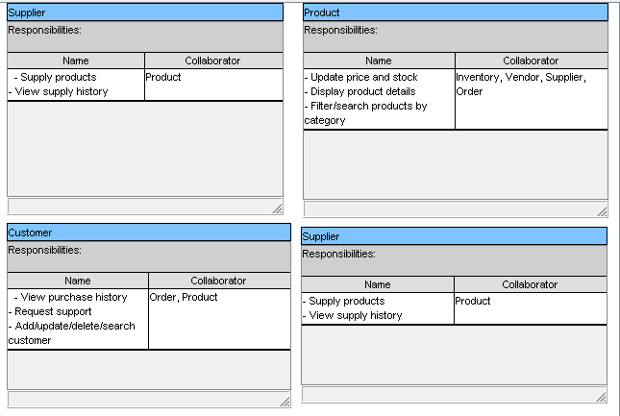

# Activity Diagram

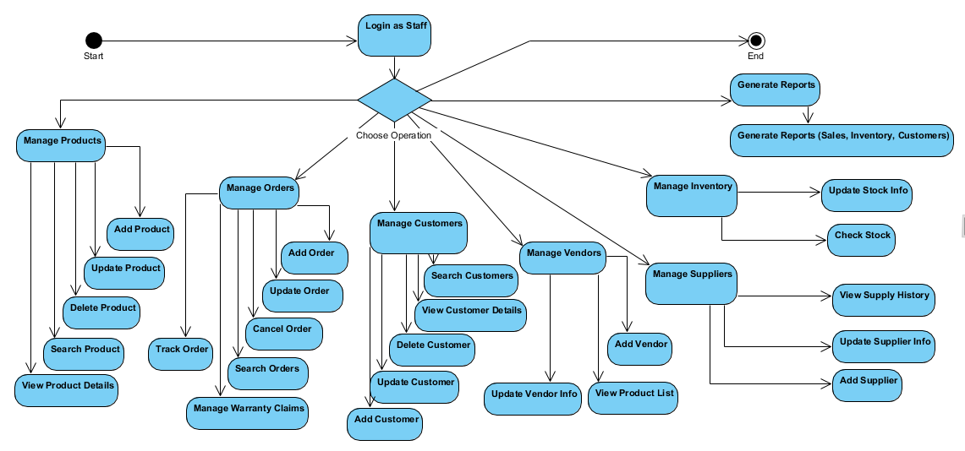

# High level Architecture :

