
NATIONAL UNIVERSITY OF MODERN LANGUAGES
Software Construction And Development Final Project

NAME: M Abdul Rafay (FL23791)
Zohaib Ijaz (FL23811)
Nazish Khan (FL23843)
Zainab Fatima (SP23690)

PROGRAM: BSSE (5th Semester)
COURSE: Software Construction and Development
SUBMITTED TO: Sir Ahsan Arif

DATE: 9/21/2025 DAY: Sunday

Hospital Appointment Booking System

1. Objective
The main objective of the Hospital Appointment Booking System is to create a digital solution that simplifies the process of booking appointments between patients and doctors. The system aims to replace manual methods with a faster and more organized platform. It helps reduce long waiting times, avoid scheduling mistakes, and keep appointment records accurate and up to date. Patients can easily book, view, or cancel appointments, while doctors and administrators can manage their schedules more effectively.
This project also aims to apply core software development practices such as requirement analysis, UML design, clean coding standards, exception handling, and unit testing. The goal is to build a reliable, user-friendly, and efficient system that supports real hospital workflows.

2. Introduction
Hospitals often face difficulties when appointments are booked manually. Long queues, busy phone lines, and misplaced records create delays and confusion for both patients and staff. As the number of patients increases, handling appointments without a proper system becomes even more difficult and time-consuming. To overcome these issues, a computerized appointment system is needed.
The Hospital Appointment Booking System is designed to automate and simplify the entire appointment process. Patients can register, log in, search for doctors by their specialization, and book appointments at a suitable time. Doctors can view their daily schedules and update their availability, and administrators can manage doctor profiles and time slots whenever needed.
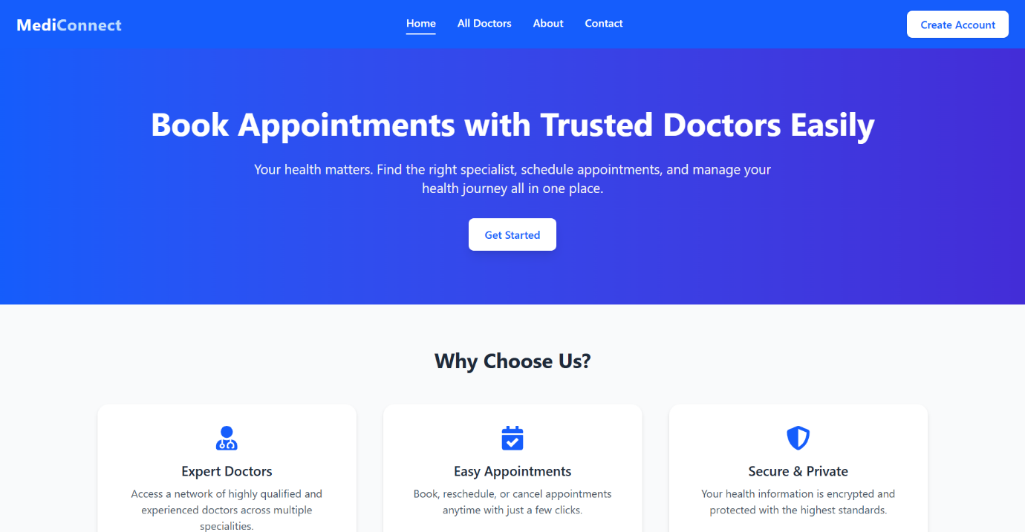
This system improves communication, reduces workload, and ensures that appointments are handled smoothly and accurately. By using proper software engineering techniques—such as UML diagrams, structured design.

3. Detailed Design

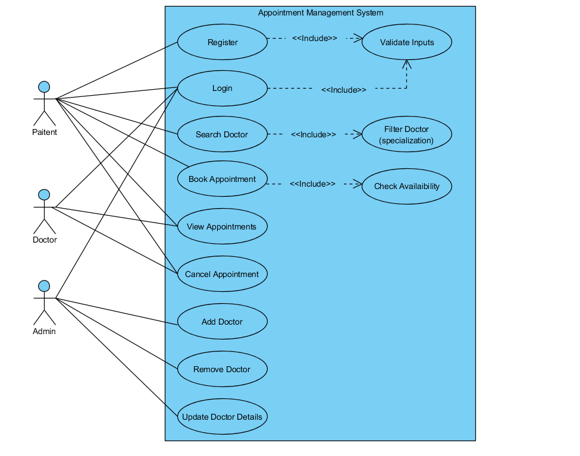
UseCase Diagram

