

NATIONAL UNIVERSITY OF MODERN LANGUAGES

Artificial Intelligence Lab Report No - 2

NAME: M Abdul Rafay
ROLL NO: FL23791
PROGRAM: BSSE (6th Semester)
COURSE: Artificial Intelligence
SUBMITTED TO: Mam Amna Sajjad

DATE: 22 Feb 2026 DAY: Sunday

Lab Tasks - Application of if-elif-else Statements
Lab Task 1: ATM Withdrawal Validation
Problem Context
A bank ATM system must validate withdrawal conditions before processing a transaction.
Task Description
The system asks the user to enter:
- Account balance
- Withdrawal amount
The program applies the following rules:
- If withdrawal amount > 25,000 → Display "Daily limit exceeded"
- If withdrawal amount > account balance → Display "Insufficient funds"
- If withdrawal amount ≤ account balance → Display "Transaction successful"
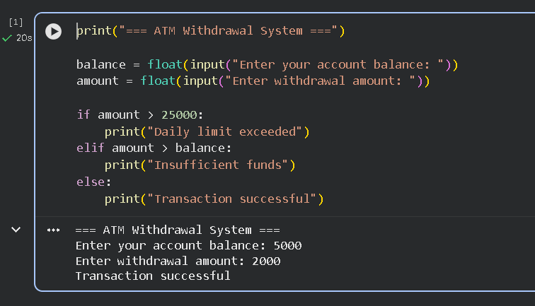
Code and Output

Lab Task 2: AI Chatbot Mood Detector
Problem Context
An AI chatbot detects the user's mood from text input and responds accordingly.
Task Description
The chatbot asks:
"How are you feeling today?"
Based on the input:
- If input contains "happy" → Great to hear!
- If input contains "sad" → I'm here for you.
- If input contains "tired" → Get some rest.
- Otherwise → Hope you have a nice day!
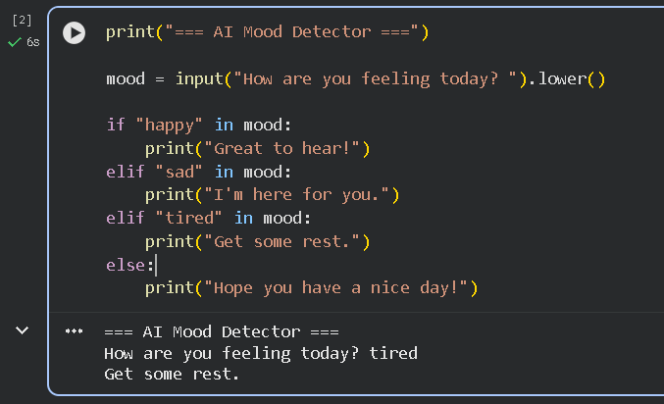
Code and Output

Lab Task 3: Smart Weather Advisor
Problem Context
A smart weather assistant provides advice based on temperature input.
Task Description
- If temperature > 35 → Stay hydrated & avoid sun
- If temperature between 20 and 35 → Pleasant weather
- If temperature < 20 → Wear warm clothes
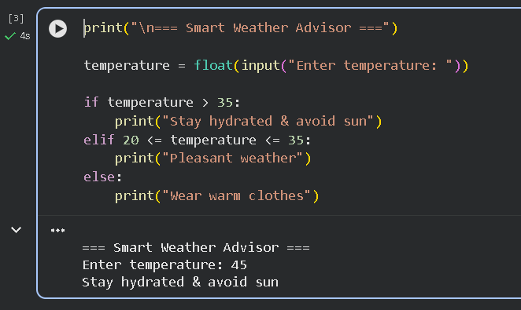
Code and Output

