

NATIONAL UNIVERSITY OF MODERN LANGUAGES

SOFTWARE QUALITY ENGINEERING PROJECT

NAME: M Abdul Rafay ( FL23791 )
Nazish Khan ( FL23843 )
M Ali Atif ( FL23824 )
PROGRAM: BSSE (6th Semester)
COURSE: SOFTWARE QUALITY ENGINEERING
SUBMITTED TO: Mam Rubab

DATE: 27 May 2026 DAY: Sunday

Contents
1. Project Introduction 1
2. System Scope and Features 1
Main Features 1
Main Users 1
3. Quality Attributes Report 1
4. Software Quality Plan 2
Quality Standards 2
Quality Activities 2
Testing Types 2
5. Software Quality Model Mapping 2
6. Software Metrics Report 2
Product Metrics 3
Defect Density 3
Cyclomatic Complexity 3
Process Metrics 3
7. Goal Question Metric (GQM) Model 3
8. Cost of Quality Analysis 4
9. Review and Inspection Checklist 4
Requirement Review 4
Design Review 4
Code Inspection 5
10. Software Testing Plan 5
Scope of Testing 5
Features Not to be Tested 5
Test Strategy 5
Entry and Exit Criteria 6
Risks and Mitigation 6
Requirement Traceability Matrix (RTM) 6
11. Manual Test Cases 6
Test Summary 10
12. Black-Box Testing Report 10
Function: calculateOrderTotal 10
Function: updateOrderStatus 11
13. White-Box Testing Report 11
Function: calculateOrderTotal 11
Function: updateOrderStatus 12
Branch Coverage Summary 14
Bugs Found Through White-Box Testing 14
Final Conclusion 14

List of Figures
Figure 1: Control Flow Diagram of Calculate total order 11
Figure 2: Control Flow Diagram of Update Order Status 13

1. Project Introduction
The Online Food Ordering System is a web-based application that allows users to order food from different restaurants. Customers can register, log in, browse restaurants, view menus, add items to the cart, place orders, make payments, and track order status.

The main purpose of this system is to provide an easy and efficient way for users to order food online. Restaurant admins can manage menus and orders, while system admins can control overall system operations.

This project focuses on applying Software Quality Engineering techniques to analyze, test, and improve the quality of the system.

2. System Scope and Features
The system includes all major functions from user registration to order delivery tracking.

Main Features
- User registration and login
- Restaurant listing
- Menu browsing
- Cart management
- Order placement
- Payment method selection
- Order tracking
- Admin management for restaurants, menus, and orders

Main Users
- Customer
- Restaurant Admin
- System Admin

3. Quality Attributes Report
The following quality attributes are required for this system:

Quality Attribute | Description
Correctness | System should give correct results for all operations
Reliability | System should run without failure
Usability | Easy to use for all types of users
Performance | Fast response during all operations
Security | User data and payment information must be protected
Maintainability | Easy to update and fix errors in the code
Scalability | System should handle increasing number of users
Availability | System should always be accessible to users

4. Software Quality Plan
Objective: To ensure the system meets all requirements with good quality and minimum errors.

Quality Standards
- Correct functionality
- Secure system operations
- Easy user interface
- Fast performance
- Reliable output

Quality Activities
- Requirement analysis and review
- System design review
- Code review
- Testing activities
- Documentation review

Testing Types
- Unit Testing
- Integration Testing
- System Testing
- Acceptance Testing

5. Software Quality Model Mapping
Using McCall's Quality Model:

Quality Factor | How It Applies to This System
Correctness | System calculates and processes orders correctly
Reliability | System performs without failure
Efficiency | Fast processing of all requests
Integrity | Data is protected from unauthorized access
Usability | Easy interface for all users
Maintainability | Code is easy to modify and update
Flexibility | New features can be added easily
Portability | System can run on different platforms and devices

6. Software Metrics Report

Product Metrics
Lines of Code (LOC): Represents the total size of the software.

Modules in System:

# | Module Name
1 | User Module
2 | Restaurant Module
3 | Menu Module
4 | Cart Module
5 | Order Module
6 | Admin Module

Total Modules: 6

Defect Density
Formula: Defect Density = Number of Defects / KLOC
Example: If 10 defects are found in 1000 lines of code, Defect Density = 10 defects per KLOC

Cyclomatic Complexity

Function | Cyclomatic Complexity | Meaning
calculateOrderTotal | 4 | 4 independent paths exist
updateOrderStatus | 5 | 5 independent paths exist

Process Metrics
- Number of test cases executed
- Number of test cases passed
- Number of test cases failed
- Number of defects found
- Number of defects fixed

7. Goal Question Metric (GQM) Model
Goal: Improve the quality and reliability of the Online Food Ordering System.

# | Question | Metric
Q1 | How many defects are found in the system? | Total number of defects found during testing
Q2 | How many test cases are successful? | Pass Rate = (Passed Test Cases / Total Test Cases) x 100
Q3 | How much time is required to fix defects? | Average defect fixing time
Q4 | Is the order calculation function working correctly? | Number of correct outputs compared to incorrect outputs

8. Cost of Quality Analysis
Cost of Quality includes all costs related to preventing, detecting, and fixing defects.

Category | Description | Examples
Prevention Cost | Cost to prevent defects before they occur | Training, planning, requirement analysis
Appraisal Cost | Cost of checking and testing the system | Testing, inspections, reviews
Internal Failure Cost | Cost of fixing defects before release | Debugging, rework
External Failure Cost | Cost of defects found after release | Customer complaints, system fixes

Conclusion: Investing in prevention and appraisal costs reduces failures. It is always cheaper to find and fix defects early.

9. Review and Inspection Checklist

Requirement Review

# | Check Item | Status
1 | Requirements are complete | Pass/Fail
2 | Requirements are clear | Pass/Fail
3 | Requirements are understandable | Pass/Fail
4 | Requirements are testable | Pass/Fail

Design Review

# | Check Item | Status
1 | System design is correct | Pass/Fail
2 | Database design is proper | Pass/Fail
3 | Security is considered | Pass/Fail
4 | Error handling is included | Pass/Fail

Code Inspection

# | Check Item | Status
1 | Code follows standards | Pass/Fail
2 | Code is readable | Pass/Fail
3 | Proper naming is used | Pass/Fail
4 | No major errors exist | Pass/Fail
5 | Comments are added in code | Pass/Fail

10. Software Testing Plan
Test Plan ID: TP-001
Project Name: Online Food Ordering System

Objective: To verify that all functions of the Online Food Ordering System work correctly according to the requirements and provide correct results to users.

Scope of Testing
- User registration and login
- Menu browsing and item selection
- Cart management
- Order placement and confirmation
- Payment method selection
- Order status tracking
- Order total calculation
- Order status update validation

Features Not to be Tested
- Database performance testing
- Network performance testing
- Third-party payment gateway internal operations
- Security penetration testing

Test Strategy
The following testing techniques will be used:
- Functional Testing
- Black-Box Testing (Equivalence Class Partitioning, Boundary Value Analysis)
- White-Box Testing (Path Coverage, Cyclomatic Complexity)
- Manual Testing

Entry and Exit Criteria

Criteria | Description
Entry | System requirements are approved, test environment is ready, code functions are available, test data is prepared
Exit | All planned test cases executed, critical defects fixed, test results documented, test summary completed

Risks and Mitigation

Risk | Mitigation
Requirement changes during testing | Review requirements regularly
Test environment failure | Maintain backup environment
Lack of test data | Prepare test data before testing
Limited testing time | Prioritize critical functionalities

Requirement Traceability Matrix (RTM)

Requirement ID | Description | Test Case ID
FR-01 | User Registration | TC-01
FR-02 | User Login | TC-02
FR-03 | Cart Management | TC-03
FR-04 | Order Placement | TC-04
FR-05 | Payment Selection | TC-05
FR-06 | Order Tracking | TC-06
FR-07 | Order Total Calculation | TC-07, TC-08, TC-09
FR-08 | Order Status Update | TC-10, TC-11, TC-12

11. Manual Test Cases

TC-01
Requirement ID | FR-01
Test Scenario | Register with valid user details
Test Steps | Enter name, email, and password and click Register
Test Data | Name: Rafay, Email: Rafay@gmail.com, Password: Rafay@123
Expected Result | Account should be created successfully
Actual Result | Account created successfully
Status | Pass

TC-02
Requirement ID | FR-02
Test Scenario | Login with correct credentials
Test Steps | Enter valid email and password and click Login
Test Data | Email: ali@gmail.com, Password: Ali@123
Expected Result | User should be logged in successfully
Actual Result | User logged in successfully
Status | Pass

TC-03
Requirement ID | FR-03
Test Scenario | Add item to cart
Test Steps | Select a food item and click Add to Cart
Test Data | Item: Burger, Price: Rs.500
Expected Result | Item should appear in the cart with correct price
Actual Result | Item added to cart correctly
Status | Pass

TC-04
Requirement ID | FR-04
Test Scenario | Place order with valid cart items
Test Steps | Add items to cart and click Place Order
Test Data | Cart with 2 items, total Rs.1000
Expected Result | Order should be placed and order ID generated
Actual Result | Order placed successfully
Status | Pass

TC-05
Requirement ID | FR-05
Test Scenario | Select payment method
Test Steps | Choose Cash on Delivery as payment method
Test Data | Payment Method: Cash on Delivery
Expected Result | Payment method should be saved successfully
Actual Result | Payment method saved
Status | Pass

TC-06
Requirement ID | FR-06
Test Scenario | Track order using order ID
Test Steps | Enter valid order ID in tracking section
Test Data | Order ID: ORD-1023
Expected Result | Current order status should be displayed
Actual Result | Order status displayed correctly
Status | Pass

TC-07
Requirement ID | FR-07
Test Scenario | Calculate order total with valid inputs, total above minimum
Test Steps | Call calculateOrderTotal with valid price, quantity, delivery and minimum order
Test Data | price=500, qty=2, delivery=50, minOrder=300
Expected Result | success: true, total=1000
Actual Result | success: true, total=1000
Status | Pass

TC-08
Requirement ID | FR-07
Test Scenario | Calculate order total when total is below minimum order
Test Steps | Call calculateOrderTotal with total below minimum order value
Test Data | price=100, qty=2, delivery=50, minOrder=300
Expected Result | success: true, total=250 (delivery charges added)
Actual Result | success: true, total=250
Status | Pass

TC-09
Requirement ID | FR-07
Test Scenario | Calculate order total with zero quantity
Test Steps | Call calculateOrderTotal with quantity set to zero
Test Data | price=200, qty=0, delivery=50, minOrder=300
Expected Result | success: false, message: Invalid quantity
Actual Result | success: false
Status | Pass

TC-10
Requirement ID | FR-08
Test Scenario | Update order status from pending to confirmed
Test Steps | Call updateOrderStatus with currentStatus=pending, newStatus=confirmed
Test Data | currentStatus: pending, newStatus: confirmed
Expected Result | Order confirmed successfully
Actual Result | Order confirmed successfully
Status | Pass

TC-11
Requirement ID | FR-08
Test Scenario | Update a cancelled order
Test Steps | Call updateOrderStatus with currentStatus set to cancelled
Test Data | currentStatus: cancelled, newStatus: confirmed
Expected Result | Cancelled order cannot be updated
Actual Result | Cancelled order cannot be updated
Status | Pass

TC-12
Requirement ID | FR-08
Test Scenario | Reverse transition from delivered back to pending
Test Steps | Call updateOrderStatus with currentStatus=delivered, newStatus=pending
Test Data | currentStatus: delivered, newStatus: pending
Expected Result | Transition should not be allowed
Actual Result | Order is pending (transition allowed - Bug)
Status | Fail

Test Summary

Category | Total Test Cases | Passed | Failed
System-Level (TC-01 to TC-06) | 6 | 6 | 0
calculateOrderTotal (TC-07 to TC-09) | 3 | 3 | 0
updateOrderStatus (TC-10 to TC-12) | 3 | 2 | 1
Total | 12 | 11 | 1

12. Black-Box Testing Report
Black-box testing tests the function based only on inputs and outputs without looking at internal code.
Techniques Used: Equivalence Class Partitioning and Boundary Value Analysis

Function: calculateOrderTotal

Equivalence Class Partitioning (ECP):

Equivalence Class | Condition | Type
EC1 | quantity <= 0 | Invalid
EC2 | quantity > 0 | Valid
EC3 | itemPrice <= 0 | Invalid
EC4 | itemPrice > 0 | Valid
EC5 | total < minimumOrder | Valid (delivery added)
EC6 | total >= minimumOrder | Valid (no delivery)

Boundary Value Analysis (BVA):

TC ID | Input Field | Test Value | Expected Result
TC-B1 | quantity | 0 | Invalid quantity
TC-B2 | quantity | 1 | Valid
TC-B3 | itemPrice | 0 | Invalid item price
TC-B4 | itemPrice | 1 | Valid
TC-B5 | total vs minOrder | total=299, min=300 | Delivery charges added
TC-B6 | total vs minOrder | total=300, min=300 | No delivery charges
TC-B7 | total vs minOrder | total=301, min=300 | No delivery charges

Function: updateOrderStatus

Decision Table:

currentStatus | newStatus | Expected Result
pending | confirmed | Order confirmed successfully
confirmed | delivered | Order delivered successfully
cancelled | anything | Cancelled order cannot be updated
delivered | pending | Should not be allowed (Bug found)
any | invalid value | Invalid order status

13. White-Box Testing Report
White-box testing looks inside the code and tests every path, branch, and condition.

Function: calculateOrderTotal
Control Flow:
START
-> Check quantity <= 0 -> YES -> return failure (Invalid quantity)
-> Check itemPrice <= 0 -> YES -> return failure (Invalid item price)
-> Calculate total = itemPrice x quantity
-> Check total < minimumOrder -> YES -> add delivery charges
-> return success with total
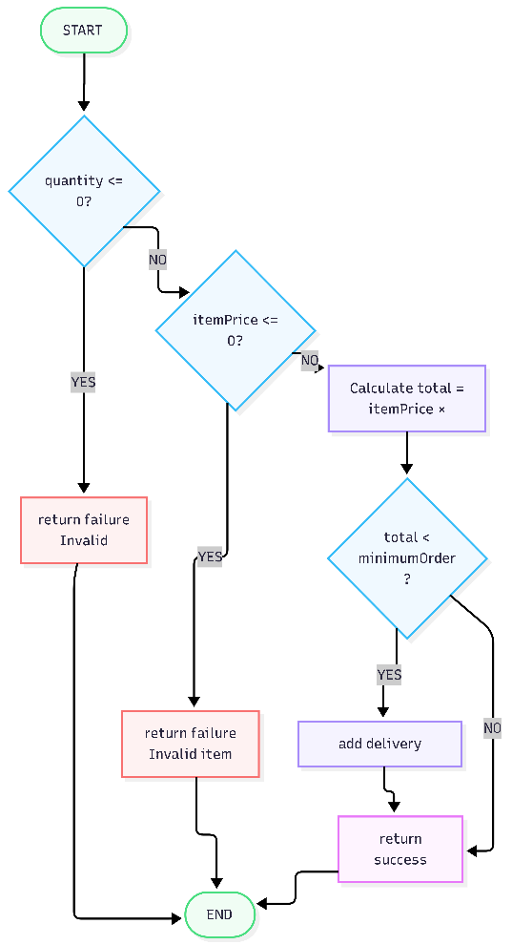
END
Figure 1: Control Flow Diagram of Calculate total order

Cyclomatic Complexity:
V(G) = Number of Decision Nodes + 1 = 3 + 1 = 4
Therefore, 4 independent paths are required for complete coverage.

Independent Paths:

Path | Description
Path 1 | quantity <= 0 -> return failure (Invalid quantity)
Path 2 | itemPrice <= 0 -> return failure (Invalid item price)
Path 3 | Valid inputs, total < minimum -> delivery charges added
Path 4 | Valid inputs, total >= minimum -> no delivery charges

Path Coverage Test Cases:

TC ID | qty | price | delivery | minOrder | Expected Result
PTC-01 | 2 | 500 | 50 | 300 | success: true, total=1000 (Path 4)
PTC-02 | 2 | 100 | 50 | 300 | success: true, total=250 (Path 3)
PTC-03 | 0 | 200 | 50 | 300 | success: false, Invalid quantity (Path 1)
PTC-04 | 2 | 0 | 50 | 300 | success: false, Invalid item price (Path 2)

Function: updateOrderStatus

Control Flow:
START
-> Check currentStatus === cancelled -> YES -> return message
-> Check newStatus === pending -> YES -> return message
-> Check newStatus === confirmed -> YES -> return message
-> Check newStatus === delivered -> YES -> return message
-> return Invalid order status
End
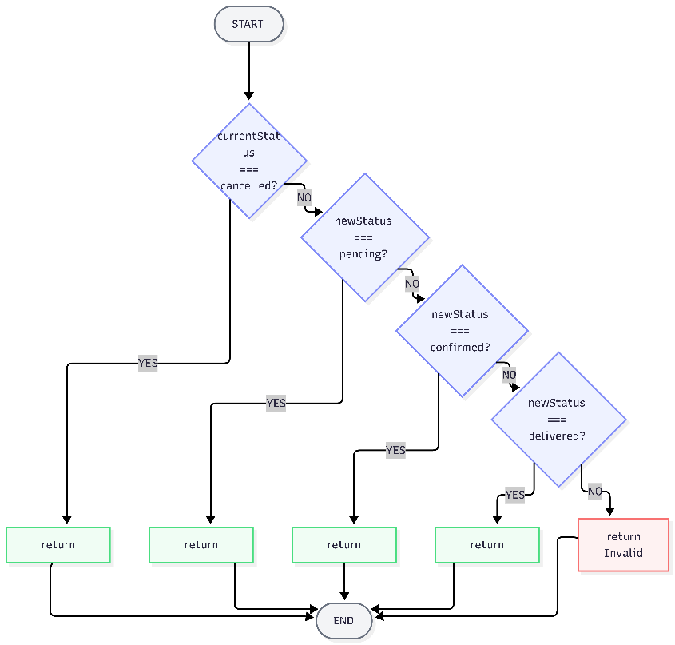
Figure 2: Control Flow Diagram of Update Order Status

Cyclomatic Complexity:
V(G) = Number of Decision Nodes + 1 = 4 + 1 = 5
Therefore, 5 independent paths are required for complete coverage.

Independent Paths:

Path | Description
Path 1 | currentStatus = cancelled == cannot update
Path 2 | newStatus = pending == order is pending
Path 3 | newStatus = confirmed == order confirmed successfully
Path 4 | newStatus = delivered == order delivered successfully
Path 5 | None match == invalid order status

Path Coverage Test Cases:

TC ID | currentStatus | newStatus | Expected Result
PTC-01 | pending | confirmed | Order confirmed successfully (Path 3)
PTC-02 | confirmed | delivered | Order delivered successfully (Path 4)
PTC-03 | cancelled | confirmed | Cancelled order cannot be updated (Path 1)
PTC-04 | confirmed | pending | Order is pending (Path 2)
PTC-05 | confirmed | cooking | Invalid order status (Path 5)

Branch Coverage Summary

Function | Total Branches | Branches Covered | Coverage %
calculateOrderTotal | 4 | 4 | 100%
updateOrderStatus | 5 | 5 | 100%

Statement Coverage: 100%. All statements in both functions are executed by the test cases.

Bugs Found Through White-Box Testing

# | Bug | Location | Severity
1 | No null check for inputs | Both functions | High
2 | Reverse transition not blocked (delivered to pending allowed) | updateOrderStatus | High
3 | Negative delivery charges not rejected | calculateOrderTotal | Medium
4 | No comments or documentation in code | Both functions | Low
5 | Missing statuses: preparing, out for delivery | updateOrderStatus | Medium

Final Conclusion
This project applied Software Quality Engineering techniques to the Online Food Ordering System. The system was analyzed and tested using black-box testing, white-box testing, and manual testing methods.

A total of 12 manual test cases were executed. 11 passed and 1 failed. The failed test case revealed a real bug in the code where a delivered order can incorrectly go back to pending status.

Other bugs found include: negative delivery charges are not rejected, null inputs are not handled properly, and some order statuses like preparing are missing from the update function.

Software quality practices helped in identifying these errors early, which reduces the cost and effort of fixing them later. Overall, the system works correctly for most cases but requires improvements in input validation and status transition logic.

