
NATIONAL UNIVERSITY OF MODERN LANGUAGES
Web Engineering Assignment NO 2

NAME: M Abdul Rafay (FL23791)
Ali Atif (FL23824)
Zohaib Ijaz (FL23811)
Nazish Khan (FL23843)

ROLL NO: FL23791
PROGRAM: BSSE (5th Semester)
COURSE: Web Engineering
SUBMITTED TO: Mam Faryal

DATE: 30 Nov 2025 DAY: Sunday

Assignment No 2
Scenario:
A leading online retail company has approached you to develop an interactive e-commerce website that is both visually appealing and user-friendly. Your primary objective is to implement CSS positioning techniques to create a well-structured and responsive layout. Additionally, the company wants a scrollable product gallery, allowing customers to browse multiple items effortlessly.
Technical Requirements: To complete this project successfully, you need to apply CSS positioning principles to meet the following implementation goals:
- Sticky Header: Keep the navigation bar fixed at the top while scrolling.
- Absolute Positioned Product Labels: Overlay “Sale” or “New Arrival” badges on product images.
- Fixed Chat Support Button: Ensure a floating customer support button stays visible in the viewport.
- Relative Positioning for Product Cards: Use relative positioning for precise element placement within product containers.
- Drop-down Menu for Categories: Create a dynamic menu that appears when users hover over a category section.
- Scrollable Content: Design a scrollable product gallery to enhance browsing experience.
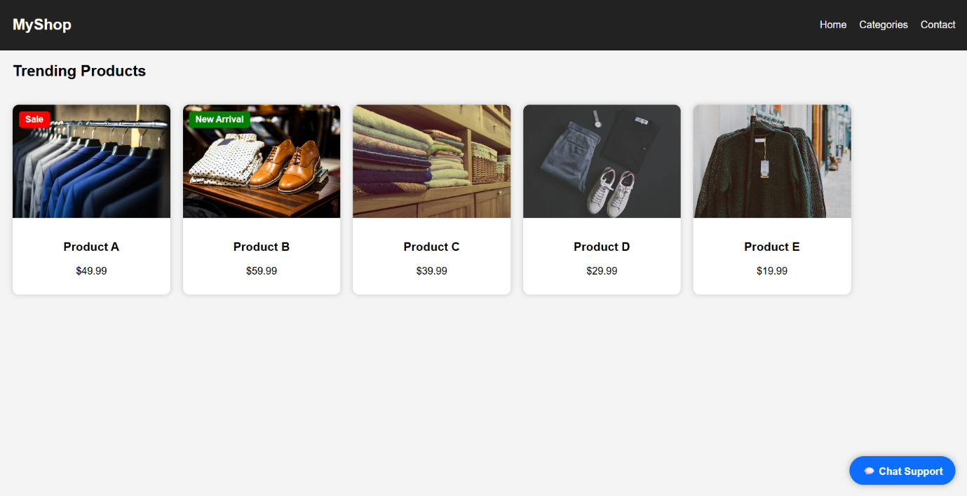
Output :

Code:
<!DOCTYPE html>
<html lang="en">
<head>
<meta charset="UTF-8">
<title>E-Commerce Layout</title>
<style>
body {
margin: 0;
font-family: Arial, sans-serif;
background: #f4f4f4;
}

.header {
position: sticky;
top: 0;
background: #222;
color: #fff;
padding: 15px 20px;
display: flex;
justify-content: space-between;
align-items: center;
z-index: 1000;
}

.header h2 {
margin: 0;
}

.nav {
position: relative;
}

.nav ul {
list-style: none;
display: flex;
gap: 20px;
}

.nav ul li {
position: relative;
cursor: pointer;
}

.dropdown {
display: none;
position: absolute;
top: 30px;
left: 0;
background: white;
color: black;
min-width: 120px;
box-shadow: 0 0 10px rgba(0,0,0,0.2);
}

.dropdown p {
padding: 10px;
margin: 0;
cursor: pointer;
}

.dropdown p:hover {
background: #eee;
}

.nav ul li:hover .dropdown {
display: block;
}

.product-gallery {
display: flex;
overflow-x: auto;
gap: 20px;
padding: 20px;
scroll-behavior: smooth;
}

.product-gallery::-webkit-scrollbar {
height: 8px;
}

.product-gallery::-webkit-scrollbar-thumb {
background: #777;
border-radius: 4px;
}

.product-card {
width: 250px;
background: white;
border-radius: 10px;
overflow: hidden;
box-shadow: 0 0 8px rgba(0,0,0,0.2);
position: relative;
}

.product-card img {
width: 100%;
height: 180px;
object-fit: cover;
}

.label {
position: absolute;
top: 10px;
left: 10px;
background: red;
color: white;
padding: 5px 10px;
border-radius: 5px;
font-size: 14px;
font-weight: bold;
}

.label.new {
background: green;
}

.product-info {
padding: 12px;
text-align: center;
}

.chat-support {
position: fixed;
bottom: 20px;
right: 20px;
background: #0d6efd;
color: white;
padding: 12px 20px;
border-radius: 50px;
cursor: pointer;
font-weight: bold;
box-shadow: 0 0 10px rgba(0,0,0,0.3);
}
</style>
</head>

<body>

<div class="header">
<h2>MyShop</h2>
<div class="nav">
<ul>
<li>Home</li>
<li>Categories
<div class="dropdown">
<p>Electronics</p>
<p>Fashion</p>
<p>Groceries</p>
</div>
</li>
<li>Contact</li>
</ul>
</div>
</div>

<h2 style="padding-left:20px;">Trending Products</h2>

<div class="product-gallery">

<div class="product-card">
<span class="label">Sale</span>
<img src="https://images.pexels.com/photos/325876/pexels-photo-325876.jpeg?auto=compress&cs=tinysrgb&w=1260&h=750&dpr=2">
<div class="product-info">
<h3>Product A</h3>
<p>$49.99</p>
</div>
</div>

<div class="product-card">
<span class="label new">New Arrival</span>
<img src="https://images.pexels.com/photos/298863/pexels-photo-298863.jpeg?cs=srgb&dl=pexels-solliefoto-298863.jpg&fm=jpg">
<div class="product-info">
<h3>Product B</h3>
<p>$59.99</p>
</div>
</div>

<div class="product-card">
<img src="https://images.pexels.com/photos/271711/pexels-photo-271711.jpeg?auto=compress&cs=tinysrgb&w=600">
<div class="product-info">
<h3>Product C</h3>
<p>$39.99</p>
</div>
</div>

<div class="product-card">
<img src="https://images.pexels.com/photos/1670770/pexels-photo-1670770.jpeg?auto=compress&cs=tinysrgb&w=600">
<div class="product-info">
<h3>Product D</h3>
<p>$29.99</p>
</div>
</div>

<div class="product-card">
<img src="https://images.pexels.com/photos/3353621/pexels-photo-3353621.jpeg?auto=compress&cs=tinysrgb&w=600">
<div class="product-info">
<h3>Product E</h3>
<p>$19.99</p>
</div>
</div>

</div>

<div class="chat-support">💬 Chat Support</div>

</body>
</html>

