
NATIONAL UNIVERSITY OF MODERN LANGUAGES
Human Computer Interaction lab Report – 11

NAME: Abdul Rafay
ROLL NO: FL23791
PROGRAM: BSSE (5th Semester)
COURSE: HUMAN COMPUTER INTERACTION
SUBMITTED TO: Sir Khateeb khan

DATE: 30 Sep 2025 DAY: Tuesday

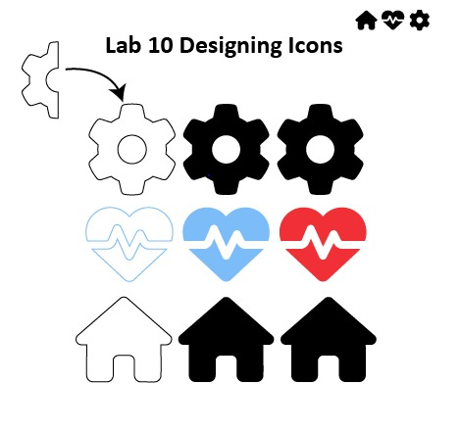
Understand How to Design Proper Icons

