
NATIONAL UNIVERSITY OF MODERN LANGUAGES
Web Engineering Mid Exam OEL

NAME: M Abdul Rafay khan
ROLL NO: FL23791
PROGRAM: BSSE (5th Semester)
COURSE: Web Engineering
SUBMITTED TO: Mam Mehr u Nisa

DATE: 20, oct 2025 DAY: Monday

Question : Create a Web from given
Output:
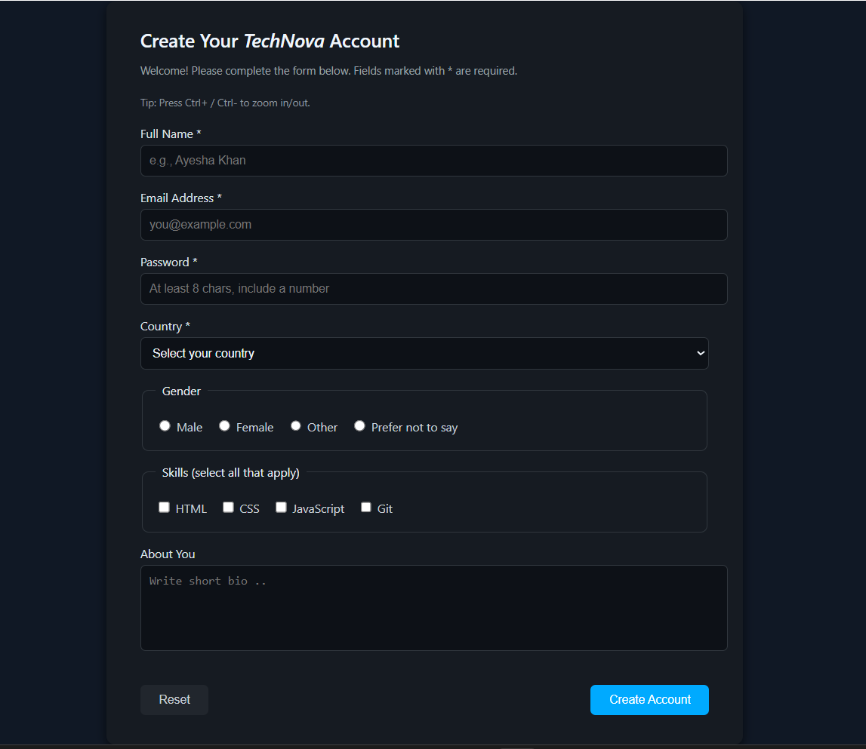

Html Code :
<!DOCTYPE html>
<html lang="en">
<head>
<meta charset="UTF-8">
<meta name="viewport" content="width=device-width, initial-scale=1.0">
<title>Create Your TechNova Account</title>
<link rel="stylesheet" href="style.css">
</head>
<body>
<form class="form-container">
<h2>Create Your <span>TechNova</span> Account</h2>
<p>Welcome! Please complete the form below. Fields marked with * are required.</p>
<p style="font-size:12px; color:#8b949e;">Tip: Press Ctrl+ / Ctrl- to zoom in/out.</p>
<label for="fullname">Full Name *</label>
<input type="text" id="fullname" name="fullname" placeholder="e.g., Ayesha Khan" required>
<label for="email">Email Address *</label>
<input type="email" id="email" name="email" placeholder="you@example.com" required
<label for="password">Password *</label>
<input type="password" id="password" name="password" placeholder="At least 8 chars, include a number" required>
<label for="country">Country *</label>
<select id="country" name="country" required>
<option value="">Select your country</option>
<option>Pakistan</option>
<option>India</option>
<option>United States</option>
<option>United Kingdom</option>
<option>Canada</option>
</select>
<fieldset>
<legend>Gender</legend>
<div class="gender-options">
<label><input type="radio" name="gender" value="male"> Male</label>
<label><input type="radio" name="gender" value="female"> Female</label>
<label><input type="radio" name="gender" value="other"> Other</label>
<label><input type="radio" name="gender" value="prefer"> Prefer not to say</label>
</div>
</fieldset>
<fieldset>
<legend>Skills (select all that apply)</legend>
<div class="skills-options">
<label><input type="checkbox" name="skills" value="html"> HTML</label>
<label><input type="checkbox" name="skills" value="css"> CSS</label>
<label><input type="checkbox" name="skills" value="js"> JavaScript</label>
<label><input type="checkbox" name="skills" value="git"> Git</label>
</div>
</fieldset>
<label for="about">About You</label>
<textarea id="about" name="about" placeholder="Write short bio .."></textarea>
<div class="btn-group">
<button type="reset" class="btn btn-reset">Reset</button>
<button type="submit" class="btn btn-create">Create Account</button>
</div>
</form>
</body>
</html>
Css code :
body {
margin: 0;
padding: 0;
background-color: #101825;
color: #e6edf3;
font-family: "Segoe UI", Arial, sans-serif;
display: flex;
justify-content: center;
align-items: flex-start;
min-height: 100vh;
}
.form-container {
background-color: #161b22;
margin-top: 40px;
width: 670px;
border-radius: 10px;
padding: 30px 40px 35px;
box-shadow: 0 4px 12px rgba(0,0,0,0.6);
}
.form-container h2 {
font-weight: 600;
margin: 0 0 5px;
font-size: 22px;
color: #f0f6fc;
}
.form-container h2 span {
font-style: italic;
}
.form-container p {
font-size: 13px;
color: #9ba1a6;
margin-bottom: 20px;
}

label {
display: block;
font-size: 14px;
margin-bottom: 4px;
color: #dce1e6;
}
input[type="text"],
input[type="email"],
input[type="password"],
select,
textarea {
width: 100%;
padding: 10px;
border-radius: 6px;
border: 1px solid #30363d;
background-color: #0d1117;
color: #f0f6fc;
font-size: 14px;
margin-bottom: 15px;
outline: none;
transition: border-color 0.2s, background-color 0.2s;
}
textarea {
height: 80px;
resize: none;
}

fieldset {
border: 1px solid #30363d;
border-radius: 8px;
padding: 15px;
margin-bottom: 15px;
}
legend {
font-size: 14px;
color: #e6edf3;
padding: 0 8px;
}
.gender-options,
.skills-options {
display: flex;
gap: 15px;
margin-top: 8px;
}
.gender-options label,
.skills-options label {
font-size: 14px;
cursor: pointer;
color: #c9d1d9;
}
input[type="radio"],
input[type="checkbox"] {
accent-color: #00aaff;
cursor: pointer;
}
.btn-group {
display: flex;
justify-content: space-between;
margin-top: 20px;
}
.btn {
padding: 10px 22px;
border-radius: 6px;
border: none;
font-size: 14px;
font-weight: 500;
cursor: pointer;
transition: 0.25s ease-in-out;
}
.btn-reset {
background-color: #21262d;
color: #c9d1d9;
}
/* Create Button */
.btn-create {
background-color: #00aaff;
color: #ffffff;
}

