
NATIONAL UNIVERSITY OF MODERN LANGUAGES
Computer Networks Lab Project

NAME: M Abdul Rafay (FL23791)
Nazish Khan (FL23843)
Zohaib Ijaz (FL23811)
Ali Atif (FL23824)

PROGRAM: BSSE (5th Semester)
COURSE: Computer Networks
SUBMITTED TO: Mam Anam Taskeen

DATE: 9/27/2025 DAY: Saturday

Contents
Enterprise-Level Network Design and Implementation Using Cisco Packet Tracer 3
1. Introduction 3
2. Project Objectives 3
3. Network Topology Overview 3
4. LAN Configuration 4
4.1 VLAN Design 4
4.2 Switch Configuration 5
4.3 Inter-VLAN Routing 5
5. WAN Configuration 6
5.1 Router Deployment 6
5.2 PPP Encapsulation 6
5.3 Dynamic Routing (RIP v2) 6
6. Network Services 7
6.1 DHCP Server 7
6.2 DNS Server 8
6.3 Web Servers 8
7. Network Testing and Verification 9
7.1 LAN Testing 9
7.2 WAN Testing 9
8. Challenges Faced 9
9. Conclusion 9

Enterprise-Level Network Design and Implementation Using Cisco Packet Tracer

1. Introduction
In today’s global environment, computer networks form the backbone of communication and data sharing between geographically distributed locations. Organizations rely on enterprise-level networks to ensure secure, reliable, and scalable connectivity between multiple sites. These networks integrate Local Area Networks (LANs) with Wide Area Networks (WANs) using routing protocols and network services.
This project focuses on designing and implementing an enterprise-level network infrastructure that connects multiple independent networks (Islamabad, Lahore, and Karachi) using Cisco Packet Tracer. The network integrates VLANs, routing, DHCP, DNS, and WAN technologies such as PPP and RIP version 2.

2. Project Objectives
The main objectives of this project are:
- To design a multi-site enterprise network.
- To implement VLANs for logical network segmentation.
- To configure inter-VLAN routing using router-on-a-stick.
- To deploy WAN connectivity using serial links and PPP encapsulation.
- To implement RIP version 2 for dynamic routing.
- To configure DHCP, DNS, and Web servers.
- To test network functionality using ping, tracert, and DNS resolution.

3. Network Topology Overview
The enterprise network consists of three main sites:
- Islamabad Site
- Lahore Site
- Karachi Site
Each site includes:
- One router
- Multiple switches
- Three VLANs
- Six PCs per site
- Servers for network services
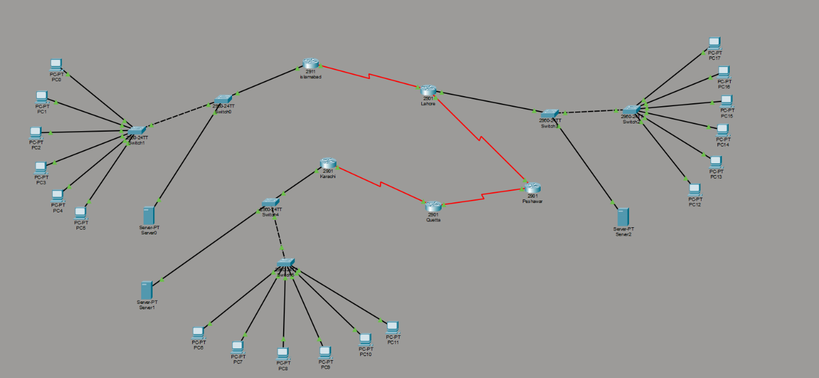
The sites are interconnected through a WAN using serial links between routers.

4. LAN Configuration

4.1 VLAN Design
Each site uses three VLANs to separate network traffic:
VLAN ID | VLAN Name | Purpose
10 | Admin | Administrative users
20 | Staff | Faculty and staff
30 | Students | Student users
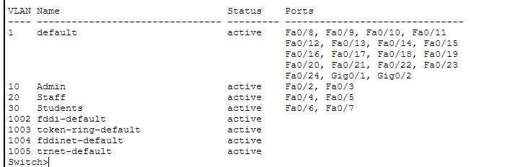
This design improves security, performance, and traffic management.

4.2 Switch Configuration
- Access ports are assigned to specific VLANs.
- Trunk ports are configured using 802.1Q encapsulation.
- Trunks allow VLANs 10, 20, and 30.
- Spanning Tree Protocol (STP) is enabled to prevent loops.
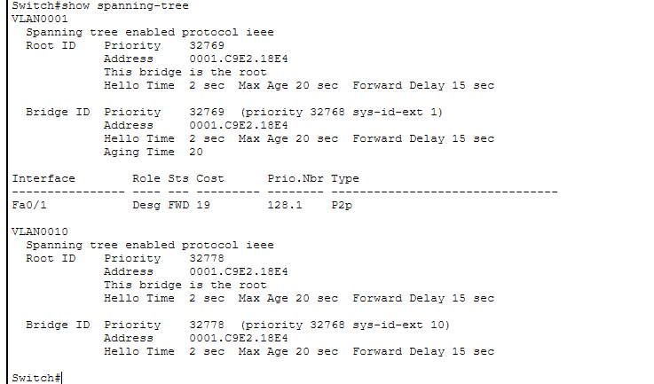
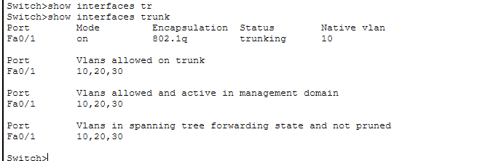

4.3 Inter-VLAN Routing
Inter-VLAN routing is implemented using Router-on-a-Stick:
- Sub-interfaces created on router interface G0/0
- Each sub-interface uses encapsulation dot1Q
- Default gateways are configured per VLAN
Example:
- VLAN 10 → 192.168.10.1
- VLAN 20 → 192.168.20.1
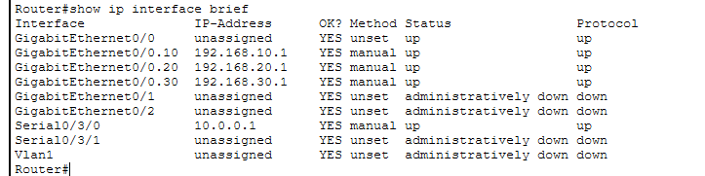
- VLAN 30 → 192.168.30.1

5. WAN Configuration

5.1 Router Deployment
A total of five routers are used (city-wise naming):
- Islamabad Router
- Lahore Router
- Karachi Router
- (Additional routers for WAN backbone)
Each router connects to:
- LAN via Fast/Gigabit Ethernet
- WAN via Serial interfaces

5.2 PPP Encapsulation
PPP encapsulation is configured on all serial links to ensure reliable point-to-point communication.

5.3 Dynamic Routing (RIP v2)
Routing Information Protocol version 2 (RIP v2) is used to enable automatic route exchange between routers.
Features:
- Supports VLSM
- Classless routing
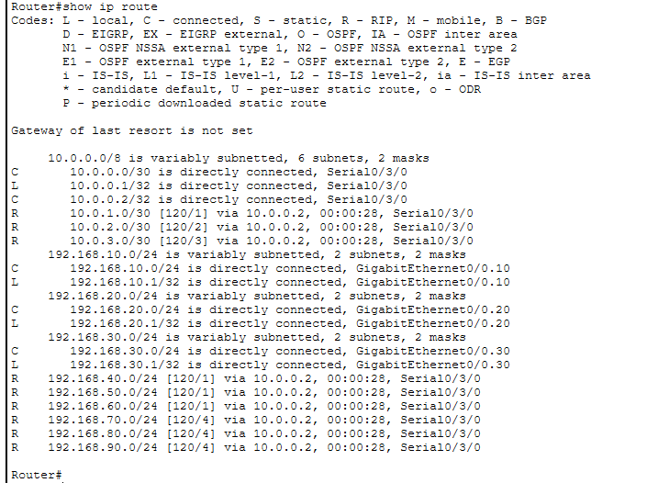
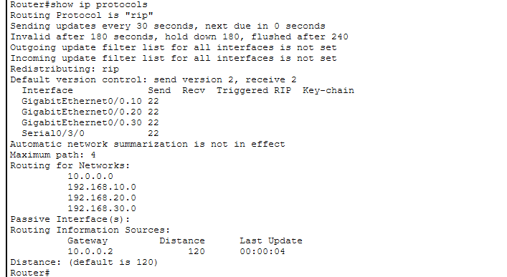
- Easy to configure

6. Network Services

6.1 DHCP Server
- DHCP is configured to automatically assign IP addresses.
- Separate pools are created for each VLAN.
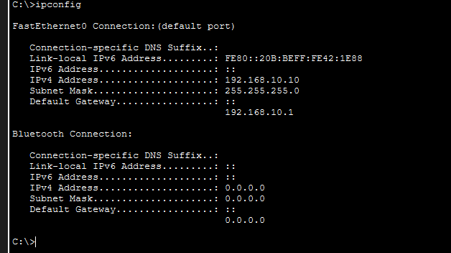
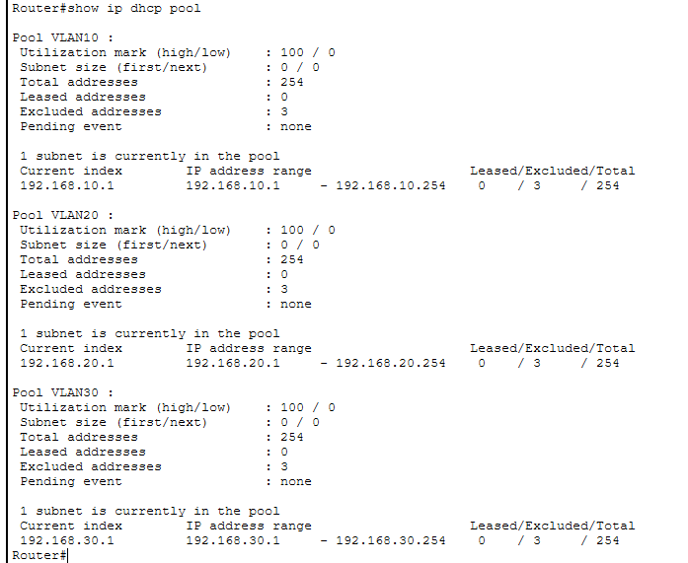
- PCs receive IP address, subnet mask, and default gateway dynamically.

6.2 DNS Server
- DNS server resolves device names to IP addresses.
- Routers and servers are named city-wise.
- Enables hostname-based communication.

6.3 Web Servers
- Two web servers are deployed.
- HTTP service is enabled.
- PCs can access web pages via browser.

7. Network Testing and Verification
To verify correct functionality, the following tests were performed:

7.1 LAN Testing
- Ping between PCs in the same VLAN
- Ping between different VLANs

7.2 WAN Testing
- Ping between PCs of different cities
- Traceroute to verify packet path

8. Challenges Faced
- Native VLAN mismatch on trunk ports
- Initial inter-VLAN communication failure
- Incorrect access and trunk port configuration
These issues were resolved by:
- Correct VLAN assignments
- Matching native VLANs
- Proper router sub-interface configuration

9. Conclusion
This project successfully demonstrates the design and implementation of an enterprise-level computer network. The network integrates LAN and WAN technologies, VLAN segmentation, dynamic routing, and essential network services. All project objectives were achieved, and successful communication between different sites was verified through extensive testing.
The project enhanced practical understanding of real-world networking concepts and their implementation using Cisco Packet Tracer.

