
NATIONAL UNIVERSITY OF MODERN LANGUAGES
Web Engineering Project Report

NAME: M Abdul Rafay (FL23791)
Nazish Khan (FL23843)
Zohaib Ijaz (FL23811)
Ali Atif (FL23824)

PROGRAM: BSSE (5th Semester)
COURSE: Computer Networks
SUBMITTED TO: Mam Faryal

DATE: 9/27/2025 DAY: Saturday

Contents
Doctor Appointment Booking System 3
Abstract 3
1. Introduction 3
2. Objectives 4
3. Problem Statement 4
4. Scope of the Project 4
5. Technology Stack 4
6. System Architecture 5
7. Use Case Diagram 5
8. Database Design Schema (ERD) 6
9. Functional Requirements 7
10. Non-Functional Requirement 7
11. API Design 7
12. Code Structure 8
14. Security Measures 8
15. User Interface Overview 8
17. Conclusion 12
19. Project Repository 12
https://github.com/git-rafaykhan/doctor-oppointment-booking.git 12

Doctor Appointment Booking System

Abstract
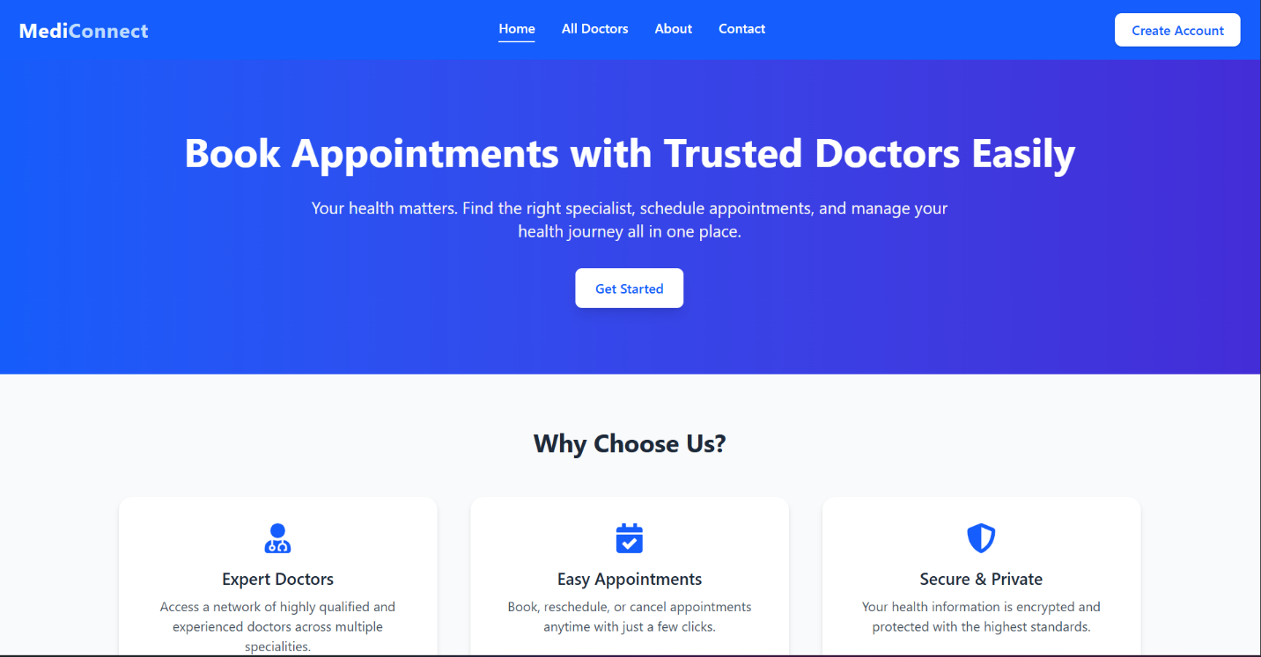
The Doctor Appointment Booking System is a full-stack web application designed to digitalize and automate the process of booking medical appointments. The system allows patients to view available doctors, select suitable time slots, book or cancel appointments, and manage their booking history. Administrators can manage doctors, schedules, and appointments through a centralized interface. This project demonstrates the application of modern web engineering principles, including client-server architecture, RESTful APIs, database design, authentication, and secure data handling.

- Figure 1: Home Page of the Doctor Appointment Booking System

1. Introduction
In traditional healthcare environments, appointment booking is often handled manually, leading to inefficiencies such as long waiting times, scheduling conflicts, and data management issues. This project aims to address these problems by providing a web-based solution that simplifies appointment scheduling for both patients and administrators.

2. Objectives
- To develop a secure and user-friendly doctor appointment booking platform
- To allow patients to book, view, and cancel appointments online
- To enable administrators to manage doctors and appointment schedules
- To apply core web engineering concepts in a real-world project

3. Problem Statement
Manual appointment booking systems are time-consuming, error-prone, and inefficient. Patients must physically visit or call clinics, while administrators struggle with record management. The Doctor Appointment Booking System provides an online solution to streamline scheduling, improve accessibility, and reduce operational overhead.

4. Scope of the Project
The scope of this project includes:
- User registration and authentication
- Doctor listing and specialization management
- Appointment booking and cancellation
- Admin panel for doctor and appointment management
- Secure data storage and retrieval

5. Technology Stack
Layer | Technology
Frontend | React.js
Backend | Node.js, Express.js
Database | Postgres
Authentication | JSON Web Tokens (JWT)
Version Control | Git and GitHub

6. System Architecture
The application follows a client-server architecture. The frontend communicates with the backend using RESTful APIs. The backend handles business logic, authentication, and database operations, while MongoDB is used for persistent data storage.

7. Use Case Diagram
The system involves three main actors:
- Patient
- Doctor
- Administrator
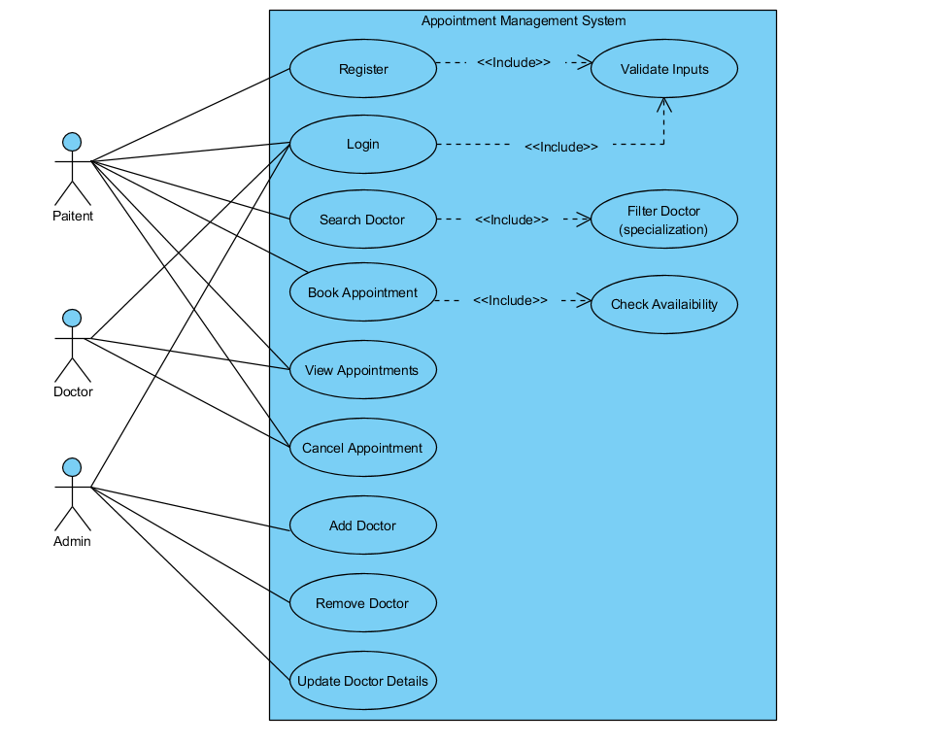
Patients can register, log in, view doctors, book appointments, and cancel appointments. Administrators can add doctors, manage schedules, and view all appointments.

8. Database Design Schema (ERD)
The database consists of the following main entities:
- User
- Doctor
- Appointment
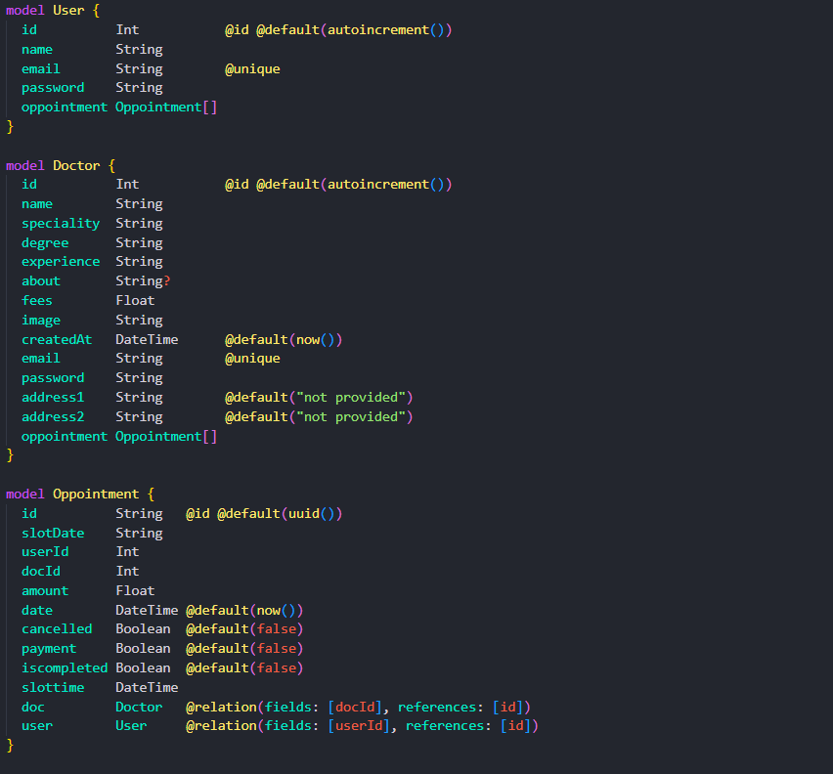
Each appointment links a patient with a doctor and a specific time slot.

9. Functional Requirements
- Users must be able to register and log in
- Users must be able to view available doctors
- Users must be able to book and cancel appointments
- Admin must be able to add and manage doctors
- Admin must be able to view all appointments

10. Non-Functional Requirement
- The system must be secure and protect user data
- The application should be responsive and user-friendly
- The system should provide fast response times
- The application should be scalable

11. API Design
Authentication APIs
- POST /api/v1/auth/register
- POST /api/v1/auth/login
Doctor APIs
- GET /api/v1/doctors
- POST /api/v1/doctors (Admin only)
Appointment APIs
- POST /api/v1/appointments
- GET /api/v1/appointments
- DELETE /api/v1/appointments/:id

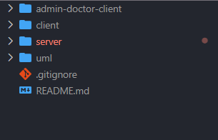
12. Code Structure

14. Security Measures
- JWT-based authentication
- Protected API routes
- Input validation
- Secure password storage

15. User Interface Overview
The user interface consists of the following screens:
- Login and Registration
- Doctor Listing
- Appointment Booking
- Appointment History
- Admin Dashboard
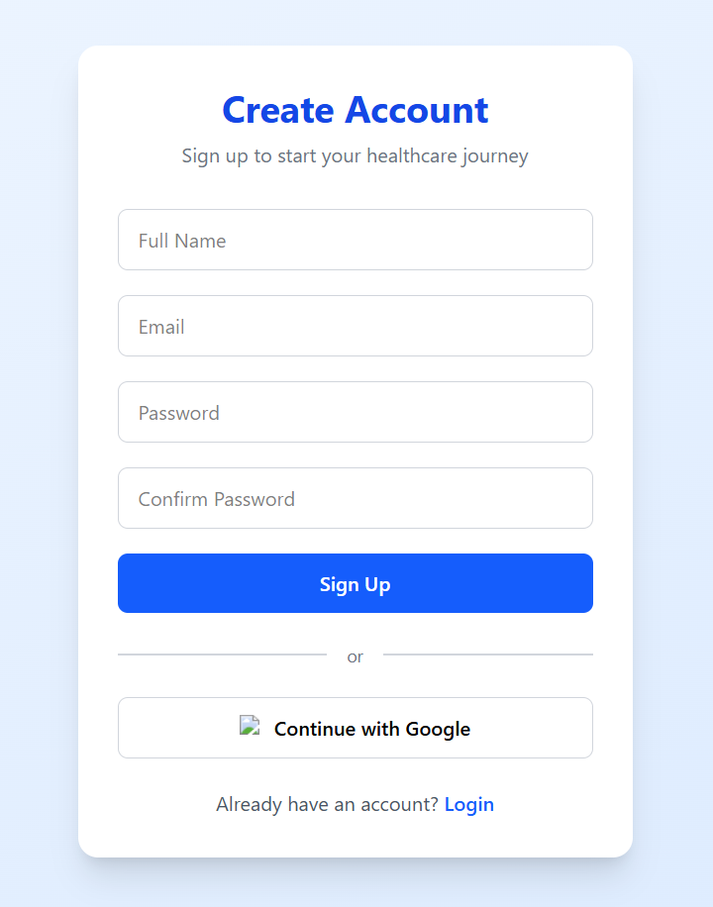
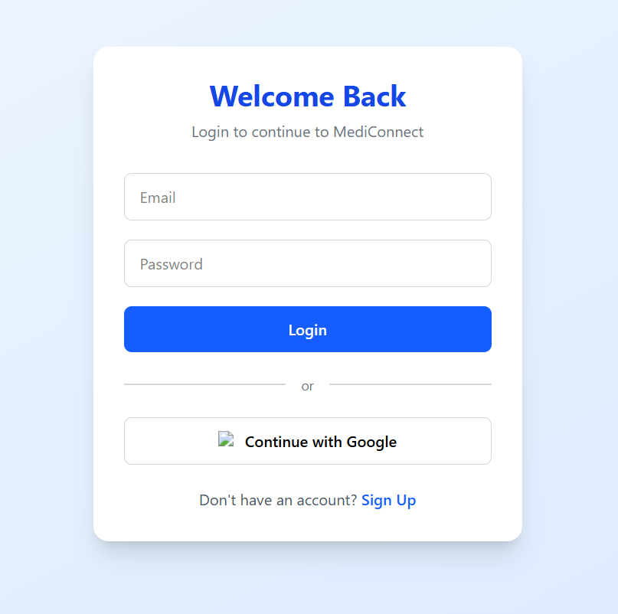

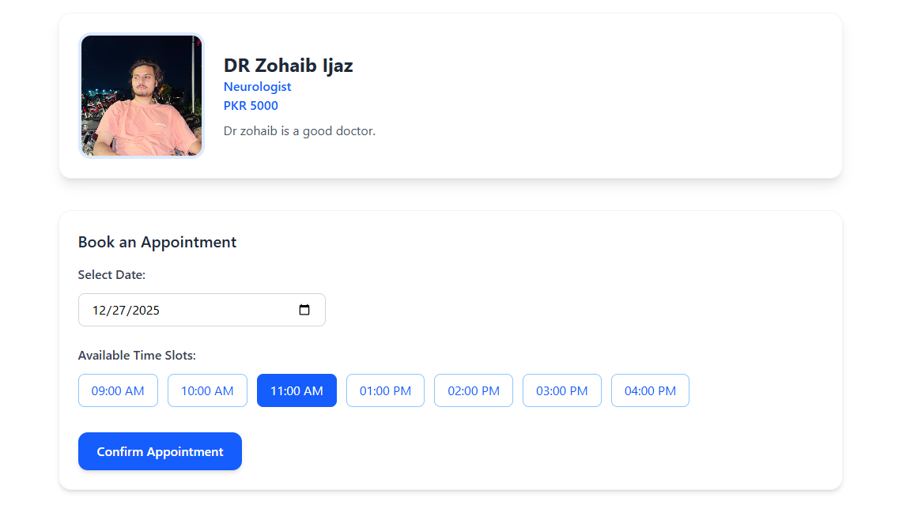
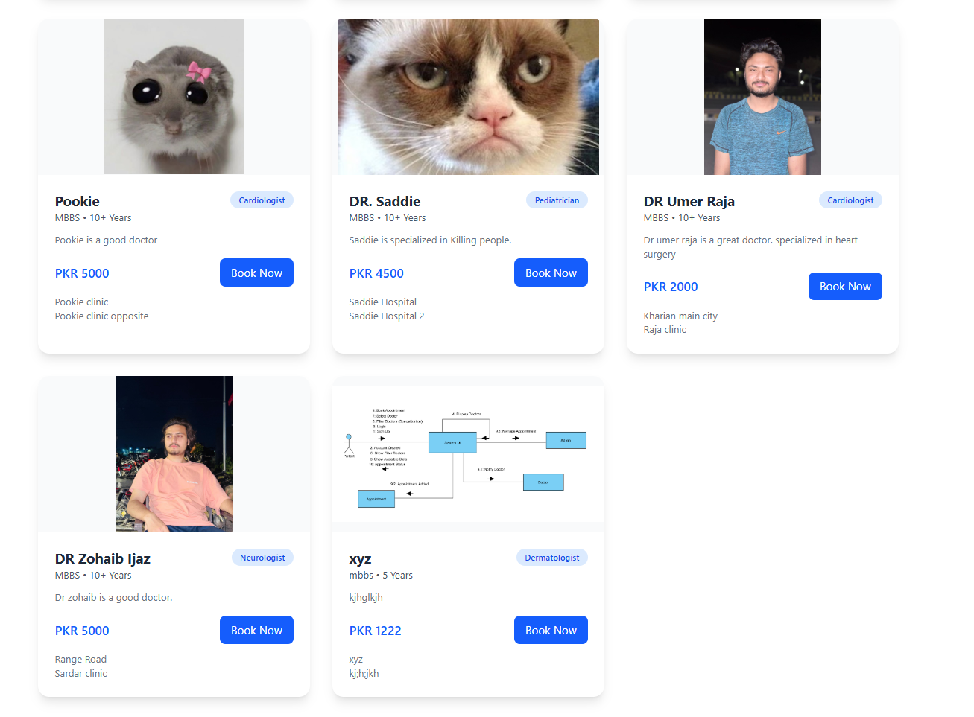
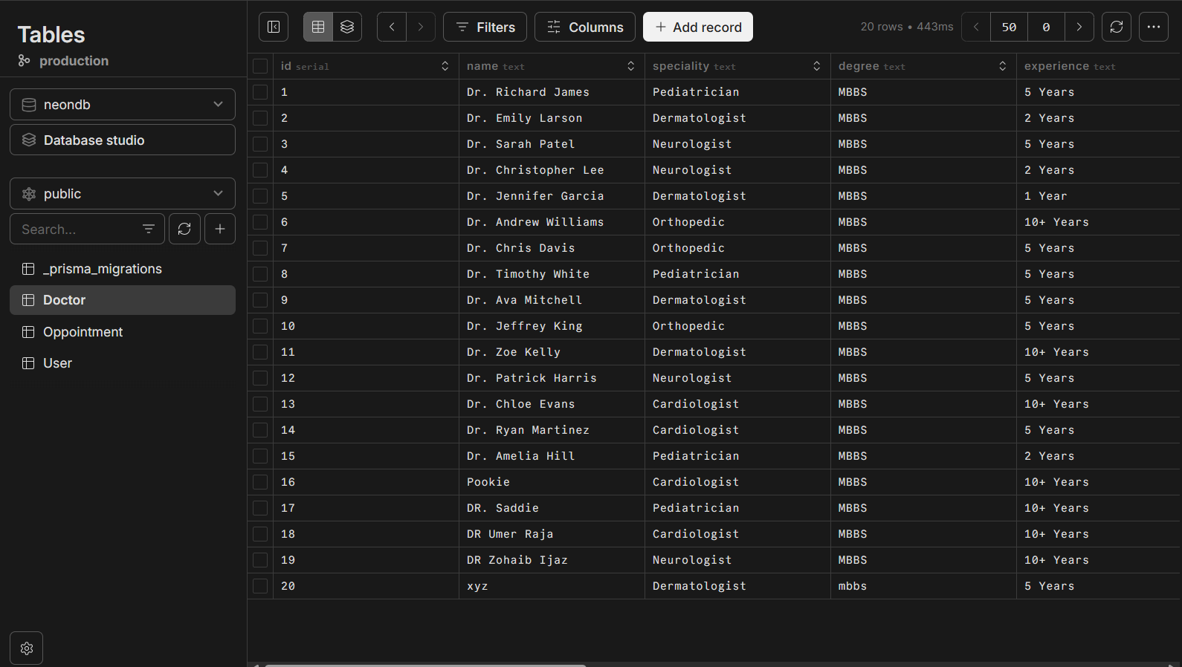
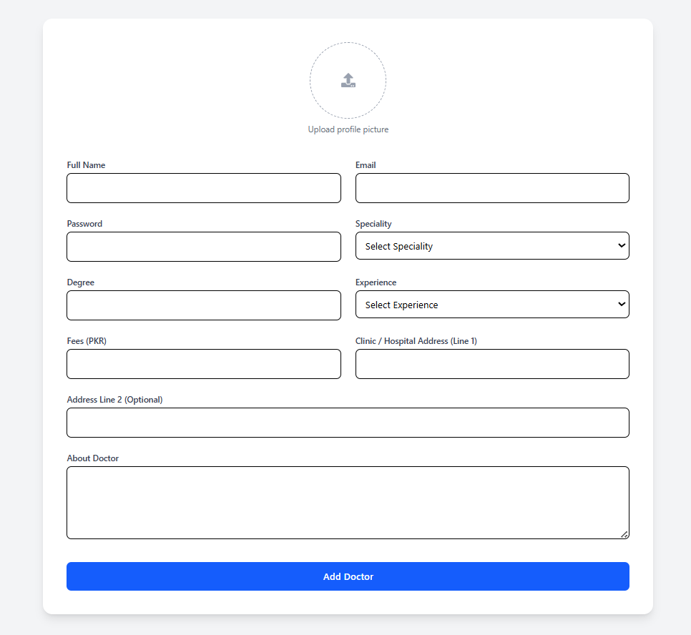

17. Conclusion
The Doctor Appointment Booking System successfully demonstrates the implementation of a real-world web application using modern web technologies. The project enhances understanding of full-stack development, database design, API development, and secure authentication. Future improvements may include payment integration, email notifications, and doctor availability management.

19. Project Repository
The complete source code of the Doctor Appointment Booking System is available on GitHub at the following link:

https://github.com/git-rafaykhan/doctor-oppointment-booking.git
The repository contains the full frontend and backend implementation, database models, API routes, and project documentation.

