

NATIONAL UNIVERSITY OF MODERN LANGUAGES

Artificial Intelligence Lab Report No - 3

NAME: M Abdul Rafay
ROLL NO: FL23791
PROGRAM: BSSE (6th Semester)
COURSE: Artificial Intelligence
SUBMITTED TO: Mam Amna Sajjad

DATE: 22 Feb 2026 DAY: Sunday

Implementation Of BFS and DFS Using An Example

1. Objective
The purpose of this lab is to implement and understand two fundamental graph traversal algorithms: Breadth-First Search (BFS) and Depth-First Search (DFS). Both algorithms are implemented in Python and tested on the same example graph. The output of each program is recorded below.

2. Example Graph
The following undirected graph with 6 nodes (0 to 5) and 7 edges is used for both algorithms. Both traversals start from Node 0.

0
/ \
1 2
/| |
3 4 - 5
Edges: 0-1, 0-2, 1-3, 1-4, 2-5, 3-4, 4-5
Adjacency List
Node | Neighbours
0 | 1, 2
1 | 0, 3, 4
2 | 0, 5
3 | 1, 4
4 | 1, 3, 5
5 | 2, 4

3. Breadth-First Search (BFS)
3.1 Concept
BFS visits nodes level by level using a Queue (First-In First-Out). It first visits all direct neighbours of the starting node, then their neighbours, and so on. It guarantees the shortest path in an unweighted graph.

3.2 Step-by-Step Trace (Start = Node 0)

Step | What Happens | Queue [front → back] | Visited
— | Start. Enqueue Node 0, mark visited. | [ 0 ] | { 0 }
1 | Dequeue 0. Neighbours 1, 2 are new → enqueue both. | [ 1, 2 ] | { 0, 1, 2 }
2 | Dequeue 1. Neighbours: 0(visited), 3, 4 → enqueue 3, 4. | [ 2, 3, 4 ] | { 0, 1, 2, 3, 4 }
3 | Dequeue 2. Neighbours: 0(visited), 5 → enqueue 5. | [ 3, 4, 5 ] | { 0, 1, 2, 3, 4, 5 }
4 | Dequeue 3. Neighbours: 1, 4 — both visited. Nothing added. | [ 4, 5 ] | { 0, 1, 2, 3, 4, 5 }
5 | Dequeue 4. Neighbours: 1, 3, 5 — all visited. Nothing added. | [ 5 ] | { 0, 1, 2, 3, 4, 5 }
6 | Dequeue 5. Neighbours: 2, 4 — visited. Queue empty. Done. | [ empty ] | { 0, 1, 2, 3, 4, 5 }

BFS Result: 0 → 1 → 2 → 3 → 4 → 5

3.3 Python Code (BFS)

from collections import deque

# Graph represented as an adjacency list
graph = {
0: [1, 2],
1: [0, 3, 4],
2: [0, 5],
3: [1, 4],
4: [1, 3, 5],
5: [2, 4]
}

def bfs(graph, start):
visited = [] # List to store visited order
queue = deque() # Queue for BFS
queue.append(start) # Start from the given node
seen = set() # To avoid revisiting
seen.add(start)

while queue:
node = queue.popleft() # Remove from front of queue
visited.append(node) # Mark as visited

for neighbour in graph[node]:
if neighbour not in seen:
seen.add(neighbour)
queue.append(neighbour)

return visited

result = bfs(graph, 0)
print('BFS Traversal Order:', result)

# Show step-by-step
print()
print('Step-by-step BFS from Node 0:')
seen = set()
queue = deque([0])
seen.add(0)
step = 1
while queue:
node = queue.popleft()
print(f' Step {step}: Visit Node {node}')
step += 1
for neighbour in graph[node]:
if neighbour not in seen:
seen.add(neighbour)
queue.append(neighbour)
3.4 Output
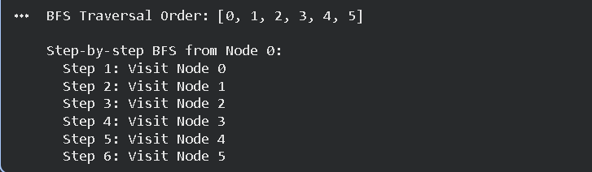

4. Depth-First Search (DFS)
4.1 Concept
DFS visits nodes by going as deep as possible along one branch before backtracking. It uses a Stack (Last-In First-Out) or recursion. It does not guarantee the shortest path but is useful for exploring all paths.

4.2 Step-by-Step Trace (Start = Node 0)

Step | What Happens | Call Stack [top] | Visited
— | Start at Node 0. Mark visited. | dfs(0) | { 0 }
1 | At 0 — first unvisited neighbour is 1. Go deeper. | dfs(0)→dfs(1) | { 0, 1 }
2 | At 1 — first unvisited neighbour is 3. Go deeper. | …→dfs(3) | { 0, 1, 3 }
3 | At 3 — unvisited neighbour is 4. Go deeper. | …→dfs(4) | { 0, 1, 3, 4 }
4 | At 4 — unvisited neighbour is 5. Go deeper. | …→dfs(5) | { 0, 1, 3, 4, 5 }
5 | At 5 — unvisited neighbour is 2. Go deeper. | …→dfs(2) | { 0, 1, 2, 3, 4, 5 }
6 | At 2 — all neighbours visited. Backtrack all the way. Done. | empty | { 0, 1, 2, 3, 4, 5 }

DFS Result: 0 → 1 → 3 → 4 → 5 → 2

4.3 Python Code (DFS)

# Graph represented as an adjacency list
graph = {
0: [1, 2],
1: [0, 3, 4],
2: [0, 5],
3: [1, 4],
4: [1, 3, 5],
5: [2, 4]
}

def dfs(graph, node, visited=None, order=None):
if visited is None:
visited = set()
if order is None:
order = []

visited.add(node) # Mark current node as visited
order.append(node) # Record visit order

for neighbour in graph[node]:
if neighbour not in visited:
dfs(graph, neighbour, visited, order) # Recurse deeper

return order

result = dfs(graph, 0)
print('DFS Traversal Order:', result)

# Show step-by-step
print()
print('Step-by-step DFS from Node 0:')
visited = set()
order = []
step_counter = [1]

def dfs_verbose(graph, node, visited, step_counter):
visited.add(node)
print(f' Step {step_counter[0]}: Visit Node {node}')
step_counter[0] += 1
for neighbour in graph[node]:
if neighbour not in visited:
dfs_verbose(graph, neighbour, visited, step_counter)

dfs_verbose(graph, 0, visited, step_counter)
4.4 Output

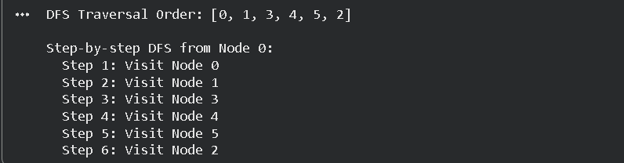

5. Comparison

Feature | BFS | DFS
Approach | Level by level | Deep path first, then backtrack
Data Structure | Queue (FIFO) | Stack / Recursion (LIFO)
Result on Example | 0, 1, 2, 3, 4, 5 | 0, 1, 3, 4, 5, 2
Shortest Path? | Yes (unweighted) | Not guaranteed
Time Complexity | O(V + E) | O(V + E)
Space Complexity | O(V) | O(V)
Best For | Shortest path, nearest node | Cycle detection, maze solving

6. Conclusion
This lab implemented BFS and DFS in Python and traced both algorithms manually on the same 6-node undirected graph. BFS produced the traversal order 0, 1, 2, 3, 4, 5 by processing nodes level by level using a queue. DFS produced the order 0, 1, 3, 4, 5, 2 by following one path as deep as possible before backtracking using recursion.
Both algorithms successfully visited all six nodes and all seven edges exactly once. BFS is preferred when the shortest path is needed, while DFS is preferred for exhaustive path exploration and cycle detection.

