

NATIONAL UNIVERSITY OF MODERN LANGUAGES

MOBILE APPLICATION DEVELOPMENT LAB REPORT - 1

NAME: Abdul Rafay
ROLL NO: FL23791
PROGRAM: BSSE (6th Semester)
COURSE: Mobile Application Development
SUBMITTED TO: Sir M Arif

DATE: 22 February 2026 DAY: Sunday

Lab Report 1 – Setup preparation and Enviroment setup for flutter
Objective
The objective of this lab was to install and configure the necessary tools required for Flutter application development. These tools include Visual Studio Code (VS Code), Dart SDK, and Flutter SDK.

Introduction
Flutter is an open-source UI software development toolkit used to build cross-platform applications for Android, iOS, Web, and Desktop. It uses the Dart programming language.
In this lab, we prepared our system for Flutter development by installing:
- Visual Studio Code
- Dart
- Flutter
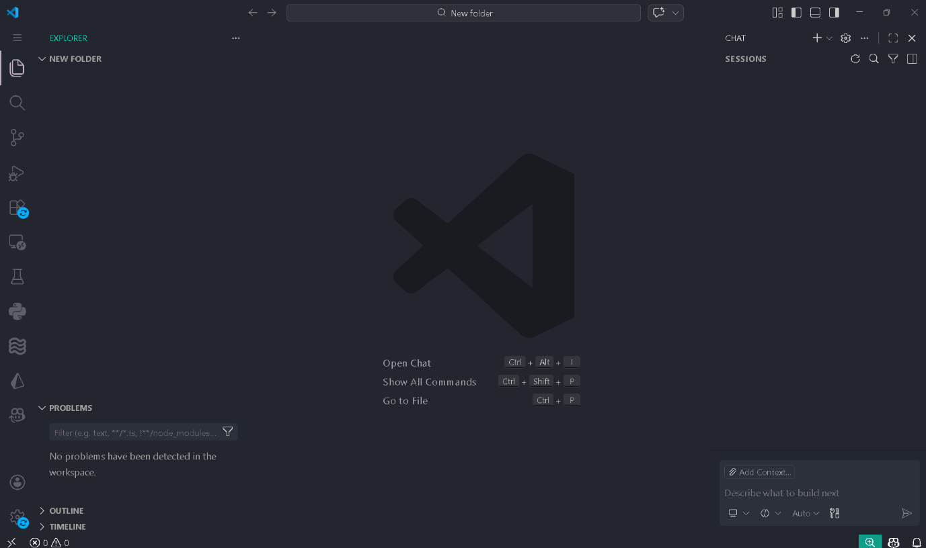
These tools are essential for building and running Flutter applications.

