

NATIONAL UNIVERSITY OF MODERN LANGUAGES

MOBILE APPLICATION DEVELOPMENT LAB REPORT – 3

NAME: Abdul Rafay
ROLL NO: FL23791
PROGRAM: BSSE (6th Semester)
COURSE: Mobile Application Development
SUBMITTED TO: Sir M Arif

DATE: 22 February 2026 DAY: Sunday

Flutter Basic Application Using Widgets
Objective
To create a simple Flutter application and understand the use of basic widgets such as MaterialApp, Scaffold, AppBar, Icon, Column, and Text.
Tools / Requirements
- Flutter SDK
- VS Code / Android Studio
- Android Emulator or Physical Device
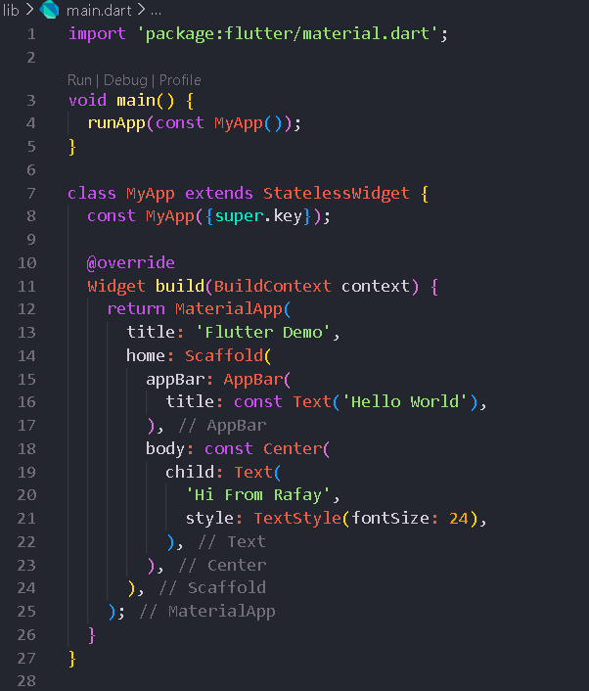
Code:

Output
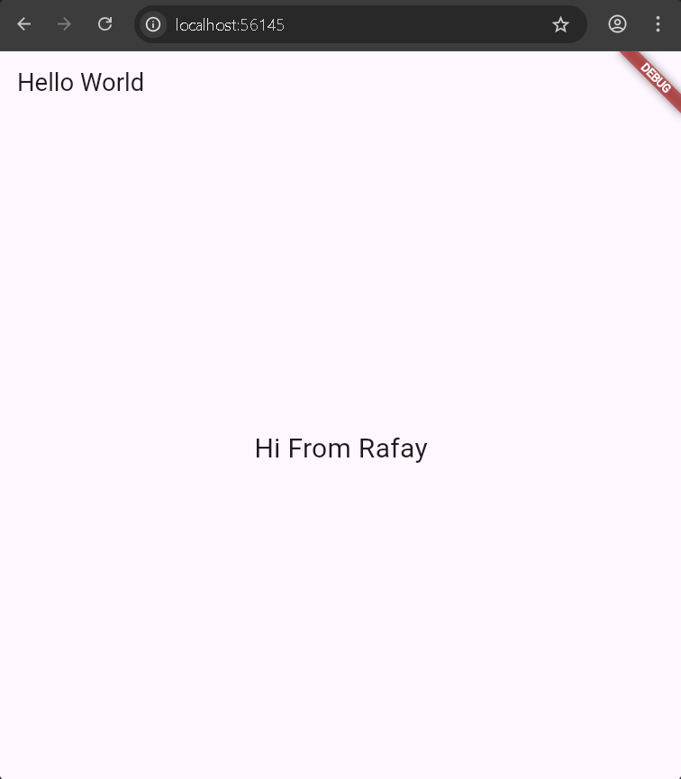
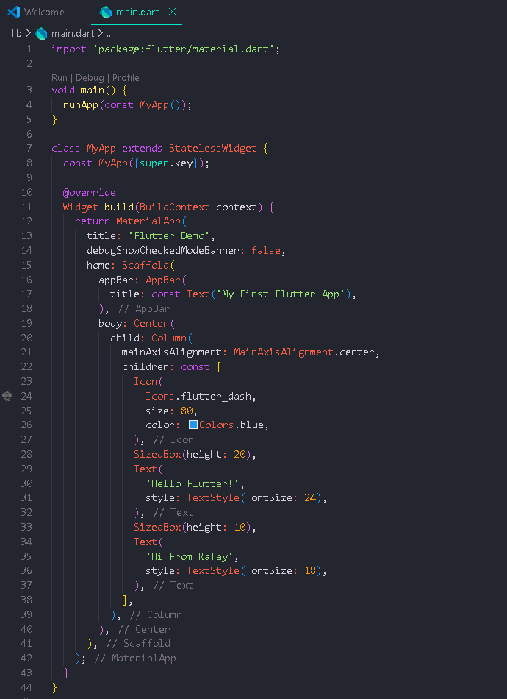
Code:
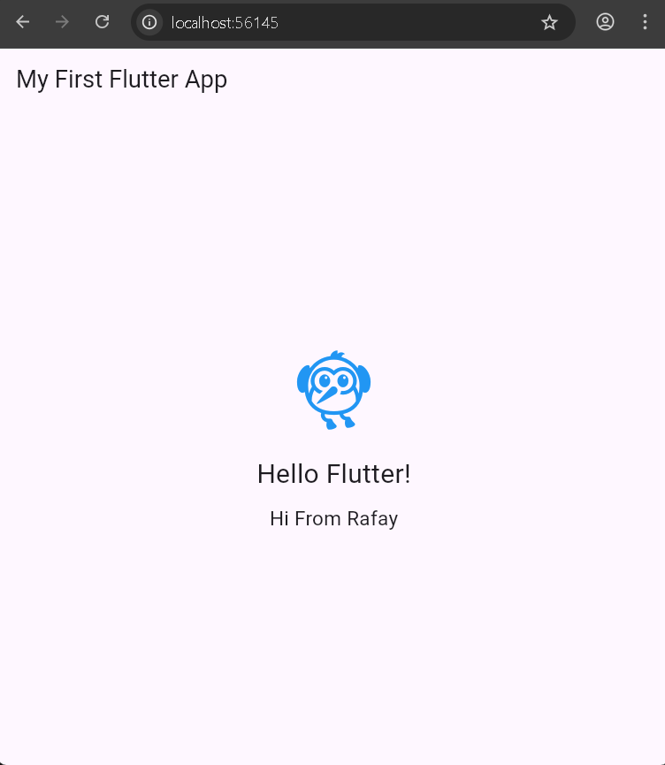
Output:

Widgets Used
- MaterialApp – Root widget of the application.
- Scaffold – Provides the basic layout structure.
- AppBar – Displays the title bar.
- Column – Arranges widgets vertically.
- Icon – Displays Flutter icon.
- Text – Displays text on screen.

