

NATIONAL UNIVERSITY OF MODERN LANGUAGES

MOBILE APPLICATION DEVELOPMENT LAB REPORT – 4

NAME: M Abdul Rafay
ROLL NO: FL23791
PROGRAM: BSSE (6th Semester)
COURSE: Mobile Application Development
SUBMITTED TO: Sir M Arif

DATE: 6 March 2026 DAY: Sunday

Implementation of Multi-Page Layout in Flutter
Objective
To develop a Flutter application with multiple pages and understand navigation between different screens using Flutter widgets.
Tools / Requirements
- Flutter SDK
- VS Code / Android Studio
- Android Emulator or Physical Device
Code
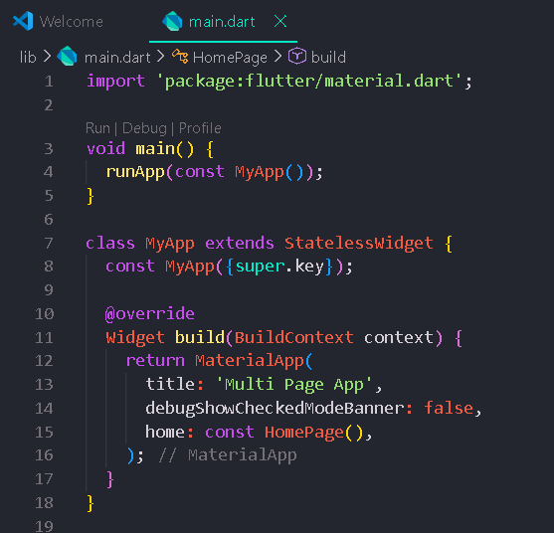
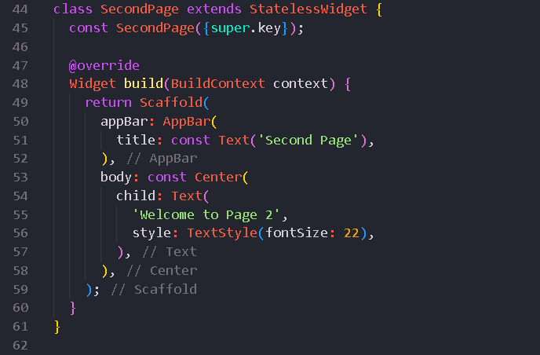
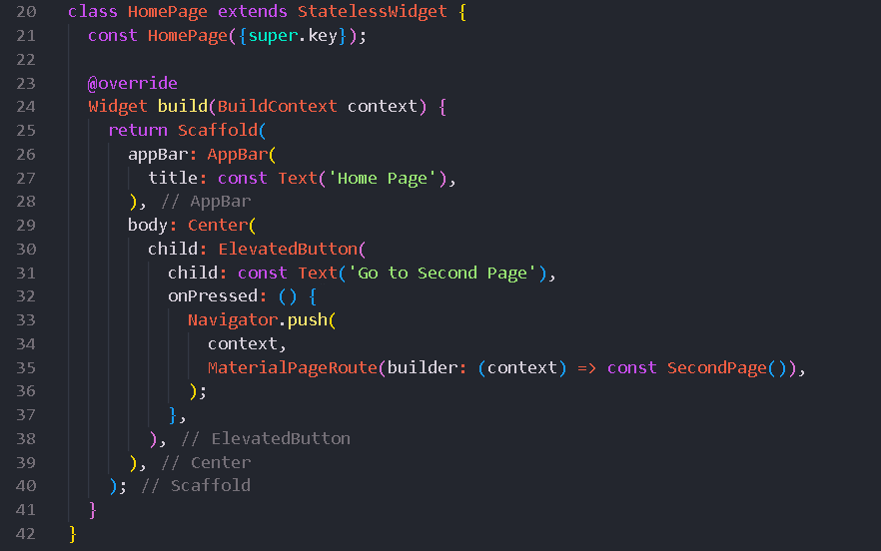

Output

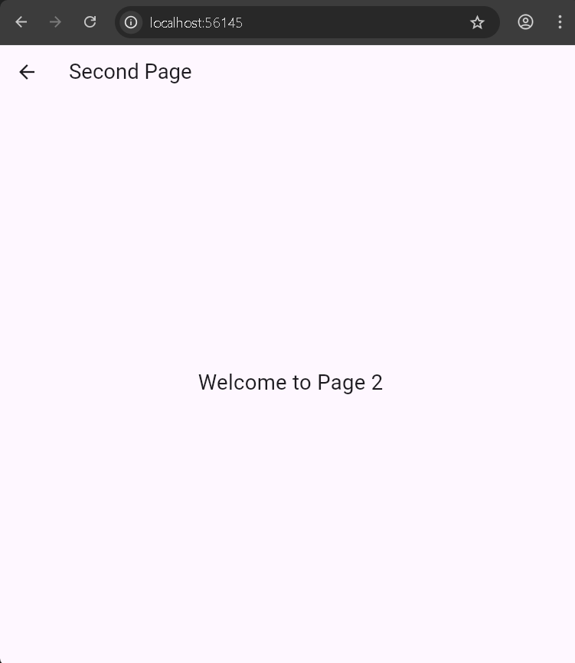
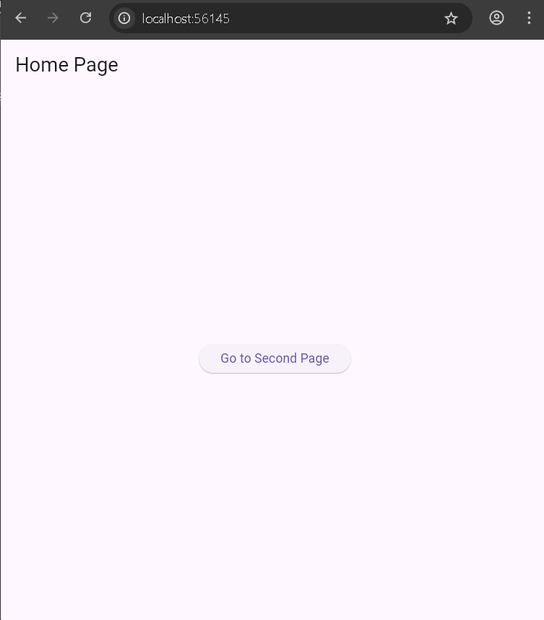
Widgets Used
- MaterialApp – Root widget of the application.
- Scaffold – Provides the page layout structure.
- AppBar – Displays page title.
- ElevatedButton – Button used for navigation.
- Navigator – Handles navigation between pages.
- Text – Displays text on the screen.

