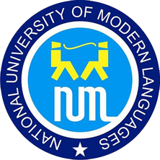

NATIONAL UNIVERSITY OF MODERN LANGUAGES

MOBILE APPLICATION DEVELOPMENT LAB REPORT – 5

NAME: Abdul Rafay
ROLL NO: FL23791
PROGRAM: BSSE (6th Semester)
COURSE: Mobile Application Development
SUBMITTED TO: Sir M Arif

DATE: March 13, 2026 DAY: Sunday

